NEWS FLASH December 2003

Focus: DC-to-DC Converters
Jeannette Plante, Editor

This issue of E-Flash Spotlight focuses on DC-to-DC converters used in flight hardware. It first provides an overview of a work in progress that will eventually be an electronic designer’s and electronic parts engineer’s guide for successful use of these components in flight hardware. Following that, other projects currently in progress will be discussed that deal with analysis of the issues associated with DC-to-DC converters and documented failures. Three studies done for the NEPP program and one by the CALCE Center at the University of Maryland are profiled. Finally, links for suppliers of space-grade DC-to-DC converters are provided.

How DC-to-DC Converters Work

DC-to-DC converters are critical items in spacecraft power systems. They accept power from the solar arrays or batteries at a range of voltages depending on the power bus design and mission conditions (typically 24 V to 36 V for many NASA satellites, around 70 V for some commercial satellites, and as high as 125 V for the International Space Station) and deliver voltage regulated outputs at the levels needed by various digital and analog electronics. These converters are voltage-regulated, switching power supplies that employ a variety of mature circuit configurations and are implemented with mature electrical and electronic parts. When the switching component inside of the converter, normally a MOSFET, is turned on and off (at rates from 20 kHz to 500 kHz and higher), voltages are produced at the output from energized capacitive or inductive components in the output stage. This method allows good current delivery with low amounts of loss inside the converter. The ratio of output power to input power is called the efficiency. Efficiency for most switching DC-to-DC converters used in space is between 65% and 80% when the converter is used near its maximum rated output power.

The input voltage of DC-to-DC converters changes with time for various reasons, including transitions between light and dark periods in the orbit and changes in the bus load conditions. Feedback circuits within the converter provide regulation of the output voltage by comparing the output voltage level to an internal reference voltage and driving the difference to a low value by fine-tuning the duty cycle of the internal switch. This is often done through a pulse width modulator (PWM) circuit.

A number of circuit designs, or topologies, have been developed to improve the output performance and durability of DC-to-DC converters in a variety of electrical and environmental conditions. Filters on the input and output help dampen signals that can result from package-related capacitances and inductances and smooth output ripple. Synchronization circuitry is provided to prevent multiple converters that are working in parallel from generating a beat frequency¹ through coupling of unfiltered harmonics. Input filters are also used to improve impedance matching. Transformers are used inside of DC-to-DC converters to provide input-to-output isolation, and to achieve the desired output voltages, including multiple voltage outputs. Careful selection of converter topology, analysis and design filter circuits, and analysis and design of power bus load management circuitry are required for successful application of these converters in an electrical power bus system.

Which DC-to-DC Converters Are Needed

The primary criteria for designing or buying a DC-to-DC converter are the voltage input range, the output voltage, the efficiency, and the power dissipation (sometimes in a W/in³ context in which miniaturization is important). Spacecraft solar arrays, and their back-up battery systems, have traditionally been designed to generate output voltages of between 21 Vdc and 34 Vdc. Output voltages of ±15 V, ±12 V, 5 V, 3.3 V, and 1.5 V have been required from the converters. Future applications are seeking voltages even lower. Power ratings below 10 W are commonly needed.

Individual integrated circuits called DC-to-DC converters are typically low-voltage regulators. The switching converters used in NASA power buses are typically achieved through a design and build that uses discrete components, or can be by using a complex hybrid microcircuit (a miniaturized circuit card within a package, containing magnetic coils, resistors, capacitors, packaged ICs, and bare IC dies) or some combination of all three. The IC solution is applicable in the low-voltage, low-power, digital arena, while the latter highly complex approaches are needed for higher power applications working at the spacecraft bus level and containing filtering and synchronization circuitry.

How Hybrid Designs Enter Into Use

DC-to-DC conversion has traditionally been implemented and has successfully been achieved through “discrete” designs at the circuit card level. While their performance may be very nearly matched to the application requirements, they may seem large by modern electronic packaging standards. Design of these circuits using hybrid microcircuit manufacturing will greatly reduce the footprint of portions of the system, may improve efficiency and may reduce common-mode noise.

Miniaturization in DC-to-DC converter hybrids is achieved mainly by eliminating some of the IC packages (implementing chip and wire technology) and by increasing the switching frequency which drives the ability to use smaller magnetic components (these miniaturized DC-to-DC converters are generally rated at an internal switching frequency of around 500 kHz but designs have been found that go up to 1 MHz). The chip and wire technology, the special substrate design and the thermal management features contribute to large non-recurring engineering (NRE) costs. The internal parts can be quite specialized for space hardware builds which causes expansion of the lead times. Another serious challenge associated with the hybrid microcircuit approach is that test points can be lost and the opportunity for post-production changes or repair is greatly diminished. The ability to assure the constituent materials, the parts and the design, in a way that we have the most experience, is diminished; this includes loss of 100% burn-in of each internal part (a.k.a. the elements).

Market conditions and business decisions made by the hybrid DC-to-DC converter suppliers have led to NASA projects buying hybrid converters from companies who are building them both for the commercial sector as well as for the high reliability market. These parts are advertised as standard, commercial-grade products and are defined to a limited degree in military specifications under the QML-38534 system. Leveraging of the logistics and NRE costs of the high reliability production line with the benefits of the higher volume commercial production line, have led the manufacturers to attempt to align the design goals of their commercial and high reliability customers. NASA is finding that the result can be a reduction in the performance that NASA projects require.

NASA’s Issues With Commercially Available Hybrid Converters

Some of the critical issues associated with the purchase of these commercially available parts are:

- A lack of knowledge by the user about, or input into, the electrical design.
- Uncontrolled processes: traceability, qualification, screening, rework.
- Quality and workmanship problems.
- Long-lead times and competition for manufacturing floor priority.
- Unavailability of build records and unpredictable progress through the production process.
- Inability to modify the design at later stages of the program to resolve problems.
- Insufficient functionality requiring design of external circuitry.

These issues are at the same time, related to design and application, parts engineering, quality assurance and procurement.

The first problem bulleted above can be the root of very serious performance problems. There is pressure on the manufacturer to make customers compromise on performance in order to reduce the number of different designs being produced. Critical features such as input and output filters and rigorous ground isolation might be dropped to satisfy the market majority’s need to maximize efficiency, thereby exposing space flight users to reliability concerns. Further, the design is tweaked to provide peak performance zones that reduce the user’s ability to realize the nominal ratings outside of a “sweet spot”. This has been experienced by NASA designers in a significant reduction in efficiency (from the advertised 70% to 90% to as little as 10% to 20%) when operating at reduced output power and associated catastrophic damage to external and internal components due to the changed load conditions.

Application-Driven Issues

To overcome these problems, users must design circuitry around the hybrids, such as filtering, grounding and protection features, to increase circuit performance. The miniaturization advantages begin to disappear at this point while the project continues to carry the risks associated with use of the hybrid components. In some cases the designer is not completely aware of these deficiencies and does not adequately mitigate the associated risks and problems. This may be from a lack of experience with the part, access to a complete set of application notes or a lack of rigorous application requirements from the project. Serious performance problems or failures have recently occurred because of the lack of sufficient application notes including:

- Floating Case: Ground pins were left floating because it was assumed that the case would be installed in such a way as to electrically connect it to chassis ground. The thermal coupling material that was chosen was electrically non-conductive leaving the case ungrounded, which is warned against in the vendor’s application notes. The result was an out-of-design condition that conflicted with the operation of the internal oscillator affecting the output signal and exposing an internal IC to voltage spikes. Though the new, higher input voltage was within the device’s rating, it put the part into a mode that was not sufficiently radiation hard. Though the application note was there about grounding the case, elaboration on the consequences of an ungrounded case might have motivated the designers to ensure the rule was followed and to more rapidly identify the problem. Knowing the consequences of improper usage can trigger good safety as well as good quality practices at Integration and Test (I&T).

- Input Filters: Input filtering application requirements are often inadequate. Though at least one manufacturer does discuss the need and proper use of input filters with their converters, no mention is made about the limit to how many converters can be supplied from a single filter. The consequences can be high noise, damaging oscillations at the input and reduced efficiency.

- Variable Power Bus Loads: There are limits to the amount of current and voltage regulation that DC-to-DC converters can provide across a power bus that has dramatically changing load conditions. These load conditions might occur because subsystems have gone off-line for replacement or repair or due to failure. Without proper design and planning, these large changes in impedance matching conditions can lead to high currents causing damage to the converters or to collateral circuitry.

- Synchronization: The synchronization (sync) pin is used to establish a leader-follower relationship among a group of converters to avoid generating beat frequencies due to the slight differences in internal switching frequencies among the individual converters in the group. To make this approach work, the sync pins must be connected and activated before the internal FET is operated. By turning all pins on at the same time, the internal frequencies of the follower units will not be properly controlled and a beat frequency will be propagated. If a “follower” unit’s oscillator has a chance to compete with the “leader” the resulting signal can cause damage to the MOSFET.

These problems can also arise with the discrete builds of DC-to-DC converters. Both hybrid and discrete builds have experienced packaging problems related to solder joints and stress relief. These problems are closely related to packaging design and proper methods for attaching packaged components to mechanically and thermally active elements in the assembly such as the hybrid lid, the hybrid substrate, the printed circuit board and the chassis. There has been a case where the hybrid package was designed to use a new, high performance thermal material that proved to be completely inadequate from a mechanical perspective. Rigorous packaging analysis, assembly design and verification can reduce these problems.

Testing and Specification Issues

Verification of the design’s capability, the manufacturing facility and the manufactured product, in the intended application, for some specified amount of time, is the goal of qualification. Screening provides the means to remove non-conforming product and infant mortals from a production lot before the parts are sold to the buyer or installed in the application. NASA has traditionally used both of these reliability assurance strategies for procuring DC-to-DC converters. They have leveraged off of the detailed written quality and test requirements that can be found in the DoD’s specification for hybrid microcircuits, MIL-PRF-38534. NASA also uses guidelines given in MIL-STD-1580 for destructive physical analysis, MIL-STD-883 for test and pre-cap visual inspection and EEE-INST-002, which contains guidelines for qualification and screening of space EEE parts.

Though these standards are readily available to us and NASA understands and uses the information contained in them, there are shortcomings in the requirements that are causing problems and the parts that are purchased are not all described by detailed specifications. One very significant shortcoming in the specifications is the lack of a requirement to fully characterize the part over a wide variety of operating conditions. Such a characterization would demonstrate the results one can expect as the converter is used outside of the small window of optimal performance conditions. The user can then determine if the result is generally acceptable in their application, acceptable only for short periods, never acceptable, or catastrophic. Some useful application notes can also be achieved during extensive characterization testing. The lack of performance characterization has led to exceeding safe operating areas (e.g. for transformer wire insulation and capacitor voltage ratings), leading to internal ringing, and voltage spikes between V_{out} and ground.

Though NASA parts engineers can personally increase their attention to these problems while following their procurement through the manufacturer’s facility, it is often difficult to discern changes to the process, including those which effectively change the design, from what was done to produce the units used in the original qualification process. For example, a failure occurred when an IC was used as a form/fit/function replacement for an obsolete part but was not an adequate replacement. This sort of change cannot be “seen” in many visual and electrical inspections. It ended up being detected during radiation testing. NASA project budgets and schedules often depend on leveraging qualification off of prior uses of the part; this can “hamstring” the parts engineer, who finds it necessary to repeat qualification tests at the lot level.

Another loophole in the specifications is the lack of attention to element derating and no requirement to use established reliability parts as the elements. Radiation testing is also not well specified, allowing the testing to be done by irradiating particular elements at a time and biasing the part with quiescent conditions or by using semiconductors that are qualified at the element level. Though the entire packaged hybrid carries a radiation tolerance rating, that rating may have been insufficiently achieved. Characterization under vacuum and radiation conditions can help identify critical problems early on in the stage before spacecraft-level assembly. Again, this approach is time consuming and costly and can be hard for projects to absorb.

Weaknesses in the manufacturer’s data sheet and the military’s specification sheets drive the parts engineers to impose additional requirements at the purchase order level. These may include:

- Pre-cap visual inspection.
- Traveler reviews.
- Review of prior qualification records.
- Progress reviews and reporting.
- Delivery of data.

The vendor may or may not comply with all of these requirements. Also, there are no penalties associated with lack of delivery to these purchase orders. Procurements over the last few years have found that the vendors can be inconsistent with loyalty to the delivery dates or even to providing full disclosure about their schedule.

Contracted Subsystem Procurements

The alternative to buying hybrid DC-to-DC converters and adding on discrete circuitry at the board level or to building the whole system in-house is to treat the DC-to-DC converter procurement in the same way as NASA would treat a subsystem through a subcontract. The advantages of this approach are:

- The ability to specify performance requirements over operating condition ranges (electrical, thermal, mechanical, and lifetime), and to negotiate design trade-offs with competing suppliers.
- Increased accountability by the manufacturer to make delivery dates.
- Quality stop-gaps such as critical design review (CDR) and manufacturing readiness review (MRR).
- First article qualification rather than using old, insufficiently related qualification data.
- Return policy.

However, these approaches have serious disadvantages too: cost and lead time. Given the erratic lead times for the hybrid parts (6 months to 1 year, usually closer to or greater than the latter) and the approximately 1 year needed for an in-house, discrete design and build, the 1 year generally needed for a contracted procurement like this makes each approach basically the same with regard to lead time. The costs can be very different, though. Recent estimates for contracted builds have ranged from $200 K to $3.2 M per system. This is a hard metric to track because of the wide range of complexity of the systems that are needed.

A variety of groups examined the issues that have caused NASA problems with DC-to-DC converters and that have prevented NASA from avoiding continued failures of converters in space hardware. Summaries of some of that work and related efforts are provided in this issue. The NEPP Information Management and Dissemination (IMD) Project has issued this E-Flash to bring awareness to the topic at a time of increased activity in this area. The features provided herein are intended to capture and share information about the topic in general and about ongoing activities.

Note 1. See this link for a definition of beat frequency: http://hyperphysics.phy-astr.gsu.edu/hbase/sound/beat.html)

Features

DC-to-DC Converter Buy for the SDO Program at NASA GSFC
Jeannette Plante, Editor

Dennis Krus, the project parts engineer for the Solar Dynamics Observatory (SDO), is working with the project’s electrical power system engineer, Amri Hernandez-Pellerano, characterizing DC-to-DC converter hybrids for use both by SDO and by the Global Precipitation Management (GPM) project. They have narrowed the need down to output voltage and power ratings of:

- +3.3 V @ 20 W.
- +3.3 V @ 40 W.
- +5, +/-15 V @ 60 W.
- +5 V @ 30 W.
- +/-15 V @ 30 W.

Other requirements at this time are:

- Must include input filtering inside of the hybrid.
- 5-year life expectancy.
- Class K construction.
- Radiation-hard elements.

The actual procurement work has not started, which will involve formulating some focused specification requirements to overcome some of the loopholes that exist in the military specifications for hybrid microcircuits and to overcome some of the problems noted above. Manufacturing capability and qualification history of available product is currently being researched.

More insight into this parts engineering work or other SDO-related parts issues can be obtained by contacting Dennis Krus at NASA GSFC, 301.286.1121, dennis.krus.1@gsfc.nasa.gov.

Return of Solder Joint Failure Due to Flexing Lid in Interpoint Converter
Jeannette Plante, NASA GSFC, Parts Branch

The most recent GIDEP Problem Advisory issued on DC-to-DC Converters is dated August 29, 2003 and was submitted by Crane Interpoint Corporation (CAGE code 50821) for the part MFL2815D/883, which corresponds to the military specification 5962-93193. The failure mode was identical to one experienced in the MTR28 style at NASA GSFC. The problem was a failed solder joint at the end of an inductor wire that resulted when stress was transferred to the joint from the inductor wire, which was stuck to the case lid. The case lid had flexed away from the case in a vacuum environment due to the pressure differential between the inside of the hermetically sealed part and the pressure of the vacuum outside of the part. The solder joint failed due to creep-to-rupture. The failure was not immediate but occurred after vacuum exposure. Crane Interpoint issued a GIDEP on the MTR28 failure in March of 2000. The newer GIDEP discusses their corrective action.

Two documents on the NEPP Web site discuss this flexing lid/breaking bond issue:

- Finite Element Analysis Done for the Image Project: http://nepp.nasa.gov/DocUploads/FA1E3FC1-14B8-449F-9B37B8E8A683AF06/IMAGE_FEA.pdf.
- Probability of Success of Interpoint MTR28xxd Converters Used in Image: http://nepp.nasa.gov/DocUploads/004B922E-920A-4348-9CFAF94AE14E7C4D/mtr28.pdf.

Members of the GIDEP system can go to http://members.gidep.org to find other alerts logged into the system. Affected products are as follows:

- SMHF28XX, 5962-95559, -91614, -92144, -91601, -92139, Crane Interpoint.
- 11930-M111 (EMI Filter), 5962-94010, Crane Interpoint.
- ATW2815D, 5962-91613, Lambda Advanced Analog.
- AFL2815DW, Lambda Advanced Analog.
- AT02815TF, Lambda Advanced Analog.
- ATW2815D, Lambda Advanced Analog.
- MI-J++-M+ Series, Vicor.
- 683-61700-001, Modular Devices Incorporated.

Phantom Application Notes for DC-to-DC Converters
Jeannette Plante, Editor

Recent failures of DC-to-DC converters in NASA projects have not all been attributable solely to design and manufacturing flaws in the hybrid DC-to-DC converter components. Several problems can be traced to varying electrical conditions that occur during integration and test, that are outside of the safe or rated operating area of the part, or are a result of how the part was installed. Though these problems are operator-induced, the industry’s stop-gap for these types of errors is the issuance of application notes. These notes enable successful use of the parts when they address known part deficiencies, idiosyncrasies, and limitations that can cause unwanted, dangerous, or catastrophic results in the circuit.

There are a number of application notes that have been dutifully and clearly reported by the major manufacturers of DC-to-DC converters used in space hardware. However, growing experience in the field is exposing the need for more. Four recent failures illustrate four new application notes that should be added to the corpus (these are discussed in the lead article above: Floating Case, Filtering, Variable Output Loads, Synchronization).

In mid-November 2003 a circuit design-parts engineering round table was convened at NASA GSFC to discuss this and other issues related to the lack of a centralized and complete collection of application notes for DC-to-DC converters for space. This organization will be addressing this need in a handbook for NASA power supply designers and parts engineers.

Convening of DC-to-DC Converter Round Table at NASA GSFC
Jeannette Plante, Editor

A meeting was held on November 14, 2003, between the power supply designers of NASA GSFC Code 563 and the parts engineers and other interested parties of NASA GSFC Code 562 to discuss issues with the use, procurement, and assurance of DC-to-DC converters at NASA GSFC. The discussion covered a wide variety of issues, some well known to the group and others not so well known by one or both of the organization represented. Broadly, the topics covered:

- Drivers for using hybrid DC-to-DC converters.
- How we attend to reliability.
- The variability of application conditions, some catastrophically dangerous to the converter and collateral parts or systems.
- The lack of a rigorous set of application notes.
- Cost, lead time, and assurance risks associated with hybrid microcircuit builds.
- Downfalls of in-house builds.
- Performance deficiencies in commercially available hybrid microcircuits.
- How we assure new buys and builds and procurement problems.
- Cost of managing discrete builds using contracts instead of purchase orders.

Much of the material contained in the lead article was generated as a result of this round table meeting. The minutes of the meeting are currently under review, looking toward what the next step will be with regard to fact finding, technical research, and tools that can be authored or built in the laboratory that can significantly decrease the number of failures of DC-to-DC converters in NASA hardware.

Preliminary Test Results for DC-to-DC Converter Noise and Transient Turn-on Characteristics for NASA Applications
Ashok K. Sharma, NASA GSFC, Alexander Teverovsky, QSS Group, Inc.

The reliability of DC-to-DC converters has long been a major concern for NASA parts and application engineers. Currently available DC-to-DC converters are complex hybrid devices that use a variety of active and passive elements such as power MOSFETs, output diodes, pulse width modulators, ASICs, stacked chip capacitors, optocouplers, inductors/transformers, etc. These DC-to-DC converters are specified for various input/output voltages, efficiencies, and power ratings ranging from a few watts to over 100 watts. The applications of these parts require operation at elevated temperatures and pulse stress conditions, and therefore the quality/performance of the elements used in the construction and assembly is crucial.

Failure modes of DC-to-DC converters experienced over the years have been related to contamination, poor construction and assembly-related defects, Schottky diode failures, optocoupler degradation, stacked chip capacitor failures, and so on. A new failure mode of DC-to-DC converters has been observed in a thermal vacuum chamber, which manifested itself as an intermittent output interruption related to the level of vacuum and temperature. Failure analysis showed that these interruptions were due to the lid deformation caused by a difference between the internal pressure of the hybrid and the external pressure created in the chamber. Deformation of the lid was transferred to the solder joints through adhesive coupling of the lid with internal elements of the hybrid. During the thermal vacuum cycling, these deformations resulted in a creep-to-rupture failure of the solder joints and caused interruptions of the output voltage of the device.

Two other important issues related to the reliability of DC-to-DC converters are noise and turn-on transients, which are design specific and can be a serious concern in some applications. Switching in DC-to-DC converters is a natural source of noise, which is an inherent feature of all switch-mode designs. Under certain conditions, the turn-on transients can create significant voltage spikes at the output of DC-to-DC converters, which can potentially damage interconnected microcircuits. The goal of this study was to perform preliminary testing of noise and transient turn-on characteristics of DC-to-DC converter part types from various suppliers.

The results from this work have not been released; for more information, contact Ashok Sharma, Ashok.K.Sharma.1@gsfc.nasa.gov, or Alexander Teverovsky, Alexander.Teverovsky@gsfc.nasa.gov.

Preliminary Report on DC-to-DC Converters Temperature Cycling Test Results
Ashok K. Sharma, NASA GSFC, Alexander Teverovsky, QSS Group, Inc.

Several types of DC-to-DC converters and EMI filters were subjected to multiple temperature cycling over the range from -65 ºC to +150 °C. Interim electrical measurements were performed at three temperatures (-55 °C, 20 °C, 125 °C) after 20, 90, 300, and 1,000 cycles. All EMI filters passed the electrical tests after the thermal cycling, but only one DC-to-DC converter withstood 1,000 thermal cycles. Electrical measurements of the EMI filters did not show any significant variations in electrical characteristics.

The results from this work have not been released because of vendor-sensitive material; for more information, contact Ashok Sharma, Ashok.K.Sharma.1@gsfc.nasa.gov, or Alexander Teverovsky, Alexander.Teverovsky@gsfc.nasa.gov.

Related NEPP/NEPAG Reports

Hybrid DC-to-DC Power Converter Survey and Analysis for NEPAG by NASA LaRC Team
Jeannette Plante, Editor

A report being prepared for the NASA EEE Parts Assurance Group (NEPAG) on DC-to-DC converters is nearing completion. A team of NASA and contractor engineers has studied market offerings and reliability benchmarks in order to determine NASA’s best strategies for meeting their needs for future missions.

The report examines the following:

- Availability of space and military specified and qualified product and the size of that market.
- The number of standard parts available for space system use and the number of vendors producing standard, space-grade parts.
- The most common styles of DC-to-DC converters that have been used by NASA programs.
- NASA application performance needs and the availability of product on the market to meet those needs.
- NASA’s most urgent needs and problems with DC-to-DC converters.
- Obstacles to growth in the high reliability DC-to-DC converter marketplace.
- Current R&D efforts being directed at NASA’s DC-to-DC converter needs.
- Industry-Government partnering opportunities.
- Related papers and publications.

For more information on this work, prior to publishing, contact Mike Sampson, msampson@pop300.gsfc.nasa.gov.

Computation of Reliability by “Virtual” Method of Plastic Encapsulated DC-to-DC Converters
K. Ghosh and F. P. McCluskey, University of Maryland (CALCE)

Introduction

The use of solid-state hi-power electronic components and modules is becoming more widespread in a variety of applications. This is true both in large power systems, as electrical control and distribution of power replaces mechanical control and distribution and in smaller, point-of-use power supply applications. The use of solid-state electronic components and modules has the potential to significantly improve the efficiency and performance of power systems while reducing their cost. Critical to the widespread incorporation and success of these solid-state modules, however, is understanding and controlling their reliability under the harsh environmental (high temperatures, humidity, salt spray) and operational loading conditions (high voltages, currents and power dissipation levels) that are typical in power electronics applications. Such knowledge is essential for maximizing performance and minimizing life cycle cost.

Accelerated tests have long been the preferred method for assessing the reliability of power electronic modules and systems. However, this method is a time-consuming and costly approach for determining the relative merits of different design options or of choosing between commercially available sub-systems. In addition, the reliability of many commercially available modules and sub-systems has improved to the point where standardized qualifications are uncovering fewer potential problems, and, thus, are less cost-effective. Finally, accelerated testing, if done improperly, can induce failure mechanisms that are not representative of field use. A new method of reliability assessment, physics-of-failure, has been developed to address these shortcomings of traditional accelerated testing. It is a methodology that assesses the reliability of electronics upfront during the design phase, based on models of the fundamental mechanisms by which they fail. The CALCE physics-of-failure (PoF) approach to reliability assessment includes virtual qualification and physical verification. Using this approach, the reliability of power electronic components, modules, and sub-systems can be assessed quickly at a minimum cost. University of Maryland researchers have developed and demonstrated methodologies and tools for performing up-front physics-of-failure reliability assessment of both plastic-encapsulated and ceramic encapsulated power electronic modules.

In this study, a virtual qualification was performed on a small DC/DC power converter, and then validated with tailored accelerated testing. The aim of this approach was to validate the virtual qualification with experimental data and then predict the life of the components under field load conditions. In the accelerated validation testing of the converter, a performance baseline was determined, environmental stress was applied, the performance was reassessed for shifts, and, finally, root cause analysis was conducted on any unit that exhibited significant reductions in performance. The results of the testing were compared against the virtual qualification to confirm that the virtual qualification predicted similar time to failure in test by similar failure mechanisms.

Virtual Qualification

Virtual qualification (VQ) is a simulation-based process that models the stress history experienced by the proposed product when it is subjected to its anticipated life cycle, to assess whether the anticipated reliability is achievable. The process can be used for identifying and ranking failure sites based on likelihood of occurrence. Physical verification then follows using accelerated stress testing to verify that the simulation adequately captures the physical design and the dominant failure mechanisms.

The parts assessed were 32 mm x 20 mm 8-pin DIP cavity packages consisting of a diallyl phthalate shell filled with thermally conductive flexible gray silicone. Embedded in the silicone was a double-sided surface mount printed wiring board. The devices had an input voltage of 48 V DC. The manufacturer qualified the devices for operation over a temperature range of –40 °C to +75 °C without derating. The devices are single output, 3 watt power systems with 100% surface mount technology (SMT), including the magnetics. calcePWA software was used in this study to model the printed circuit board of the DC-DC converter. Component data for the simulation was obtained from the manufacturers, while the board was modeled based on layer stack-up information determined by cross-sectioning. The model is illustrated in Figure 1.

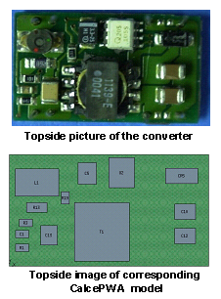

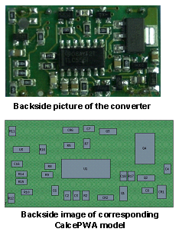

Figure 1. calcePWA Model of the Converter PCB

Table 1 indicates that the DC/DC converter should survive 20 years life in its intended application environment, which was 5 temperature cycles per day from 25 °C to 50 °C with a 30-minute dwell at high temperature. It also provides the time-to-solder joint failure in test for the components most likely to fail in this manner. The test condition was 24 cycles per day from -55 °C to 125 °C with a 15 minute dwell at high temperature. The inductor and leadless capacitors are considered to be most at risk for early failure in test.

Accelerated Testing

Multiple test configurations were used to carry out a full set of experiments. Each setup was capable of testing multiple units simultaneously. A block diagram illustrating the fixturing for accelerated test characterization is shown in Figure 2.

Five samples, soldered to the board, were used in each test. The output ends of the wires were connected to a data acquisition unit. A power supply unit was supplying the 48 V input. Three different experiments were conducted. Two were life tests at 12 5°C and 11 0°C at half load, and the third was temperature cycling between –50 °C to +150 °C with 10 °C/min ramp. Half load means that the load resistance across the output of the converters was drawing half the maximum current. The temperature cycling test was done unpowered.

Two out of five samples had failed by 405 unbiased thermal cycles, one at 210 cycles and one at 405 cycles. Solder joint failure at the inductor was observed to be the failure mechanism. This corresponded to the virtual qualification prediction. This observation and those following life testing matched the virtual qualification predictions.

Conclusion

Virtual qualification based on physics-of-failure has proven to be an effective method to evaluate the robustness and reliability of DC-DC converters from manufacturers in a cost-effective and timely manner. The technique indicated that under field load conditions the critical parts are expected to survive more that 30 years, while the predictions under test loading were validated by the results of the accelerated testing.

Four thousand, four hundred hours of life testing at 110 °C and 3,911 hours of life testing at 125 °C were completed. Eight-hundred fifty cycles of temperature cycling was completed. Samples from the 125 ºC life test failed at 725, 1,902, 3,187, 3,191 and 3,911 hours. The failure criterion was considered to be Vout crossing the 5 ± 0.05 V tolerance limit when tested at room temperature. Failure analysis revealed evidence of temperature overstress on the backside, under the transformer as shown in Figure 3; this is the location of the highest temperature in the corresponding calcePWA model.

Table 1. Component Solder Joint Lifetime (Field: 5 Cycles Per Day; Accelerated: 24 Cycles Per Day)

Component | Description | Field  Environment  (years) | Accelerated Test Environment  (Cycles)
L1 | Inductor | >30 | 200.00
C10,C12,C13 | 22-47MF Capacitor | >30 | 811.66
R1-R3,R5,R7-R12,R14-R17,R19 | Resistor | >30 | 1451.75
Q4 | Power Mosfet | >30 | 1501.24
U1 | Timer | >30 | 1949.97
C1-C4,C6-C8,C16,C18 | Capacitor | >30 | 2570.26
C5 | Tantalum capacitor | >30 | 3711.86
T1 | Transformer Power SMT | >30 | 9898.31

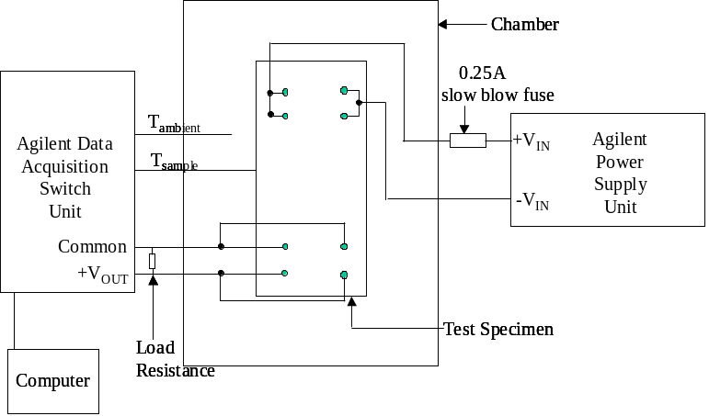

Figure 2. Block Diagram of the Electrical Setup

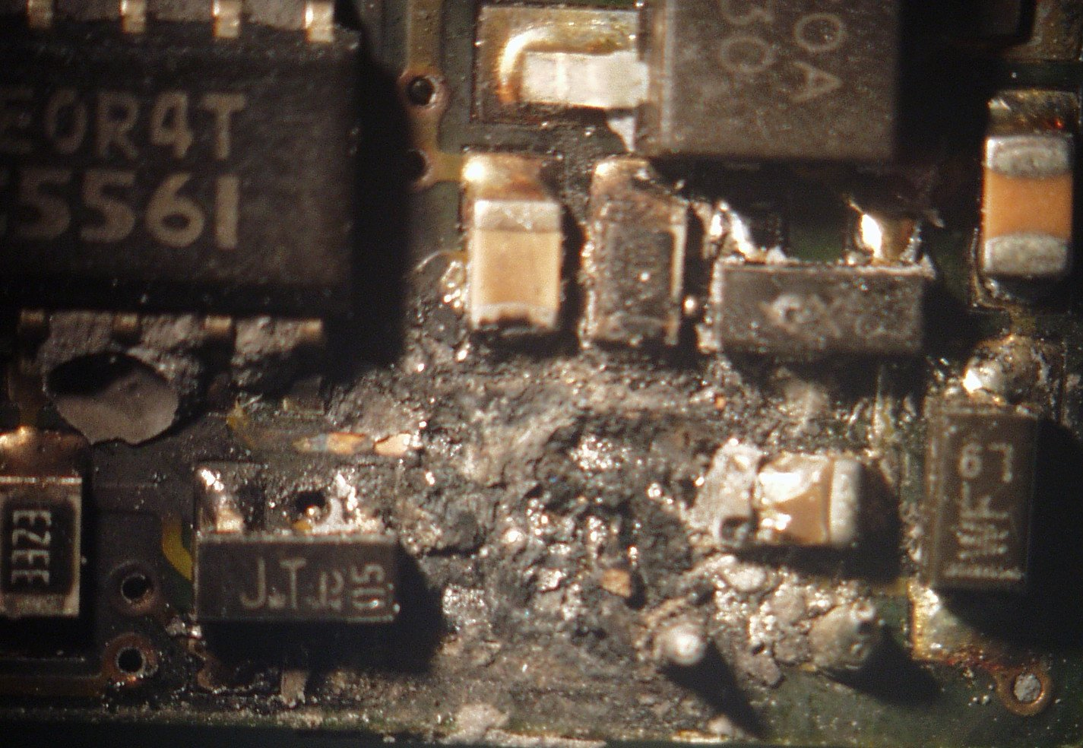

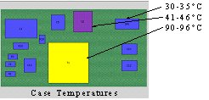

Figure 3. Failure Site Due to Life Test and Verified by calcePWA Software

For more information, contact Patrick McCluskey, mcclupa@eng.umd.edu

Phase and Gain Response of a Closed-Loop-Control High Voltage DC-DC Converter at Cryogenic Temperatures
Scott Gerber, ZIN Technologies, Malik Elbuluk, The University of Akron, Richard Patterson, NASA Glenn Research Center, Ahmad Hammoud, QSS Group, Inc., NASA Glenn Research Center, Cleveland, Ohio

Background

The phase and gain response of a 1 kW, 80-110 V/500 V closed-loop-controlled high-voltage full-bridge DC-to-DC converter was evaluated at room temperature and at various temperatures down to -185 °C. The converter design was based on that of a beam power supply for a space electric propulsion system, with the added capability of being able to operate over a very wide, low-temperature range. This cryogenic beam supply was previously tested for efficiency, output voltage regulation, switching behavior and transient load testing. Recent availability of a Venable frequency response system has made phase and gain response testing of the supply a reality.

Test Setup

Testing of the cryogenic beam supply was performed in a liquid nitrogen cooled chamber manufactured by SUN Systems. A Venable frequency response system was used to measure phase and gain response over a frequency range of 10 Hz to 1 MHz. Response measurements were recorded at chamber temperatures of 25 °C, -55 °C, -100 °C, -150 °C, and -185 °C. Due to limited availability of the frequency response system, initial testing was limited to a single operating point of 100 V input voltage, 500 V output voltage, and a 600 Ω load (half load ≈ 415 W).

Results and Discussion

The closed-loop controller was constructed from metal film resistors; solid tantalum, npo, ceramic, and mica capacitors; and CMOS devices (timer, logic, and operational amplifier). The controller utilized a Type I compensation network. Previous testing utilized a 0.01 μF compensation capacitor. After the initial response measurements showed a phase margin of approximately 45º and a gain margin of 14 dB at 25 °C, additional compensation was added by utilizing a 0.02 μF compensation capacitor. Response measurements for this configuration showed a phase margin of approximately 60º and a gain margin of 30 dB at 25 °C. Table 1 lists the measured phase and gain margins of the controller at each test temperature. As the temperature was decreased to -100 °C, both phase and gain margins were reduced to their minimum values of 45° and 16 dB, respectively. As temperature was further decreased down to -185 °C, the phase and gain margins returned to values close to those obtained at 25 °C. At all temperatures the controller maintained adequate phase and gain margins for controller stability.

Table 1. Measured Phase and Gain Margins of the Controller at Various Test Temperatures

Temperature (°C) | Phase Margin (°) | Gain Margin (dB)
25 | 60 | 30
-55 | 60 | 27
-100 | 45 | 16
-150 | 48 | 17
-185 | 53 | 35

The phase and gain vs. frequency plots for the controller at test temperatures of 25 °C and -185 °C are shown in the full report.

Conclusion

A 1 kW, 80-110 V/550 V closed-loop controlled, full-bridge DC-to-DC converter, designed to operate from 25 °C to -185 °C using commercially available components, was evaluated in terms of its frequency response over temperature. Testing was performed at a single nominal operating point of 100 V input voltage, 500 V output voltage, and a 60 0Ω load (half load ≈ 415 W). Phase and gain response measurements were made over a frequency range of 10 Hz to 1 MHz. The converter’s phase margin varied from a maximum of 60° at 25 °C to a minimum of 45° at -100 °C, and the gain margin varied from a maximum of 35 dB at -185 °C to a minimum of 16 dB at -100 °C. Measured phase and gain margins at -185 °C were similar to those measured at 25 °C. At all temperatures the controller maintains adequate phase and gain margins for controller stability. The results from this work indicate that control circuits can be designed and operated at very low temperatures well beyond normal operating temperatures.

The full report, including the charts and schematics not shown here and the references can be found by “Phase and Gain Response” in the search box and clicking on “Search Alphabetically” at the Web site: http://nepp.nasa.gov/index_nasa.cfm/477/. For more information about low temperature testing of DC-to-DC converters contact Dr. Richard Patterson, Richard.L.Patterson@grc.nasa.gov

Vendor Links

International Rectifier: http://www.irf.com/product-info/govt-space/dcdcconverters.html and http://www.irf.com/product-info/govt-space/rrart2800.pdf

VPT, Inc.: www.vpt-inc.com/space_power_products

Crane Interpoint: http://www.interpoint.com

Modular Devices Incorporated: http://www.mdipower.com

Editorial Staff

NEPP Program Managers:
Mike Sampson, NASA, GSFC, 301-286-3335, Michael.J.Sampson.1@gsfc.nasa.gov
Ken Label, NASA, GSFC, 301-286-9936, klabel@pop700.gsfc.nasa.gov

Editor:
Jeannette Plante, Dynamic Range Corp., GSFC, 301-286-7437, jfplante@pop500.gsfc.nasa.gov

