

Moisture Characteristics of Molding Compounds in PEMs

Alexander Teverovsky
QSS Group, Inc./Goddard Operations
Alexander.A.Teverovsky.1@gsfc.nasa.gov

Table of Contents

I. Characteristic Times of Moisture Diffusion and Bake-out Conditions for Plastic Encapsulated Parts

Abstract 4
I-1. Introduction 4
I-2. Theoretical Modeling 5
I-3. Diffusion Characteristics of Epoxy Encapsulating Materials 9
I-4. Rating Bake-out Times With Temperature 10
I-5. Comparison of the Calculated Bake-out Times With the JEDEC
Recommendations 11
I-6. Low Temperature Bake-out Conditions 12
I-7. High Temperature Testing of PEMs Stored in Laboratory Conditions 13
I-8. Conclusion 14
I-9. References 15

II. A Rapid Technique for Moisture Diffusion Characterization of Molding Compounds in PEMs

Abstract 16
II-1. Introduction 16
II-2. Theoretical Modeling 17
II-3. Analysis of Assumptions 19
II-3.1. Arrhenius Law 19
II-3.2. Fickian Law 19
II-3.3. Equilibrium Moisture Uptake 20
II-3.4. Temperature Variation Across the Sample 21
II-4. Experiments 21
II-5. Analysis of the Method 23
II-5.1. Lead Frame Effect 24
II-5.2. Comparison With Conventional Methods 27
II-6. Moisture Diffusion Characteristics of Molding Compounds in
Different Types of PEMs 28
II-7. Conclusion 30
II-8. References 30

III. Environmentally Induced Swelling and Shrinkage of Molding Compounds in PEMs

Abstract 32
III-1. Introduction 32
III-2. Technique 34
III-2.1. Measurements of Volume Derivations and
Hygroscopic Swelling 34
III-2.2. Effect of Lead Frame 35
III-3. Swelling Characteristics of Different MCs and
Encapsulating Materials 36
III-3.1. Testing in 85 °C/85% RH Chamber 36
III-3.2. Effect of Temperature and Humidity 37
III-3.3. Sorption Isotherms 39
III-4. Effect of Bake-out and High Temperature Exposure 41
III-5. Discussion 44
III-5.1. Mechanism of Hygroscopic Swelling 44
III-5.2. Mechanisms of the Bake-induced Volume Deviations 47
III-6. Conclusions 50
III-7. References 51

I. Characteristic Times of Moisture Diffusion and Bake-out Conditions for Plastic Encapsulated Parts

Abstract
Simple equations for calculation of the characteristic times of moisture diffusion in plastic packages of different shapes and sizes are suggested. It is shown that the moisture-prevention strategy can be developed and the adequate bake-out regimens for different situations can be calculated based on the temperature dependency of the moisture diffusion coefficient, D(T), of encapsulating polymer materials.
In the available literature, moisture diffusion characteristics of molding compounds used in plastic encapsulated microcircuits (PEMs) have been analyzed and typical D(T) characteristics are calculated. The bake-out times calculated using averaged diffusion characteristics of molding compounds are in agreement with the JEDEC recommendations. Examples of calculations of bake-out regimens for parts allowing only low temperature treatment and for parts temporarily exposed to high humidity conditions are considered.
I-1. Introduction
The capability of polymer materials to absorb moisture from the environment is one of the major reliability concerns for microelectronic devices encapsulated in plastic packages. Moisture condensation into microgaps (delaminations or cracks) between the die surface and molding compound (MC) can cause failures due to increased leakage currents, charge instabilities, or corrosion of aluminum metallization. Moisture sorption in the volume of molding compounds causes swelling of the packages, resulting in additional mechanical stresses in dies and in parametric shifts in precision linear devices.
The presence of moisture in plastic packages might cause failures during assembly of surface mount technology (SMT) devices on boards. Special measures, such as limited exposure of the SMT parts to moisture environments and bake-outs before reflow soldering, should be performed to keep the moisture content below the critical level and to prevent the popcorning effect.
Moisture in epoxy molding compounds, conformal coatings, or glob top encapsulants decreases glass transition temperature and plasticizes polymer materials, thus decreasing internal mechanical stresses in the parts. Desorption of moisture in vacuum for the parts intended for space applications will result in increasing stiffness and in shrinkage of polymers, which might cause cracking and delaminations in the encapsulating materials and failure of the parts. For this reason, it is important to perform testing of parts that are sensitive to mechanical stresses in conditions close to those in space where polymer materials contain no moisture.
Bake-out conditions (time and temperature) for SMT parts should be provided by the part manufacturer. However, in most cases manufacturers specify the industry standard bake: 125 °C for 24 hours [1]. Obviously this condition cannot be optimal for all cases. For example, if deterioration of solderability and lead finishing at high temperatures is a concern, the maximum allowable temperature must be decreased (sometimes temperatures as low as 40 °C are recommended). The bake-out times depend on the size and shape of the package; however, in most cases these factors are neglected. One may use the bake-out regimens recommended by IPC standard (IPC-TM-650): 125 °C for 6 hours for packages with less than 2 mm of body thickness, and 24 hours for thicker packages. A recent IPC/JEDEC J-STD-033 document, “Standard for Handling, Packing, Shipping and Use of Moisture/Reflow Sensitive Surface Mount Devices” (July 2002), has more refined bake-out regimens that are discussed below.
It should be noted that all IPC/JEDEC standards and manufacturer recommendations for bake-out conditions are focused only on moisture/reflow sensitive SMT parts and are intended to prevent the popcorning effect and avoid damage caused by exposure of the parts to high temperatures during reflow soldering onto the boards. However, the major quality assurance strategy for all types of PEMs intended for space applications is to prevent moisture sorption in parts during the whole ground phase integration, testing, and storing period, which lasts typically from 2 to 5 years. This strategy can be realized by a computer simulation or engineering estimations of moisture content in the package during exposure to humid environments and by implementing adequate bake-out conditions for PEMs and PEM-containing assemblies.
The following study was performed to establish simple equations for the characteristic times of moisture diffusion in plastic packages of various shapes and sizes and to estimate bake-out conditions for different devices based on the experimental data of the temperature dependence of diffusion characteristics of molding compounds.
I-2. Theoretical Modeling
Moisture sorption/desorption processes in a plastic package are described by the same equation and result in the same characteristic times of the diffusion process. For simplicity, a sorption process is considered in the following analysis.
Fick’s second law controls distribution of moisture concentration in plastic packages. In the case of a flat package it can be described by the following one-dimensional equation:
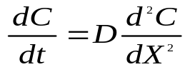 (1)
where C is the moisture concentration (which depends on time t and coordinate X ), and D is the diffusion coefficient of moisture in the plastic.
Assuming that the package initially contains no moisture, its thickness is 2h, and the die-plastic interface is in the middle of the package (X=0), the following initial and boundary conditions can be written:
C(X,0) = 0 at -h < X < h
C(-h,t) = C(h,t) = C_{o} at t > 0 (2)
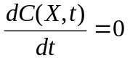 at X = 0, t > 0
where C_{o} is the equilibrium concentration of moisture at saturation.
The solution to the equations (1) and (2) gives the moisture concentration at the die surface C(t) as a function of time [2]:
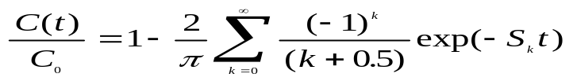 (3)
where S_{k} = π²D/h²×(k +0.5)² , k = 0, 1, 2, ...
Ignoring all terms in this series except for the first one, the solution to the diffusion equation for a flat plastic package can be approximated by the following simple expression:
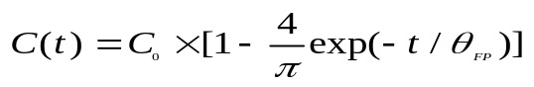 (4)
where θ_{FP}= 4h²/(π² D) is the characteristic time for moisture diffusion in a flat package.
A sphere or cylinder is a convenient approximation for many discrete semiconductor devices (such as switching or emitting diodes, transistors, rectifiers, etc.). For a spherical package of radius R, the solution of the relevant Fick’s equation can be written as:
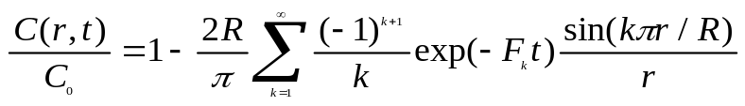 (5)
where F_{k} = π² k²D/R², and r is the die’s effective radius.
The power series (5) at a relatively large time (t) will converge on zero. Ignoring all terms but the first, Eq. (5) can be approximated by the following expression:
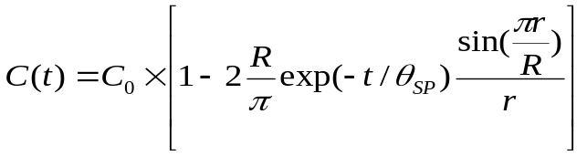 (6)
where θ_{SP} = R²/(π² D) is the characteristic time for moisture diffusion in a spherical package.
If r<<R the above equation can be simplified further:
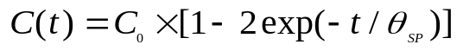 (7)
For a cylindrical package, the time dependence of the moisture concentration can be expressed using Bessel functions of the first (J_{o}) and second (J₁) type:
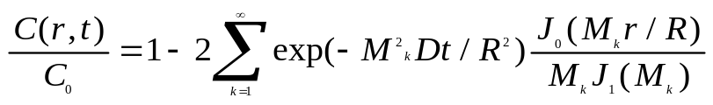 (8)
where M_{k} are positive roots of equation J_{o}(M) = 0.
The series (8) will also quickly converge on zero with time and at r<<R Eq. (8) becomes:
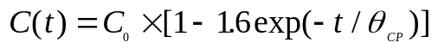 (9)
where θ_{CP} = 0.176R²/D is the characteristic time for moisture diffusion in a cylindrical package.
Figure I-1 displays variations of the rated moisture concentration at the die surface vs. rated times (t/θ_{P}) calculated by exact (3, 5, 8) and simplified (4, 7, 9) equations. Here ϑ_{P} is the characteristic time of diffusion in the package, which is equal to ϑ_{PF}, ϑ_{PC}, and ϑ_{PS} for flat, cylindrical, and spherical packages, respectively.
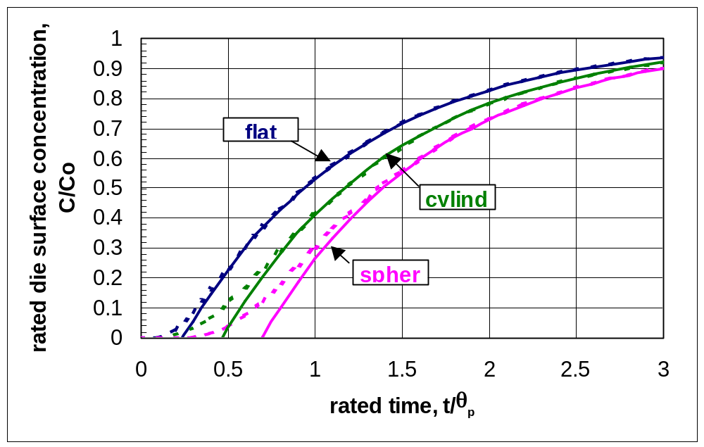
Figure I-1. Variation of moisture concentration at the die surface vs. time for plastic packaged devices of different shapes. The dashed lines were calculated using the exact equations (3, 5, 8) and the solid lines were calculated using approximations (4, 7, 9).
The exact and the approximate curves converge for C/C_{o} greater than 0.2, suggesting that the simplified equations give a fairly good approximation for the moisture concentration variance with time at t/θ_{P} > 0.3 for a flat package and t/θ_{P} > 1 for a spherical package. At t = ϑ_{P} the rated concentration is far from the saturation levels: C/C_{o} ~ 0.55 for flat packages and C/C_{o} ~ 0.3 for spherical packages. Thus, the characteristic times of moisture diffusion can be defined as times when the concentration of moisture at the surface of a die in initially dry package reaches 55%, 44%, and 29% respectively for flat, cylindrical, and spherical packages.
It is reasonable to assume that the bake-out time of moisture diffusion, τ_{p}, is the time when moisture concentration at the die surface for a device, which is presaturated in moisture to equilibrium uptake, decreases to 10% of the saturation level. In Figure I-1 this condition corresponds to C/Co = 0.9. At this condition τ_{p} = 2.5×θ_{FP} for a flat package, 2.3×θ_{CP} for a cylindrical package, and 3×θ_{SP} for a spherical package. Table I-1 shows formulae that allow calculation of the moisture bake-out times for packages of different shapes.
Table I-1. Moisture diffusion characteristic times (θ) and bake-out times (τ_{b}) for packages of different shapes.
Package Shape | θ | τ_{b}
Flat, thickness 2h | 4h²/π²D | 1.01×h²/D
Sphere, radius R | R²/π²D | 0.3×R²/D
Cylinder, radius R | 0.176R²/D | 0.4×R²/D
Numerical computations of Eq. (1) and (2) allow for calculation of the distribution of moisture concentration, C(X,t), across the thickness of a package at different times of exposure to humid environments. Results of these calculations for a flat plastic package are shown in Figure I-2.
Integrating these distributions allows for calculation of the mass of desorbed water, dM, at different times during baking:
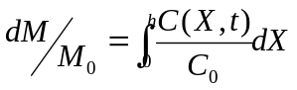 (10)
where M_{o} is the total mass of the desorbed water.
The results of these computations together with C/Co data from Figure I-1 are shown in Figure I-3. As expected at t/τ = 1.01, which corresponds to the bake-out time as it is shown in Table I-1, C/Co = 0.1 and dM/Mo = 0.06.
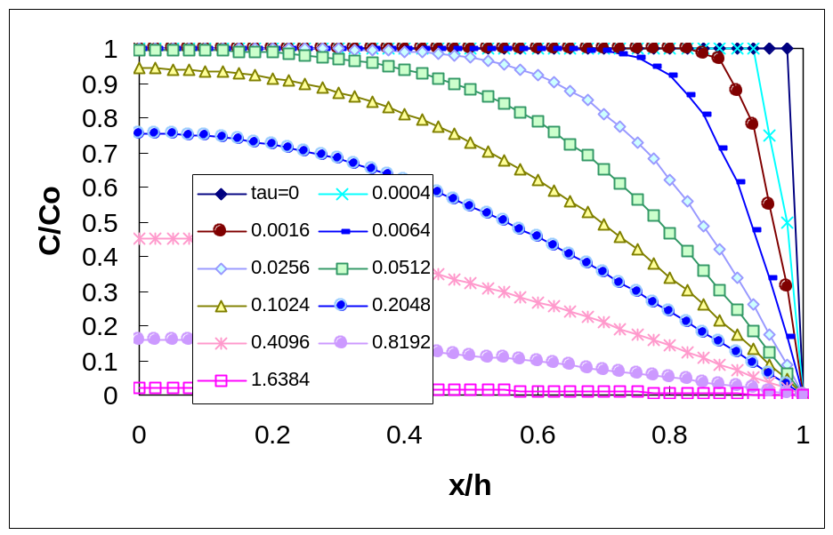

Figure I-2. Normalized distributions of moisture concentration in a flat package at different times (t/τ, where τ = h²/D) during moisture desorption.

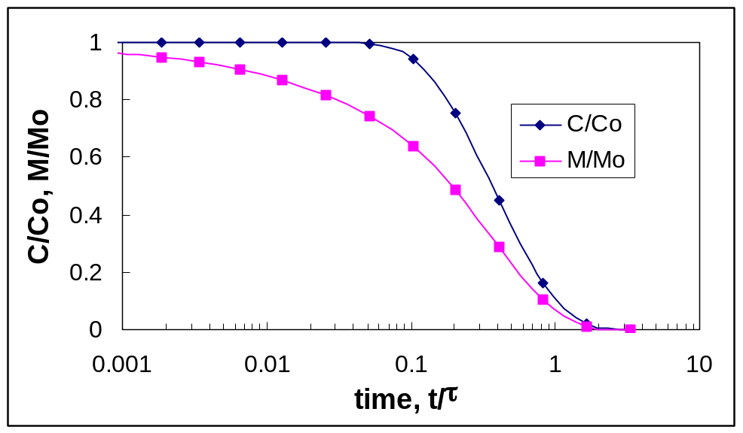

Figure I-3. Moisture concentration at the die surface and mass losses of a flat package with time of baking. Here the τ = h²/D.

The moisture uptake or release for PEMs is usually expressed as a percent of the package mass, δM/M_{p}, where δM is the mass of absorbed/released water and M is the mass of a part. Typically, this value varies from 0.2% to 0.5% when devices are stored at 85% RH. This means that baking of the parts, which are fully saturated with moisture, during the time calculated per Table I-1 will reduce the moisture content to less than 0.012% to 0.03%. This is a negligibly small amount, which in most cases will not cause any moisture-related degradation even in parts with a high level of sensitivity to moisture. It should be noted that in the cases when parts are exposed to humid environments with RH < 85% and/or for the time t < τ_{b}, the baking would reduce moisture content to a level much less than 0.03%.

I-3. Diffusion Characteristics of Epoxy Encapsulating Materials
To estimate bake-out conditions for PEMs, the value of the diffusion constant D for the encapsulating material must be known. The data available on diffusivity of epoxy encapsulating molding compounds, which were found in the literature, together with our data obtained for several types of molding compounds manufactured by Poliset, Nitto Denko, and Sumitomo, are displayed in Figure I-4. It is seen that at a given temperature different compounds have diffusion constants scattered over an order of magnitude. All temperature dependencies of D reported in the literature indicate that the D exponentially increases with temperature and the D(T) characteristics follows Arrhenius law:
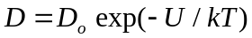 (11)
where D_{o} is constant, U is the activation energy, T is the absolute temperature, and k is the Boltzmann constant.
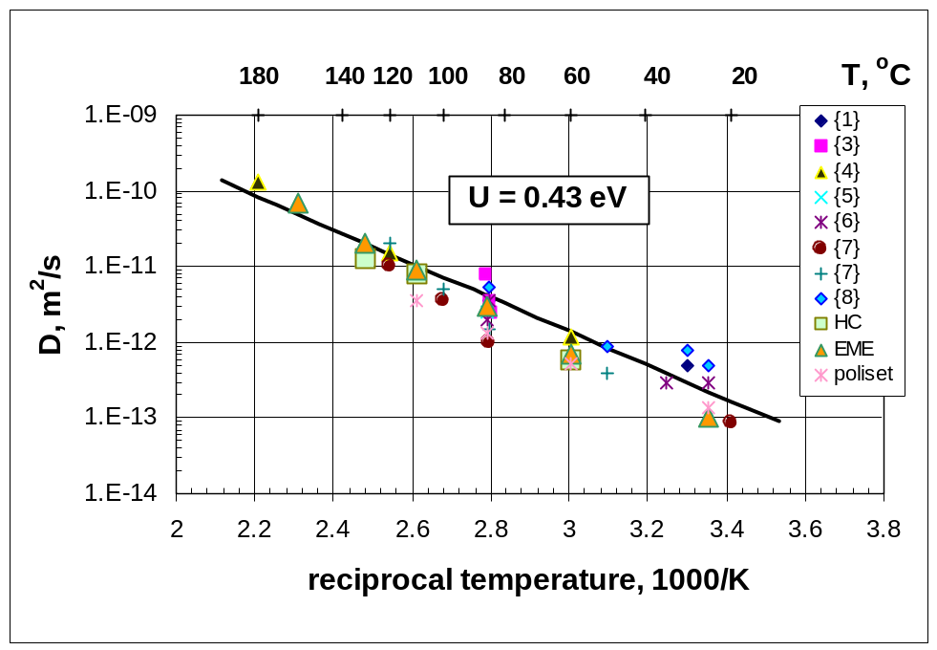
Figure I-4. Experimental data on temperature dependence of moisture diffusion coefficient for different epoxy encapsulating materials. Figures in brackets are references.
The best-fit curve approximation to all data displayed in Figure I-4 gives
D_{o} = 7.35×10⁻⁶ m²/sec and U = 0.43 eV. This value of activation energy is fairly close to those reported by the other authors [3, 4, 8, 9].
I-4. Rating Bake-out Times With Temperature
Considering Eq. (11) a temperature dependence of the bake-out times can be written in the following form:
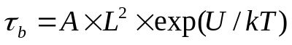 (12)
where A is a shape-dependent parameter (see Table I-2.), L = h for a flat package, and L = R for a cylindrical or spherical package.
Table I-2. Shape parameters in Eq. (12) for different packages.
Package Shape | A, hr/mm²
Flat | 3.83×10⁻⁵
Sphere | 1.15×10⁻⁵
Cylinder | 1.53×10⁻⁵
Temperature dependencies of bake-out times for flat packages with thicknesses of 4 mm, 2 mm, and 1 mm, as well as for spherical and cylindrical packages with a radius of 2 mm, are shown in Figure I-5. These times vary from approximately 1 year for thick (4 mm) flat packages at room temperature (in dry conditions or in vacuum) to several hours for thin (1 mm) packages at high (140 °C to 150 °C) temperatures. This means that plastic parts with a thickness of more than 2 mm can retain a high level of moisture concentration at the die surface for thousands of hours after being exposed to humid environments. For example, during the highly accelerated temperature and humidity stress test (HAST) performed per JEDEC Method A110 at temperature of 140 °C, an equilibrium of moisture distribution would occur in approximately 40 hours (for a thick flat plastic package of 4 mm). At room temperature this part would keep excessive moisture for several months. Storage at temperatures below 20 °C (for example, dormant period of an instrument during a deep space mission) can preserve high moisture concentration in the parts for years.
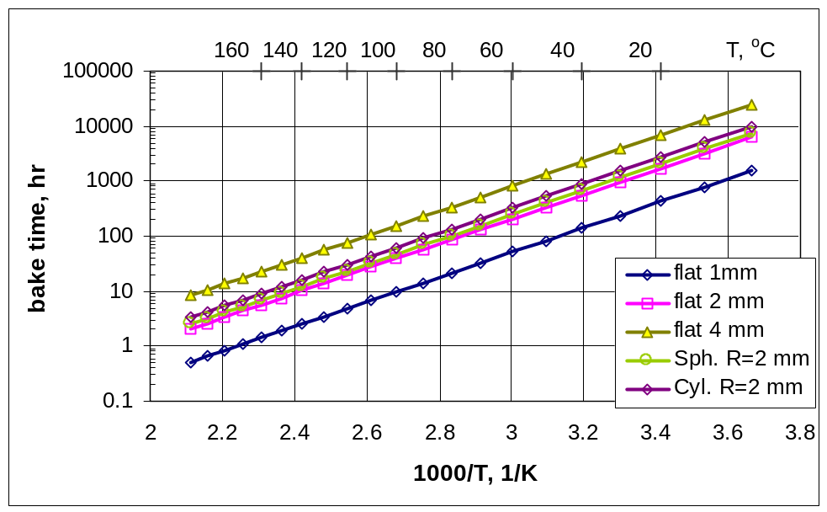
Figure I-5. Calculated temperature dependencies of moisture bake-out times for packages of different size and shape.
I-5. Comparison of the Calculated Bake-out Times With the JEDEC Recommendations
The bake-out times for several types of PEMs at temperatures of 40 °C, 90 °C, and 125 °C were calculated using Eq. (12) and diffusion characteristics for a typical molding compound (D_{o}= 7.35×10⁻⁶ m²/sec and U=0.43 eV). The results of these calculations are shown in Table I-3. The bake-out conditions recommended by IPC/JEDEC J-STD-033 (July 2002), “Standard for Handling, Packing, Shipping and Use of Moisture/Reflow Sensitive Surface Mount Devices,” are shown in brackets. The minimum value in the brackets corresponds to less moisture sensitive devices (level 2), and the maximum value corresponds to devices with a moisture sensitivity of level 5.

Table I-3. Calculated bake-out times for different plastic packages and JEDEC recommendations for parts with moisture sensitivity levels from 2 to 5 (in brackets).
Package | Thickness, | Temperature
Type | mm | 40 °C | 90 °C | 125 °C
DIP-24 | 3.8 | 1996  (1608-1608) | 206  (168-240) | 59  (48-48)
DIP-8 | 3.2 | 1416  (1608-1608) | 146  (168-240) | 41  (48-48)
PQFP-44 | 2 | 553  (528-1608) | 57  (48-144) | 16  (16-40)
PLCC-32 | 3 | 1244  (1608-1608) | 128  (168-240) | 36  (48-48)
TSOP-32 | 1 | 138  (120-240) | 14  (11-24) | 4  (3-10)

Generally, the data presented in Table I-3 are in agreement with the JEDEC recommendations, suggesting that the recommendations were made based on averaged moisture diffusion characteristics of molding compounds used in PEMs. However, in some cases these recommendations result in much greater times than necessary to properly dry out the part. For example, for a part packaged in PLCC-32 the required time is 30% to 35% greater; however, for DIP-24 parts it is 25% to 30% less than necessary. This is most likely due to a relatively rough classification of the parts according to their thickness: all parts are divided only in three groups: ≤ 1.4 mm, ≤ 2 mm, and ≤ 4.5 mm.

It should be noted that the bake-out time is proportional to the square of the package thickness. This means that size variations within the same size group used in IPC/JEDEC J-STD-033 might more than five times change the value of τ_{b}. Considering possible variations in D, which might exceed an order of magnitude, the time recommended per IPC/JEDEC J-STD-033 can be either more than 10 times greater or less than the time necessary to remove moisture from the part.

I-6. Low Temperature Bake-out Conditions
A temperature of 40 °C is recommended to bake out parts susceptible to lead finishing oxidation and/or intermetallic growth. Low-temperature bake conditions might be necessary also for assemblies containing PEMs.
Figure I-6 shows variations of the relative humidity calculated inside the chamber, which is installed in a room with a temperature of 25 °C and humidity of 60% RH. It is seen that the relative humidity in this chamber at 40 °C would be 25%. Obviously, this level of humidity is not low enough and a 40 °C bake can be performed only in vacuum. The vacuum conditions do not speed up the moisture release process compared to conditions in a regular chamber at the same temperature, and it would take several weeks of pumping to dry out even a relatively thin 2 mm package. Besides, using a low-pressure oven with a mechanical pump might cause contamination of the leads with pumping oil, which would affect solderability of the parts.
Based on temperature dependence of the relative humidity in the chamber displayed in Figure I-6, reasonably dry conditions (< 10% RH) in the chamber can be reached at temperatures above 58 °C. The bake-out time at this temperature for a 2 mm part would be approximately 1 week. This bake-out condition is much more practical and in many cases should not create any problems with lead finish oxidizing or intermetallic formations.
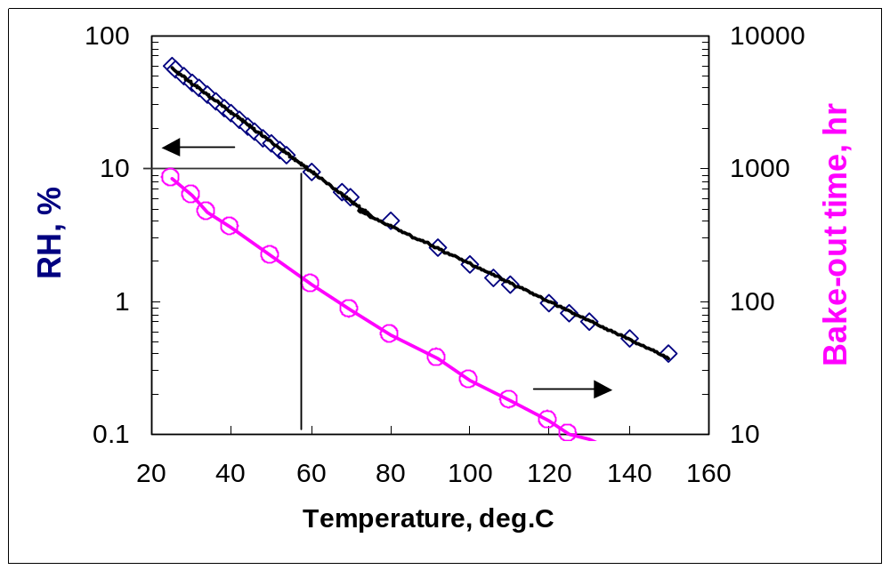Figure I-6. Temperature dependence of relative humidity in a non-hermetic temperature chamber (diamond marks) at room conditions: T = 25 °C, RH = 60%. The circle marks show the calculated bake-out times for a 2 mm flat package.
I-7. High Temperature Testing of PEMs Stored in Laboratory Conditions

Let us consider a lot of 2 mm thick PEMs, which had no moisture in the package initially, but had been stored for 1 month before testing in laboratory conditions at 25 ºC, 70% RH. Let us assume that these parts will be subjected to burn-in testing at 85 ºC for 1 week. Results of the numeric calculations of the rated concentration at the die surface and moisture content in the package during storage at the lab conditions and during burn-in testing are displayed in Figure I-7. The diffusion characteristics of the molding compound were assumed to be: D_{o} = 7.3×10-6 m²/s and U= 0.43 eV.
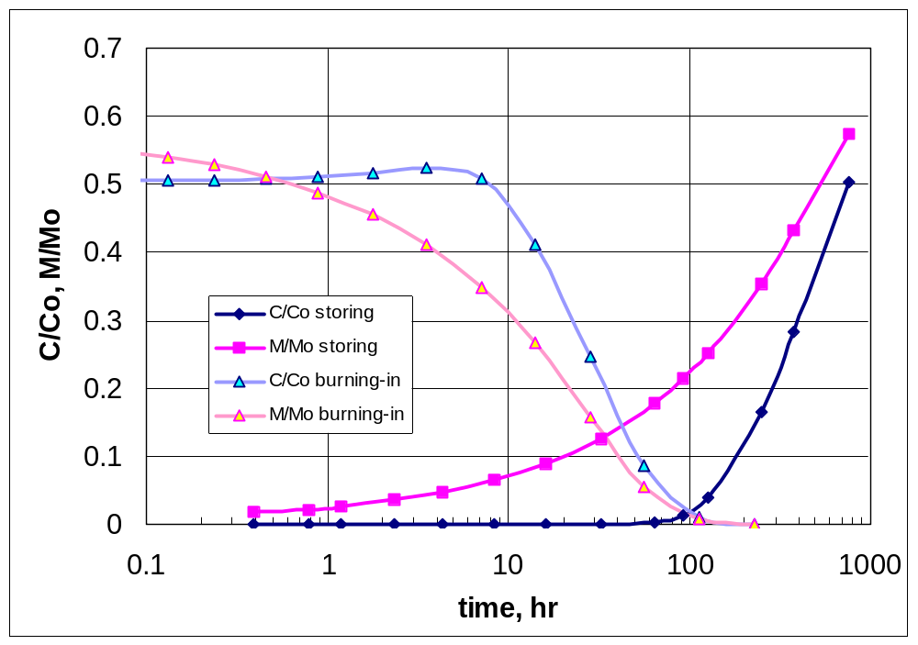
Figure I-7. Variations of moisture concentration and mass in a 2 mm thick package with time during 1 month’s storage at 25 ºC and 70% RH and then during burn-in testing at 85 ºC. Note that C/C_{o} = 1 corresponds to the equilibrium moisture saturation at 100% RH.

It is seen that the concentration of moisture at the die surface reaches ~50% of the level corresponding to 100% RH after 1 month of the storage; this level remains stable, and even slightly increases, during approximately 9 hours at 85 ºC. This means that during the first 9 hours of burning in, the moisture concentration remains relatively high and the conditions of this testing are close to the conditions of the moisture resistance test, which is performed at 85 ºC and 85% RH. Note that in the latter case C/Co = 0.85 after ~ 70 hours required for moisture saturation at 85 ºC. To avoid possible problems related to moisture during this testing, a bake-out at 85 ºC could be performed. Figure I-7 shows that during 96 hours at this temperature, both moisture concentration and moisture content drop below the 10% level.

I-8. Conclusion

Simple equations have been suggested to calculate moisture diffusion characteristic times and bake-out regimens for plastic encapsulated devices of different sizes and shapes.
Analysis of moisture diffusion coefficients reported in the literature shows that different molding compounds have values of D varying approximately an order of magnitude. Considering variations in shape and size of different plastic encapsulated parts, the required bake-out times might vary more than 10 times even within the same size group of the parts. To develop an adequate moisture protection strategy for parts intended for space applications, D(T) characteristics of the molding compound should be measured for each lot of PEMs.
Comparison of the bake-out times, which had been calculated using average moisture diffusion characteristics (D_{o} = 7.35×10⁻⁶ m²/sec and U = 0.43 eV), and the regimens suggested by the existing JEDEC standards IPC/JEDEC J-STD-033, are in reasonable agreement. However, the suggested method in this work allows for estimations of adequate bake-out conditions and provides much more flexibility, enabling calculation of the regimens for a specific lot of parts depending on their history of exposure to moisture environments and possible temperature conditions.
Calculations of the bake-out conditions for parts that do not allow high temperature treatment are performed. Variations in moisture concentration and content in PEMs temporarily exposed to humid environments before burn-in testing have been analyzed.
I-9. References
- C. R. Totten, Managing moisture sensitive devices, Circuit Assembly, Oct. 1996, pp. 34-38.
- A. N. Tikhonov and A. A. Samarskiy, Equations of Mathematical Physics, Moscow, Nauka, 1977.
- S. Ito, T. Nishioka, S. Oizumi, K. Ikemura, and K. Igarashi, Molding compounds for thin surface mount packages and large chip semiconductor devices, Proc. of 41st ECTC, 1991, pp. 190-197.
- M. Kitano, A. Nishimura, S. Kawai, and K. Nishi, Analysis of package cracking during reflow soldering process, IEEE/IRPS Proc., 1988, pp. 90-95.
- H. Kimura, T. Yoshida, S. Ohizumi, T. Nishioka, M. Nakao, and M. Harada, New analytical study for popcorn phenomenon, IEEE Trans. on CHMT, Vol. 15, No. 6, 1992, pp. 1117-1122.
- R. L. Shook, Moisture sensitivity characterization of plastic surface mount devices using scanning acoustic microscopy, IEEE/IRPS Proc., 1992, pp. 157-168.
- R. L. Shook, T. R. Conrad, V. S. Sastry, and D. B. Steele, Diffusion model to derate moisture sensitive surface mount ICs for factory use conditions, Proc. of 45th ECTC, 1995, pp. 440-449.
- J. E. Gallow and B. M. Miles, Moisture absorption and desorption predictions for plastic ball grid array packages, IEEE Trans. CPMT, Part A, Vol. 20, No. 3, 1997, pp. 274-279.
- M. Pecht, L. Nguyen, and E. Hakim, Plastic Encapsulated Microelectronics, J.Willey & Sons, 1995.

II. A Rapid Technique for Moisture Diffusion Characterization of Molding Compounds in PEMs

Abstract
A non-isothermal technique for rapid characterization of moisture diffusion in molding compounds of plastic encapsulated microcircuits (PEMs) is suggested. The technique is based on measurements of the weight losses during heating in dry conditions of a polymer sample or plastic package pre-saturated with moisture. It allows calculation of the moisture diffusion coefficients and the activation energy of diffusion. The duration of this test does not exceed a few hours, and the necessary calculations can be performed easily in an MS Excel spreadsheet. The test can be performed directly on PEMs using a thermogravimetric analyzer (TGA) or a simple balance with 0.1 mg accuracy and a regular thermal chamber, which is capable of providing a linear temperature increase, fast heating to a pre-set temperature, and cooling down to room temperature.
The results obtained by the non-isothermal desorption technique are shown to agree with the results of the diffusion coefficient measurements obtained by conventional isothermal sorption/desorption techniques.
The effect of lead frames on measurement results is discussed. It has been demonstrated that the probability of moisture leakage along the molding compound/lead frame interface can be estimated by comparing diffusion coefficients measured on the molding compound and on the plastic package.
Temperature dependencies of moisture diffusion coefficients of molding compounds used in different types of PEMs (QFP, DIP, and PLCC packages) manufactured by different vendors have been characterized.
II-1. Introduction
Moisture diffusion in epoxy molding compounds (MC) is considered to be one of the major reliability concerns in PEMs. The rate of moisture ingress to the die surface and/or moisture release from the package depends on the geometry of the package and on the coefficient of moisture diffusion (D) of the packaging material. Given the values of D at different temperatures, D(T), the characteristic times of moisture diffusion (θ) can be calculated for different environmental stress testing and/or field operation conditions. The knowledge of θ allows for estimation of adequate bake-out regimes and provides a time scale for assessment of reliability risks related to moisture-induced degradation in PEMs.
Recent studies of the popcorning effect in PEMs have stressed the need for evaluation of the moisture characteristics specific to each product type to adequately estimate the moisture sensitivity level of the part [1]. Unfortunately, manufacturers of commercial microcircuits usually do not provide any information on characteristics or type of the encapsulating materials used. This necessitates development of in-situ techniques to allow for evaluation of the moisture characteristics of a given lot of PEMs.
Extensive testing and qualification of commercial-off-the-shelf (COTS) PEMs performed recently in the military and aerospace community have demonstrated that the performance and reliability of these parts is strongly affected by the type of molding compound used. Permanent improvement of the technology and design of PEMs makes lot-to-lot variations in MCs possible, even for the same part type. This requires an assessment of characteristics of encapsulating materials used in PEMs to ensure consistency in the quality of the parts and to identify design and/or technological changes in a given lot of PEMs. The necessity of fast test methods to characterize molding compounds in PEMs is considered one of the priorities in the ROBOCOTS (robust packaging of COTS ICs) program started recently at the Rockwell International Corporation [2].
Moisture sorption and diffusion characteristics of MCs provide valuable data for quality and reliability evaluation of the parts operating in moisture environments. However, these characteristics are also important for quality assurance of the parts intended for space applications. For these parts, the quality assurance strategy is to prevent moisture sorption in PEMs during the ground phase integration, testing, and storing period, which lasts typically from 2 to 5 years. This strategy can be realized by a computer simulation or engineering estimations of moisture sorption in the package due to exposure to high humidity environments during the pre-launch period and by implementing adequate bake-out conditions for PEMs and PEM-containing assemblies. Both the assessment of moisture sorption and bake-out regimes require knowledge of the D(T) characteristics.
Typically, to obtain the moisture diffusion coefficient, a sample of molding compound is placed in a humidity chamber at isothermal conditions and is weighted periodically until an equilibrium moisture uptake is reached. The following calculations on the sorption curve yield the value of D at a given temperature [3]. Depending on the temperature and thickness of samples, this might require hundreds or thousands of hours to reach the steady-state condition. A temperature dependence of diffusivity can be obtained by repeating this procedure at different temperatures, which significantly increases the time of testing.
An engineering methodology to determine the rate of water evaporation from polymer at high temperatures has been suggested in [4]. This technique is based on analysis of non-isothermal desorption kinetics of a sample during heating with a stepped temperature profile, and it allows for calculation of criteria for development of delaminations in PEMs [5]. However, the desorption rate is a function of the diffusion coefficient and moisture concentration distribution in a sample and cannot be used for evaluation of characteristic times of moisture diffusion in plastic packages.
The purpose of this work is to demonstrate a simple and rapid technique for an estimation of temperature dependence of moisture diffusion characteristics directly on the plastic packages of PEMs. The suggested technique is based on replacement of the time domain measurements of the moisture sorption kinetics with the temperature domain measurements of moisture desorption from a flat polymer sample or a flat package of a PEM that has been pre-saturated with moisture in a humidity chamber.

II-2. Theoretical Modeling
Let us consider a flat sample of a polymer of thickness 2h, which is evenly saturated with moisture to concentration C_{o}. The corresponding equilibrium moisture uptake per unit area of the sample is dM∞ = 2×h×C_{o}. Also, let us assume that the D(T) function follows the Arrhenius-type relation:
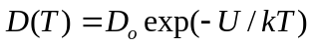 (1)
where D_{o} is the constant, U is the activation energy, T is the absolute temperature, and k = 1.38×10⁻²³ J/K is the Boltzmann constant.
Let us heat the sample in dry conditions and monitor its mass loss variation with time dM(t).
The distribution of moisture concentration in the sample follows Fick’s second law:
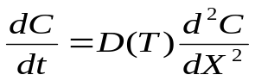 (2)
where C is the moisture concentration that depends on time t and coordinate X.
Assuming that the die-plastic interface is in the middle of the package (X=0), the following initial and boundary conditions can be written:
C(X,0) = C_{o} at -h < X < h , t = 0
C(-h,t) = C(h,t) = 0 at X = h, t > 0 (3)
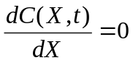 at X = 0, t > 0
Considering symmetry of the sample, the quantity of moisture desorbed during time t is:
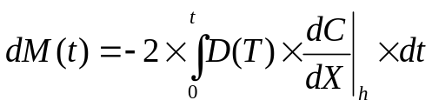
Let us introduce the rated time τ:
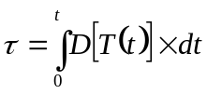
Using rated time, Eq. (2) can be written as:
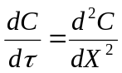 (2a)
This expression is like the equation describing isothermal diffusion. Similar to isothermal conditions, the solution to Eq. (2a) at dM(t)/dM∞ < 0.6 can be expressed as:
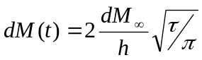 (4)
Differentiation with respect to time yields the following expression for D(T):
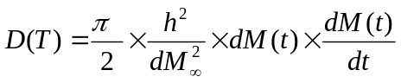
Considering temperature variation with time, the previous expression can be rewritten as:
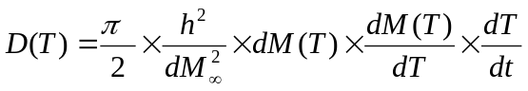 (5)
This equation allows for calculation of temperature dependence of moisture diffusion coefficient using mass loss measurements during heating of a flat sample. The constant D_{o} and the activation energy U in Eq. (1) can be obtained by plotting D(T) values calculated according to Eq. (5) in Arrhenius coordinates and using the least squares fit technique.
II-3. Analysis of Assumptions
The non-isothermal measurement technique for D(T) calculations according to Eq. (5) is based on the following assumptions:

- Temperature dependence of the diffusion coefficient follows Arrhenius law.
- Moisture diffusion in molding compound follows Fickian equations.
- Equilibrium moisture uptake does not depend on temperature.
- Temperature variations across the sample during the test are negligible.
Let us consider how fair these assumptions are.
II-3.1. Arrhenius Law. Most studies on epoxy polymers and molding compounds have confirmed an exponential increase in moisture diffusion coefficient with temperature [6-8]. An increase in the activation energy of moisture diffusion can be expected at high temperatures above the glass transition temperature (T_{g}) of polymer; however, no experimental data were found in the literature. A slight increase in the activation energy of diffusion above T_{g} for argon and oxygen diffusion in polyvinilacetat films was reported in [9]. However, for epoxy molding compounds used in PEMs, which typically have T_{g} of 140 ºC to 180 ºC, no variation from the Arrhenius behavior at high temperatures has been reported. Kitano et al. [8] observed linearity of the lgD variation with 1/T up to 180 ºC.
II-3.2. Fickian Law. Several researchers have observed non-Fickian diffusion in epoxies. Deviations from the Fickian behavior typically occur at high temperature and high humidity (typically more than 85% RH) conditions after a long-time exposure to moisture environments [10, 11]. In these cases moisture uptake does not saturate, but increases slowly with time. Similar behavior was explained by water condensation in micro-pores of the molding compound [12]; swelling of the polymer matrix, which increases the number of active sites available for sorption [9]; and by chemical degradation of epoxy resins and/or epoxy/filler interface [13, 14]. In the latter case, the water diffusion initially follows the Fickian model, but then the deviations from the ideal behavior are explained by the flow of water molecules along the filler-matrix interface followed by diffusion into the bulk resin and transport of water by microcracks [15].
Studies of epoxy composites and molding compounds showed that even for materials, which generally do not obey Fickian behavior due to gradual increase in moisture uptake with time, initial stages of the sorption typically follow Fick’s law [11, 12, 15, 16]. For these materials, the Fickian diffusion is considered to be a reasonable approximation for most technical applications [17, 18].
In a general case, the diffusion coefficients determined by the kinetics of moisture absorption (D_{A}) differ from those that are calculated using the desorption kinetics (D_{D}). Soles and co-workers [14] analyzed absorption and desorption behavior of different types of epoxy resins. They found that for high-polarity amine-cured resins at relatively high temperatures (70 ºC), the desorption diffusion coefficients can be two to three times larger than the sorption diffusion coefficient due to strong trapping of the water molecules at the polar group sites. At low temperatures (below 50 ºC) for these resins, the difference was much smaller, and D_{D} = (1 – 1.5)D_{A}. For low-polarity resins no significant difference was observed, and D_{D} = (0.6 – 1.2)D_{A} even at high temperatures.
Epoxy molding compounds used in PEMs are typically based on ortho-cresol-novolac, bi-phenyl, and multi-functional epoxy resins hardened with phenol-novolac or multi-function resins. Curing of the system results in formation of rigid but mild or relatively low polarity polymers. For similar polymers, no significant difference between D_{A} and D_{D} values is expected. Studies of moisture diffusion in molding compounds used in PEMs performed by Galloway and Miles [19] indicated a close agreement between sorption and desorption coefficients at temperatures up to 110 ºC.
It was also observed that the desorption process closely follows Fickian diffusion even for materials exhibiting non-Fickian moisture absorption.
II-3.3. Equilibrium Moisture Uptake. It is generally assumed that in equilibrium conditions moisture concentration in epoxy polymers is described by Henry’s law [9, 16], and the moisture equilibrium uptake increases linearly with the pressure of moisture vapor (P):
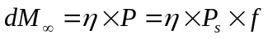 (6)
where P_{s} is the pressure of saturated water vapor; f is the relative humidity.
The sorption coefficient η exponentially decreases with temperature:
η =η_{o}×exp(ΔH/kT)
where ΔH is the heat of moisture solution in polymer.
The pressure of water vapor in the range of temperatures from 20 ºC to 150 ºC closely follows the exponential law:
P_{s}=P_{o}×exp(-Q/kT)
where Q is the heat of water vaporization = 539 kcal/kg (0.42 eV).
Considering temperature dependencies of η and P_{s}, Eq. (6) can be written in the following way:
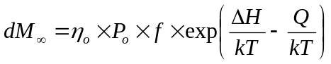 (7)
At Q ≈ ΔH the saturated moisture sorption has weak temperature dependence, which was confirmed for different epoxy resins [11] and molding compounds used for PEMs [10, 16].
II-3.4. Temperature Variation Across the Sample. A uniform distribution of temperature across the sample during the non-isothermal desorption experiments can be ensured by a low rate of the temperature rise. To estimate the limit of the temperature rate, α = dT/dt, let us assume that the acceptable temperature variation across the sample is ΔT. For a sample of thickness 2h with the specific thermal conductivity λ, heat capacity C, and specific density ρ, the characteristic time of temperature distribution is τ_{h} = 4×ρ×C×h²/λ. The limit for the temperature rate can be found from a simple condition:
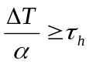
This allows calculation of the maximum temperature rate during the measurements:
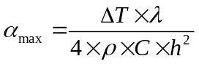
Assuming ΔT = 1 °C, h = 2 mm, and using typical characteristics for the MC, C = 0.24 Cal/g×K, λ = 0.001 Cal/cm×s×K and ρ=1.8 g/cm³, the calculation yields α_{max} = 0.9 K/min.
II-4. Experiments
Experiments were performed with several types of plastic encapsulated microcircuits produced by different manufacturers during the period 1995 to 1997. The samples were saturated with moisture in a humidity chamber at temperatures from 85 ºC to 121 ºC and relative humidity 85% or 100% and weighted on a scale with accuracy of 0.1 mg. Then the samples were placed in a thermal chamber, which was programmed to perform cycles consisting of fast heating to the preset temperature, linear temperature increase during a certain interval of time, and then fast cooling down to room temperature. After weighting at room temperature, the heating cycle was repeated starting with the maximum temperature at which the previous cycle had been completed. An example of temperature variation with time during these experiments is shown in Figure II-1. Typically from 10 to 12 measurements were taken in the range from 20 ºC to 170 ºC in 15 ºC increments. All experiments were performed on three samples of each type.

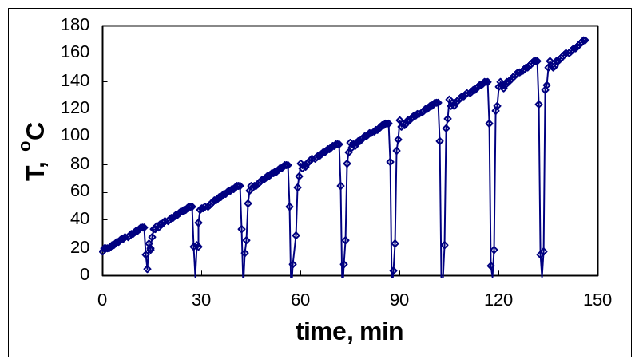
Figure II-1. A typical temperature diagram during moisture diffusion measurements.
Figures II-2 and II-3 show examples of measurements and calculations performed on three plastic QFP-144 packages. The results suggest fairly good sample-to-sample repeatability of the measurements. Given the simplistic nature of the TGA simulations by using a regular temperature chamber and weight measurements, this technique yielded D(T) data that are reasonably aligned with Arrhenius law.

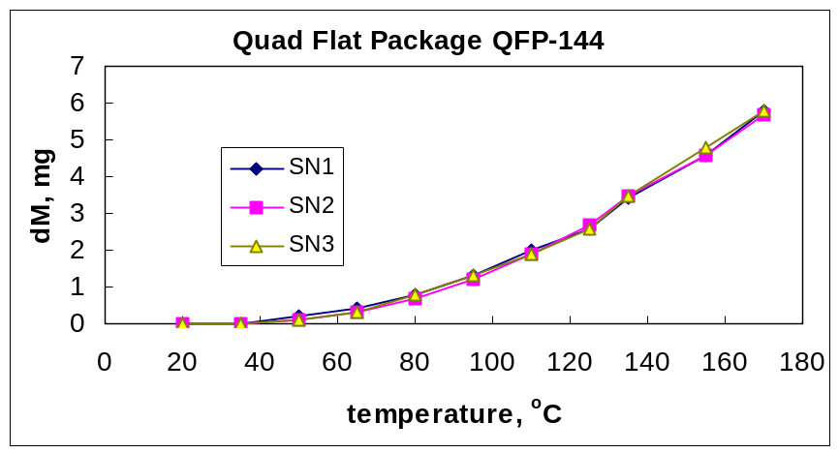
Figure II-2. Mass losses of three QFP-144 packages during moisture diffusion measurements. The samples were saturated with moisture in 85 °C/85% RH chamber for 250 hours. Note that the average saturated moisture level was 17.3 mg, which means that only approximately 30% of moisture was lost during the test.
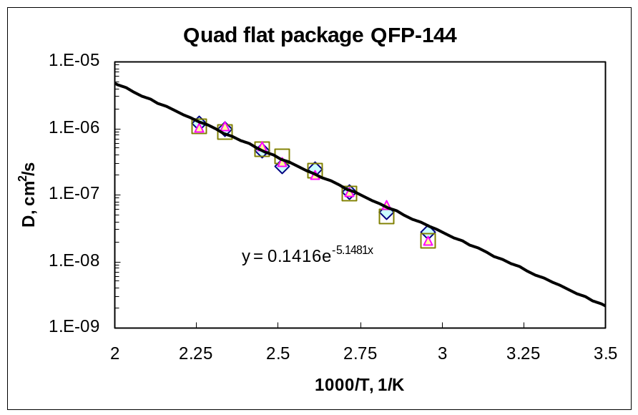
Figure II-3. Results of calculations of data presented in Figure II-2 according to Eq. (5) in Arrhenius coordinates. The least squares fit calculations yields D_{o} = 0.14 sm²/s and U = 0.42 eV.
To evaluate reproducibility of the technique, three microcircuits manufactured by V3 Semiconductor in QFP-160 packages were tested two times: first after pre-saturation at 85 ºC/85% RH during 204 hours, and second after pre-saturation at 85 ºC/100% RH during 168 hours. Each time before moisture saturation, the parts were baked at 150 ºC for 48 hours. The test results are shown in Figure II-4 and suggest good reproducibility of the method. The estimated accuracy of the D(T) measurements in the temperature range from 50 ºC to 130 ºC was ~30%.

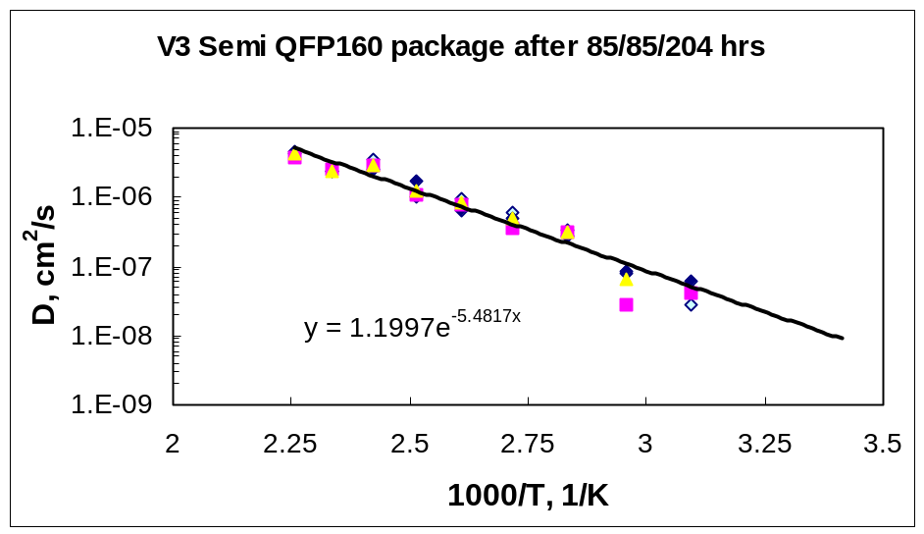
(a)
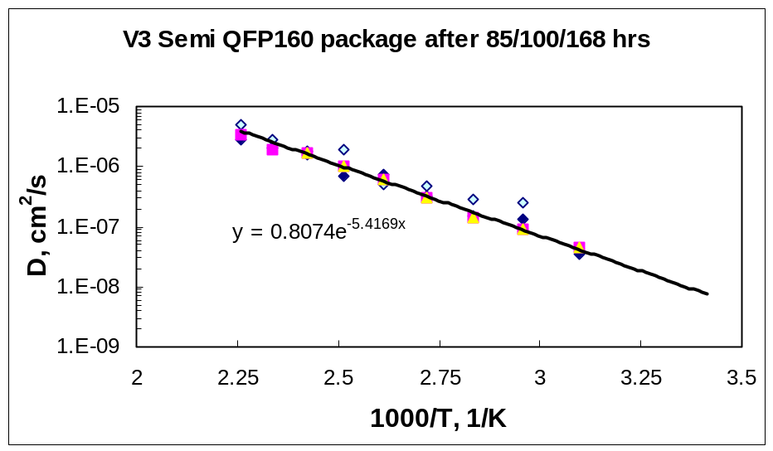
(b)
Figure II-4. Moisture diffusion coefficient measurements after different moisture soak conditions: 85 ºC/85% RH/204 hrs. (a), and 85 ºC/100% RH/168 hrs. (b). Calculations gave close activation energies U (0.451 eV and 0.456 eV) and constants D_{o} (1.2 cm²/s and 0.8 cm²/s).

II-5. Analysis of the Method
According to the suggested method, the diffusion coefficient of moisture in molding compounds is calculated based on the non-isothermal kinetics of moisture desorption measured directly on plastic packages of microcircuits. This brings up two questions: how does the lead frame affect the results of measurements, and how do the results of the non-isothermal technique relate to the results obtained using the conventional technique, which is based on analysis of the isothermal sorption or desorption kinetics?
II-5.1. Lead Frame Effect. Obviously, in the absence of the lead frame/molding compound delaminations, the error due to presence of the lead frame can be neglected when the thickness of the package is much greater than the thickness of the leads. Analysis of different designs of QFP-type plastic packages showed that the thickness of the package (t_{p}) varies from 1.4 mm to 3.4 mm, whereas the thickness of the lead frame (t_{l}) changes from 0.1 to 0.15 mm. With these variations, the lead frame thickness is from 2.9% to 10.7% of t_{p}. As a square of the sample thickness is used for D calculations (see Eq. [5]), the error caused by neglecting the presence of the leads will vary for different packages from 5.8% to ~21%. To avoid this error for thin packages with relatively thick lead frames, the appropriate correction of the h value in Eq. (5) should be made.
Another source of errors in D calculations is due to possible delaminations at the lead frame/MC interface. This delamination might result in moisture penetration along the leads and thus effectively increase the surface area for moisture absorption in the molding compound. Considering that the kinetic diameter of a water molecule is only ~3Å (0.3 nm), even small delaminations with the thickness of only ~100 nm, which are below the sensitivity of the acoustic imaging technique (C-SAM mode) [20], might significantly increase moisture uptake in the package.
Let us consider for example a PQFP package with 144 leads. Figure II-5 shows overall top optical and X-ray views of the part. The internal part of the lead frame area (S_{LF}) is a substantial part of the package area (without external section of the leads) (S_{P}). If the lead frame/MC interface is delaminated, a surface area of the molding compound available for moisture diffusion will be increased significantly.

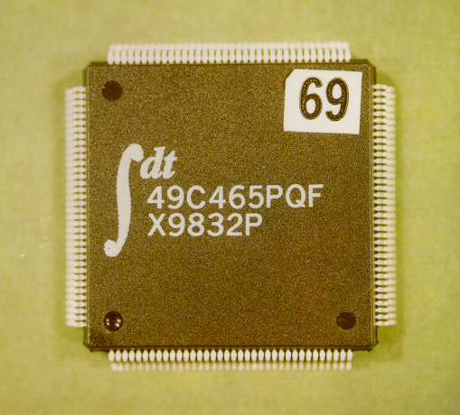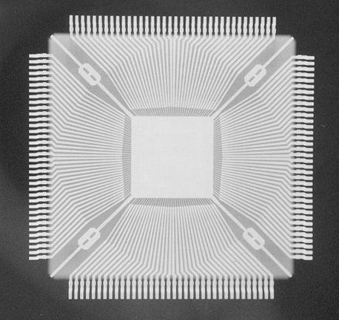
(a) (b)
Figure II-5. Optical (a) and X-ray (b) views of a QFP-144 plastic package showing that the surface area of the lead frame is a substantial portion of the package surface.
Let us assume that the proportion of the delaminated area of the lead frame is ϕ and the lead frame factor for a package is k = S_{LF}/S_{P}. Then, the proportion of the internal area of the package available for diffusion will be ϕ×k. In this case the surface area available for moisture diffusion in a delaminated package (S_{D}) will be S_{D} = 2S_{P} + 2ϕS_{LF} = 2S_{P}(1+kϕ).
During the initial stages of sorption, moisture uptake is proportional to the surface of the sample and can be expressed as follows:
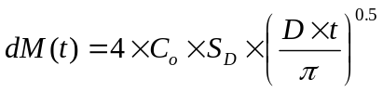
This means that delamination would increase moisture uptake at the early stages of sorption in (1+ϕk) times. Respectively, the effective diffusion coefficient for the package (D_{p}), which is calculated as for a non-delaminated sample, would be (1+ϕk)² times larger than the diffusion coefficient for the molding compound (D_{MC}):
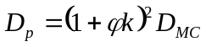 (8)
This equation allows for estimation of the delamination coefficient ϕ by measuring diffusion coefficients on package and molding compound.
Possible values of ϕ vary from 0 for a non-delaminated sample to 1 for a fully delaminated sample. The lead frame factor for a package (k) depends on the type of package and typically varies from 0.3 to 0.6. For example, a package shown in Figure II-5 has the lead frame factor k ≈ 0.5. In a case of full delamination between the lead frame and molding compound, ϕ = 1 and D_{p} = 2.25×D_{MC}.
To estimate the delamination coefficient ϕ according to Eq. (8), the diffusion coefficient for the encapsulating material used in a given lot of PEMs must be known. The D_{MC} value could be determined experimentally using a sample of MC prepared by grinding off a part of the package with a die and lead frame. Three samples of MC with a thickness of 1 mm had been prepared using IDT QFP-144 packages shown in Figure II-5 using the grinding-off technique. The D(T) characteristics of three samples of MC, together with three QFP-144 packages, were measured two times: first after pre-saturation in 85 ºC/85% RH chamber, and second after soaking in PCT cell at 121 ºC/100% RH. Diffusion coefficients averaged over the three samples for each test are plotted in Arrhenius coordinates in Figure II-6.
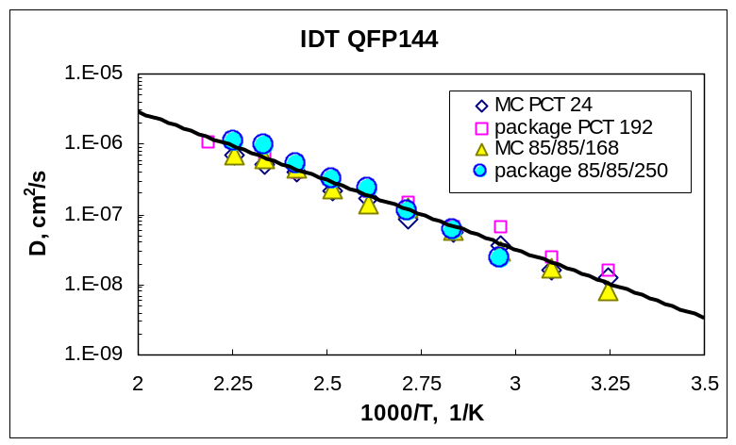
Figure II-6. D(T) characteristics measured on IDT QFP-144 packages and on samples of molding compound prepared by the grinding-off technique after different conditions of moisture saturation.

The results displayed in Figure II-6 looks similar; however, statistical analysis revealed some difference between diffusion coefficients measured on the packages and on the samples of the molding compound (see Table II-1).

Table II-1. Comparison of moisture diffusion characteristics measured on IDT QFP-144 packages and on samples of the molding compound.
Preconditioning | Package/MC | D_{o}, cm²/s | U, eV | D₈₅, cm²/s
PCT, 24 hrs. | MC | 1.07E-3 | 0.36 | 7.08E-09
PCT 192 hrs. | Package | 1.15E-3 | 0.35 | 1.01E-08
85 °C/85% RH 168 hrs. | MC | 2.88E-2 | 0.39 | 6.86E-08
85 °C/85% RH 250 hrs. | Package | 1.41E-1 | 0.43 | 7.7E-08
The results show that D(T) characteristics measured on PEMs and on MCs pre-saturated with moisture in similar conditions are closely related, and the difference between D_{P} and D_{MC} values is within the 30% error limit. However, measurements on packages and MC samples pre-saturated in a PCT chamber at 121 °C and 100% RH resulted in seven to 10 times larger values of D compared to relatively mild 85 °C/85% RH pre-saturation conditions.
Table II-2 shows diffusion coefficients calculated at temperatures from 50 °C to 130 °C for the packaged microcircuits and molding compound samples. In both cases (PCT and 85 °C/85% RH pre-saturation conditions), the results were similar: the D_{p} values were 10% to 60% larger than D_{MC}. For this range of the D_{P}/D_{MC} ratio, the calculated delamination factor ϕ varies from 0.1 to 0.5. However, considering possible errors in the diffusion coefficient calculations of ~30%, delaminations for packages with ϕ < 0.5 are within the experimental error of the technique. Increasing the accuracy of D(T) measurements, for example by using the TGA system to monitor weight losses, might improve accuracy of the delamination assessment.
Table II-2. Diffusion coefficients calculated for packages (D_{P}) and molding compounds (D_{MC}), and the coefficient of lead frame/MC delamination, ϕ. Conditions of moisture pre-saturation are shown in brackets.
T, °C | D_{MC}  (PCT ) | D_{P}  (PCT) | D_{MC} (85/85) | D_{P}  (85/85) | D_{P}/D_{MC} (PCT) | D_{P}/D_{MC} (85/85) | ϕ  (PCT) | ϕ  (85/85)
50 | 1.66E-09 | 2.59E-09 | 1.47E-08 | 1.63E-08 | 1.56 | 1.11 | 0.50 | 0.10
85 | 6.15E-09 | 9.24E-09 | 6.05E-08 | 7.75E-08 | 1.50 | 1.28 | 0.45 | 0.26
130 | 2.37E-08 | 3.42E-08 | 2.61E-07 | 3.88E-07 | 1.45 | 1.49 | 0.41 | 0.44

II-5.2. Comparison With Conventional Methods. To obtain values of diffusion coefficients using the conventional technique, two types of PEMs packaged in DIP-28 and QFP-144 packages have been used. Three packages of each type, together with three samples of molding compounds prepared by the grinding-off technique, were placed in 85 °C/85% RH humidity chamber and weighted periodically. After exposure to moisture conditions for 240 hours, the samples were placed in a dry chamber at 85 °C and their desorption kinetics were also monitored gravimetrically. The results of this test are shown in Figure II-7.

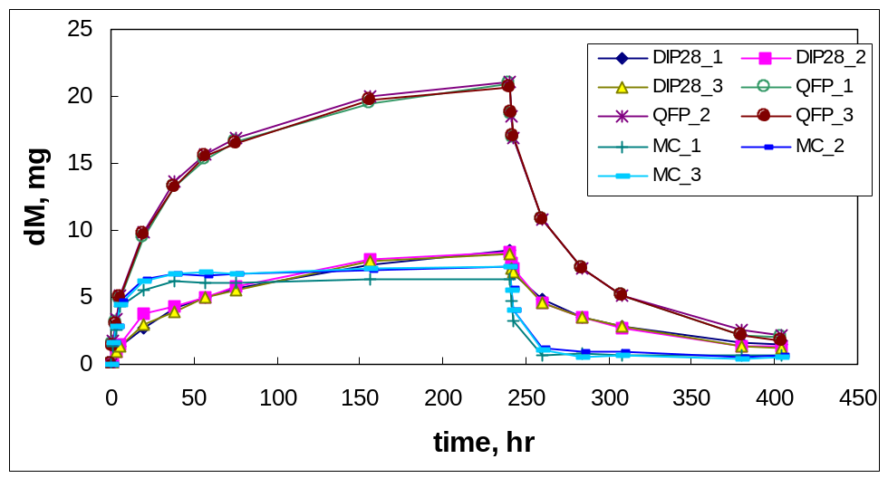
Figure II-7. Sorption/desorption kinetics of moisture in plastic packages and samples of molding compounds at 85 °C.
The initial stage of sorption/desorption process at dM/M∞ <0.6 can be described as follows:
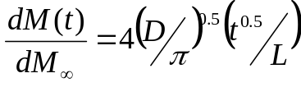 (6)
where L is the thickness of a sample.
According to this equation, the sorption/desorption kinetics displayed in a chart with rated coordinates, rated moisture sorption dM(t)/dM∞ versus (t^{0.5}/L), is a straight line with a slope α which allows for D calculation:
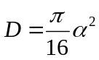
An example of these calculations using the data presented in Figure II-7 is shown in Figure II-8.
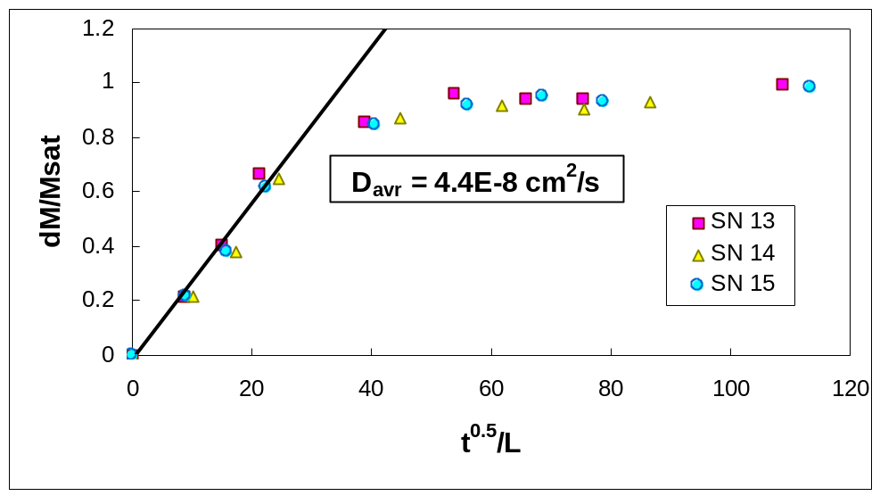
Figure II-8. Moisture sorption kinetics in rated coordinates allowing calculation of the diffusion coefficient. Measurements were performed on samples of QFP-144 molding compound.
Averaged results of D₈₅ calculations during sorption/desorption measurements are displayed in Table II-3. Analysis of the table shows that the data obtained by conventional, isothermal technique during sorption and desorption tests agree closely within 10% tolerance. Moisture diffusion coefficients obtained by the non-isothermal desorption technique are somewhat larger. However, the overall variations of the data obtained by different techniques do not exceed 30%, which is within the accuracy of the non-isothermal technique.
Table II-3. Moisture diffusion coefficients at 85 °C (cm²/s) calculated using different measurement techniques.
Package/  Material | Isothermal  Sorption | Isothermal  Desorption | Non-isothermal  Desorption | Data  Variation, %
QFP-144 | 7.1E-08 | 6.3E-08 | 7.7E-08 | 10
MC (QFP-144) | 4.4E-08 | 4.6E-08 | 6.8E-08 | 25.3
DIP-28 | 5.8E-08 | 6.2E-08 | 8.8E-08 | 23.5

II-6. Moisture Diffusion Characteristics of Molding Compounds in Different Types of PEMs
Several types of PEMs have been tested using the suggested non-isothermal desorption technique. Description of these packages including manufacturer, date code, mass, and thickness, together with the measured diffusion characteristics of molding compounds, are displayed in Table II-4. At room temperature, diffusion coefficients for different MCs used in these packages varied more than an order of magnitude, which corresponds to the data reported in [1]. The activation energy of diffusion varied from 0.32 eV to 0.5 eV, which is also within the range of values reported in the literature.
Given the value of D and the thickness of the package (L), the characteristic time for moisture diffusion in a package can be calculated as:
θ= L²/(π² D)
At time t = θ, the concentration of moisture at the die surface (C_{s}) in an initially dry package placed in moisture environments would be approximately 55% of the saturated moisture concentration (C∞) and the moisture uptake dM ≈ 75% of the equilibrium moisture uptake (dM∞). Calculations show that at t = 3θ both values, C_{s} and dM, will be more than 99% of the corresponding equilibrium values. This time (τ =3θ) can be considered as the time necessary to achieve equilibrium conditions during moisture sorption/desorption processes. The values of τ calculated for different packages based on the D(T) measurements are presented in Table II-4. At room temperature these times vary from approximately 8 days to more than half a year, whereas at 130 °C the steady-state conditions can be reached in a few hours. These data show that in all cases 1 week (168 hrs.) of soaking in a humidity chamber at 85 °C will result in saturation of the packages with moisture. For this reason, 85 °C/85% RH/168 hrs. condition can be considered as a standard preconditioning of PEMs before the non-isothermal diffusion coefficient measurements.
Table II-4. Moisture diffusion characteristics of molding compounds and characteristic times of equilibrium moisture uptake for different PEMs.
Package | QFP-144 | QFP-160 | PLCC-32 | QFP-240 | DIP-28 | QFP-144
Mfr. | Actel | V3 Semi. | AMD | Xilinx | Ramtron | IDT
DC | 9505 | 9652 | 9550 | 9608 | 9907 | 9832
M, g | 5.35 | 5.95 | 1.12 | 7.13 | 4.2 | 5.2
L, mm | 3.4 | 3.75 | 2.85 | 3.42 | 3.82 | 3.4
D_{o}, cm²/s | 2.09 | 0.253 | 0.011 | 0.0815 | 0.011 | 0.141
U, eV | 0.50 | 0.45 | 0.32 | 0.41 | 0.35 | 0.43
D₂₀, cm²/s | 3.0E-09 | 2.4E-09 | 3.2E-08 | 4.5E-09 | 6.54E-09 | 3.2E-09
D₈₅, cm²/s | 1.2E-07 | 6.9E-08 | 3.2E-07 | 9.4E-08 | 8.83E-08 | 7.7E-08
D₁₃₀, cm²/s | 7.8E-07 | 3.7E-07 | 1.0E-06 | 4.3E-07 | 3.27E-07 | 3.9E-07
τ ₂₀, hrs. | 3032.7 | 4611.5 | 199.8 | 2045.7 | 1756.1 | 2843.2
τ ₈₅, hrs. | 75.8 | 160.4 | 20.0 | 97.9 | 130.1 | 118.2
τ ₁₃₀, hrs. | 11.7 | 29.9 | 6.4 | 21.4 | 35.1 | 23.3

II-7. Conclusion
A rapid technique for measurements of moisture diffusion coefficients and the activation energy of diffusion in polymer materials has been described. The technique allows in-situ measurements of D(T) characteristics of molding compounds in PEMs by measuring mass losses of the package in dry conditions while the temperature is increasing with time. The accuracy of the measurements is approximately 30%, and within the experimental errors the data obtained with the non-isothermal diffusion technique agree with the results of conventional measurements based on isothermal kinetics of moisture sorption.
The technique can be implemented using a thermo-gravimetric analyzer, which allows measurements of mass losses uninterruptedly during the temperature increase. For relatively thick samples (more than 2 mm) a regular programmable temperature chamber, which allows fast heating/cooling and linear temperature increase with time, can be used. In this case, the weighting can be performed periodically using a regular balance with an accuracy of 0.1 mg after fast cooling of the sample to room temperature.
For packages with delaminations at the molding compound-lead frame interface, the diffusion coefficient determined for the package is larger than the one determined for a polymer sample. It has been shown that the degree of delamination (φ) could be estimated by comparing D_{p} and D_{MC} values.
Several types of PEMs have been tested using the non-isothermal desorption technique. The results show that the diffusion coefficient of moisture in molding compounds at room temperature varied from 2.4×10⁻⁹ cm²/s to 3.2×10⁻⁸ cm²/s. The activation energy of moisture diffusion was in the range from 0.32 eV to 0.5 eV.

II-8. References
- R. Blish, Sidharath (Advanced Micro Devices), Product-specific ‘moisture levels’: A conceptual framework, 40th IRPS, Dallas, TX, 2002, pp. 130-135.
- J. H. Hagge, http://home.att.net/~ritf/robocots_paper.pdf.
- JEDEC Standard JESD22-A120, Test method for the measurement of moisture diffusivity and water solubility in organic materials used in integrated circuits, June 2001.
- C. Iok-Tong, D. C. C. Lam, and P. Tong, Measurement of water evaporation rate from epoxy, International Symposium on Electronic Materials and Packaging, 2000, pp. 440-443.
- C. Iok-Tong, D. C. C. Lam, and P. Tong, Parametric analysis of steam driven delamination in electronics packages, IEEE Transactions on Electronics Packaging Manufacturing, Vol. 23, No. 3, July 2000, pp. 208-213.
- R. Shook, B. Vaccaro, and D. Gerlach (Lucent Technologies), Method for equivalent acceleration of JEDEC/IPC moisture sensitivity levels, 36th IRPS, Reno, NV, 1998, pp. 214-219.
- C. Soles and A. Yee, A discussion of the molecular mechanisms of moisture transport in epoxy resins, Journal of Polymer Science, Part B, Polymer Physics, Vol. 38, 2000, pp.792-802.
- M. Kitano, A. Nishimura, S. Kawai, and K. Nishi, Analysis of package cracking during reflow soldering process, IEEE/IRPS Proc., 1988, pp. 90-95.
- W. R. Vieth, Diffusion in and through polymers, Hanser Publishers, 1991.
- B. K. Bhattacharyya, W. A. Huffman, W. E. Jahsman, and B. Natarajan, Moisture absorption and mechanical performance of surface mountable plastic packages, Proceedings of the 38th Electronics Components Conference, 1988, pp. 49-58.
- M. R. VanLandingham, R. F. Eduljee, and J. W. Gillespie, Jr., Moisture diffusion in epoxy systems, Journal of Applied Polymer Science, Vol. 71, 1999, pp. 787-798.
- E. H. Wong, K. C. Chan, T. B. Lim, and T. F. Lam, Non-Fickian moisture properties characterisation and diffusion modeling for electronic packages, Proceedings of the 49th Electronic Components and Technology Conference, 1999, pp. 302-306.
- T. Kamazawa, M. Oishi, and M. Todoki, High-humidity deterioration and internal structure change of epoxy resin for electrical insulation, IEEE Transactions on Dielectric and Electrical Insulation, Vol. 1, No. 1, Feb. 1994, pp. 133-138.
- C. L. Soles, F. T. Chang, D. W. Gidley, and A. F. Yee, Contributions of the nanovoid structure to the kinetics of moisture transport in epoxy resins, Journal of Polymer Science, Part B, Polymer Physics, Vol. 38, 2000, pp. 776-791.
- A. Lekatou, S. E. Faidi, D. Ghidaoui, S. B. Lyon, and R. C. Newman, Effect of water and its activity on transport properties of glass/epoxy particulate composites, Composites Part A: Applied Science and Manufacturing, Vol. 28, Issue 3, 1997, pp. 223-236.
- E. H. Wong, S. W. Koh, K. H. Lee, and R. Rajoo, Advance moisture diffusion modeling and characterization for electronic packaging, Proceedings of the 2002 Electronic Components and Technology Conference, 2002, pp. 1297-1303.
- G. Springer, Environmental effects, in Composites Design, S. W. Tsai (ed.), Fourth Edition, Dayton, Paris, Tokyo, 1988, pp. 16-2 to 16-18.
- S. Luo, J. Leisen, and C. P. Wong, Study on mobility of water and polymer chain in epoxy for microelectronic applications, Proceedings of the 51st Electronic Components and Technology Conference, 2001, pp. 149-154.
- J. Galloway and B. Miles, Moisture absorption and desorption predictions for plastic ball grid array packages, IEEE Intersociety Conference on Thermal Phenomena, 1996, pp. 180-186.
- O. Selig, P. Alpern, and R. Tilgner, Corrosion in plastic packages-sensitive initial delamination recognition, IEEE Transactions on Components, Hybrids, and Manufacturing Technology, Vol. 18, Issue 2, May 1995, pp. 353-357.

III. Environmentally Induced Swelling and Shrinkage of Molding Compounds in PEMs

Abstract
This work analyzes swelling and shrinkage of plastic packages of PEMs caused by various environmental conditions. These conditions include moisture sorption during normal storage in laboratory conditions, accelerated environmental stress testing in humidity chambers, bake-outs at 125 ºC and 150 ºC, and short-term high temperature exposure at temperatures above 200 ºC simulating soldering processes. The volume deviations in molding compounds and plastic packages of microcircuits were measured using a simple hygrostatic weighting technique.
Several types of plastic encapsulated microcircuits (PEMs) and encapsulating materials have been evaluated. The coefficients of moisture expansion (CME) were found to depend on moisturizing conditions, increasing with temperature and relative humidity above 60% RH. Saturation with moisture at 85 ºC/85% RH resulted in the CME varying for different molding compounds from 0.1 to 0.49. The extent of deformations caused by moisture removal (baking out) in the samples stored for a long time at normal conditions (T ≈ 22 ºC, RH ≈ 50%) was comparable with the deformation caused by swelling in high humidity environments. Depending on the type of molding compound used, initial moisture content, and temperature of bake, baking of PEMs can result either in increase or in decrease of the volume of the package. Exposure to high temperatures causes significant reduction of the volume of plastic packages. Different physical mechanisms of environmental effects causing swelling and shrinkage of plastic packages in PEMs are discussed.

III-1. Introduction
It is known that moisture sorption at high humidity conditions might degrade mechanical characteristics and cause swelling or hygrothermal expansion of molding compounds (MC) in PEMs. These effects can significantly increase mechanical stresses in plastic packages and degrade performance and reliability of sensitive microcircuits operating in humid environments.
Several researchers have observed a significant decrease (tens of ºC) of glass transition temperature in MC due to moisture sorption [1, 2]. The thermal expansion of cured epoxy resin that had been saturated with water was found in [3] to be more than twice that of the dry resin. Moisture caused reduction in tensile strength and adhesion of epoxy underfill materials, used in the flip-chip technology [2]. Hygroscopic swelling of the underfill in flip chip PBGA packages was found to be the main failure driver during autoclave test (121 ºC, 100% RH) [4] and the prime reason of the warpage of large PBGA packages [5].
Moisture induced mechanical stresses were found to be significant compared to thermal stress during the solder reflow process [4]. Calculations showed that the moisture expansion coefficients of MCs and polymer die attach materials have a significant impact on delamination failures during soldering of PEMs [6].
Until recently, moisture-induced stresses have been largely ignored in the analysis of packaging stresses. E.H.Wong and co-authors [4] attributed this to the lack of characterization techniques, lack of material hygroscopic swelling characteristics, and under-assessment of the magnitude of hygroscopic stress.
In spite of their importance for reliability evaluation of PEMs in moisture environments, hygrothermal expansion characteristics for epoxy compositions and MCs are rarely found even in special technical literature. Table III-1 shows some reported characteristics and the techniques used for their measurements. Here the coefficients of moisture expansion (CME) is defined as the ratio of the hygro-swelling strain and the moisture absorption (both measured in %).
Table III-1. Reported value of the coefficient of moisture expansion in epoxy compounds.
Study | Material | Technique | CME, %/%
H. S. Choi et al. ’01 [7] | epoxy/carbon composite | Size measurements | 0.2 – 0.53
K. Ogi et al., ’99 [8] | epoxy/carbon composite |  | 0.47
L.Nguyen et al., ’95 [9] | MC | Size measurements | 0.24 – 0.26
Wong, E.H et al., ’00 [4] | MC | TMA + TGA | 0.45 – 1.53
VanLandingham., ’99 [10] | Unfilled epoxy | Size measurements | 0.22
E. Stellrecht et al.,’02 [11] | MC | Moire interferometry | 0.16 – 0.27
The available data show that the CME values vary from 0.2 to 1.5 for different epoxy materials.
To estimate the significance of the hygro-swelling effect in developing mechanical stresses in plastic packages let us consider thermo- and moisture-related strains in encapsulating materials. Deformation of MC due to temperature expansion is 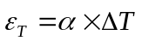, where α is the coefficient of thermal expansion (CTE) and ΔT is the increase in temperature. For a typical MC α = 1.6E-5 1/°C. At ΔT = 100 °C, ε_{T} = 0.16%. The strain caused by moisture swelling is 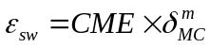, where δ^{m}_{MC} is the moisture uptake. At 85% RH the δ^{m}_{MC} typically varies from 0.3% to 0.5%. At CME in the range from 0.2 to 1.5, the moisture induced strain ε_{sw} varies from 0.06% to 0.75%.
These estimations show that the strain in MC at high humidity conditions might be comparable and even much larger than the deformation caused by the temperature expansion. The mechanical stress in a plastic package of PEM is the sum of stresses caused by moisture swelling and by the CTE mismatch between MC, α_{MC}, and the lead frame, α_{LF} :
where E is the Young’s modulus.
The portion of this stress caused by the CTE mismatch will be negligible when α_{MC} ≈ α_{LF}. In this case the stress will be due to only hygroscopic swelling of the packaging material.
Opposite to the hygrothermal expansion of encapsulating materials in humid environments, shrinkage of MCs can be expected in space, where parts are operating in vacuum. In these environments moisture will gradually desorb from polymers causing reduction of the volume of plastic packages, changing mechanical characteristics of encapsulating materials, and thus imposing additional stress to the active elements of the circuits. The effect of these variations on performance and reliability of PEMs intended for space applications has not been properly addressed in the literature so far. Understanding of the physical mechanisms of the environmentally induced deformations and stresses in encapsulating polymer materials is important to develop an adequate qualification strategy, evaluate results of reliability testing, and predict behavior of parts during operation in space.
A purpose of this work is to develop a simple measurement technique, evaluate expansion and shrinkage of molding compounds due to moisture absorption and desorption processes, and discuss physical mechanisms of the environmental hysteresis in volume deviations of PEMs.

III-2. Technique
III-2.1. Measurements of Volume Deviations and Hygroscopic Swelling. Several techniques are available for measurement of the hygroscopic swelling characteristics of epoxy composites and molding compounds (see Table III-1). The simplest method is direct measurement of the dimensions of samples before and after moisturizing. However, due to the small size of plastic packages, this technique has poor accuracy when applied to PEMs. Moire interferometry has been used at the CALCE center [11]. This technique requires special optical equipment and corrosion-resistant gratings. Combined thermal mechanical analysis (TMA) and thermal gravitational analysis (TGA) measurements, performed simultaneously on two identical samples, has been used by E. H. Wong et al. [4]. The samples were subjected to isothermal high temperature bake, during which their mass loss and linear dimension were monitored with time. The high temperature baking, as shown below, might itself cause non-moisture-related deformations of polymer samples with time. This effect, in particular, could be responsible for anomal large values of the CMEs measured by this technique.

In this work, the hygrothermal expansion coefficient was calculated based on volume measurements of PEMs using the Archimedes principle. According to this technique, the weight measurements of a plastic package, P, were first performed in air and then after immersion into a fluid, P_{im}. The volume of the sample was calculated using the density of the liquid, ρ_{liquid}:
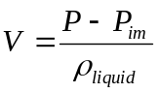
To calculate the coefficient of moisture expansion, CME, the volume and mass of the sample was measured two times: after saturation in moisture environments and after baking-out at high temperatures:
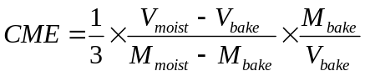
Galden D02 was used as media for the immersion measurements. It is a low molecular weight perflouropolyether (PFPE) liquid having extreme chemical inertness, boiling point of 175 ºC, density at 25 ºC of 1.77 g/cm³, kinematic viscosivity at 25 ºC of 1.8 cSt, and vapor pressure at 25 ºC <1 torr. This liquid used widely for electronic reliability testing, including thermal shock and hermetic seal testing.
The weight measurements were performed using a digital scale with 0.1 mg accuracy, which gives an error in the volume measurements of 0.1% to 0.004% for the packages with volume ranging from 0.1 cm³ to 3 cm³, respectively.
III-2.2. Effect of Lead Frame. Measurements of moisture uptake and volume deviations on PEMs would give different results compared to the measurements on samples of MCs due to the presence of the lead frames. Assuming the volume of the lead frame is V_{LF}, and the specific density ρ_{LF}, the relationship between the hygroscopic volume swelling, β, moisture uptake, δ^{m}, and volume deviation, δ^{v}, measured on a package and on encapsulating material can be written as follows:

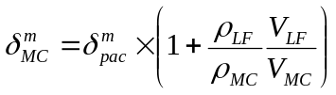

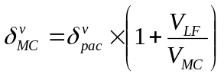

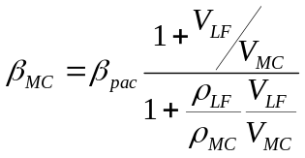
Here δ_{MC}^{m} = m_{w}/M_{MC} and δ^{v}_{MC} = v_{w}/V_{MC ,}where m_{w} and v_{w} are the mass and volume of absorbed moisture. The subscripts v and m refer to volume and mass; LF, pac, and MC refer to the lead frame, package, and molding compound, respectively.
For a typical case of a QFP144 package with a thickness of 3.4 mm and a copper lead frame of 0.18 mm of thickness, V_{LF}/V_{MC} ≈ 0.036. Considering that the specific densities of copper and MC are 9 g/cc and 1.8 g/cc, calculations give δ_{MC}^{m} ≈ 1.275×δ_{pac}^{m} , δ_{MC}^{v} ≈ 1.055×δ_{pac}^{v} , and β_{MC} ≈ 0.87×β_{pac} .
To estimate the accuracy of assessments of CME for MCs based on measurements of moisture uptake and swelling of PEMs, experiments were performed with QFP144 plastic packages and samples of MC used in these packages. Three samples of MC with a thickness of ~1 mm were prepared by grinding off a part of the package with a die and lead frame. Masses and volumes of the three packages and three samples of MC were measured two times: first after baking at 125 ºC for 48 hours and then after saturation with moisture in 85 ºC/85% RH chamber for one week. Average values of the moisture characteristics and their standard deviations are shown in Table III-2.
Table III-2. Moisture uptake and swelling of QFP-144 packages and molding compound.
Sample | dM, % | stdev._M | dV, % | stdev _V | β_{MC} | CME
Package | 0.329 | 0.011 | 0.266 | 0.034 | 0.81 | 0.23
MC | 0.426 | 0.011 | 0.281 | 0.077 | 0.66 | 0.22
The results show that the CME calculations based on direct measurements on samples of MCs and on plastic packages agree within 5%. The accuracy of moisture swelling measurements depends on the initial volume of the sample, V_{o}, and was 12.7% for packages (V_{o} ~ 2.5 cm³) and 27.4% for MC samples V_{o}~ 0.75 cm³). This gave overall accuracy of CME measurements of 16% and 29% for the packages and MC samples, respectively.
Characteristics of plastic packages used in this study, including the thickness of packages and lead frame-to-package volume ratios, are displayed in Table III-3.
Table III-3. A list of studied PEMs.
Mfr | PN | DC | Package | L, mm | t, mm | V_{LF}/V_{p}
Harris | HA3-5217A-5 | 9827 | DIP-8 | 3.3 | 0.25 | 0.038
Harris | HA3-5104-5 | 9810 | DIP-14A | 3.3 | 0.24 | 0.035
Harris | HA3-5330-5 | 9732 | DIP-14B | 3.3 | 0.24 | 0.035
Ramtron | 1808 | 9907 | DIP28 | 3.82 | 0.25 | 0.032
Ramtron | 1608 | 0045 | DIP28 | 3.82 | 0.25 | 0.032
Dallas | DS80C320 | 9536 | QFP44 | 2.0
IDT | 49C465PQF | 9832 | QFP144 | 3.4 | 0.18 | 0.036
AMD | LT1014IS | 9617 | PLCC32 | 2.84 | 0.24 | 0.05
XILINX | XC4005H-5 | 9608 | QFP240 | 3.29 | 0.16 | 0.024
V3 Semi | H7MG00104B | 9652 | QFP160 | 3.75 | 0.19 | 0.025
ACTEL | A1240A - 1 | 9505 | QFP144 | 3.36 | 0.19 | 0.028

III-3. Swelling Characteristics of Different MCs and Encapsulating Materials
The swelling characteristics were measured on packages listed in Table III-3 and also on two Hysol liquid epoxy compositions and on Struers Epofix epoxy compound. All measurements were performed on three packages or three samples of materials.
III-3.1. Testing in 85 ºC/85% RH Chamber. For this testing the parts were measured after baking at 125 ºC/48 hours and then after one week of storage at 85 ºC/85% RH conditions. Averaged moisture characteristics of the packages and encapsulating materials and standard deviations of the moisture uptake and swelling are displayed in Tables III-4 and III-5. Also, the calculated errors of the β_{pac} measurements are shown.
Table III-4. Moisture characteristics of different PEMs after 85 ºC /85% RH/186 hrs.
Package | dM, % | stdev._M | dV, % | stdev _V | β_{pack} | error, % | CME MC
DIP-8 | 0.296 | 0.016 | 0.252 | 0.074 | 0.85 | 34.9 | 0.25
DIP-14A | 0.310 | 0.012 | 0.527 | 0.106 | 1.70 | 24.0 | 0.49
DIP-14B | 0.319 | 0.002 | 0.395 | 0.045 | 1.24 | 12.1 | 0.36
DIP28 | 0.184 | 0.002 | 0.200 | 0.015 | 1.09 | 8.7 | 0.32
QFP144/IDT | 0.329 | 0.011 | 0.266 | 0.034 | 0.81 | 16.1 | 0.24
PLCC32 | 0.266 | 0.013 | 0.168 | 0.07 | 0.63 | 46.5 | 0.18
QFP240 | 0.315 |  | 0.116 |  | 0.37 |  | 0.11
QFP160 | 0.278 | 0.012 | 0.092 | 0.02 | 0.33 | 26.0 | 0.10
QFP144/Actel | 0.318 | 0.011 | 0.122 | 0.023 | 0.38 | 22.3 | 0.11

Table III-5. Moisture characteristics of different encapsulating materials after 85 ºC /85% RH/186 hrs.
Material | dM, % | stdev._M | dV, % | stdev _V | β | error, % | CME MC
QFP144 MC | 0.426 | 0.011 | 0.281 | 0.077 | 0.661 | 29.8 | 0.22
Hysol FP4450 | 0.348 | 0.014 | 0.268 | 0.055 | 0.770 | 24.5 | 0.25
Hysol EO1016 | 2.026 | 0.007 | 1.976 | 0.024 | 0.975 | 1.56 | 0.32
Struers Epofix | 2.020 | 0.012 | 1.542 | 0.010 | 0.764 | 1.23 | 0.25
The results show that the CME for different molding compounds varies from 0.1 to 0.49. In spite of different level of filling, variation of the CME for encapsulating materials was relatively small: 0.22 < CME < 0.32. These data are in agreement with the results reported in literature (see Table III-1).
Sample-to-sample variations were in the range from 1% to 5% and from 10% to 25% for the moisture uptake and volume deviation measurements, respectively. This gives an error of the hygroscopic expansion coefficients below 30%.
III-3.2. Effect of Temperature and Humidity. Swelling in several types of PEMs was measured after storing in humidity chamber at 85 ºC /100% RH for 168 hrs and after pressure cooker testing (PCT) at 121 ºC /100% for 140 hrs. As a reference, a standard testing at 85 ºC /85% RH for 168 hrs was also performed. Before each environmental stress the parts were baked at 150 ºC for 17 hours. Typical test results are shown in Figure III-1. The data (masses and volumes) measured after each bake were used as a baseline for calculations of the hygrothermal volume expansion coefficients. Figure III-2 shows results of these calculations plotted against the moisture uptake as it increased during storage at higher humidity and/or temperature conditions.
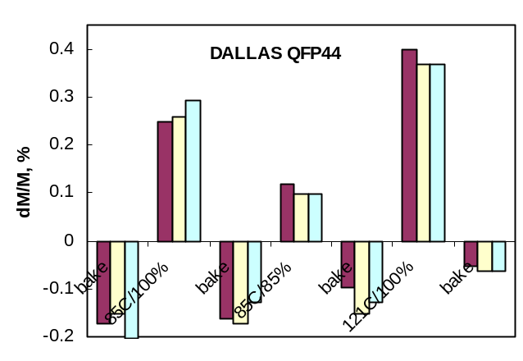a) | 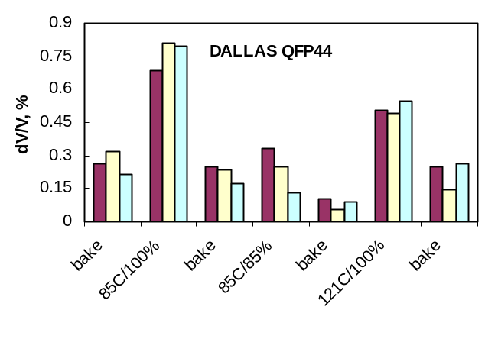  b)
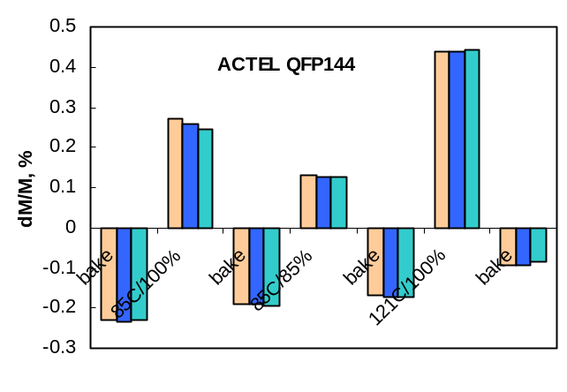  c) | 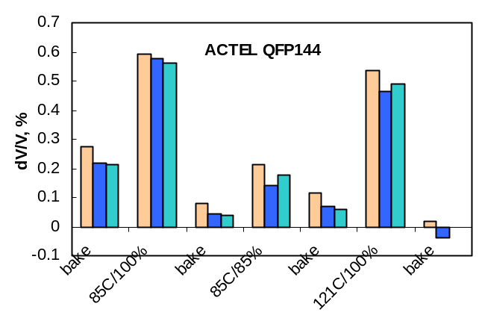  d)
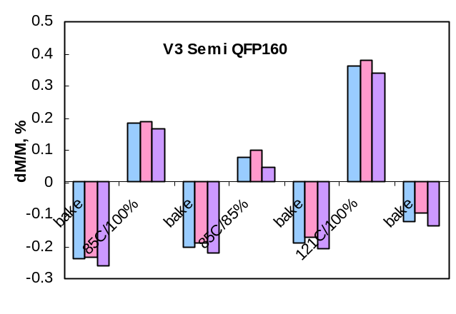  e) | 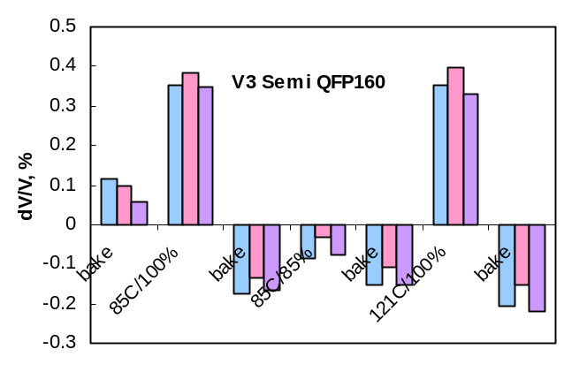  f)
Figure III-1. Moisture uptake (a, c, e) and volume deviations (b, d, f) of three types of PEMs during bakes and different moisturizing conditions. Three samples were tested for each package type.

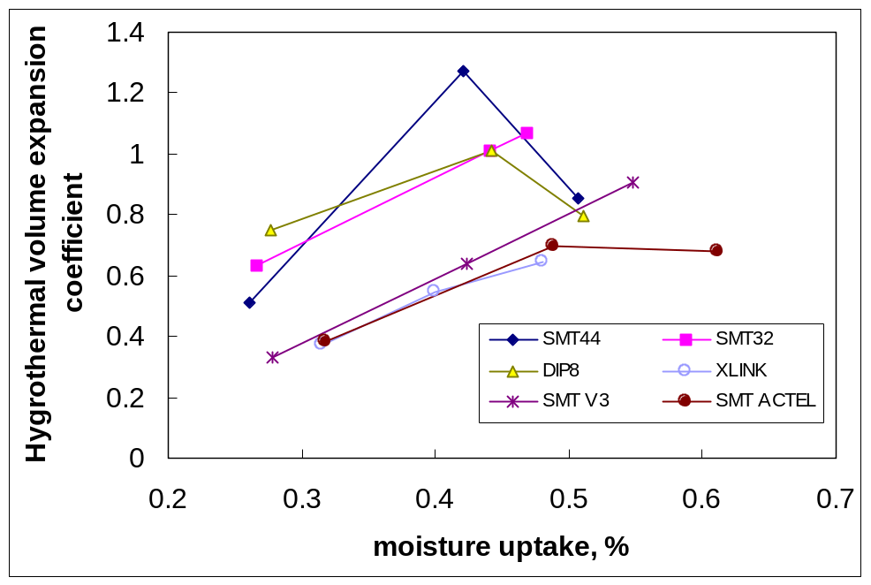
Figure III-2. Hygroscopic volume expansion coefficients for different PEMs plotted against the moisture uptake, which varied with moisturizing conditions: 85 ºC /85% RH, 85 ºC /100% RH, and 121 ºC /100% RH.
The results show that the coefficient of hygrothermal expansion is not a constant, but depends on moisturizing conditions and has a trend of increasing with moisture uptake.
III-3.3. Sorption Isotherms. To evaluate the effect of relative humidity on moisture uptake and swelling of molding compounds, several types of PEMs and two types of epoxy molding compounds were subjected to environmental stresses at 85 ºC and relative humidity varying from 20% to 90%. The epoxy molding compounds used, MG33F-0520 and MG70F-0627, were manufactured by DEXTER/HYSOL for encapsulation of solid chip tantalum capacitors. Three samples of each type of package and MCs were stored consequently at humidity of 20%, 40%, 60%, 80%, and 90% for 168 hrs. Before storing at 20% RH the parts were baked at 150 ºC for 24 hours and the MC samples were post mold cured at 177 ºC for 2 hours. Masses and volumes of all samples were measured after bake (baseline data) and after each RH run. Average values of moisture uptake, volume swelling, and CME are shown in Figure III-3.

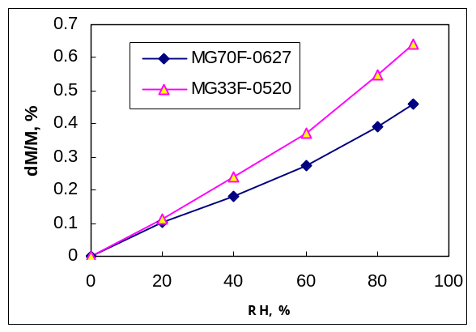  a) | 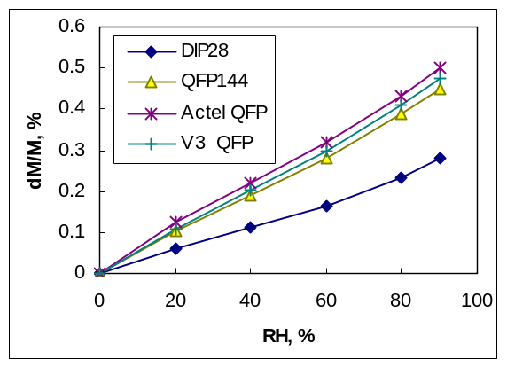  b)
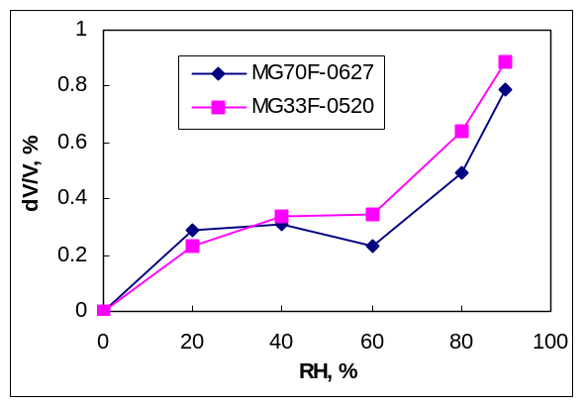  c) | 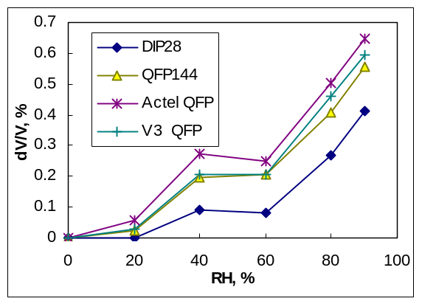  d)
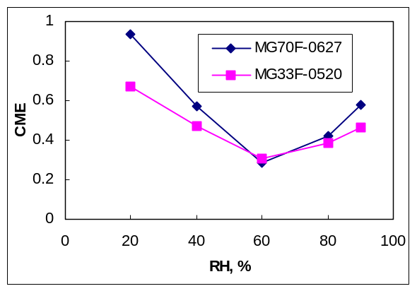  e) | 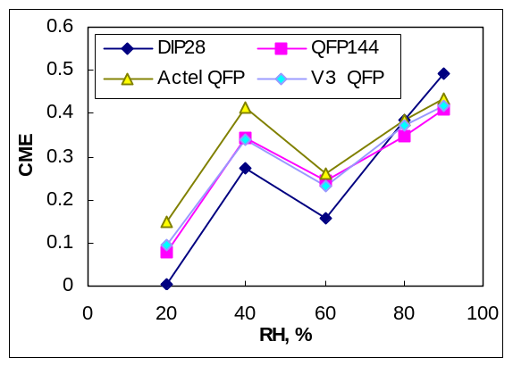  f)
Figure III-3. Isotherms of the equilibrium moisture uptake (a, b), volume swelling (c, d), and coefficient of moisture expansion (e, f) at 85 ºC for different PEMs (b, d, f) and epoxy molding compounds (a, c, e).

The results show that the moisture uptake is virtually a linear function of the relative humidity (see Figures III-3a, b) for all tested MCs and plastic packages. This confirms that at equilibrium conditions, the concentration of moisture in epoxy polymers follows Henry’s law, and the moisture uptake increases linearly with the pressure of moisture vapor (P):
where P_{s} is the pressure of saturated water vapor, f is the relative humidity, and η is the sorption coefficient, which varies exponentially with temperature.
Figure III-3c and III-3d show that the moisture swelling isotherms for all samples had a sigmoidal shape. The volume did not changed significantly when moisture soaking was performed between 20% and 60% of relative humidity for molding compounds and between 40% and 60% RH for PEMs and then increased at RH > 60%. Similar to what was observed before, the CME increased 2.5 to 5 times when RH increased from 60% to 90%. Minimal CME values for MCs and PEMs were observed at 60% RH and at lower RH the CMEs for molding compounds increased up to 0.67 to 0.93. All PEMs had anomaly low swelling at 20% RH, which resulted in the CMEs below 0.15.
III-4. Effect of Bake-out and High Temperature Exposure
Bake-out of epoxy polymers was expected to remove moisture from the samples and, opposite to moisture-induced swelling, cause shrinkage of molding compounds. To evaluate this shrinkage experiments were performed with several types of PEMs stored in laboratory conditions (22 ºC, ~50% RH) for time varying from one to more than 4 months. Masses and volumes of these parts were measured before and after 125 ºC/48 hours bake. The results of these tests are displayed in Table III-6.
Table III-6. Effect of bake at 125 ºC for 48 hrs.
Package/  material | dM avr, % | dV avr, % | β_{pack}
QFP44 | -0.18 | 0.27 | -1.51
SMT32 | -0.16 | -0.03 | 0.17
SMT16 | -0.15 | 0.01 | -0.07
DIP8 | -0.13 | -0.02 | 0.13
QFP144 | -0.22 | -0.1 | 0.47
QFP260 | -0.21 | 0.28 | -1.32
QFP160 | -0.24 | 0.09 | -0.37
ACTEL QFP144 | -0.23 | 0.23 | -1.01
DIP28 | -0.06 | 0.15 | -2.48

Baking resulted in mass losses varying from 0.1% to 0.24%, thus indicating that the moisture uptake at room temperature conditions is comparable with the moisture uptake at 85 ºC/ 85% RH conditions. This suggests that the moisture uptake virtually does not depend on temperature and can be explained assuming that the heat of moisture solution in polymer and the heat of water vaporization have close absolute values. As it was shown above, the moisture uptake varies linearly with RH and the dM_{RT} values measured after saturation at 50% RH and room temperature are approximately 59% of the dM_{85/85} measured after quenching at 85 ºC/85% RH conditions. Using data from Table III-4, the dM_{85/85} varies from 0.2% to 0.3%. This gives dM_{RT} estimations of 0.12% to 0.18%, which is close to data presented in Table III-6.
Much to our surprise, after baking the volume of some PEMs increased 0.06% to 0.27%, resulting in negative values of the hygroscopic volume expansion coefficients.
To evaluate how bake temperature affects results of the measurements, IDT QFP144 packages, which manifested normal volume-reduction-at-bake behavior, were baked at different conditions: 125 ºC during 96 hrs, 165 ºC during 24 hrs, and 205 ºC during 2 hrs. Nine samples were split in three groups, with 3 samples each. Each group was subjected to baking at one of the three conditions, then to moisturizing at 85 ºC, 100% RH for 168 hours, and then baking was repeated at the same temperature as before. The results of these measurements are shown in Figure III-4.
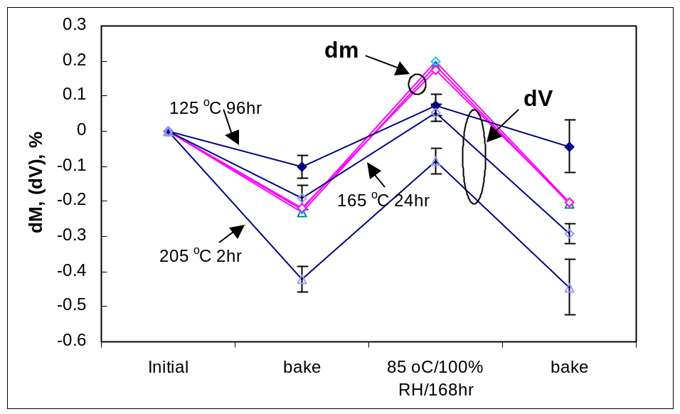
Figure III-4. Effect of baking conditions on moisture uptake and volume deviation in IDT QFP144 packages.
It is seen that different baking conditions and moisturizing resulted in the same variations of the mass of the samples, suggesting that in all cases baking resulted in virtually complete removal of moisture. However, the volume variations increased with the bake temperature. The two-hour bake at 205 ºC caused more than 0.4% decrease in the volume compared to only ~ 0.1% after 125 ºC bake. The decrease in volume after high temperature bake was not restored after one week of saturation of the samples with moisture at 85 ºC.
Note that the decrease in the mass after baking was more significant (~ 0.106%) compared to the moisture uptake due to saturation at 85 ºC, 85% RH (~0.07%). This also confirms the fact that the equilibrium moisture uptake does not depend on temperature.
Based on the data in Figure III-4, the hygroscopic expansion volume coefficients, β_{pac}, had been calculated for different bake/moisture saturation conditions. Results of these calculations are displayed in Table III-7. An increase in the bake-out temperature from 125 ºC to 205 ºC more than 3 times increased swelling effectiveness of moisture absorption. Analysis of the data presented in Table III-7 shows that moisture, which was absorbed by the plastic packages during the long-term storage at room conditions, has higher swelling efficiency compared to the moisture absorbed at 85 ºC, 100% RH conditions.
Table III-7. Effect of bake temperature on the hygroscopic expansion volume coefficient.
Bake temperature | Calculations
Bake temperature | Initial-to-bake | Moisture-to-bake
125 ºC | 0.47 | 0.31
165 ºC | 0.87 | 0.83
205 ºC | 1.83 | 0.92
During assembly of PEMs, which are designed for surface mounting technology (SMT), the parts undergo baking (to remove moisture and thus reduce the probability of popcorning) and then soldering reflow when they are experiencing a high temperature shock. To simulate these conditions, several PEMs were baked at 125 ºC for 96 hours and then exposed to 230 ºC for 15 minutes. Figure III-5 shows mass and volume variations in these parts during the bake, high temperature exposure, and then after 6 month of storing at room conditions (RH ~ 50%). In all cases most of the mass losses, ~ 80%, occur during the 125 ºC bake, and only ~20% were lost during HT exposure. It is possible that much more than 80% of moisture was removed during the bake, and the losses at high temperature exposure were due to some volatile organic molecules in the molding compound. The long-term storage of the samples at RT conditions in all cases, except for DIP 28 packages, resulted in moisture uptake, which overshoots the initial level of moisture; however, the initial level of volume was restored only partially.

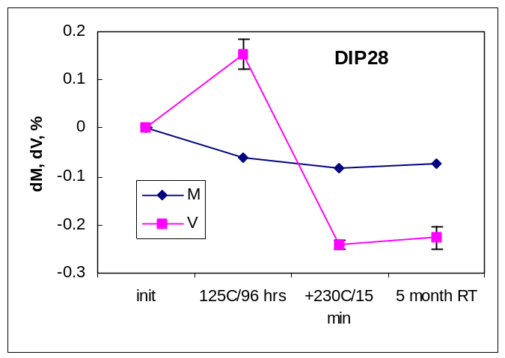a) | 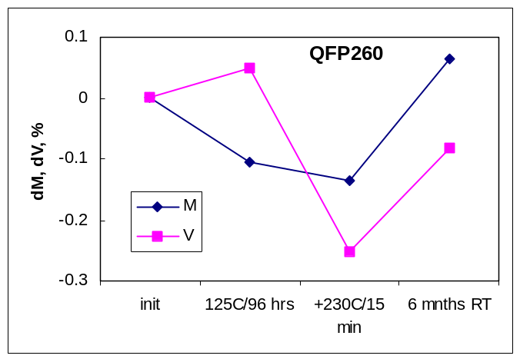b)
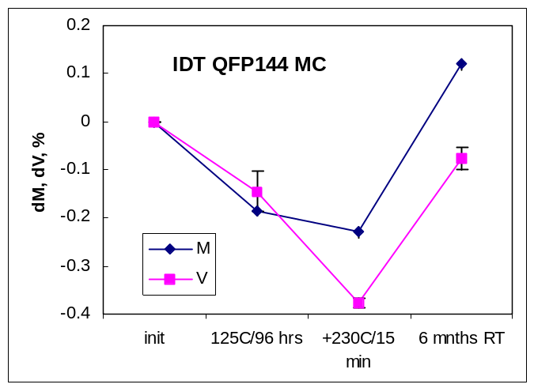c) | 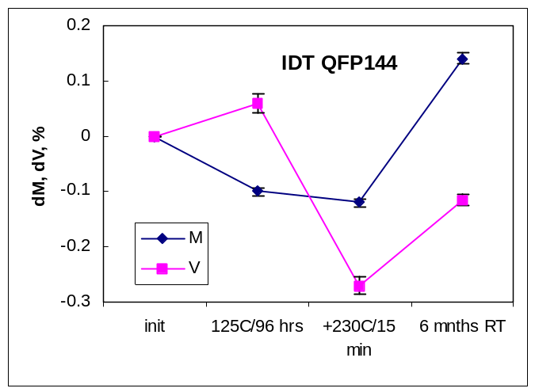d)
Figure III-5. Effect of 125 ºC bake and exposure to 230 ºC on the mass and volume deviations in different PEMs (a, b, d) and MC (c ). All samples have been stored initially for several months at laboratory conditions (T ~ 22 ºC, RH ~ 50%).
Baking 0.05% to 0.15% increased the volume of packages, but the high temperature exposure resulted in a significant decrease (from 0.3% to 0.5%) of the volume. Assuming that mass losses during the high temperature exposure were due to a release of some remnant moisture from the packages, calculations of the hygroscopic volume coefficient yield anomaly high values of β_{pack} varying from 5 to 17.
III-5. Discussion
The performed experiments show that the coefficient of moisture expansion is not a constant, but strongly depends on both conditions: moisturizing and baking. Possible physical mechanisms of deviation of moisture induced swelling from a simple linear relationship with the moisture content are discussed below.
III-5.1. Mechanism of Hygroscopic Swelling. The universally adopted mechanism of hygroscopic expansion is based on the concept of two states of the absorbed water in epoxy polymers [1, 3, 10, 12]. Unbonded or free water molecules, which exist as clusters, reside in micropores or nanovoids, and can easily move through the free volume of polymer, are forming one state. In this state water dos not cause swelling. Another state is formed by water molecules, which are disrupting interchain polymer ties, causing swelling and plasticizing the polymer. It should be noted that so-called “unbonded” water molecules in reality are attached to the polymer by weak hydrogen bonds, which causes their condensation in the micropores. The “bonded” molecules are attached to polar sites of the polymer forming stronger bonds, which secure molecules in states with lower energy compared to the “unbonded” molecules.
To evaluate maximum swelling of molding compound, let us consider a polymer as a liquid without free volume. In this case an increase in the volume of the sample will be equal to the volume of absorbed water and a simple relationship between the relative moisture uptake, δ^{m} = m_{w}/M_{p}, and moisture swelling, δ^{v} = v_{w}/V_{p}, can be obtained:
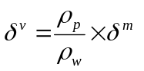
where m_{w}, v_{w}, and ρ_{w} are the mass, volume, and specific density of water; m_{p}, v_{p}, and ρ_{p} are the mass, volume, and specific density of polymer.
It can be shown that a similar equation is valid also for filled polymers, and in particular for molding compounds:
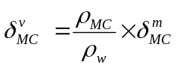,
where δ^{m}_{MC} = m_{w}/M_{MC} and δ^{v}_{MC} = v_{w}/V_{MC}.
The volume hygroscopic expansion coefficient, 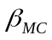, is defined as a ratio of moisture swelling and moisture uptake: = δ^{v}_{MC}/δ^{m}_{MC} and indicates the “efficiency” of the adsorbed moisture to cause swelling of the polymer. The coefficient of moisture expansion, CME, is defined as the ratio of the strain to the moisture uptake and is one-third of the volume coefficient:
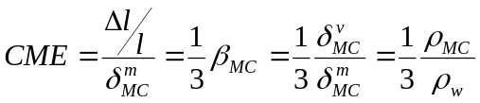
where l is the initial dimension of a dry MC and Δl is the change due to moisture absorption at saturation.
For a typical molding compound ρ_{MC} ≈1.8 g/cm³, which gives maximum value of the β_{MC} ≈ 1.8 and maximum CME ≈ 0.6. All CME values, calculated for the standard moisturizing conditions of 85 ºC/85% RH, were below 0.6. A deviation from the maximum CME level indicates a proportion of water, which exists in the free volume and does not mix intimately with the polymer chain:
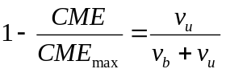
where v_{u} and v_{b} are the volumes of the bonded and unbonded water.
Based on the obtained data, the proportion of the free, or unbonded, water after saturation at 85 ºC/85% RH conditions varied for different materials from 20% to 80%.
It is reasonable to assume that the filler does not absorb moisture and the moisture sorption and swelling of MC are due to the polymer binder. In this case the relationship between moisture characteristics of MC and polymer binder can be written in the following form:
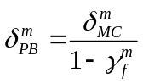,

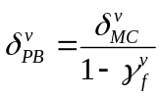,

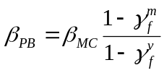

where γ_{f}^{m} and γ_{f}^{v} are respectively mass and volume fractions of filler in the molding compound.
In a typical case γ_{f}^{m} ~ 0.75 and γ_{f}^{v} ~ 0.5, which gives the following approximations: δ_{PB}^{m} ≈ 4δ_{MC}^{m} and δ_{PB}^{v} ≈ 2δ_{MC}^{v} ; hence CME_{PB}=δ_{PB}^{v} /δ_{PB}^{m} = 0.5 CME_{MC}. This means, that the CME for molding compounds are approximately two times larger than for the epoxy binder resin.
To estimate maximum moisture uptake, which might be due to the free volume of an epoxy binder in a molding compound, let us assume that ϕ is the proportion of the free volume in the epoxy resin. In this case maximum possible moisture uptake, which will not cause swelling, can be calculated as:
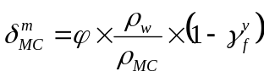
For most polymer materials the fractional free volume α is approximately 2.5%. This gives the moisture uptake for a molding compound with free volume completely filled up with water molecules of ~ 0.69%. Note that this value does not consider water molecules possibly residing in micropores at the MC – filler interface. Accounting for this amount of absorbed water would further increase the possible capacity of MC to absorb moisture without swelling. Typical moisture uptakes for MCs are below 0.5%. Considering that from 20% to 80% of this water causes swelling, the free volume is filled with water molecules to less than 15% to 60%.
This estimation shows that calculations of the free volume by the difference between the volume of adsorbed water and actual swelling of a polymer, which has been suggested in [3], are not correct. The relatively low swelling efficiency of water observed in [3], which is absorbed at the first stages of the sorption kinetic, can be explained by a swelling delay. Most likely, first absorbed molecules reside in a free volume, but their transfer to a bonded state with a lower energy level requires overcoming some energy barriers and occurs relatively slowly. It is quite possible that most of the bonded water is the water, which causes non-Fickian diffusion behavior, that typically manifests as a gradual increase of moisture uptake with time and might be considered as a swelling creep.
Sorbtion isotherms and experiments with baking showed that the swelling efficiency is larger at low RH and after high temperature bakes. This can be explained assuming that at the steady-state conditions with a low moisture concentration, most water molecules will occupy the low energy sites at disrupted polymer chains, thus causing swelling of the material. As humidity increases, most of the available low-energy sites became occupied and the dynamic equilibrium between the concentration of bonded and unbonded molecules shifts towards increasing the proportion of unbonded molecules. This means that a larger proportion of water will be clustering in free volume of the polymer without swelling. This explains saturation of the swelling isotherm at 20% < RH < 60% (see Figure III-3c). It is possible, that swelling enhances the access of water molecules residing in the free volume to new low-energy interchain sites in the polymer resin, thus causing the swelling creep. This might explain an increase in the volume of samples as swelling progresses at humidity higher than 60%.
III-5.2. Mechanisms of the Bake-induced Volume Deviations. Experiments showed that the hygroscopic coefficients depend on the baseline state of MCs, which are formed as a result of a high temperature baking. Moisture removal during baking-out at relatively mild conditions (125 ºC to 150 ºC) increased volume in some MCs. Exposure to temperatures above approximately 200 ºC caused significant negative deviations in volume of the packages resulting in anomaly high coefficients of the hygroscopic expansion.
The observed anomalies with the baking-induced volume deviations strongly indicate that moisture is not the only factor affecting swelling and shrinkage of molding compounds and that the exposure to high temperature might cause significant deformations in plastic packages. Superposition of volume deviations caused by variations of moisture content and by exposure to high temperatures complicates swelling/shrinkage processes in PEMs.
The thermal hysteresis is a well-established effect in glassy polymers [13, 14]. It results, in particular, in gradual decrease in the volume of a sample heated above the glass transition temperature (Tg) and then cooled down below Tg. For MCs with a relatively high Tg, above 125 ºC, this effect is negligible at room temperatures (the relaxation time exceeds several years), but occurs with a noticeable rate at temperatures close to Tg (Tg > T > Tg-20 ºC). Using the free volume concept and the kinetic theory [14], this process can be explained as a volume relaxation to the stationary state. When a sample is quenched at temperatures above Tg, a significant amount of the free volume is introduced. Normally (unless cooled extremely slowly, with the rate >> 1 C/min), cooling to temperatures below Tg results in the non-equilibrium state of the glassy polymer with excessive free volume. Aging of such a sample at T < Tg will result in squeezing out of this excessive volume with time, resulting in gradual decrease in the size of the sample. According to this mechanism, baking would cause a decrease in the volume of a sample, which is not related to the moisture content, resulting in an apparent increase of the swelling efficiency.
In cases when MC was not cured fully during manufacturing of PEMs, high temperature storage might provide additional post-mold curing of the encapsulating material, which also affects the volume of PEMs. In a separate set of our experiments with molding compounds MG33F-0520 and MG70F-0627, it was shown that additional curing decreased the specific density of the molding compounds and increased their volume on approximately 0.35%. These results agree with the results reported by Ko and Kim [15]. The post-mold curing effect is also not related to the moisture content, and opposite to the physical aging would result in an apparent decrease the CME.
Gonon and co-workers [16] observed drastic decrease in the dielectric constant of MCs subjected to preconditioning in humidity chamber at 85% RH and 85°C during 168 h and then to reflow soldering simulations at 240°C per standard JEDEC procedures. The results were explained by the building of micro-porosity within the material, which should proceed with an increase in the volume of the molding compounds. This micro-popcorning effect was not observed in our experiments, where high temperature exposure always decreased the volume of the parts.
To evaluate the effect of high temperature exposure, deformations in QFP144 packages and molding compounds were monitored using a thermo-mechanical analyzer TMA2904. Experiments were performed on samples “naturally” moisturized during a long-term storage at laboratory conditions and after highly accelerated testing (HAST) at 130 ºC, 85% RH for 72 hours. During these experiments the temperature was raised from 125 °C to 200 °C with 15 °C increments and 15 minutes bake at each step. After exposure to 200 °C for 15 minutes the samples were cooled down to room temperature with the rate of 3 °C /min. The deformation and temperature of the sample were monitored and recorded. The thermo-mechanical analysis performed using the cooling curve gave the glass transition temperature for the molding compound of 153 +-3 °C.
Figure III-6 a shows variations of dimension and temperature with time during testing of molding compound, which had been “moisturized” at room conditions. A reduction in size was observed during each 15-minutes step. The total deformation during this test was 0.26% and the mass loss was 0.47%. This gives CME of ~ 0.55, which is in agreement with our previous results presented in Table III-7.

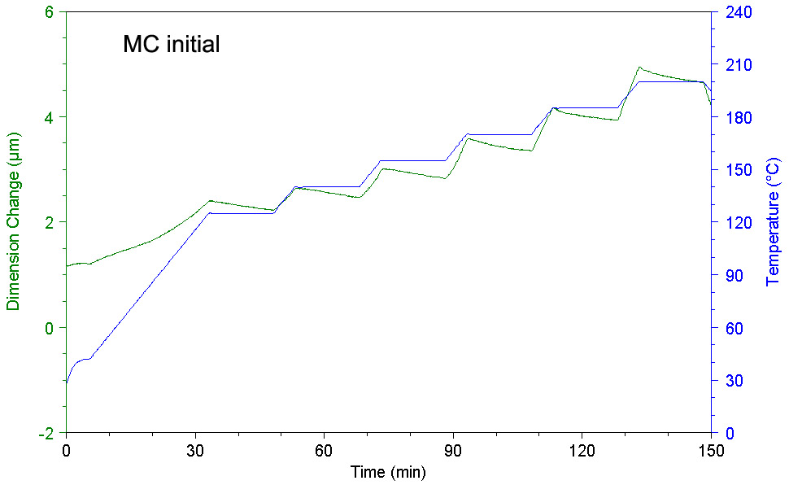  a) | 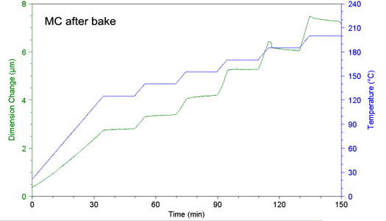  b)

Figure III-6. Results of thermo-mechanical analysis carried out twice on a sample of MC. First test was performed after moisturizing at “normal” conditions, when a sample has been stored for a few months at laboratory conditions (~22 ºC and ~50% RH). The second test (b) was performed right after the first one, which resulted in moisture removal from the sample.
The repeat testing was performed right after the first one, so this time the sample is considered as being baked and containing no moisture. This time (see Figure III-6b) an increase in the size at temperature steps below 175 °C was observed. Similar results were obtained during measurements performed with the plastic package. Figure III-7 displays deformations measured during the 15-minute bakes in the MC and QFP144 package versus the temperature of baking for different conditions of the samples.

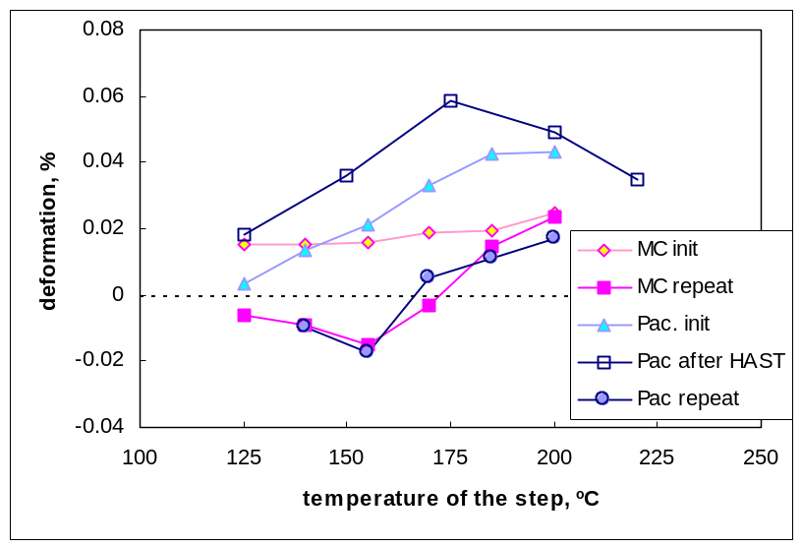
Figure III-7. Decrease in size of the package (QFP144) and the sample of MC during 15-min bake at different temperatures calculated from the thermo-mechanical tests. The tests of the package were performed after normalizing at laboratory conditions (initial measurements), after HAST at 130 ºC/85% RH for 72 hours and then repeated after 15-minuted step baking in the range from 125 ºC to 200 ºC.

The results show that the MC and the package manifested similar behavior. In both cases samples containing moisture reduced in size during the each baking step, while for the dry (baked) samples the size increased with time at temperatures below approximately 170 °C. This behavior is opposite to the one expected during physical aging of epoxy resins, when the free volume supposedly squeezes out from the sample.

This anomaly most likely can be explained if mechanical stresses in the resin of molding compound are taken into account. In highly filled molding compounds typically used in PEMs, the resin at normal conditions is under significant tensile stresses due to the difference between CTE of the epoxy resin and the filler. Most glassy materials dilate under the tensile stress by the amount proportional to the applied tensile strain [13]. This dilation is mostly suppressed at low temperatures, but will manifest as a creep when the temperature approaches Tg, thus resulting in a gradual increase of the volume of the package with time. Depending on moisture content and moisture swelling efficiency, the creep, which is due to baking conditions, will change the value and even the sign of the hygroscopic moisture swelling coefficient.

Anomaly low increase in the volume of plastic packages during sorption isotherm measurements at 85 ºC and 20% RH (see Figure III-3d) could be explained considering that along with the moisture-related swelling, aging processes resulting in volume reduction of MCs occur. One such process could be physical aging taking place at 85 ºC during 168 hours storing in the humidity chamber. However, the storing temperature was far below the glass transition temperatures for the used MCs (Tg > 130 ºC). At these conditions the rate of the volume reduction should be extremely small. Another possibility is the baking-induced creep during the 150 ºC bake before storing the parts in a humidity chamber. As it was shown above, similar bake might increase the volume of plastic packages. As creep in polymers at low strains (<1%) is essentially recoverable [17], it is possible that this recovery occurred in the humidity chamber during the first testing (20% RH), causing reduction of the volume and thus decreasing the effect of moisture-induced swelling. Note also that additional thermo-mechanical analysis performed on MG33F-0520 and MG70F-0627 MCs did not reveal any significant creep during 125 ºC / 150 ºC bakes.
High temperature exposure, at T > 200 ºC, caused considerable reduction of the volume of PEMs and relatively small losses of the mass. This resulted in values of β varying fro 5 to 17, which significantly exceeded the calculated maximum value of ~1.8. The higher efficiency of water to cause reduction of the volume during desorption at higher temperatures is most likely due to a lower energy level of the bonded water molecules. Obviously, more energy is necessary to activate and remove bonded water molecules compared to the molecules in the free volume. However, to explain the fact that this efficiency exceeds the maximum level, calculated by a simple, volume-added model, we have to assume that the high temperature exposure causes some chemical and structural changes in the resin, which are partially reversible during long-term aging at normal room temperature and humidity conditions.

III-6. Conclusions
- A simple, hygrostatic weighting technique has been suggested to assess deviations in volume of plastic packages caused by environmentally induced swelling and shrinkage of molding compounds in PEMs.
- Measurements of 11 different types of plastic packages and 3 types of liquid epoxy encapsulants showed that the coefficient of moisture expansion varies from 0.1 to 0.49 when the samples are moisturized at 85 ºC/85% RH conditions.
- The coefficient of moisture expansion is not a constant, but depends on moisturizing and baking conditions increasing with the moisture uptake at RH > 60%. The efficiency of moisture to cause swelling has a trend to increase at low humidities and after high temperature bakes (at T > 200 ºC).
- All tested molding compounds manifested virtually linear sorption isotherm at 85 ºC. However, the swelling isotherms had a sigmoidal shape, indicating higher swelling efficiency of water molecules absorbed at low humidity (<60 % RH).
- Depending on moisture content in a plastic package, baking at relatively low temperatures (125 ºC to 150 ºC) might result in positive or negative variations in the volume of PEMs. Baking of samples with even relatively low moisture content at temperatures above 200 ºC significantly reduces the volume of molding compounds.
- Physical mechanisms of environmentally induced volume deviations in PEMs are discussed. The observed anomalies in moisture-induced swelling and moisture desorption caused shrinkage of plastic packages are attributed to a creep in epoxy resins, which occurs at baking temperatures.
- Moisture sorption in PEMs at normal laboratory conditions (~22 ºC and ~50% RH) during ground phase integration period or moisture desorption in vacuum during space operations might cause significant (up to 0.35%) deviations in the volume of plastic packages. Similar deformations might affect characteristics of precision microcircuits and degrade performance of sensitive space instruments. Parametric sensitivity of PEMs intended for space applications due to environmentally induced swelling and shrinkage of molding compounds requires additional analysis.

III-7. References
- S. Luo and C. P. Wong, Thermo-mechanical properties of epoxy formulations with low glass transition temperatures, Proceedings 2002 8th International Symposium on Advanced Packaging Materials, 2002, pp. 226-231.
- C. E. Park, B. J. Han, and H. E. Bair, Humidity effects on adhesion strength between solder ball and epoxy underfills, Polymer, Vol. 38, Issue 15, July 1997, pp. 3811-3818.
- M. J. Adamson, Thermal expansion and swelling of cured epoxy resin used in graphite/epoxy composite materials, J. Material Science, Vol. 15, 1980, pp. 1736-1745.
- E. H. Wong, K. C. Chan, R. Rajoo, and T. B. Lim, The mechanics and impact of hygroscopic swelling of polymeric materials in electronic packaging, Electronic Components & Technology Conference, Proceedings, 50th, 2000.
- J. C. L. Wu, M. Liang, A. Le, Z. Chen, S. Wu, K. Lo, and J. J. Lee, Hygroscopic behavior and in-line thermo-mechanical treatment of polymeric material effects on PBGA warpage, Advanced Packaging Materials: Processes, Properties and Interfaces, 2000 Proceedings, International Symposium on, 2000, pp. 243-248.
- S. Liu and Y. Mei, Behavior of delaminated plastic IC packages subjected to encapsulation, cooling, moisture absorption, and wave soldering, IEEE Trans. On CPMT, Part A, Vol.18, No. 3, 1995, pp. 634-645.
- H. S. Choi, K. J. Ahn, J. -D. Nam, and H. J. Chun, Hygroscopic aspects of epoxy/carbon fiber composite laminates in aircraft environments, Composites Part A: Applied Science and Manufacturing, Vol. 32, Issue 5, 1 May 2001, pp. 709-720.
- K. Ogi, H. S. Kim, T. Maruyama, and Y. Takao, The influence of hygrothermal conditions on the damage processes in quasi-isotropic carbon/epoxy laminates, Composites Science and Technology, Vol. 59, Issue 16, 1 December 1999, pp. 2375-2382.
- L. T. Nguyen, K. L. Chen, and J. Schaefer, A new criterion for package integrity under solder reflow conditions, Proceedings, 45th Electron Components and Technology Conference, ECTC, 1995, pp. 478-490.
- M. R. VanLandingham, R. F. Eduljee, and J. W. Gillespie, Jr., Moisture diffusion in epoxy systems, Journal of Applied Polymer Science, Vol. 71, 1999, pp. 787-798.
- E. Stellrecht, B. Han, and M. Pecht, Characterization of hygroscopic strains due to hygroscopic swelling coefficient mismatches in PEMs, CALCE report C2-20, 2002.
- S. Luo, J. Leisen, and C. P. Wong, Study on mobility of water and polymer chain in epoxy for microelectronic applications, Electronic Components and Technology Conference, 2001, Proceedings, 51st, 2001, pp. 149-154.
- S. Matsuoka, Relaxation phenomena in polymers, Hanser, 1992.
- A. Eisenberg, The glassy state and glass transition, in Physical Properties of Polymers, Second Edition, ACS Reference Book, Washington, DC, 1993, pp. 61-94.
- M. Ko and M. Kim, Effect of postmold curing on plastic IC package reliability, Journal of Applied Polymer Science, 1998, Vol. 69, 2187-2193.
- P. Gonon, A. Sylvestre, J. Teysseyre and C. Prior, Combined effects of humidity and thermal stress on the dielectric properties of epoxy-silica composites, Materials Science and Engineering, Vol. B83, Issues 1-3, 21 June 2001, pp. 158-164.
- M. Ward and D. W. Hadley, An introduction to the mechanical properties of solid polymers, Wiley, 1993.

