Relay Failures Specific to Space Applications

Alexander Teverovsky, Ph.D.
alexander.a.teverovsky.1@gsfc.nasa.gov
UNISYS/NASA GSFC Operations, Lanham, MD

Abstract

Low-pressure conditions, as experienced in space applications, are considered benign for many electronic components. However, for switching devices the probability of failure may be significantly greater than at normal atmospheric pressure due to arcing-at-break processes. This study was stimulated by a relay failure in a 60-V power bus in a spacecraft module, and it was intended to analyze failure modes and the probability of their occurring under low-pressure conditions. The effects of gas pressure, power bus voltage, and load current on arc duration and probability of arc flashover have been investigated. It was shown that arc duration mostly depends on switching power and gas pressure, significantly increasing when power is rising and pressure is decreasing. Failure analysis indicated two major mechanisms in low-pressure conditions: (1) contact damage (excessive erosion and/or microwelding) and (2) arc flashover to a grounded case and/or grounded coil post. For a relay operating in a vacuum, the effect of leak rate on the time to failure at low-pressure conditions is discussed.

Introduction

Telemetry data indicated the failure of a 60-V power bus in a spacecraft module. The failure occurred during the first switching of a relay, and it caused a 10-A fuse in the bus power distribution unit to blow open.
One conceivable failure scenario involved the possibility of transient case arcing (arc flashover) in a hermetically sealed relay used in the module. No indication of arc flashover was observed under vacuum and normal pressure conditions during multiple testing of the module before launch. However, it is possible that a fine leak in the relay may have decreased internal air pressure while the module was operating in space.
Although failures due to arc flashover in relays are well known since the 1960’s [1], the mechanism of this process is not completely understood. In particular, the effect of low-pressure conditions on relay arcing and the possibility of flashover failures has not been adequately addressed in technical literature. Obviously, this low-pressure condition is of particular interest for space applications.
This work analyzes arc flashover in hermetically sealed latching relays operating in vacuum and estimates effect that a hermetic-seal leak has on this phenomenon. For this purpose, the effects of internal air pressure (ranging from 760 torr to 0.2 torr), power bus voltage (12 V to 60 V) and load current (0.2 A to 3.5 A) on arc-at-break duration and relay failures were investigated.

Experiments

The setup used to simulate conditions in the bus power distribution unit is shown in Figure 1. A power source was created by combining five car batteries in series, allowing voltage to vary in 12-V increments up to 60 V dc. Standard 10-A/250-V CSA/UL-F fuses were used to detect flashover events. Load current was adjusted from 0.24 A to 3.6 A using 200-W wire-wound resistors. Inductances of these resistors are listed in Table 1. Wires of 12 AWG type with lengths of approximately 2.1 m (7 ft) were used to connect the circuitry. A straight wire of this length has an inductance of approximately 1.5 μH. Inductance of the ammeter was 0.23 μH. Total inductance in the circuit depended primarily on the resistor used, but it was relatively low (≈ 90 μH maximum). The impact of the circuitry inductance is discussed later.
Three hermetically sealed latching relays were used in this study. The contacts in these relays were rated for 12-A resistive load at 28 V dc. According to the manufacturer application note, it is possible to derate the contacts for higher dc voltages provided lower currents are used during switching. At 60 V, the calculated current limit is 3.73 A.

Table 1. Inductances of resistors used in the experimental setup.
Resistance | Inductance | Type
5 Ω | 19 μH | wire-wound
10 Ω | 20 μH | wire-wound
10 Ω | 0.5 μH | carbon
20 Ω | 40 μH | wire-wound
50 Ω | 87 μH | wire-wound

The movable relay contacts were connected to the positive battery terminal. Arc duration, θ, was monitored with a current probe and an oscilloscope. The sample was switched five times at each combination of experimental parameters, and mean values and standard deviations of θ were analyzed. Small holes were drilled in the relays before installing them in the vacuum chamber to permit pressure equalization.

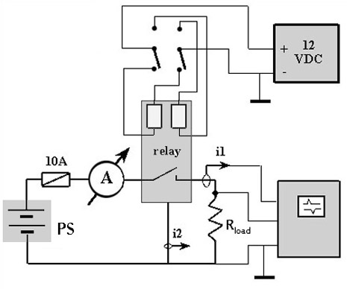
Figure 1. Block diagram of the test set-up.

Results

Atmospheric Pressure Condition

A typical transient oscillogram measured at contact break under normal conditions in the 60-V/3-A circuit is shown in Figure 2. Duration of the arc for all tests was in the range of 2.2 to 2.7 ms, and it did not vary more than approximately 20% during switching.
Two relays with cases removed were examined under a low-power microscope during operation. Bright arcing was observed for both relays at the moment of contact break. The arcing, which was reproducible, was localized at a certain area between the contacts. The arcing was visible even when the load resistance was increased, causing the current to decrease from 3 A to 1.7 A, 1.15 A, and even to 0.9A (at 70 Ω). This is consistent with the minimum arcing current of silver contacts which is generally considered to be about 0.4A [2].

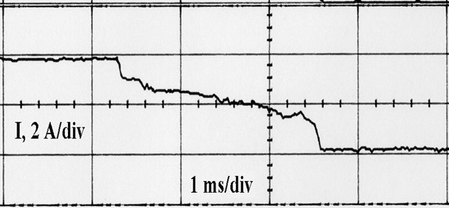
Figure 2. Typical transient oscillogram at contact break (60 V/3 A) at atmospheric pressure.

Low-Pressure Conditions

Preliminary Experiments. The first 60-V/3-A experiment (first contact break), conducted with sample SN 1 (contacts B1-B2) at an internal gas pressure of 1 torr, resulted in a blown fuse, indicating that a flashover event had occurred. The fuse was replaced, and the experiment was repeated with the same result (i.e., the second 10-A fuse was blown open). Following the fuse change, the chamber valve was opened, and testing was conducted at atmospheric air pressure. No fuses blew during multiple switching tests. The transient current oscillograms at contact break and the arc duration were found to be similar to those observed during the initial test, thus indicating that no damage to the relay had occurred during flashover events.
The experiments were continued using the A-side contacts. No failures occurred during multiple switching at low-pressure conditions. Arc behavior was much less stable than at atmospheric pressure, and θ varied from 15 ms to 1.1 s. Figure 3 shows an example of the transient at contact break in the low-pressure condition.

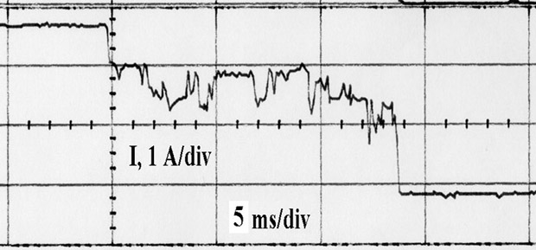
Figure 3. Transient at break (60 V/3 A) at air pressure of 6 torr, SN 1.

Experiments with contacts B1-B2 were continued, first at normal conditions (atmospheric pressure) and then in the vacuum chamber (6 torr). No failures occurred in the experiments conducted at atmospheric pressure and during the first seventeen switchings at low-pressure conditions. But the eighteenth switching blew the third 10-A fuse. The flashover event (see Figure 4) occurred approximately 15 ms after arc ignition (θ ≈ 40 ms). After this event, the relay failed open (it was not latching).

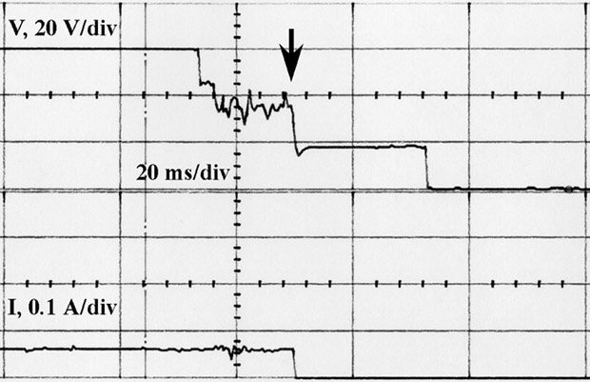
Figure 4. “Blowing fuse” event in SN 1 at contact break (60 V/3 A) in vacuum chamber at 6 torr; current was measured between case and ground.

Effect of Air Pressure. Two samples were tested at various pressures in the vacuum chamber at the 60-V/3-A condition. Similar to SN 1, arc duration at low-pressure conditions was much longer, less reproducible, and significantly noisier with spikes up to 2 A peak. No fuse blowing occurred during these experiments. The arc-duration-pressure (θ-p) relationship had an extremum at approximately 10 torr (see Figure 5). Similar extremal behavior of the θ-p dependence was expected. The arc is known to be suppressed at high and low air pressures, and these effects are used in practical design of vacuum and high-pressure circuit breakers. However, the range of air pressure that would cause significant increase in θ for the JL type relays was not known. Based on Figure 5 and assuming a 5-times increase in θ (compared to atmospheric pressure) as significant, the low-pressure condition range can be defined between approximately 1 torr and 200 torr.
Sample SN 2 failed (the contacts stuck closed) during experiments at 19 torr after sustaining an arc for about a second.

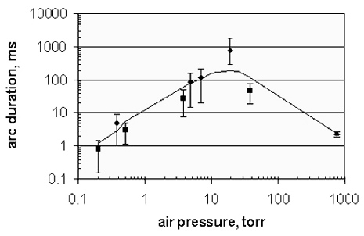
Figure 5. Arc duration variance with pressure for 60-V/3-A condition.

Effect of Current and Voltage. To avoid possible damage to the contacts by long arc duration at pressures between 1 torr and 200 torr, these experiments were performed first at atmospheric pressure and then at 0.4 torr. Sample SN 3 was switched first at minimal voltage (12 V) while changing load resistors in the sequence 50, 20, 10, and 5 Ω. Then, the voltage was increased in 12-V increments to 60 V. The results of measuring mean θ as a function of the short-circuit current, I, for various power supply voltages are shown in Figure 6. A power function was used to describe θ(I) variance:

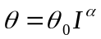 (1) (1)

where α and θ₀ are parameters. Parameter θ₀ increases with the power supply voltage, whereas α is relatively independent of current and voltage (above 12 V), but it increases from 0.6 to 0.9 at atmospheric pressure to 3.6 to 5.2 at the internal air pressure of 0.4 torr.

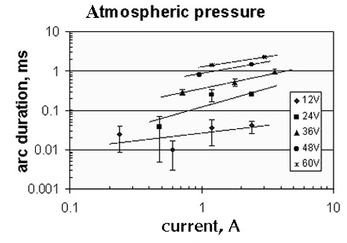

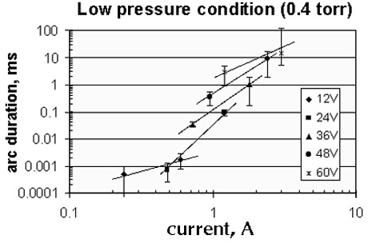

Figure 6. Arc duration at break vs. short-circuit current.

The flashover event (10-A-fuse blowing) occurred during the second switch at 0.4 torr and the 60-V/3-A condition. The oscillogram of this event was similar to Figure 4. This time, the flashover occurred in 5 ms, whereas the arc duration was 23 ms in length. Blowing of the fuse coincided with failure of the relay that stuck open.

Effect of Circuitry Inductance. Experiments with the carbon and wire-wound resistors showed that inductance of the 10-Ω resistors did not significantly affect duration of the arc (θ_{carbon} ≈ 940 μs, θ_{wire-wound} ≈ 900 μs). This suggests that circuit inductance, L, in the range of tens of microhenries can be considered as negligible. On the other hand, it is known [3], that an increase in the load inductance above ≈0.2 mH substantially increases the arc duration (i.e., approximately 10 times). The following approximate calculations facilitate estimation of the condition at which the load can be regarded as resistive.
Energy dissipated during the arcing period θ is:

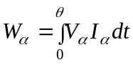 (2) (2)

where V_{a} and I_{a} are the voltage and current of the arc.
Analysis of the arc oscillograms suggests that arc current and voltage in these experiments can be roughly assumed as constants that are equal to fractions (30%-60%) of the load current and switching voltage. This facilitates estimating W_{a} ≈ kVIθ, where k is an empirical coefficient, k ≈ 0.1-0.4.
Obviously, if the arc energy is much larger than the energy stored in the circuit inductance (W_{L} = 0.5LI²), the inductance effect can be neglected. This gives the following equation for a “negligible” inductance of the circuitry:

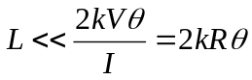 (3) (3)

where R is the load resistance.
Typically, arc duration was in the millisecond range at the 60-V/3-A conditions. At these conditions the above estimation gives L<< 4 mH. This means that inductance of the circuitry with any of the resistors used in the experimental setup can be considered as negligibly low. The shortest arcs (in the microsecond range) occurred at low air pressure with minimal load currents (load resistance = 50 Ω). At this condition the negligible inductance should be below 10 μH. As the 50-Ω resistor had L ≈ 90 μH, this circuit inductance should affect arc duration. This most likely explains the higher-than-expected (according to the power law) values of arc duration in the 12-V/50-Ω experiments (see Figure 6b).
Analysis of the low-inductance criterion (Equation 3) shows that arc duration depends on the circuit inductance in the microsecond range of θ. To analyze resistive-load conditions, we will consider results with θ > 100 μs. Besides, this range of θ corresponds to the gaseous phase of arc where the internal air pressure is expected to affect the arcing process [4].

Failure Analysis

Sample SN 2, which failed without the arc flashover, had a melted movable contact (anode) that was fused to the stationary contact. Appearance of this damage was typical for a contact failure caused by excessive power dissipation (excessive arc duration in our case). A polymer cap (arc suppressor), which isolated the contact area from the case, had evidence of severe overheating and burning, confirming excessive power dissipation during arcing.
Sample SN 1 had a melted armature which had developed a bump in the area above the post X2. This post and the welded coil wire were partially melted (see Figure 7). Appearance of the damage suggests that flashover occurred between the armature (connected to the movable contact) and the grounded coil post. The damaged site was approximately 8 mm from the normal location of the arc (between the silver contacts). However, the polymer cap had dark burned spots indicating overheating at the silver contacts, and both (A and B) movable contacts had evidence of excessive erosion. These defects most likely were caused by excessive power dissipation during relay switching under low-pressure conditions.
Internal examination of SN 3 revealed a melted post with a fused spring and melted glass at the periphery of the glass seal around the stationary contact. Figures 8 and 9 show damaged sites in this relay. The damage appearance suggests a breakdown (arc flashover) between the post connected to the armature and the header. The damaged area is at a distance of approximately 5 mm from the silver contact location. The polymer cap had a dark burned edge near the stressed contacts.

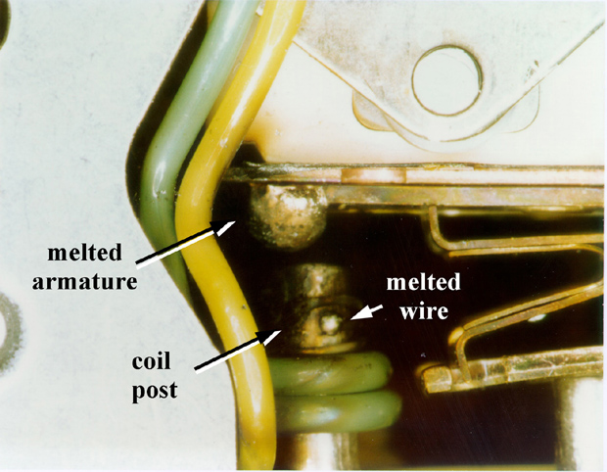

Figure 7. SN 1 failed at 60-V/3-A circuit break in vacuum chamber at 6 torr due to a flashover between the armature and the grounded coil post.

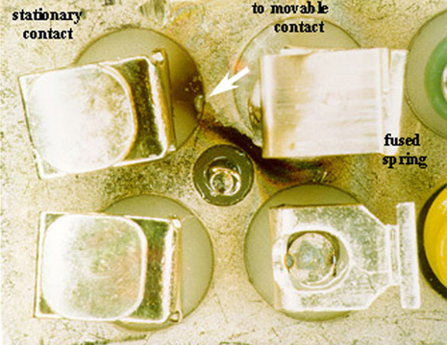

Figure 8. SN 3 failed at 60-V/3-A circuit break at an air pressure of 0.4 torr due to a flashover between the post connected to armature and the case. The black area on the case is an arc track. A white arrow indicates damage to the glass seal (see below).

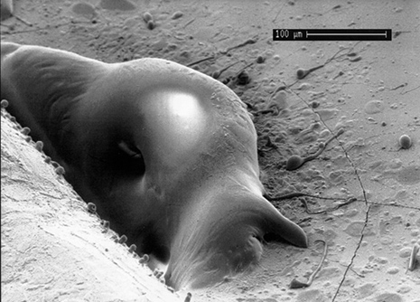

Figure 9. Close-up view of the melted glass seal shown above.

Discussion

It is believed that flashover is caused by the ionized gas diffusing from the between-contacts arc column to the surrounding case or header [1]. This diffusion can initiate a gas breakdown between the contact and the case, and although it may not cause damage to the relay, a failure of the circuit is quite possible. In this sense, a similar event can be considered as a relay failure.
Types of gas molecules and gas pressure significantly affect the arcing process. Data reported by Holm [2] indicate that the arc can be sustained to much wider contact separations at low air pressures (10 torr – 100 torr) and that arc durations may be correspondingly longer than at normal atmospheric conditions. Also, arc behavior changes at low pressures. The arc column becomes wider, its temperature decreases (at pressures below approximately 10 torr), and the longitudinal potential gradient of the arc in inert gases has a minimum at approximately 2 torr [5].
Our experiments showed that flashover failures occurred within several milliseconds after switching. This indicates that duration of the arc may have a significant effect on the probability of flashover. Arc duration is governed by a complex processes taking place in the gaseous phase of the plasma.
At relatively low electrical switching levels (I<3 A and V<50 V), the gaseous phase of arcing, which follows the metallic phase, starts after 200-300 μs, when the contact separation reaches approximately 100 μm [4]. The process is controlled by electron emission from the cathode spots which ionizes gas molecules and thus sustains a plasma. The cathode spots are in permanent chaotic movement from site to site along the electrode surface (probably due to the silver oxide decomposition being caused by the high-temperature plasma [6]). This shifting of the cathode spot constitutes a weakening and subsequent restoration (reignition) of the arc [2]. The reignition process is attended by plasma bursts that cause spikes and noise in the arc current. Similar plasma bursts can probably ignite the gas breakdown causing flashover failure provided the cathode spot is in a suitable location and the burst is powerful enough. Acceleration of the cathode spot motion as gas pressure decreases [6] may also increase the probability of finding a suitable location to initiate this breakdown.
According to this model, an increase in arc duration increases the probability that the plasma burst (which initiates the breakdown) will occur. Correspondingly, the same factors that cause an increase in arc duration are favorable for flashover failures.
It should be noted that an increase in θ increases the energy dissipated in the arc and correspondingly enhances the probability of a “regular” failure event (such as contact erosion and microwelding). This may result in a “regular” failure occurrence before the flashover event.

Arc Duration
Arc duration is mostly considered to be a function of the short-circuit current, I. Two types of arc-duration-versus-current laws are usually used to represent θ(I) functions: an exponential law and a polynomial law [7]. Although none of the functions has received the necessary theoretical justification, the exponential function is mostly used to describe processes in the metallic phase of arcing [4, 8], whereas a power function better describes arcing in the gaseous phase. Our experimental data, which are presented in Figure 6, seem to confirm this conclusion.
An increase in power supply voltage, V, is also known to increase θ, but θ(V) dependencies have not received much consideration. The minimal voltage that is necessary to start acing in relays is about 10 V [2]. This is explained by the fact that to start ionization at contact break, electrons must gain sufficient energy to overcome the energy barrier in the metal electrode and to ionize the metal vapor. As the work function for silver is ϕ = 4.3 eV (for silver oxide, it is less, ≈ 1-1.2 eV) and ionization potential of silver atoms (vapor phase) is V_{i} = 7.5 V, the minimum voltage necessary to start an arc is V_{min} ≈ ϕ/e + V_{i} ≈ 9-12 V. Ionization of the gas atoms and molecules requires more energy, so it, correspondingly, occurs at higher voltages. For example, the V_{i} values for oxygen and nitrogen molecules are 12.1 V and 15.6 V, respectively. Ionization of helium requires 24.5 V. Several tens of electron-volts are required to strip electrons from internal levels of atoms and molecules. Ben Jemaa and co-workers [4, 8] have proven that the arc voltage in the gaseous phase goes through several stages with voltage plateaus that are specific for various types of gases and that are related to their ionization potentials. This mechanism explains changes in the θ(I) relationship when the power supply voltage was increased from 12 V to 24 V (see Figure 6). The increase in voltage intensifies gas ionization, facilitates the arc-reignition process, and correspondingly increases arc duration.
In the range of currents and voltages used, an increase in both external parameters of the arc, V and I, resulted in a rise of θ, with both parameters having a similarly appreciable effect. This implies that a switching power, P=IV, may be used as a single parameter relating to arc duration. Figure 10 shows the θ(P) variance at atmospheric pressure and at 0.4 torr.

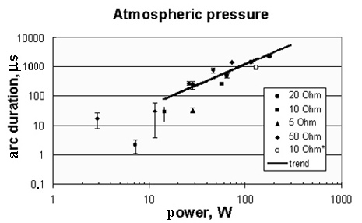

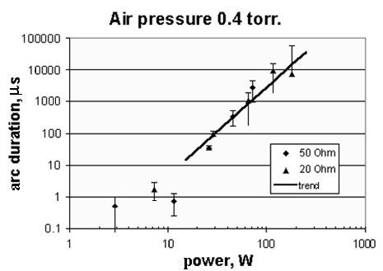
Figure 10. Arc duration variance with switching power at various internal pressures in the relays.

It is apparent that θ is relatively independent of load resistance and, correspondingly, of the power supply voltage. At θ > 100 μs, the θ - P relationship can be approximated with the power law:
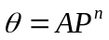 (4) (4)

where A and n are constants.
Calculations gave n = 2.8 for the low-pressure condition and n = 1.4 for the atmospheric-pressure condition. At the low-pressure condition θ increases with power much faster, and above approximately 80 W, arc duration exceeds the corresponding values for the normal-air-pressure condition.

Internal Gas Pressure in Leaking Relays
A decrease in the internal gas pressure with time in a leaking relay can be approximated by an exponential function:

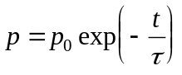 (5) (5)

where p₀ is the initial (atmospheric) pressure, τ = p₀V/L, V is the relay volume (cm³), and L is the standard air leak rate (atm•cm³ /s).
The internal free volume, V, of the relays was estimated at approximately 3.6 cm³. Time dependency for the internal gas pressure in relays with air leak rates in the range from 10⁻⁵ to 10⁻¹¹ atm•cm³/s are shown in Figure 11.
The low-pressure condition (below 200 torr) can be reached in less than 10 years if the leak rate exceeds 10⁻⁸ atm•cm³/s of air. The value of 1x10⁻⁸ atm•cm³/s of air is used as a rejectable limit for relays with internal volume of less than 33 cm³ (2 in³) (per MIL-R-6106). Although this limit is much more severe (more than two orders of magnitude) than the one that is used for microcircuits, it is justified in the light of the described low-pressure condition failures.
The helium leak test is usually used to confirm the required level of the relay hermeticity. With the standard air leak rate, L, the measured leak rate of the tracer gas (He), R₁, can be calculated using the well known formula [see, for example, 9]. Calculations showed that to provide the standard leak rate L = 1x10⁻⁸ atm•cm³/s of air, the measured leak rate for the part, R₁, should be less than 1x10⁻¹¹ atm•cm³/s of He. This value is near the detection threshold of regular helium leak detectors. Besides, in many instances helium desorption from paint on the relay masks a real leak from the case, thus giving an effective leak rate of more than 1x10⁻⁸ atm•cm³/s of He. If the real (from the case) leak rate is approximately 1x10⁻⁸ atm•cm³/s of He, then the corresponding standard air leak rate would be 3x10⁻⁷ atm•cm³/s, and the low-pressure condition would be reached in a few months.
These estimates show that in real life, use of a leaking relay is quite possible despite stringent screening of parts intended for space applications. Such a relay may cause a circuit failure provided the time of its operation in vacuum is within certain limits such that internal pressure is below ≈200 torr, but above ≈0.3 torr. A longer vacuum operation time further decreases air pressure and, thus, reduces the possibility of the arc-related failures.

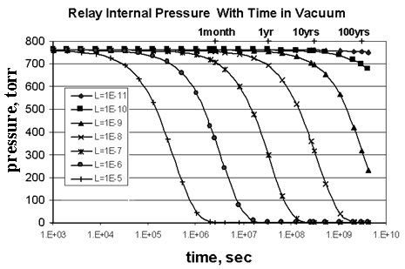
Figure 11. Calculated gas pressure in a leaking relay in vacuum; Leak rate, L, varied from 10⁻⁵ to 10⁻¹¹ atm•cm³/s of air.

Conclusions

1. A decrease in internal air pressure in relays significantly increases the probability of failures caused by arc flashover and/or contact damage. Under favorable conditions, a flashover can occur even at the first relay switching (contact break), thus resulting in a single-event catastrophic failure.
2. For the examined relays rated for 12-A/28-V service, flashover failures occurred while breaking a 3-A/60-V resistive-load circuit at pressures between 6 torr and 0.4 torr. The gas breakdown (flashover) occurred 5 to 15 ms after arc ignition. Damage appeared between the armature and grounded coil post or relay header at distances 5 to 8 mm from the contacts.
3. Arc duration significantly increases when internal pressure decreases, reaching a maximum at approximately 10 torr (from 2 to 3 ms at atmospheric pressure to timespans of seconds at low pressure). Excessive arc duration (more than 20 to 30 ms) at low-pressure conditions (between approximately 200 torr and 1 torr) resulted in excessive erosion and/or microwelding of electrodes and in overheating of polymer caps (arc suppressors).
4. The power supply voltage (in the range 24 V to 60 V) was found to have a similarly significant effect on arc duration as did the short-circuit current (in the range 0.5 A to 3 A). Within these ranges, arc duration mostly depends on switching power, and at P > 10 W, arc duration can be approximated with the power law: θ = AP^{n} with the power coefficient n being larger for the low-pressure condition (n = 2.8 at 0.4 torr) than for atmospheric-pressure condition (n = 1.4). Above approximately 80W, arc duration at the low-pressure condition is longer, correspondingly increasing the probability of the relay failure.
5. Increased arc duration and flashover failures suggest that the internal air pressure range from 0.3 torr to 200 torr can be considered as a high-risk region. Estimates showed that internal pressure in relays with leaks greater than 1x10⁻⁸ atm•cm³/s of He can reach this critical region in less than a year when operating in vacuum.

Acknowledgements

The author would like to thank John Slonaker, Scott Hull, Frederick Felt and Steve Esmacher for useful discussion and for review of this manuscript. The reported work was performed at Goddard Space Flight Center Parts Analysis Lab, and it was supported by the Office of Systems Safety and Mission Assurance (OSSMA, code 562).

References

1. J. Lawrence, Application notes for preferred parts and materials, NASA, GSFC (1965).
2. R. Holm, Electric Contacts Handbook, p. 309, Springer Verlag, (1958).
3. N. Ben Jemaa, L. Nedelec, S. Benhenda, IEEE Trans. on CPMT., part A, v. 19, 82 – 86 (1996).
4. N. Ben Jemaa, J.L. Queffelec, D.Travers, IEEE Trans. on CHMT, v. 14, 113 – 117 (1991).
5. J.M.Somerville, The electric arc, p. 19, John Wiley & Sons Inc., NY (1959).
6. I.G.Kesaev, Cathode process in the mercury arc, p. 49, Consultants Bureau, NY (1964).
7. Handbook of vacuum arc science and technology, edited by R.L.Boxman, D.M.Sanders, P.J.Martin, p. 116, Noyes Publications, New Jersey (1995).
8. N. Ben Jemaa, J.L. Queffelec, R.Haug, J.Phys. D: Appl.Phys., v.20, 468-475 (1987).
9. Electronic materials handbook, v. 1, p. 1063, Packaging, ASM International (1989).

