


Embedded Passives Technology
An Overview
FY ’04 Report

Author: R. David Gerke
Jet Propulsion Laboratory
david.gerke@jpl.nasa.gov
818-393-6372

http://nepp.nasa.gov

Date: July 2005

This research was carried out at the Jet Propulsion Laboratory, California Institute of Technology, under a contract with the National Aeronautics and Space Administration.

Reference herein to any specific commercial product, process, or service by trade name, trademark, manufacturer, or otherwise, does not constitute or imply its endorsement by the United States government or the Jet Propulsion Laboratory, California Institute of Technology.

Table of Contents

1 Summary 4
2 Description of Embedded Passives Technology 4
3 State of the Technology 8
3.1 Comparison between embedded passives and discrete passives 8
3.1.1 Advantages 8
3.1.2 Disadvantages 9
3.2 Applications 10
3.3 Producibility and Manufacturability Issues 10
3.3.1 Resistors 11
3.3.2 Capacitors 11
3.3.2.1 Present Implementation - Power Plane Applications for Buried Capacitance………..11
3.3.2.2 Future Implementations – Replacement of Chip Capacitors…………………….….12
3.4 Vendors 13
3.4.1 Major Resistor and Capacitor PCB Materials 13
3.4.2 Major Resistor and Capacitor LTCC Materials 18
3.4.3 Thin Film Suppliers 18
3.5 General Quality and Reliability Concerns 19
4 Future of Integrated Passives 20
4.1 High yielding processes 21
4.2 Microvia technology 22
4.3 Higher power densities 22
4.4 Prototyping of integral substrates 23
5 Use of Embedded Passives in Space Applications 23
6 Recommendations for NASA 24
7 References 25

Summary
Embedding passive components into a circuit board (organic or ceramic) is not a new technology. Originally the driving force to employ the use of embedded passive components was the desire of consumers to have smaller and lighter products for lower cost. Once the commercial sector began developing embedded components and addressing major quality and reliability issues, the high-rel communities of automotive, telecom, aerospace and space communities have begun to use the advantages of embedded passives technology; namely 1) system cost and weight reduction, 2) assembly cost reduction, 3) board surface area preservation, 4) performance increases, 5) reliability improvements, 6) design density and functionality.

With new applications and functions designers must find room for larger numbers of discrete passives to provide advanced filtering and protection in next generation products. The embedded technology with the most maturity is the embedded resistors manufactured by Ohmega Technologies. Over the last twenty years of use they have manufactured resistor material that has not experienced a single failure in the field due to the resistive material in millions of circuit boards and trillions of component hours of operation [1]. Ohmega-Ply was supplied for use by the Leicester University Beagle 2 team in a number of Beagle 2 instrument circuit boards [1]. Even though the Lander part of the Mars Express Mission (Beagle 2) was not successful in 2004, the fact is that the Space community is beginning to take advantage of this technology.

Capacitive materials for printed circuit boards have made great strides in just the past year alone. Dupont’s Interra and 3M’s C-Ply materials have both provided planar embedded capacitor laminates that allow flexibility in design because they offer thinness combined with a high dielectric constant. A NASA evaluation which studied the Ohmega and Dupont materials was completed in FY’04. The results of the study concluded that the materials warrant further investigation in an actual circuit board [2].

Acceptance of Low Temperature Co-Fired Ceramic (LTCC) is accelerating in RF module designs with integrated passives providing a cost-effective solution for mobile communication. Companies such as Kyocera have years of experience producing millions of RF modules to support cost sensitive yet performance driven wireless communication industry. The LTCC technology has been used in a number of NASA programs in high-frequency RF applications without the embedded passives technology. The results of a recent NASA study of LTCC embedded passives technology concluded that the materials warrant further investigation in an actual circuit board [2].

Description of Embedded Passives Technology
Passive components refer to the type of electrical components that cannot generate power. Typical components are resistors, capacitors and inductors. They are a multi-billion dollar business, supporting electronic products in automotive, telecommunications, computer, consumer and aerospace industries, both for digital and analog-digital applications. Most of the passive components used today are discrete surface mount passive components that directly mount on the surface of a PC board. The primary functions of passive components are to manage busses and bias, decouple ICs, act as by-pass and filter, tune, convert, sense and protect active circuitry. Passive components are commonly referred to as "glue components" since they "glue" integrated circuits (ICs) together to make the system. Table 1 shows some recent consumer products and the amount of "glue" that it takes to make a system.

Table 1: Product Passive to Active Ratios [3]

System | Total Passives | Total ICs | Ratio
Cellular Phones  Ericsson DH338 Digital  Ericsson E237 Analog  Philips PR93  Nokia 2110 Digital  Motorola Mrl 1.8 GHz  Casio PH-250  Motorola StarTAC  Matsushita NTT DoCoMo | 359  243  283  432  389  373  993  492 | 25  14  11  21  27  29  45  30 | 14:1  17:1  25:1  20:1  14:1  13:1  22:1  16:1
Consumer Portable  Motorola Tango Pager  Casio QV10 Digital Camera  1990 Sony Camcorder  Sony Handy Cam DCR-PC7 | 437  489  1226  1329 | 15  17  14  43 | 29:1  29:1  33:1  31:1
Other Communication  Motorola Pen Pager  Infotec Radio Modem  Data Race Fax-Modern | 142  585  101 | 3  24  74 | 47:1  24:1  7:1
PDA  Sony Magic Link | 538 | 74 | 7:1

New electronics designs are requiring that greater functionality fit into smaller, more portable products, and the number of passive devices required for these products has increased significantly. For example, a typical Pentium III motherboard used approximately 2,200 passive devices. The growing number and types of passives used in PC motherboards are listed in Table 2. PC motherboards of today’s computers require even higher quantities of passive devices. Designers have a number of choices for performing passive functions in a system design: discrete passives, array passives, passive networks, integrated passive devices and embedded passives. In addition to these components, designers may also select on-chip passives, where the passive elements are fabricated along with the active elements as part of the semiconductor wafer.

The National Electronic Manufacturing Initiative (NEMI) reports that the average cell phone contains 446 passive devices, a passives-to-ICs ratio of approximately 17:1 [4]. Of all of the passive components used in the microelectronics industry today more than 95% of the components are discrete assembled by using surface mount technology (SMT) [5]. However, the faster buss speeds require new technology. Printed circuit board (PCB) traces have always had transmission line characteristics and are more sensitive at subnano-second rise times. The via/package lead inductance and line capacitance have greater impact on signal integrity. The integrated circuit industry is achieving faster speeds by shrinking technology; it follows that the passive solution must also shrink. The way to accomplish this shrinkage or densification is to embed the passives into the substrate.

TABLE 2: Number and type of passive components in PC motherboards. [6]

Motherboard | 486 | Pentium  120 | Pentium  200 MMX | Pentium II  333 Mhz | Pentium III
Leaded MLC | 58 | 0 | 0 | 0 | 0
Surface Mounted MLC | 0 | 151 | 190 | 300 | 600
Cap Arrays (4) | 0 | 0 | 32 | 140 | 200
Leaded Tantalum | 15 | 1 | 0 | 0 | 0
Surface Mounted Tantalum | 0 | 0 | 0 | 37 | 80
Aluminum | 0 | 7 | 32 | 11 | 15
Feedthrough | 0 | 0 | 3 | 0 | 0
Disks | 0 | 0 | 0 | 4 | 0
Leaded Resistors | 92 | 0 | 0 | 0 | 0
Surface Mounted Resistors | 0 | 146 | 188 | 635 | 1,000
Resistor Arrays (x2) | 0 | 0 | 0 | 10 | 0
Resistor Arrays (x4) | 0 | 64 | 148 | 336 | 300
Total | 165 | 369 | 593 | 1,473 | 2,195

Embedded passives are buried (embedded or integrated) into the substrate material. The substrate could be a small piece of ceramic, a large FR-4 board, a small laminate package substrate or silicon. As long as the passive elements are an integral part of the substrate, they are called embedded or embedded passives. The deciding characteristic is that the passive component does not need to be mounted on or connected to the substrate. Although capacitors, resistors and inductors are all candidates for embedding, the greatest interest is currently focused on capacitors and resistors. Both capacitors and resistors can be embedded as individual, “singulated” components when a particular value is needed. Alternatively, if the capacitance only has to be greater than a minimum value, the capacitance can be distributed as an entire plane of capacitance between the power and ground planes in the PCB.

Examples of singulated and distributed planar construction are shown in Figures 1 and 2. In singulated construction (Figure 1), the resistor (R1) becomes embedded on the resistor plane; numerous resistors may be embedded, depending on the design. The resistor layer covers the entire surface and is etched away to provide the desired values. Similarly, the capacitors (C1 and C2) become electrode patterns on a dielectric layer that is buried in the substrate. In distributed planar construction (Figure 2), the single decoupling capacitor covers the entire plane. Each decoupling requirement drops down to the same power-ground electrode plane.

The primary goal of embedding passives in the substrate has been to reduce the amount of surface area required for passive devices. However, by being located directly beneath the integrated circuit (IC) it services, an embedded passive has shorter leads and lower inductance, both of which result in improved electrical performance. Embedded passives have no solder joints, resulting in greater reliability.

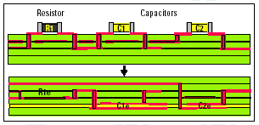

Figure 1: Passive components, once confined to the board surface (top), can now be embedded in a substrate (bottom). Capacitors can be planar or singulated; resistors are singulated [4].

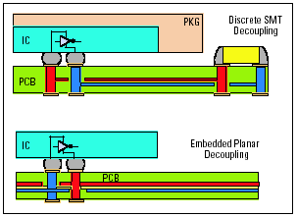
Figure 2: A power and ground plane pairing can create a capacitance of 250 nF, eliminating 30 to 40% of the surface mount decoupling capacitors from a board [4].

The advanced electronics systems being designed and built today require greater component density for increased functionality. They also demand lower equivalent series inductance for increased speed as well as overall control of parametric resistances, capacitances, and inductances that produce electromagnetic interference. Although discrete component size reduction will continue, this can only address the first driver of integration – component density. Even on this count, size reduction provides diminishing returns now that the leading edge has reached the 0201 case size. At this point, the circuit board area required for the solder pads and the “keep-out zone” around the part become factors. In addition, the handling and testing of extremely small individual components can introduce reliability problems. The other drivers such as lower ESL and parasitics become more difficult with the part size reduction.

Several technical solutions are being developed for passive integration. Some integration is actually occurring on the ASIC die in the redistribution layer for flip-chip devices where low-value inductors have been incorporated. Low-temperature cofired-ceramic (LTCC) solutions are available for some RF functions. Another method is to bury resistors, capacitors and inductors in advanced printed wiring boards (PWBs) and remove the SMD devices.
Thin-film technology has a long history of discrete, ultra-tight tolerance capacitors, inductors, and fuses. Recently a couple of thin-film fabs for passive integration began operating [6]. Thin-film technology excels where precision, tight-tolerance, low-inductance, controlled parasitic parameters and component density are required.

State of the Technology

Comparison between embedded passives and discrete passives
Today, the generic single board computer is generally composed of 5% integrated circuits, 4% connectors, 40% capacitors, 33% resistors and 18% miscellaneous parts [7]. Clearly resistors and capacitors are the majority of components on any generic PCB. The target is to reduce the number of SMT resistors from 33% of the total components to 10% or less, increase the yield, while allowing designers better signals and more surface real estate [7]. It is easy to obtain some obvious advantages that embedded passives have over discrete passives. They are size, weight, cost and performance. When the number of passive components is large, the cost of assembly can be quite large, including purchase, stocking, placement, test and repair. But for embedded passives, a parallel process can reduce the cost [7]. Surface mount resistors and capacitors have inherent parasitic functionalities, due to their geometries. Embedded passives can reduce or eliminate the parasitics associated with the current passive packages. There are also some intangible benefits for embedded passives; such as improved wireability, higher reliability, and reduction in part numbers, higher throughput in manufacturing assembly and increased yield in manufacturing assembly. Very thin buried power and ground planes can also be used to reduce parasitic inductance from copper traces. Some designers are contemplating using these power planes to replace chip capacitors completely [6].

Advantages
Embedded resistors and capacitors (for the PCB industry) are formed within a plane of circuitry using standard subtractive print and etch circuit board processing. The product can be processed by virtually any printed circuit board manufacturer using conventional processing equipment and chemistries. The LTCC version is likewise similarly easy to apply to the technology by using materials typically employed by the ceramic industry. Advantages of using embedded passives include:

Increased Active Circuit Density
- Replace discrete resistors and capacitors
- Build resistors on a board surface or inside a multilayer circuit board
- Reduction of circuit board size
- Weight savings
- Convert double sided SMT to single sided SMT

Improved Electrical Performance
- Reduce signal path to resistors and capacitors
- Provide low inductance
- Improve signal integrity
- Reduce surface EMI
- High density of lines throughout the part

Improved Reliability
- Elimination of solder joints
- Increase loaded board testability
- Reduced number of through holes and vias
- Simplified rework
- Good heat transfer ability
Reduced costs
- Elimination of discrete resistors and their attendant costs
- Reduced rework
- Reduced board size
- Increased board yield

Disadvantages

On the other hand, embedded passives have limits too. Using today’s technology, they cannot provide a wide range of resistor values, and tight tolerances that are needed on their values. This also exists for embedded capacitors. An additional problem is that even simple engineering changes can not be made to an embedded passive substrate. Therefore consistent and rapid turnaround of prototype designs is needed for fabricators [7]. Table 3 is a detailed comparison from some actual examples.

Table 3: Comparison between embedded passives and discrete passives [7]

 | Embedded passives | Discrete passives
Overall cost | Low | High
Circuit board costs | Low | High
Manufacturing cost | Low | High
Rework costs | Low | High
Board area consumed | Small | Large
Machine set-up time | Fast | Long
Yield | High | Low
Electrical performance (especially at high frequency) | Better | Good
Components costs | High | Low
Materials costs | High | Low
Design/development | Slow | Fast
Requiring designer training | More | Less
Time to market | Long | Fast
Design flexibility | Little | Large
Risk | High | Low

The above table was an attempt by the referenced author to compare embedded technologies to discrete technologies. It in no way covers all possible combinations of technologies, costs and testability. It is, however, a good attempt to qualitatively compare the two assembly technologies. In some cases categories overlap and seem to confound the ratings. For example, the table has rework and manufacturing costs of embedded passives as “low” but other costs that are “high” such as materials and components cost. The author was most likely trying to illustrate that once the materials and design are set, the manufacturing and other costs associated with assembly are small for the passives portion of the board. Likewise, with the design flexibility of embedded technologies being “little” translates to the overall risk of the design being listed as high because if the passive values are incorrect, the board will have to be scrapped. Discrete component values (in a non embedded design) can easily be changed for a design modification which makes the design flexibility “large” and correspondingly the risk is rated as “low” for a particular design.

Applications
Over the years there have been numerous applications utilizing embedded passives technology. Embedded resistors were developed nearly 30 years ago but have become main-stream with the other technologies in more recent years [1]. The following list is a compiled listing of applications covering all major electronic markets. The list is not meant to be all inclusive but rather to give an idea of the applications that have utilized embedded passives [1, 11, 13].

Computers
- Supercomputers
- Mainframes
- Parallel Processors
- Servers
- Workstations
- Add-on and peripheral cards
- PC cards
- IC cards
Telecommunications
- Cellular bay stations
- ATM switching systems
- Portable communications equipment
- Sonet Multiplexers
Instrumentation & Test Equipment
- Loaded board testers
- Logic analyzers
- IC probe cards
- Burn-in boards
- Interface cards
Military & Aerospace
- Satellites
- Antennas
- Radar systems
- Mil-spec computers
- Radomes
Consumer & Automotive
- Potentiometers
- Actuator circuits
- Heater elements

Producibility and Manufacturability Issues
Just as in the early stages of surface mount component development, embedded passive components are a fairly new technology and there are several inhibitors that keep embedded passives from reaching their market potential. They are:
- Need to demonstrate the technical viability of integral substrates, including materials, processes, design and test system;
- Need to demonstrate the value or economic justification for substituting discrete capacitor and resistors with embedded technology;
- Potential delay to the product development cycle. These passives are usually designed in the final stages of a product. The economic impact of a product delay could easily out weigh any cost saving in size reduction or conversion costs;
- Embedded passives reduce engineering and manufacturing flexibility. The ability to apply engineering changes to an integral substrate without delaying the schedule is critical;
- Lack of availability from multiple suppliers;
- Industry standards are required to capture the true market potential for this technology.

Resistors
Embedded resistors are technically feasible and have demonstrated their capability to replace a large number of low value (10,000 ohms and under) resistors with a tolerance of plus or minus 12% [1]. Therefore, the greatest challenges to feasible embedded resistors are [7]:
- Resistor tolerance and sheet resistivity: Both resistivity and thickness tolerances are goals that must be met by resistor materials suitable for resistivity required for widespread applications. Epoxy-based materials can have high resistivity but have poor tolerance and poor stability over time.
- Yields: Yield loss per device must be extremely small because embedded resistors cannot be repaired.
- Rapid prototyping: The turnaround time for a revision of resistor values and placement must be fast.
- Cost: Since most capacitors and resistors cost less than half a cent, it will be a challenge to make the new materials and processes cheap enough to reduce the overall cost.
- Design capability: A new family of design software is needed that allows engineers to simultaneously design the embedded components and the interconnection substrate. The CAD system must be able to determine the parasitics produced by metal adjacencies and back-annotate the schematic with these parasitics.
- Test capability: Bare board electrical testing is needed to verify embedded capacitance, inductance and resistance and frequency response.

Capacitors
Usually, there are more capacitors than resistors per system. However, capacitors come in more flavors (ceramic, tantalum, aluminum, films) and are much more sensitive to their environment than resistors (e.g. frequency dependency, board resonance). They also serve a wide variety of functions (e.g. decoupling, by-pass, tuning, filtering, converting, protecting). This complicates matters since the economic justification for integral passives requires the removal of large quantities of SMT devices. The market for embedded capacitors is not just the replacement of decoupling capacitors but the replacement of low value ceramic chip capacitors (<1000pF) used for decoupling, bypass and other functions [7].

Present Implementation - Power Plane Applications for Buried Capacitance
The largest application for PCB buried capacitance is in power and ground plane designs for high end microprocessors [6]. Power supply design has recently received increased attention because microprocessor voltages are dropping to improve switching speed while, simultaneously, power consumption is increasing to support more functionality. Figure 3 shows a typical power bus design.

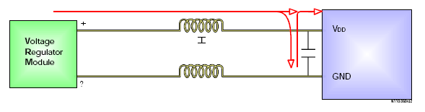
Figure 3: A representation of a typical power bus design [6].

Parasitic, stray, or series inductance develops between the power supply and the load. The larger the area enclosed by the current loop (the circumference of the power and ground path), the higher the inductance. This inductance is insignificant at low frequency and low power designs, but at higher frequencies and at high currents it becomes a serious concern because of the voltage drop over this stray impedance.

Current designs incorporate ceramic chip capacitors that are placed close to the processor to provide a reservoir of charge for high frequency currents. An arrangement such as the one described effectively bypasses the stray inductance on the power line. However, the equivalent series resistance (ESR) and the equivalent series inductance (ESL) of chip capacitors are beginning to limit their usefulness because the impedance of the ceramic capacitors at high frequencies is largely determined by ESR and ESL. Figure 4 shows a typical impedance curve as a function of frequency for a multilayer chip capacitor. Note that at high frequencies, the impedance rises past resonance and the circuit is inductance dominated. Newer low ESL capacitors, as well as paralleled chip capacitors are currently being used to solve high frequency power supply design problems.

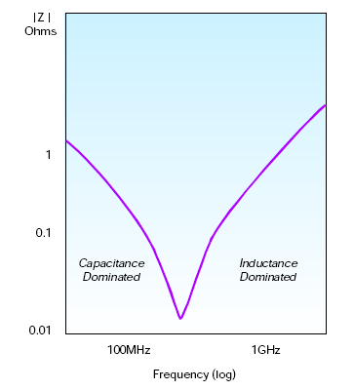
Figure 4: An illustration of the effect of impedance of a multilayer chip capacitor used in a circuit with a microprocessor [6].

Very thin buried power and ground planes can also be used to reduce parasitic inductance from copper traces [6]. It can be shown through electromagnetic field theory that the thickness of the dielectric is directly proportional to the stray inductance from the energy source (i.e, supply, chip capacitors) to the microprocessor. Some designers are contemplating using these power planes to replace chip capacitors completely [6].

Future Implementations – Replacement of Chip Capacitors
If embedded capacitor technology is to replace close to half of the low value ceramic chip capacitors, some technological break-throughs will need to occur over the next several years. For capacitors of 100pF to 0.01μF, a higher dielectric constant material, additional area, and additional board layer become necessary. The goal will be to obtain the highest dielectric constant, with the thinnest film, consistent with yield and process-ability. The greatest challenges to feasible, high capacitance embedded capacitors are [7]:
- Design and test capabilities: The same requirements for design and test capabilities needed for embedded resistors are needed for embedded capacitors.
- Thin, low cost and high dielectric constant material: A higher dielectric constant material, additional area and additional board layers are necessary for implementing capacitors having a value greater than 0.02μF. For most products this value range may include 40% of the total capacitors used. A dielectric separation of wiring layers of 5 microns in a HDI technology board is needed to make capacitors up to approximately 300pF useful without dielectric change.
- Defect free manufacturing: The manufacturing processes for these embedded capacitors should not substantially reduce board yield.
- Planar constructions and surfaces: The thinner layers which will be required for the desired capacivity dictate planar surfaces.

The need for increased product miniaturization and increased product function will eventually drive electronic designers to increase their use of embedded passive components. Embedded passives offer increased component density beyond the physical capability of discrete-like devices. They also offer high product reliability and eventually lower overall system costs via decreased conversion costs.

Vendors

Major Resistor and Capacitor PCB Materials
“Ohmega-Ply” was developed in the early ’70s. Available from Ohmega Technologies as a laminate, it is constructed with virtually any dielectric. As shown in Figure 5, it is made by depositing a thin film of nickel phosphorous to one side of copper foil, then bonding that foil (NiP inward) to a specified dielectric material clad with copper foil on the other side. That product, Ohmega-Ply® RCM (Resistor-Conductor Material) is then laminated to a dielectric material and subtractively processed to produce planar resistors. Because of its thin film nature (approximately 0.1 - 0.4 micron thick), it can be buried within layers without increasing the thickness of the board or occupying any surface space like discrete or axial-lead resistors. “Ohmega-Ply” is available in sheet resistances of 25, 50, and 100Ω/ with a tolerance of +/-5%. It is also available as 350Ω/ but with a tolerance of +/-10%. The quoted values are for sheet resistance tolerances of the raw material. When they are defined as discrete resistors, the processing tolerance must be considered. As such, the final untrimmed resistor tolerances will be in the range of 15 to 20%. The material is also laser trimmable to 2 to 3%. The material has a history of reliability [1]. It is limited by its resistance range and the presence of nickel on the bottom of the conductor traces, which may cause losses in high-speed applications [10].

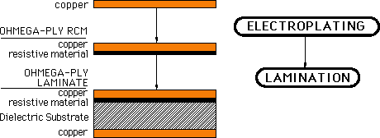

Figure 5: Ohmega-Ply Construction representation [1].

MacDermid has a thin-film plated resistor that can be selectively applied directly to inner layers. Merix is working with MacDermid to integrate this process into PCB manufacturing. The process, called “M-Pass,” shown in Figure 6, is similar to “Ohmega-Ply” in that it uses nickel phosphorous as the resistive element. “M-Pass,” however, does not leave a deposit of the resistive material under the copper traces. The resistor is selectively deposited using a modified electroless process [11]. The MacDermid advanced R&D team has been working closely with industry consortia to develop the M-Pass™ "embedded passive" process. The outcome of this effort is a unique, patent-pending technology designed to replace discrete surface mount resistors. Using the deposition of resistive metals, this innovative technology is designed to meet a wide range of ohms-per-square resistor requirements. To commercialize this process, MacDermid provides a comprehensive support program, including products used in surface preparation, catalysis, and resistor deposition. Compatibility with laser trimming allows achievement of exact resistance values. And, equipment costs can be minimal as the M-Pass™ process can utilize currently available processing equipment [12].

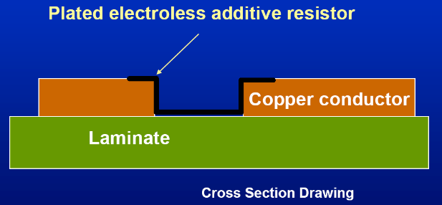

Figure 6: MacDermid M-Pass additive process construction representation [12].

Motorola, in partnership with Vantico AG, developed “ProbelecT CFP” (ceramic-filled photodielectric) mezzanine structure for embedded capacitance [13], and is shown in Figures 7 and 8. The term mezzanine is used to emphasize the fact these capacitors are formed in an intermediate layer between a core layer of a PWB and an HDI layer of a PWB. The capacitor, therefore, does not consume any real estate on the HDI layer except for a microvia that is dropped to access the top capacitor electrode. These capacitors are formed by a fairly conventional process of coating, laminating, printing, etching, and developing, followed by the application of a microvia to connect the capacitor to layer 1. Key to this process is the photosensitive dielectric and the ability to apply it in controlled thickness to the smooth solid-copper surface of the sub-core (layer 3). The capacitance density of this process is about 10 nF/in².

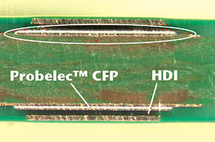

Figure 7: A thin layer of ProbelecT CFP (Ceramic Filled Photo-dielectric) is used to form parallel plate capacitor structures. The capacitors are completely buried under the HDI layer, freeing the HDI layer for circuit routing or for surface mount components [13].

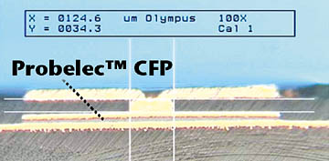

Figure 8: The top electrode of the mezzanine capacitor is accessed through a microvia. Discrete embedded capacitors ranging in value from 1 to 500 pico-farads (pF) can be fabricated with the technology [13].

“SIMOV” (“Siemens Multiple Overlay Vias”) is a structure combining embedded “BC 2000” capacitance layers with organic thick-film screen-printed resistors and microvias [14]. This was a development of Inboard (now co-owned by Siemens and Sanmina-SCI). The structure, shown in Figure 9, works as follows: A multilayer sub-composite core is fabricated incorporating “BC 2000” layers. The outer layer core surfaces are printed and etched with resistor termination patterns. The polymer thick-film resistor pattern is screen-printed in the appropriate locations and cured. A laser-formed microvia structure is built outward from the resistor layer(s), incorporating one or two microvia layers, depending on the routing requirements. (This is also described by Siemens as an “Integrated Passive Microvia Structure.”) Microvias may be constructed with FR-4, BT resin, or resin-coated copper. The integrated passive layers consist of up to two capacitor cores using thin FR-4 (“BC 2000”) and up to two resistor layers with values ranging from 20 to 470,000 Ω with resistance tolerance of +/-25%. Due to cost, the “SIMOV” process does not trim resistors, i.e., specific applications must be compatible with the high resistance tolerance.

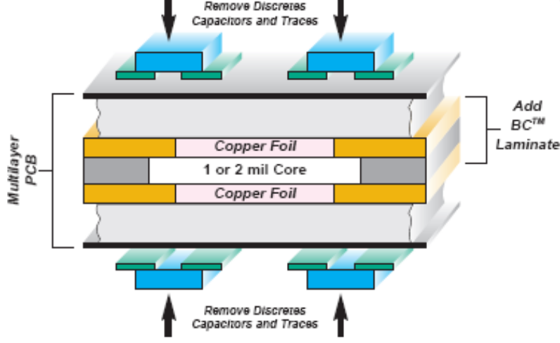

Figure 9: Siemens Multiple Overlay Vias structure combining embedded “BC 2000” capacitance layers with organic thick-film screen-printed resistors and microvias [14, 15].

DuPont™ Interra™ is a family of products designed to meet the challenges of the evolution occurring in the electronics world. DuPont is moving rapidly into this growing market with three product lines under the Interra™ trademark. Embedded planar products are designed to function as planar capacitors in printed circuit boards. Interra™ HK laminates offer thinness, flexibility, and durability, producing reduced impedance and reduced EMI and embedded capacitance. Interra™ offers a family of screen printable polyimide thick film paste products processable at standard PWB temperatures. This product permits screen printing of resistors and capacitors to allow embedding of discrete components within the typical infrastructure of a PCB fabricator. Interra™ also offers a family of ceramic based screen printable thick film paste products in the broadest range of resistance and capacitance available on the market. These products enable embedding of large value capacitors and laser trimmable precise resistors in an organic PWB [16]. A typical structure is shown in Figure 10.

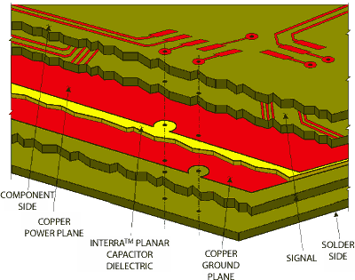

Figure 10: Construction representation of Dupont’s Interra Capacitor Construction [16].

In parallel with the DuPont and MacDermid research, 3M has been working aggressively through the Advanced Embedded Passive Technology consortium (AEPT) and prior consortia on a planar capacitance material. 3M’s material, “C-Ply,” shown in Figure 11, is an extremely thin laminate comprised of copper foil on the outside separated by a barium titanate-filled epoxy resin dielectric. With a dielectric constant in the range of 14 to 18 and thickness from 0.00016 to 0.001 inches, capacitance densities are achievable from 5 to 30 nF/in ². When used as "power" and "ground" layers in a multilayer PCB, this material effectively becomes a decoupling capacitor inside the board, allowing for the elimination of many discrete surface-mount capacitors [17].

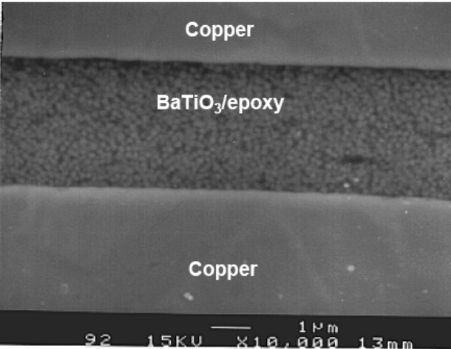

Figure 11: SEM photograph illustrating the construction of 3M’s C-Ply Material [17]

Direct Writing describes any technique or process capable of depositing, dispensing, or processing (including removal of) different types of materials over various surfaces following a preset computer-generated pattern or layout [18]. With funding from the Defense Advance Research Projects Agency (DARPA), Potomac Photonics is developing and commercializing the use of direct-write laser deposition, a recent advancement in deposition technology. Tools and techniques are being developed that permit direct patterning of metal, dielectric, resistor and ferrite materials onto virtually any substrate [19]. As shown in Figure 12, the goal is to produce a machine that can fabricate custom microminiature circuit boards, complete with conductive traces, resistors, capacitors and inductors, as well as blind and through-vias. This is accomplished by using a mask-less tool in a normal environment for prototyping and/or production applications.

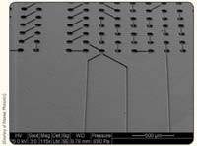

Figure 12: SEM photograph of a Laser Patterned Substrate [18].

Major Resistor and Capacitor LTCC Materials
LTCC is the technology of choice for passive integration of RF modules. However, it is perceived to have less than perfect consistency by many users [8]. LTCC’s biggest shortcoming has been that it shrinks 10%-20% during the firing process. Hereaus-Cermalloy recently produced a “zero-shrink” raw material system for LTCC substrate manufacturers, which may solve the shrinkage problem and someday tilt the odds strongly in favor of LTCC [20].

The largest suppliers of LTCC components and modules to the commercial market are the traditional multi-layer co-fire ceramic (MLCC) capacitor manufacturers (Murata, Kyocera, TDK, Taiyo Yuden, Panasonic, EPCOS) and the traditional resistor network manufacturers (such as CTS Corporation, C-Mac, and MMC). MLCC manufacturers in Taiwan and Korea are also investing in LTCC capabilities.

The supply chain for LTCC has become complex. Raw material suppliers, such as Du Pont, Ferro and Hereaus, are competing against in-house captive raw material development by such companies as Murata and Kyocera. An example of multi-layer capacitors manufactured using the Ferro material is shown in Figure13. Substrate manufacturing is done by still more companies, such as Sumitomo, CTS, Kyocera and Sorep. Hitachi Metals and Ericcson (and others) provide module assembly services. Many companies, including Motorola and Lucent, have placed their brand name on LTCC products made by other module manufacturers, while other manufacturers, most notably Robert Bosch, have captive LTCC production capabilities.

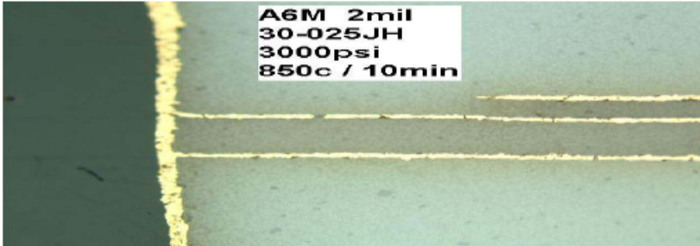
Figure 13: Multi-Layer Capacitors Made with Ferro A6M 2 mil Tape [21]

Thin Film Suppliers
Thin film on silicon, is considered expensive and most providers are focusing on providing component solutions rather than offer manufacturing services [4]. The majority of structures manufactured using thin film on silicon primarily represent a class of passive components called integrated passive devices (IPD) where resistor networks are manufactured on chips, for example. This document’s main focus is to cover the embedded passives technology where the passives are embedded into an interconnect substrate such as a ceramic, PWB, silicon or flex. It is important, however to show some of the work being done in the area of IPDs as some of the technology will likely spill over into the embedded passives arena.

The unique process from Micro Analog Systems (MAS) allows the creation of custom passive networks of unprecedented small size in a process similar to manufacturing ICs. One very important application for wafer CSPs is integrated passives. Prismark predicts that this will in fact be the major wafer CSP application in terms of die count [6]. "Die" is a somewhat euphemistic description since the "die" in question may be a combination of diodes and capacitors on silicon, thin- film on glass, or thin-film on silicon. However, each is recognizable as a flip-chip-type device even if the "wafer" is a 200mm x 300mm sheet of glass. The principal advantages of wafer CSP technology for passives are low cost and small physical footprint. There are many companies that are active in this area: Intarsia, Bourns, Murata, STMicro, International Rectifier, and California Micro Devices.

Integral Wave Technology (IWT), a spin-off company from the University of Arkansas, has entered the embedded passives arena as a thin film company. They have capabilities to deposit thin-film resistor, capacitor and inductors onto silicon and organic flex substrates. Figure 14 illustrates the structure of a floating plate capacitor fabricated by IWT using a three photo mask process. The capacitors vary in size from 1x 10⁻⁴ cm² to 2.9 cm² and have capacitance values ranging from 1 pF to 41 nF, respectively [22]. The base material is a flexible polyimide sheet, 50μm thick. The bottom plate of the capacitor is a sputtered blanket of 1μm thick copper. A 0.5μm thick layer of tantalum oxide is reactively sputtered onto the lower electrode. Reactive sputtering of the dielectric is performed at 5 mT using a tantalum target in an argon and oxygen (partial pressure of 1 mT) ambient. To achieve high capacitance values, it is desirable to have a thin dielectric layer. On the other hand, the thickness of the dielectric must be adequate for proper step coverage of the bottom plate of the capacitor to prevent electrical shorting of the electrodes.

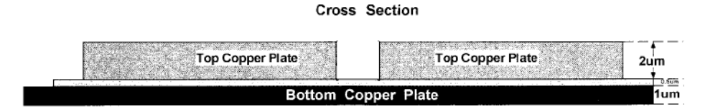

Figure 14: Structure of the tantalum oxide floating plate capacitor [23].

General Quality and Reliability Concerns
The primary driver for replacing SMT resistors with embedded resistors is faster bus speeds (100 MHz +). As the bus speeds exceed 100 MHz the number of resistors required to manage these systems becomes quite large. Embedded resistors reduce conversion costs, improve performance, save valuable board area and improve reliability by elimination of hundreds of solder joints required for SMT resistors.

Reliability and history are the two primary drivers behind thick-film ceramics for embedded resistors and capacitors. Thick-film ceramics are reliable because of the inherent stability of the inorganic materials used, including their resistance to moisture, temperature, thermal shock, and electrostatic discharge. They have been in production in the ceramic passive component and ceramic hybrid industries for many years. Embedding them in PCBs involves merging a pair of time-proven technologies: thick-film processes and multilayer processes. Conventional PCB methods are used to apply ceramic materials to copper foil. The process control has proven to be very manageable and not significantly unlike application to ceramic substrates. Standard PCB manufacturing can precisely reproduce conductor images in virtually unlimited geometries. The merger of ceramic thick-film and PCB technologies occurs when the foil carrying ceramic components is laminated into a multi-layer board (MLB) structure and the component termination is formed using print-and-etch methods. These processes are very similar to conventional MLB lamination and imaging processes and are easily controlled and managed.

The National Center for Manufacturing Sciences (NCMS) Embedded Decoupling Capacitance (EDC) Project concentrated on embedding a distributed capacitance layer within a circuit board. Both commercially available materials and developmental materials were evaluated for compatibility with circuit board fabrication including fabrication processes, materials properties, reliability, and the ability to perform the decoupling function. These objectives were achieved and the project has thus taken some of the first steps towards the realization of embedded capacitance in organic substrates. Additional work needs to be done to fully commercialize and transfer the technology to the industry at large [24].

Three Embedded Passives technologies developed by the Advanced Embedded Passives Technology (AEPT) consortium are based on ceramic thick-films developed by DuPont, plated materials from MacDermid, and laminates from 3M. Process engineering staff at Coretec Denver (formerly SAS Circuits) has been working with DuPont on processes to incorporate the foil into a PCB structure [25].

Future of Integrated Passives
All embedded approaches suffer from tolerance limitations when compared to discretes. Because the tolerance of discrete chip resistors is typically in the 1% range, exposing a design to possible 15% variations is not an appealing proposition to most designers [6]. Discrete passive solutions are considered the lowest cost solution but they comprise a significant portion of the design’s total cost. Embedding the passive components in a design could reduce the overall design costs. However, should the embedded passive components require trimming to get to the same tolerance point, the total conversion cost comparisons may be moot. Embedded passive components therefore will need to solve the tolerance issue before they can become widely used for discrete component replacements.

The industry transition to smaller discrete surface mount sizes indicates that smaller packages become main stream about every five years [6]. 0402 device usage has accelerated and are becoming widespread. 0201 discrete devices have slowly become more popular in high-density systems. Prismark predicted that the same historical trends will continue in discrete packages [6]. They also forecasted that embedded passives (for use in replacing discretes) are still a few years away as shown in Figure 15.

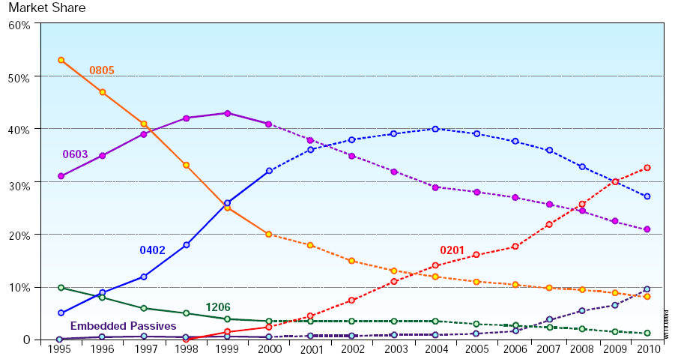

Figure15: Estimate of market share of various discrete package sizes and embedded passives [6].
Cost in the commercial world will drive the integration of embedded passives into systems. In many commercial applications, it costs more to place a chip resistor than to buy it. Six-and-a-half percent of the average finished electronic product is component placement cost, 55 percent of which is discrete passives [27]. Widespread implementation of embedded passives will require additional materials research and a cost-effective infrastructure for design, manufacture and test. Embedded passive resistors are planar resistive elements incorporated within the substrate, by what is considered by many, to be a mature technology. Significant progress has resulted in the development of several new materials options that enable more functionality and flexibility in the application of integral substrates. Some critical areas for further development are: developing high yielding processes, microvia technology, developing higher power densities, prototyping of integral substrates, design systems, as well as test and trim.

High yielding processes
Many new materials under consideration require processes that are new to circuit board fabricators. Some materials require processes that are not currently being done at all, such as laser trim on FR-4. Well-defined areas, thickness control, and achieving tight tolerances are critical needs of the manufacturing process. Some progress has been made by the AEPT consortium, but additional progress is needed for materials to become cost and performance competitive [26]. The selection of passive components available to design engineers has greatly enlarged in the last decade. Maturing technologies as well as size and performance demands have enabled arrays and Integrated Passive Devices (IPDs) to account for a growing position of the passives used in modern electronics. The selection criteria for passive components are given in Table 5 [5].

Table 4: Passive Component Selection Criteria [5]

 | Discretes | Arrays  Networks | IPDs | Embedded Passives
Cost | Good – The benchmark for all other technologies | Better - when local densities have 4 or 8 devices close together | Better - when high local densities are Application specific | Better – when average component density are above 3 devices / cm2 Cost is panel size dependent
Size | Good – board area required for each and every device | Better – 50% and greater board area savings over discretes | Better - Application specific IPDs can replace dozens of components | Best – No Surface board area required since the devices are buried
Performance | Good - Self resonates at low frequencies | Good – Self resonates at low frequencies | Better – Qualified out to several dozens of components | Best – Ideal components when buried underneath the integrated circuit (IC) it serves due mainly to decreased lead length and avoidance of the inductance of the connection loops
Reliability | Good – Heavy use of solder joints | Better - Reduces solder joints slightly | Better – Significantly reduced solder joints | Good – Elimination of solder joints but not characterized for inherent reliability yet
Flexibility | Best – most flexible for both design and manufacturing | Better than IPDs and Integral | Better than Integral | Good – Requires modeling and simulation
Time to Market | Best – Flexibility allows quick turns | Better – Simple Quad and Octal arrays can be designed in quickly | Good – IPDs require additional design iterations for wire ability | Fair – Most board shops require at least 5 – 7 days to build an embedded passives board
Availability | Best – Highly available from multiple sources | Better – Standard parts from multiple suppliers | Better – Non-standard parts from multiple suppliers | Fair – Few suppliers
Values | Best – All values available at commodity prices | Better – Thick film arrays offer high values | Good – Thin films have limited capacitor values | Good – Currently limited to low values
Tolerances | Best – Tight tolerances available at commodity prices | Better – Both offer tight tolerances | Better – Thin films offer tight tolerances | Good – Loose tolerance (5-10%)

Microvia technology
High-density interconnect (HDI) substrates, including microvias, are an enabling technology for embedded passive components and array packaging. High-speed design becomes useful when embedded passives are used in conjunction with microvias to obtain the lowest possible inductance.

Integral substrates (almost by definition) are dependent upon the development and implementation of HDI (microvia) technology. HDI is a prerequisite for embedded components. Appropriate CAD/CAM tools are not widely in use but should see wide spread availability soon. The analysis for distributed planar capacitance is given in Table 5. Embedded Passive Technology will cause a major shift in responsibilities from the custom manufacture/assembler to the PWB fabricators. The PWB fabricator will now be responsible for delivering a board with correct passive values as well as electrical performance. The fabricators will have to develop new processes for the construction or embedding technologies required for the new passives.

Table 5: Gap Analysis for Embedded Resistors and Distributed Planar Capacitors [5].

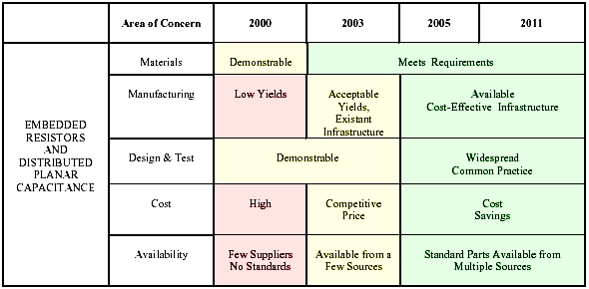

Microvias today are used in threshold and state-of-the-art products, such as high-end laptop computers, video recorders, high-end cell phones and in special niche markets. These products are being produced with >75 μm lines and spaces. While microvia technology is growing in product usage in the electronics industry, volume manufacturing is largely confined to the Pacific Rim, primarily Japan. Although high-density interconnect (HDI) boards with microvias are available from several North American suppliers, more than 90 percent of the production volumes still come from the Far East. As microvia technology continues to improve in terms of performance and cost metrics, it will find its way into broader product applications. As this trend occurs, regional supply chains without microvia volume capability could see a shrinking PCB market.

Higher power densities
The power density of the available materials is rated at 10 W/in.² or more, which is adequate in the near term. However, as densities increase, this rating may become inadequate.

Prototyping of integral substrates
The turnaround time for a revision of resistor values and placement is three days. This factor is closely tied to the ability to design with greater accuracy. This problem can be overcome by only targeting, for example, the 40 percent of the passive devices whose design value are relatively stable and do not have any propensity to change.

There is on-going research in the area of resistor and capacitor materials, and if some of the projections are correct, the capacitance values for 2011 could be 100 times greater than now [5]. It all has to do with whether the dielectric must be an epoxy with ceramic loading, or if a true ceramic-like dielectric that can be deposited on copper foil. Table 6 shows the projected possibilities.

Table 6: Expected Ranges for Embedded Passive Layers [5]

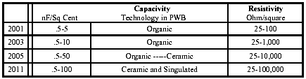
Year

Use of Embedded Passives in Space Applications

NASA began to evaluate the materials sets used in both Organic and Inorganic board systems [2]. The results of the evaluation suggest that circuit boards should be evaluated with active circuits and stressed to NASA accelerated environmental test levels so that future projects can make a determination as to whether this technology is advantageous to their design. Other evaluations have also been performed by NASA. Several resistors were embedded into conventional PCBs and evaluated down to LN₂ temperatures [28]. The tests indicate that the technology can be implemented with no problems noted. Transformers have been designed inside a conventional PCB and initial evaluations have taken place [28]. The direct write technology using a laser to place material selectively has been evaluated with future evaluations planned [28].

The European Space Agency Mars Express mission launched in 2003 utilized Ohmega-Ply® embedded resistor material manufactured by Ohmega Technologies, Inc. [1]. Ohmega-Ply was supplied for use by the Leicester University Beagle 2 team in a number of Beagle 2 instrument circuit boards. The Beagle 2 project consisted of a consortium lead by the Open University. More information on the Beagle 2 can be found at the following web sites: Open University Beagle2 http://www.beagle2.com/index.htm Leicester University Beagle2 http://www.src.le.ac.uk/projects/beagle2/index.html.

Even though the Beagle 2 Lander was not a successful part of the Mars Express Mission, it can be seen that embedded passives are beginning to be utilized for Space Missions where PC Board size is a factor. Figures 16 - 19 illustrate some of the key aspects of the design.

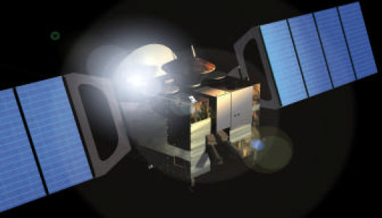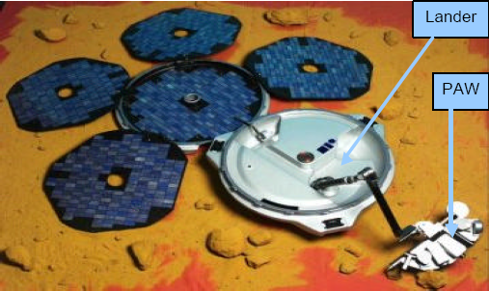
Figure 16*: Mars Express orbiter. Figure 17*: Beagle 2 Lander with instruments
on its robotic arm.

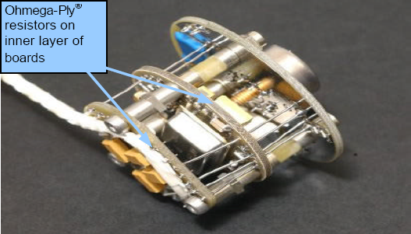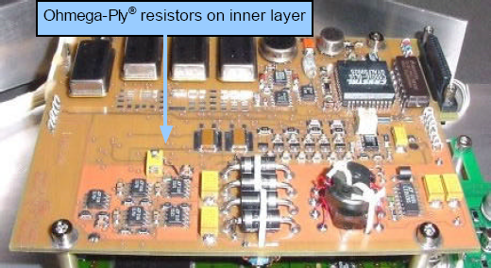
Figure 18*: X-Ray Spectrometer (XRS) with Figure 19*: Ohmega-Ply® resistors in electronic
Ohmega-Ply® resistors. lander PC board.
*All images all Rights Reserved Beagle 2 [1].

The various space mission environments (such as Low-Earth-Orbit, Geo-synchronous orbit and Mars/Deep Space) are not expected to be show-stoppers for Embedded Passives. Stresses such as temperature cycling, vibration, mechanical and thermal shock will not present any problems for the embedded materials discussed in this report as the materials are integral with the organic and inorganic substrate materials and processes. Also, the passive materials are comprised of metals and inorganic materials which behave consistently over temperature. The effects of radiation on the passives components (charging and total dose, for example) are not expected to present problems, but have not been well characterized to date. In most cases the embedded passive components should behave similarly to the discrete passives used in standard board assemblies.

Recommendations for NASA
All of the work studied to data at NASA has been on either test coupons [2] or on a trial basis [28]. The next step would be to evaluate the resistor and capacitor materials in a standard 3U (minimum size), 6U, 9U or 12U card with a capacitor layer used as a large decoupling capacitor to eliminate surface mount capacitors. A large multilayer (minimum of 6 layers) would more closely simulate a typical use. The electrical performance should be characterized and the board materials should be environmentally stressed to evaluate long term compatibility and integrity. It is recommended that this type of board be evaluated in a PCB format and a LTCC format for high/RF applications. The AEPT test vehicles (discussed in this report) are currently being “manufactured” at NAVSEA Crane Division under the Emerging Critical Interconnect Technology (ECIT) Project. The purpose of the PCB builds is to demonstrate the capability at NAVSEA Crane to support industry and the military. PCBs are available to certain qualified agencies for evaluation. Where possible, NASA should participate with this effort.

References
[1] Ohmega Technologies web-site, http://www.ohmega.com/Technology.html
[2] D. Ator and R. D. Gerke, “Embedded Passives Technology, Final Testing Report FY’04 Work”, November 2004, http://nepp.nasa.gov
[3] Rector, J., Economic and Technical Viability of Integral Passives, 1998, IEEE Electronic Components & Technology Conference.
[4] NEMI. 2000 Roadmap. Herndon, VA: National Electronics Manufacturing Initiative.
[5] Joseph Dougherty, J. Galvagni, L. Marcanti, P. Sanborn, R. Charbonneau, and R. Sheffield, “The NEMI Roadmap Perspective on Integrated Passives,” May 2001.
[6] Pushing the Shrinking Envelope, A Status Report on Embedded Passives in PCBs, Prismark Partners LLC, December 2000.
[7] Song, L., “Embedded Passive Components”, 2000.
[8] D. Zogbi, LTCC Components & Modules: The Newest Concept In Integration, September 9, 2002.
[9] Kyocera Electronics web-site, http://global.kyocera.com/prdct/semicon/ic_pkg/ltcc.html
[10] Don Cullen, B. Kline, G. Moderhock, and L. Gatewood, “Effects of Surface Finish on High Frequency Signal Loss Using Various Substrate Materials,” IPC Printed Circuits Expo, April 2001.
[11] Joseph D’Ambrisi, D. Fritz, and D. Sawoska, “Plated Embedded Resistors for High Speed Circuit Applications,” IPC Annual Meeting, October 2001.
[12] MacDermid Printed Circuits Technology web-site, http://www.macprintedcircuits.com/advanced
[13] John Savic, M. Zhang, A. Tungare, K. Noda, P. Tan, J. Herbert and W. Bauer, “Embedded Mezzanine Capacitor Technology for Printed Wiring Boards,” IPC Printed Circuits Expo, March 2002.
[14] HDI Simov Technologies.
[15] Sanmina website: http://www.sanmina-sci.com
[16] Dupont Electronics web-site, http://www.dupont.com/fcm/interra
[17] 3M Electronics web-site, http://www.3m.com/us/electronics_mfg/microelectronic_packaging/materials/index.jhtml
[18] D. Young, S. Sampath, B. Chichkov, and D.B. Chrisey, “The Future of Direct Writing in Electronics, Feb. 1, 2005, http://www.circuitree.com/CDA/ArticleInformation/coverstory/BNPCoverStoryItem/0,2135,142466,00.html
[19] Potomac Photonics website: http://www.potomac-laser.com/
[20] W. C. Heraeus web-site, http://www.wc-heraeus.com/wch2/dach/e_wch_home.nsf/$pages/news_heralock
[21] Henry, J., “The Effect of Gold Metallization on Dimensional Stability of A6M”, Ferro Electronic Materials Technical Report, May 10, 2001
[22] C. Morcan, S. S. Ang, T. G. Lenihan, L. W. Schaper, J. P. Parkerson, and W. D. Brown, “Electrical Characterization of Thin Film Integral Passive Devices on Polyimide-based Packaging Structures,” Int. J. Microcirc. Electron. Packag., Vol. 21, no. 4, pp. 306–315, 1998.
[23] Morcan G., Ang S. S., Lenihan T., Schaper, L. W. and Brown, W. D., “Characterization of Thin Film Tantalum Oxide Capacitors on Polyimide Substrates”, IEEE Transactions on Advanced Packaging, Vol. 22, No. 3, August 1999, pp. 499-509.
[24] R. Snogren, “Embedded Passives: The Next Revolution”, Emerging Technologies, PC Fab, November 2002, pp. 26 - 29.
[25] John Felten, R. Snogren, and J. Zhou, “Embedded Ceramic Resistors and Capacitors in PWB: Process and Performance”, IPC Annual Meeting, October 2001.
[26] AEPT. The Advanced Embedded Passives Technology project is being conducted by the National Center for Manufacturing Sciences; http://aept.ncms.org/ and http://www.ncms.org/.
[27] V. Biancomano, “Focus on EMI/RFI – Integrated Passives Go Chip-Scale”, Electronic Engineering Times, August 18, 2003, p. 65.
[28] Personal conversation with David Liu at Goddard Space Flight Center, June 17, 2005.

