Qualification of PEMs Using Board-level Testing

Alexander Teverovsky
QSS Group, Inc./Goddard Operations
Alexander.A.Teverovsky.1@gsfc.nasa.gov

Abstract
This paper describes low-cost alternatives to the product assurance system for Plastic Encapsulated Microcircuits (PEMs) described in the 311-INST-001 instructions, Revision A, PEMs section, June 2002 (referred to hereafter as 311-PEM). It might be applicable to projects working under extreme time and budget constraints and willing to accept a higher level of risk on their parts program activities (typically level 3+ projects).
The suggested qualification system is based on board-level functional testing of the parts and includes several standard elements of the qualification system, such as destructive physical analysis (DPA), special design evaluation, and innovative qualification methods. An example of such a new method, monitored temperature transients, which is based on the local heating technique, is described.

Background
Manufacturers of commercial and military or aerospace graded components employ different ideologies regarding quality and reliability issues of their products, which can be described as “produce-it-right” and “produce-it-to-rules plus test-it-right” approaches. Most PEM manufacturers rely on built-in reliability design and thorough process control, leaving testing and verification of quality and reliability of their product to the end users. For these reasons, use of PEMs in high reliability systems is always a risk, and the purpose of qualification and testing of PEMs is to mitigate these risks against known failure mechanisms in project-specific conditions.
A comprehensive quality assurance system for PEMs intended for space projects, as described in the Goddard Space Flight Center 311-PEM instructions, is extremely time and resource consuming, and for good reasons. The existing quality assurance system for PEMs requires full-scale electrical and stress testing of the parts and consists of several elements. Three most important elements are screening, environmental stress testing (or qualification), and DPA. The major elements of screening are electrical testing and burning-in (BI). The major elements of environmental stress testing (EST) are multiple temperature cycling, radiation testing, high temperature operational life test (HTOL), and highly accelerated stress test (HAST) in moisture environments. Figure 1 illustrates key procedures that are performed during qualification and screening of commercial-off-the-shelf (COTS) parts per 311-PEM instructions.

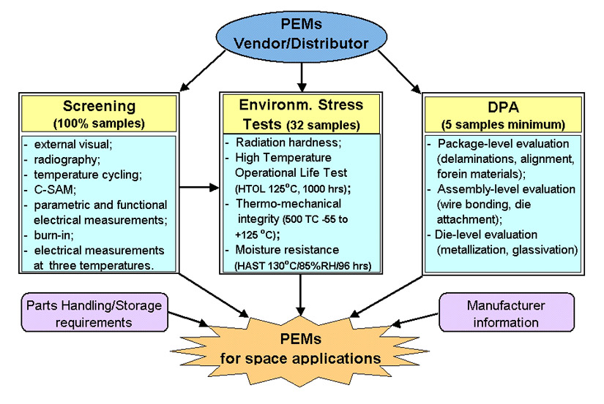
Figure 1. Simplified test flows for a traditional qualification system for PEMs.

The most cost and time consuming procedures in the traditional quality assurance system are electrical measurements, burn-in, and high temperature operational life testing. These types of tests are especially expensive for complex microcircuits such as microprocessors, memories, high speed/high resolution A/D and D/A converters, ASICs, etc. The cost of these procedures typically includes development of a test program for automatic test equipment (ATE) to measure characteristics and functioning of the parts, purchase of sophisticated sockets, design and manufacturing of burn-in/HTOL test boards, performing measurements, etc., and varies from $20K to $100K and higher for a lot of parts.
A premise for the alternative, low-cost strategy is to replace comprehensive but costly electrical measurements and stress testing of individual parts with evaluation of their operation and resistance to environmental stresses after assembly onto a board using board-level functional tests. Obviously, such a replacement cannot provide the level of confidence in the quality and reliability of the parts similar to the traditional qualification system, and it is aimed only at mitigating the risk of parts application in the project-specific conditions.
Typically the board-level testing is performed to evaluate quality and reliability of assemblies with components soldered onto printed circuit boards (PCB). Although recent studies have demonstrated that the level of assembly defects might exceed 0.1% [1], evaluation of solder joints and metallization interconnects in PCBs is out of the scope of this paper, which has the purpose of incorporating of the board-level testing into a qualification system for COTS PEMs.
In accepting a cost-effective risk-mitigation strategy for commercial parts, different notions should be considered and evaluated:
- It is generally assumed in the electronics industry that finding a fault at any stage in the process of system integration and use (component → board → system → field) costs approximately 10 times what it costs to find the same fault at the preceding stage [2]. Considering extensive testing and screening of systems for space applications, the rate of the cost increase at the final stages of the integration process or during mission can be much higher than 10. The cost of comprehensive testing should be weighed against the cost of possible failures during system integration and mission.
- A comprehensive electrical testing of complex ICs with a large number of functional test vectors can be performed only by the manufacturer or by a specialized test lab, might require dozens of hours of testing for one sample, and still might have a high probability of escaped defective parts. Use of specialized methods, like IDDQ test, might help to further reduce the probability for faulty parts to escape the screening.
- Recent studies have showed that for a “good quality lot” of PEMs, additional screening might not add value to the quality and reliability of the parts [3, 4]. Furthermore, there is a probability of damaging parts due to poor handling and possible ESD/EOS overstress during testing. In this situation it is conceivable to develop a risk mitigation strategy that would focus on the overall qualification of the lot and reduce to a minimal acceptable level screening of flight parts. Such a qualification might use only non-destructive inspection of the parts and functional testing after assembly onto a board as limited screening procedures. To compensate for the lack of screening, this system should effectively use other elements of the quality assurance system including destructive physical analysis, special design evaluation, and analysis of history of the parts. Positive results of these tests, inspections and analysis, together with manufacturer information and history of application of the parts, might provide valuable information regarding their quality and reliability and thus significantly mitigate risks of application of not-fully-screened parts for the project.
It should be noted that there is no generally accepted reliability evaluation system for commercial microcircuits that would be universally applicable in all cases. For this reason, qualification systems for PEMs should be developed according to the specific requirements of the project, thoughtfully using various elements of the 311-PEM instructions as applicable. The quality assurance system based on board-level testing should be worked out jointly by parts and system or design engineers considering complexity of the part, PCB, and budget limits. The decision regarding usage of board-level testing to screen and qualify PEMs should be made by a project at the earliest stages of planning and designing the instrument.

Board-level testing
To effectively use board-level testing for evaluation of a component, the design of the board circuit should comply with the following requirements and recommendations:
- The circuit and the application board should be designed for testing, preferably using a PC-based system. The boundary scan test gives an example of the “design-for-testability” technique, which allows access to internal components from the board’s edge using serial signal buffers [2, 5].
- A program for the PC-based system and related test procedures should be developed by a system or design engineer who intimately understands the board function and possible modes of malfunctions caused by faults in the part of interest.
- Conformal coating is recommended to be applied to the board after electrical testing to facilitate replacement of the part in a case of failure.
- When economically and technically feasible, spare boards should be manufactured to allow destructive testing for environmental stress test qualification.
In the cases when a necessary level of design-for-testability for a part of interest is difficult to achieve using application boards, a special evaluation board should be developed. This evaluation board might present a simplified version of the application board and should be designed to facilitate tests of the part of interest.
Employment of the evaluation board, when it is manufactured with a socket to install the component of interest, allows for screening of each part in the lot by functional testing, thus providing much more confidence in the quality of the lot. Design of the evaluation board should go along with development of test software for the PC-based system employing standard interfaces. Evaluation boards should be fabricated under thoroughly controlled conditions to avoid failures related to interconnects and poor soldering.
When possible, a standard evaluation board and related software might be purchased from the manufacturer of PEMs. Replacement of the part of interest on this board with an adapter and/or socket will allow using this board for screening and testing of all parts in the lot.

Application of the board-level testing for qualification of PEMs
The board-level testing is only one part of the qualification system for PEMs. To obtain maximum confidence in the quality and reliability of the parts, various elements of the qualification system should be used: in particular, non-destructive inspection, destructive physical analysis (DPA), and evaluation. These elements, as well as manufacturer information, are relatively cheap and fast procedures, which can compensate to some extent the lack of reliability testing data, and partially mitigate the risk of PEMs application in space projects.
An example of the qualification system for PEMs is shown in Figure 2. Here all three major elements of the traditional qualification system are presented. However, the screening is limited to only non-destructive inspections and board-level burning-in and functional testing. The environmental stress tests are performed on the non-flight boards and are fully based on the board-level testing capabilities. Destructive physical analysis (DPA) is implemented fully, and a special design evaluation is added to address issues related to PEMs degradation caused by temperature cycling, moisture, and solder reflow conditions.

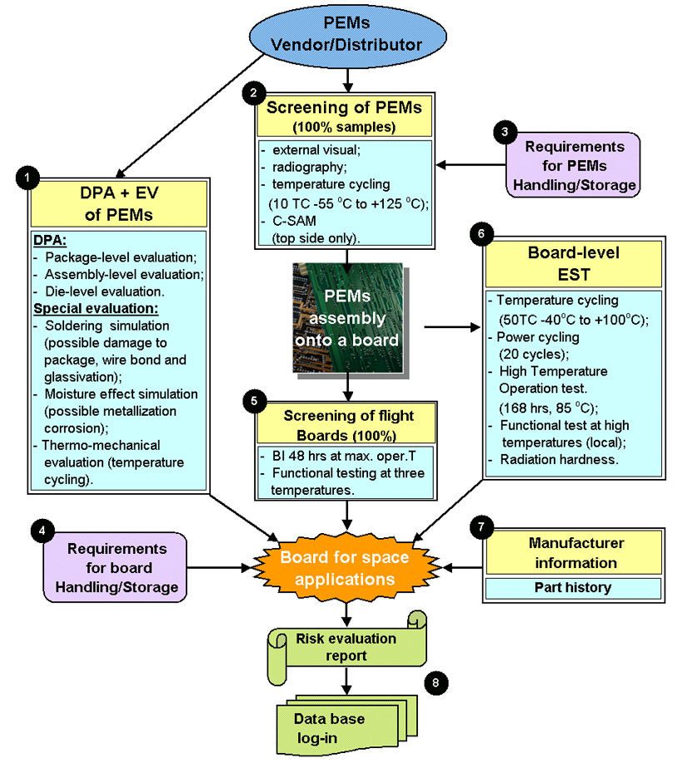
Figure 2. Qualification system for PEMs based on board-level testing.

Comments below explain the purpose of the relevant procedures and refer to the documents describing test/analysis conditions and requirements.
- DPA is performed according to Section 5 of the 311 - PEM.
In addition to 5 DPA samples, a minimum of 5 more samples should be submitted for evaluation of soldering, moisture, and temperature cycling effects. These five parts will be subjected to external visual and CSAM examinations and preconditioned (moisture soak + reflow/soldering simulation) according to the 311- PEM instructions, Section 4, steps 1 to 5. After preconditioning, the parts will be subjected to 100 temperature cycles from –55 °C to +150 °C and then stressed in moisture conditions (HAST testing at 130 °C, 85% RH, 96 hrs). Following these environmental stresses, all parts will be inspected under acoustic microscope (CSAM examination) and subjected to evaluation analysis according to Section 6 and 4 of the 311 - PEM instructions.
- Non-destructive inspection will be performed as a part of screening procedures on all samples per 311 - PEM instructions, Section 3, steps 1 to 4.
- Requirements for PEMs handling and storage are described in the PEM supplement to 311- PEM instructions, Section 8.
- Detailed requirements for handling and storage of PEM-containing boards have to be developed. General requirements are: to avoid moisture and contamination and to store boards in dry, controllable conditions. Note that conformal coatings do not prevent moisture from sorption in molding compounds encapsulating plastic microcircuits.
- Burn-in temperature should be 10 °C below the maximum safe operating temperature for the board. The applied voltages should correspond to maximum operating conditions, and the test duration is 48 hours minimum. Before BI the boards are tested at room temperature, but after BI the test is performed also at minimal and maximal operating temperatures for the board.
- Environmental stress tests of PEMs using board-level testing is considered as destructive and should be performed on the non-flight boards. A typical test flow consists of temperature cycling (50 cycles minimum from –40 °C to +100 °C), power cycling (20 cycles minimum), and high temperature operational life test (168 hours minimum at 85 °C or rated maximum operational temperature for the board, whichever is less).
Radiation hardness of the part can be verified by the board testing before and after exposure to radiation conditions according to the project requirements. A lead plate might be used to protect elements on the board during radiation tests.
- Recommendations for information that can be acquired from the manufacturer to evaluate quality of the parts are described in Section 9 of the 311-PEM instructions. Additional information regarding the history of the parts can be obtained from the PEM database maintained by code 562.
- Collection and analysis of the test results is very important for estimation of the effectiveness of testing and for timely correction of the test strategy. A copy of the qualification report, which presents a summary of all performed tests and their results, should be submitted to code 562 for risk evaluation and database login.

Qualification system based on use of evaluation boards
This option might be viable when a large lot of parts will be used for similar applications. In these cases designing or purchasing of a special evaluation board with a socket to perform functional testing for screening and qualification of the lot might be economically justified. An example of the test flow using both evaluation and application boards is shown in Figure 3. This test flow is similar to the one shown in Figure 2, and all comments to Figure 2 are also applicable here.
Two additional sections in the test flow of Figure 3, sections 5 and 6a, are due to insertion of section 5 in the screening procedure for 100% functional testing of the parts (performed at room, minimum, and maximum operational temperatures), and to insertion of section 6a in the environmental stress testing, which is augmented to include thermo-mechanical and moisture resistance environmental tests. The extended environmental stress test qualification section also allowed for elimination of evaluation analysis.

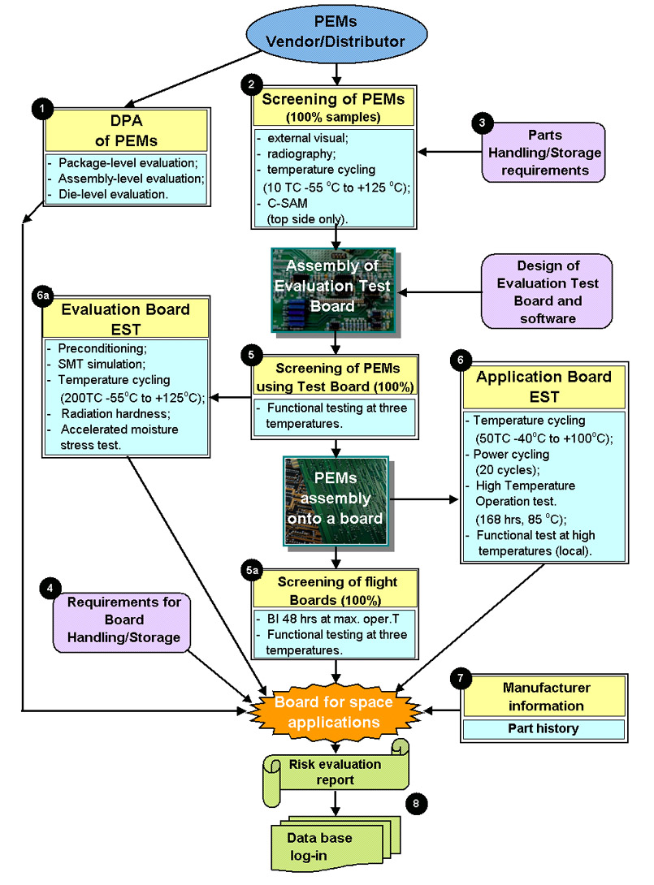
Figure 3. Qualification test flow for PEMs based on use of evaluation boards.

Application of the local heating technique for board-level qualification of PEMs (an example).
One of the major drawbacks of using board-level testing for qualification of PEMs is a relatively narrow operational and storage temperature range available for testing of assemblies. The maximum operating temperature of an assembled board is typically about 50 °C, which is much lower than the maximum operating temperature of PEMs typically 85°C. This does not allow proper acceleration of most of the degradation mechanisms to screen out potentially week parts and significantly limits the ability of evaluation of long-term reliability of PEMs.
The range of temperatures, which is typically used for temperature cycling, is also much lesser for the boards and card assemblies (-30 °C to +70 °C) than for PEMs (-55 °C to + 155 °C). This considerably restricts capabilities of evaluation of the thermo-mechanical robustness of PEMs.
These temperature limitations could be bypassed by application of the local heating technique when only a part of interest is heated up to a necessary temperature, so that the rest of the board will operate at room temperature conditions. Local heating of a PEM can be implemented using small flexible foil heaters applied directly to the top of the microcircuit. In this case, controllable heating of the part will allow functional testing at maximum operational temperatures or performing temperature cycling by switching power of the heater.
One of the benefits of this technique is that it allows evaluation of thermo-mechanical robustness of the parts by simulating soldering reflow conditions and/or multiple temperature cycling and monitoring characteristics of the part during temperature cycles. This enables observation of possible failures due to intermittent contacts that cannot be revealed during regular temperature cycling tests when electrical measurements are performed only at room temperature after testing.
It should be noted also that monitored fast hot-to-cold and cold-to-hot temperature transitions could be much more effective in revealing bonding problems, in particular, due to poor solder joints or wire bonding inside the package, than the standard, relatively slow cycling, or during burn-in testing [2, 6]. For example, cycling between –40 °C and +125 °C at a rate of 5 °C /min. revealed all defects in a particular surface mount class of devices assembled onto a board in 400 cycles. Increasing the rate to 10 °C /min reduces the number of cycles to 55. At 15 °C /min, the same result required only 17 cycles (and 6 hrs.). The dwell or soak time at temperature extremes does not contribute significantly to product stress.
The purpose of this part of the work was to evaluate effectiveness of the local heating technique and to get preliminary results on high temperature monitored temperature transients.
Experimental
Experiments were performed on two types of PEMs, Ramtron FM1808 (packaged in DIP-28) and Motorola MMA1201 (packaged in DIP-16). These parts had been selected because of significant difference in the results of multiple temperature cycling performed previously according to MIL-STD-883, TM 1010. For FM1808 parts no failures were observed in a group of 25 samples after 1000 cycles between –65 °C and +150 °C. However, 96% of the Motorola parts out of 25 tested samples failed after 200 cycles between –65 °C and +155 °C, and 4% failed cycling at relatively mild temperature range of – 40 °C to + 105 °C (see Figure 4).

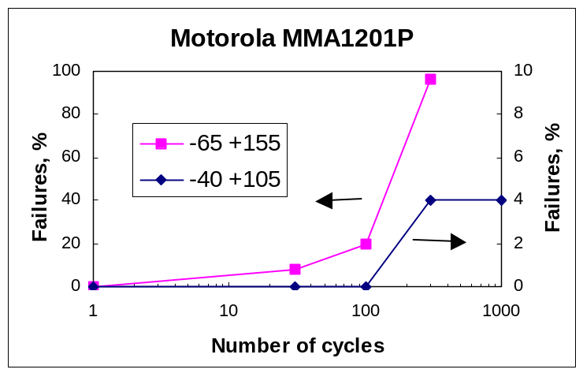
Figure 4. Temperature cycling test results showing proportion of failures versus number of cycles for two test conditions –40 °C to +105 °C and –65 °C to 155 °C.

Two types of Minco thermofoil heaters with different shapes were used: HK5572R26.5L12A for Ramtron parts and HK5568R25.0L12A for Motorola parts. Temperatures at the top (under the heater) and at the bottom (board side) of the parts have been monitored using miniature spot platinum wire-wound PDY24A temperature sensors. Typical results of temperature measurements are shown in Figure 5.
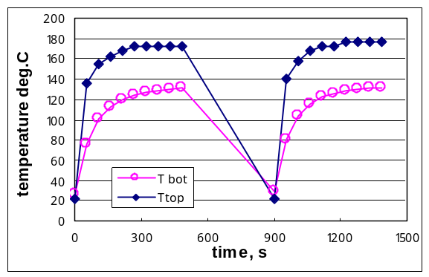 | 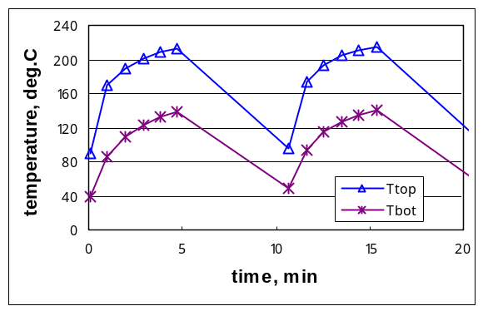
a) Motorola MMA1201. Heater HK5568R25.0L12A, IH = 400 mA | b) Ramtron FM1808. Heater HK5572R26.5L12A, IH = 700 mA.
Figure 5. Temperature variation at the top and bottom of the part during heater power cycling. Note that the temperatures were measured only when the heaters were ON.
The results show that approximately 5 minutes are necessary for temperatures to stabilize at a high or low levels; however, the most significant changes occur during first 30 to 60 seconds of heating when the temperature rate reaches 80 to 120 °C/min. As expected, the temperature at the top of the parts is significantly higher than the temperature at the bottom side. Figure 6 shows that an increase in the power dissipated in the heater results in a linear increase of the top-side temperature and also raises the temperature gradient across the part. At the top-side temperatures of approximately 220 °C the difference between the top– and bottom-side temperatures reaches ~60 °C.

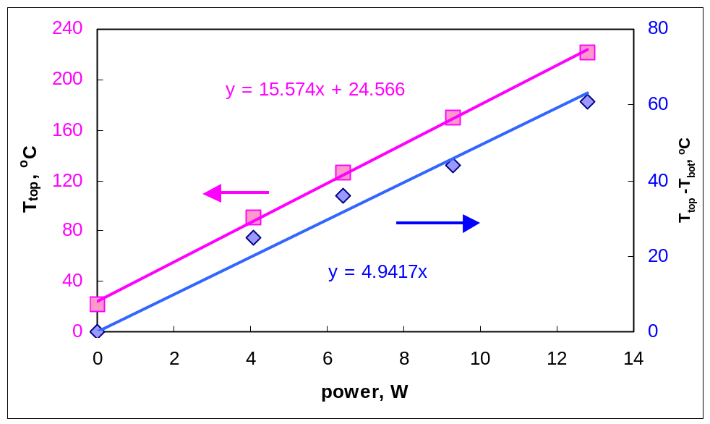
Figure 6. Ramtron FM1808. Top-side and bottom-side temperatures vs. power dissipated in the HK5572R26.5L12A heater.

Measurements of die temperatures during the local heating tests can be performed using temperature dependencies of forward voltage drops, VF, at I/O pins in the microcircuits. To calibrate VF with temperature, several I/O pins in both parts were measured at IF=0.5 mA in the range from 25 °C to 180 °C. Results of this calibration are shown in Figure 7. For both parts VF(T) curves were reproducible straight lines with a slope of approximately 2 mV/°C, which is a known averaged K-factor for silicon diodes. The results of calculations are shown in Table 1.
Table 1. K-factors for I/O pins of the microcircuits.
Part | Number of samples | K_{avr}, mV/°C | Standard deviation
MAA1201 | 3 | 2.16 | 0.023
FM1808 | 16 | 2.04 | 0.0059

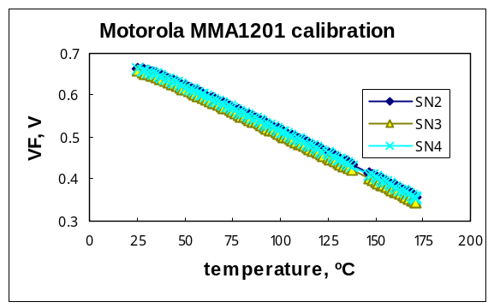 | 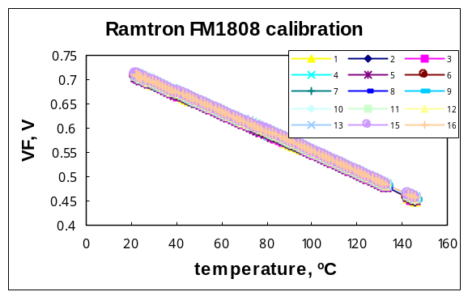
a) | b)
Figure 7. Temperature dependence of forward voltage drops at IF = 0.5 mA for three pins in MMA1201 (a) and 16 pins in FM1808 (b).

Monitored temperature transient cycles test results
One Ramtron and one Motorola parts were subjected to 100 monitored temperature cycles from room temperature to approximately 155 ºC (die temperature) using the local heating technique. The developed PC-based set-up allowed for automatic power switching and measurements of the forward voltage drops at 16 I/O pins, as well as for measurements of resistances of the temperature sensors installed on the parts. The power of the heaters was switched on and off every 5 minutes, but the measurements were performed every minute only during the heating part of the transient cycles.
Experiments showed (see Figure 8) that the die temperature was closer to the bottom-side temperature of the part and the difference between the top-side and die temperatures reached 55 ºC. This is most likely due to a low resistance of the copper lead frames resulting in effective sinking of the heat from the die through the leads.

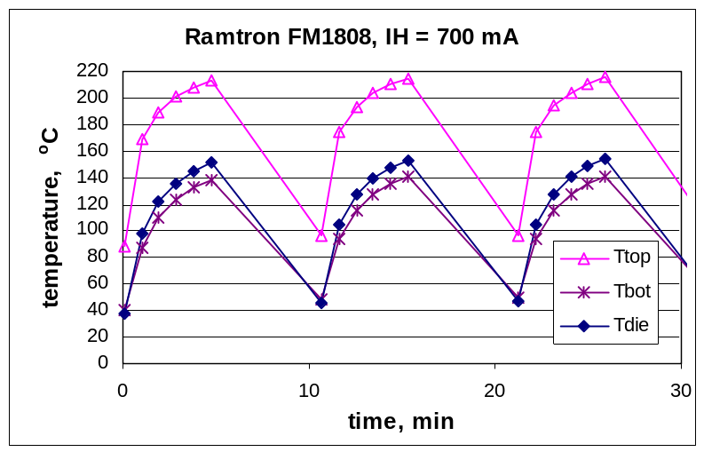
Figure 8. Temperature variations during monitored temperature cycling tests.

Two out of four monitored pins failed in the Motorola part (see Figure 9). Pin 7 failed after approximately 14 hours of testing and intermittent failures at pin 5 were first observed after approximately 6 hours of testing and then repeated several times during the rest of the test. Note that pin 5 did not reveal any anomaly during the after-testing measurements.
No anomalies have been observed while monitoring 16 I/O pins in the Ramtron part. Figure 10 shows typical test results during several first and last temperature cycles of the FM1808 microcircuit.
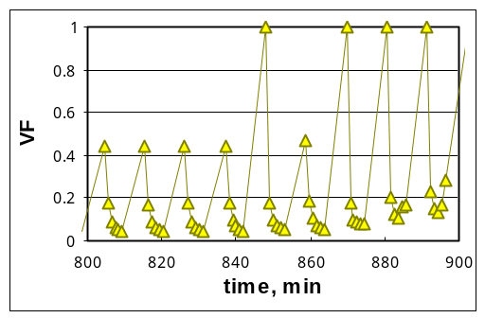 | 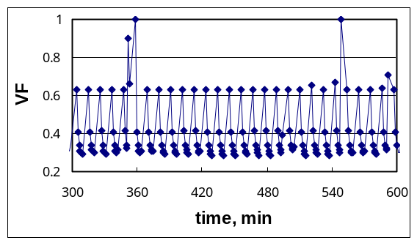
a) | b)
Figure 9. Two pins in MMA1201, pin 7 (a) and pin 5 (b), had intermittent failures during monitored temperature cycling test. Pin 7 failed open after the test while pin 5 showed normal characteristics.

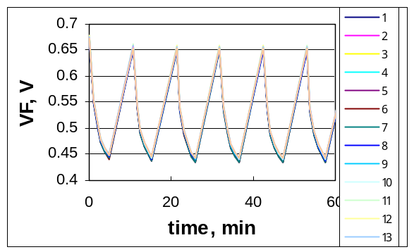  a) | 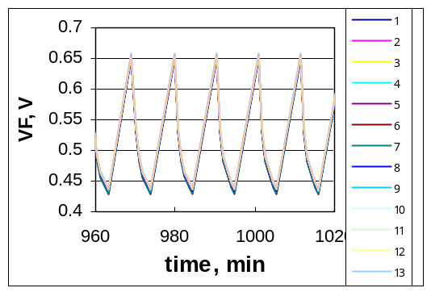  b)

Figure 10. Several first (a) and last (b) cycles during the 100 TC testing of Ramtron FM1808. the forward voltage drop was measured at 0.5 mA. No anomalies were observed during this test.

Conclusion
A qualification system based on board-level testing of components has been suggested to mitigate risks of use of commercial-off-the-shelf (COTS) PEMs for projects working under high budget and time constrains. This system might be an inexpensive alternative to a standard screening and qualification system described in the 311-INST-001 instructions, Revision A, PEMs section, June 2002 for projects accepting higher level of risk in their parts program and implementing the design for testability ideology in developing circuits and boards for their instruments.
To effectively mitigate risks associated with the employment of COTS PEMs in space projects, the qualification system in addition to the board-level testing should include different elements of the system available for quality assurance of PEMs, in particular, destructive physical analysis, special design evaluation, non-destructive screening, and analysis of manufacturing and application history of the part.
To overcome temperature limitations inherent to the board-level testing, a monitored local heating stress testing has been suggested and sampled. Two types of PEMs have been subjected to 100 monitored local heating cycles. The part, which had 2 out of 4 pins fail the local heating test, also had multiple failures during a regular temperature cycling tests. Another part, which had no anomalies in 16 tested pins, had no failures after 1000 temperature cycles performed according to MIL-STD-883, TM 1010. These preliminary results indicate that the local heating technique might be a valuable supplement or alternative for evaluation of thermo-mechanical robustness of PEMs during solder reflow simulations and/or temperature cycling tests. It can be also used to evaluate temperature performance of PEMs and for development of a high temperature board-level accelerated stress test.

References
- S. Oresjo, New study reveals component defect levels, Circuit assembly, May 2002, pp. 39-43.
- S. F. Sceiber, Building a successful board-test strategy, Butterworth-Heinemann, 1995.
- M. Pecht, R. Radojcic, G. Rao, Guidebook for managing silicon chip reliability, CRC press, 1999.
- K. D. Hester, M. P. Koehler, H. Kanciak-Chwialkowski and B. H. Jones, An assessment of the value of added screening of electronic components for commercial aerospace applications, Microelectronics Reliability, Volume 41, Issue 11, November 2001, Pages 1823-1828.
- K. P. Parker, System issues in boundary-scan board test, Proceedings of the ITC international conference, 2000, pp. 724-728.
- M. Amagai, Chip scale package (CSP) solder joint reliability and modeling, Reliability Physics Symposium Proceedings, 1998. 36th Annual. 1998 IEEE International, 1998, Page(s): 260 –268.

