Reliability of NMOS Transistors
from LL Fully Depleted SOI Processes

Udo Lieneweg
Lisa Reiner
Bernard G. Rax
Jagdishbhai U. Patel

JPL

Final Report for NEPP/EPAR

18 December 2001

JPL Document D-22252

Acknowledgement

The research described in this report was carried out by the Jet Propulsion Laboratory, California Institute of Technology, and was sponsored by the National Aeronautics and Space Administration’s Electronic Parts and Packaging Program (Code AE).

Lisa Reiner, while studying at California State University Northridge, was funded by a NASA Institutional Research Award.

The “RelChip” was fabricated at MIT/Lincoln Laboratory in a multi-project run funded by DARPA.

We thank Travis Minto and Michael Wiedeman for technical assistance.

Cleared for public release CL#02-0445.
Content

Acknowledgement 2
1 Introduction 4
2 Samples 4
3 Experimental 5
4 Results 8
4.1 Overview 8
4.2 0.18-μm Technology 9
4.2.1 H-Gate Transistors with L = 0.2 μm 9
4.2.2 H-Gate Transistors with L = 0.4 μm 13
4.3 0.25-μm Technology 15
4.3.1 Standard Transistors with L = 0.25 μm 15
4.3.2 H-Gate Transistors with L = 0.25 μm 16
5 Physical Interpretation of Results 17
5.1 Power Time Law 17
5.2 Logarithmic Time Law 18
6 Simulation 21
7 Conclusions and Recommendations 24
8 References 25

Introduction

Silicon-On-Insulator (SOI) MOS technology introduces from the buried oxide (BOX) a second oxide interface to the active silicon region, which can interact with the transistor channel when the silicon film is so thin that it is normally fully depleted (FD) from charge carriers. This situation in FD SOI gives rise to new reliability phenomena, which are absent in bulk MOS and partially depleted (PD) SOI MOS technologies. In earlier investigations on samples from a Lincoln Lab (LL) 0.25-μm process, we found that high-energy (“hot”) carriers, which are generated in the high-field region near the drain, particularly in short-channel NMOSFETs, can be injected into the BOX or its interface and create degradations of the front channel characteristics even when the gate oxide is unaffected. Now we report on hot-carrier tests on samples from the LL 0.18-μm multi-project run MP 4. The results are compared to results from the 0.25-μm run and a new interpretation of the latter is presented.

Samples

Table 1 lists the process parameters for the 0.25-μm and 0.18-μm technologies.

Table 1: Process Parameters
Parameter | 0.25-μm | 0.18-μm
Gate oxide thickness | 7.3 nm | 4.0 nm
Silicon film thickness | 50 nm | 47 nm
Buried oxide thickness | 195nm | 170 nm
Wafer type | SIMOX | SIMOX
Isolation technology | mesa-etched | mesa-etched
Minimum gate length (target) | 250 nm | 180 nm
Sidewall oxide thickness | 15 nm | ?
n-channel doping | 4×10¹⁷cm⁻³ | 5.8×10¹⁷cm⁻³
p-channel doping | 4×10¹⁷cm⁻³ | 5.5×10¹⁷cm⁻³

The transistors from the 0.25-μm process were on an LL process monitor chip and of standard gate, floating-body design, except for one with an H-gate with body-contact. The transistors from the 0.18-μm run were on the JPL Reliability Chip (“RelChip”) and all designed as H-gates with body contacts. The term “body” refers to the active silicon part of a transistor. The term “H-gate” refers to the layout of the gate in form of the letter H, as shown in Fig. 1. The channel of layout-length L and width W is present only under the horizontal bar of the H, so that no parasitic transistor effects come from the parts where the gate layer runs over the edge of the silicon mesa. The vertical bars of the H afford body contacts without shorting source and drain.

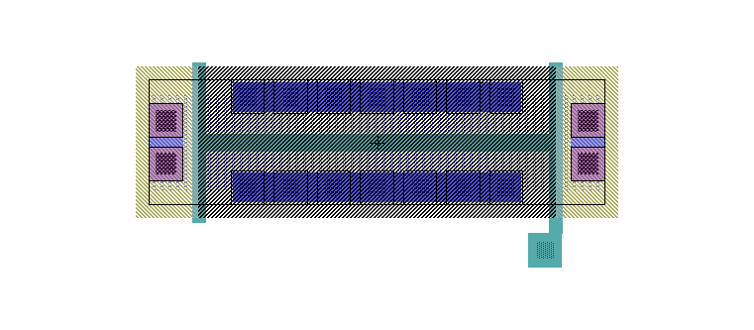
Fig. 1: H-gate NMOSFET with L / W = 0.2-μm / 8-μm

The RelChip contains three identical n-channel transistors for each drawn gate length L = 0.2 μm and L = 0.4 μm, which are identified as B3-L, -M, and -R; and B4-L, -M , and –R; respectively. The effective gate length for the minimum design is specified as 0.18-μm, which gives the process its name. From the delivered 13 RelChip samples, three were packaged in 40-pin DIPs and wired to transistor blocks B3 (Chip 9 and 10) or B4 (Chip 11). The other chips were used for the evaluation of the metalization under a companion NEPP task.

Experimental

The packaged chip was placed in an HP 16058A test fixture, and the transistor characteristics were measured with an HP 4145 parametric analyzer, which provided also periodic bias stress. The control and some parameter calculation were provided by Metrics/ICS software. The source-monitor units (SMUs) were assigned to transistor terminals as follows:

Table 1: Connections
SMU | Terminal | Source | Monitor
1 | gate | Vg | Ig
2 | drain | Vd | Id
3 | source, [body] | = 0 | Is [+Ib]
4 | substrate (back) | Vsub, usually = 0 | Isub

Before any stress and after each stress interval, an Id vs Vg characteristic was taken at Vd = 50 mV with Vg swept in increments of 10 mV from –0.20 V to 1.25 V. The upper limit was intentionally kept under the specified supply voltage of 1.5 V to minimize any pre-stressing. The software extracted the transconductance gm = dId/dVg, gm_max, and a threshold voltage Vth_extr by extrapolating the tangent to the Id vs Vg curve at the point of maximum slope to Id = 0. In spite of increasing the integration time for each measurement “medium” (20 ms) , the gm vs. Vg curves remained still somewhat noisy, which translated into an even greater effect on the extrapolated threshold voltage. A further increase of the integration time to “high” (16 s) seemed not advisable because of the resulting long interruptions of the stress. Instead we extracted a threshold voltage at a (previously used) constant gate current Id = 3.83 μA by linear interpolation of the Id vs. Vg data. This value is close to the often-used value of (W/L)×0.1 μA ≈ 4 μA. The interpolation was done in MS Excel and the interpolated values plotted over the smoothed Id vs. Vg curves at high resolution. The linear interpolated Vg values lay below those on the smoothed curves by maximally 0.2 mV.

In Fig. 2, the correlation between the interpolated and the extrapolated threshold voltages is shown for one sample after different stress times. Vth_extr is about 100 mV higher than Vth_intpl. Since the stress not only increases the threshold voltage but also diminishes the transconductance, the fitted line has a slope of only about 0.7. Thus Vth_intpl describes better the turn-on of a transistor independent of the carrier mobility.

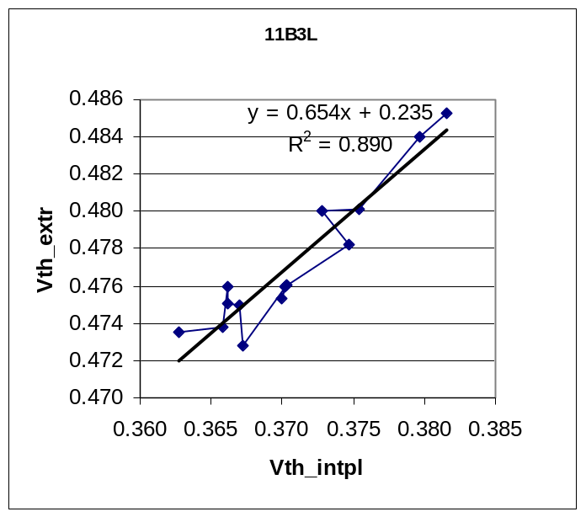
Fig. 2: Correlation between extrapolated and interpolated threshold voltages for one sample after different stress times
The cumulative stress time for each sample was varied exponentially in increments of a factor 10 ^{1/ 3}. Many of the data show oscillations with an amplitude up to about 2 mV peak-to-peak and an apparent fixed period on the plots with logarithmic time scale, see next section. For this we offer the following likely explanation: The temperature in the room oscillates usually by 2 ºC between late afternoon and early morning. The threshold voltage has a temperature sensitivity of about 0.5 mV/ºC. This would cause an oscillation with a peak-to-peak voltage of 1 mV and a period of 1 d on a linear time scale. In Fig. 3, a sine wave with a 1-d period has been sampled on the same exponential time scale as the experiments. The semi-logarithmic plot shows also a close-to-periodic behavior as found in the experiments. Peak-to-peak values of 2 mV and their apparent diminution in some cases can be explained by larger than normal temperature variations in the summer and lack of air-conditioning during weekends. However, since the temperature was not recorded at the same time the measurements were made, we cannot exclude other causes for the observed oscillations. In future measurements, the temperature should be controlled to better than 0.5ºC.
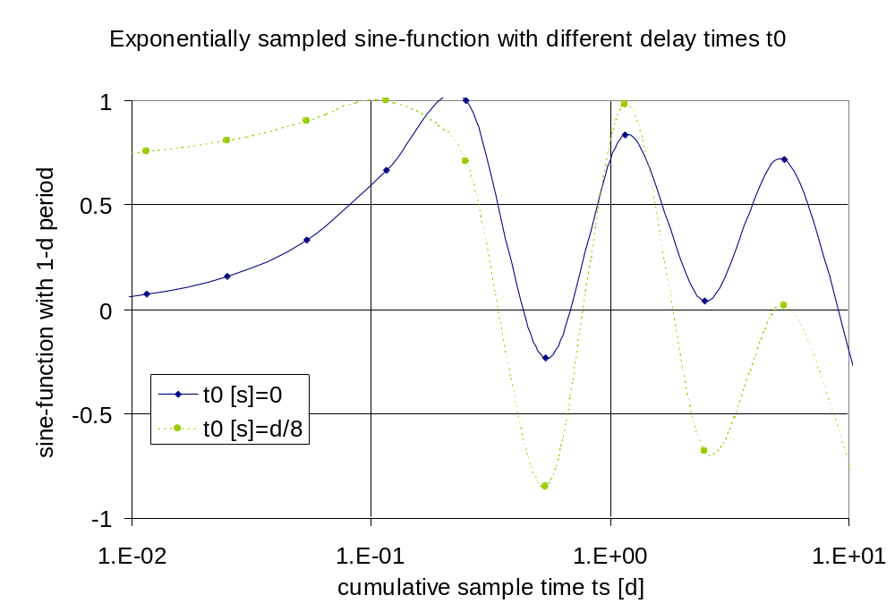

Fig. 3: Function sin{(ts +t0)/T} vs. ts, where ts is sampled on an exponential scale and T = 1 d. Sampled points are connected by spline function, suggesting periodicity on logarithmic time scale.

Results

Overview

Table 2 gives an overview of the stress tests performed for this report together with the initial threshold voltages. Besides the tests on devices from the 0.18-μm run, structures from the 0.25-μm run were tested for completion and comparison. Although we report only the threshold voltage shifts in detail, degradation of the maximum transconductance with stress was also observed in all cases.

Table 2: Overview of present hot-carrier tests
0.18-um Technology:
W = 8 um, | n-type, H-gate
L = 0.2 um | Vth(0) [V] | Vd [V] | Vg [V] | Body | t_max [s]
11-B3 L | 0.3545 | 2.10 | 1.00 | grounded | 215k
9-B3 R | 0.3955 | 2.00 | 1.00 | grounded | 100k
9-B3 M | 0.3597 | 1.75 | 1.00 | grounded | 215k
9-B3 L | 0.3664 | 2.00 | 1.00 | floating | 215k+1M
Avg Vth(0) | 0.3690
StDev Vth(0) | 0.0183
L = 0.4 um | Vth(0) [V] | Vd [V] | Vg [V] | Body | t_max [s]
10-B4 L | 0.3996 | 3.00 | 1.50 | grounded | 100k
10-B4 M | 0.4216 | 2.50 | 1.50 | grounded | 215k
10-B4 R | 0.4383 | 2.70 | 1.50 | grounded | 215k
Avg Vth(0) | 0.4198
StDev Vth(0) | 0.0194
0.25-um Technology:
W = 2 um, | n-type, standard gate
L = 0.25 um | Vth(0) [V] | Vd [V] | Vg [V] | Body | t_max [s]
6-I | 0.408 | 2.15 | 1.00 | floating | 100k
10-I |  | 2.05 | 1.00 | floating | 100k
W = 8 um, | n-type, H-gate
L = 0.25 um | Vth(0) [V] | Vd [V] | Vg [V] | Body | t_max [s]
8-Hgate | 0.344 | 2.20 | 1.00 | grounded | 215k

0.18-μm Technology

H-Gate Transistors with L = 0.2 μm

Results for the 0.2-um gate-length transistors, stressed at drain voltages of 2.1 V, 2.0 V, and 1.75 V with body grounded, are shown in Fig. 4, Fig. 5, and Fig. 6, respectively. The threshold voltage shift was plotted against the logarithm of the cumulative stress time. The data exhibit the oscillations discussed in the previous section. Nevertheless, they show clearly a superlinear trend in the semi-logarithmic plot, so that they are better fitted with a power law
ΔVth = a t ^{b}
Eq. 1
than with a logarithmic law, which ruled the behavior of the previously measured 0.25-μm transistors. Due to the oscillations and small initial charging effects, some measured threshold shifts were negative, and we had to resort to a nonlinear fitting procedure, provided by Sigmaplot, rather than linearly fitting to the logarithms of both variables as
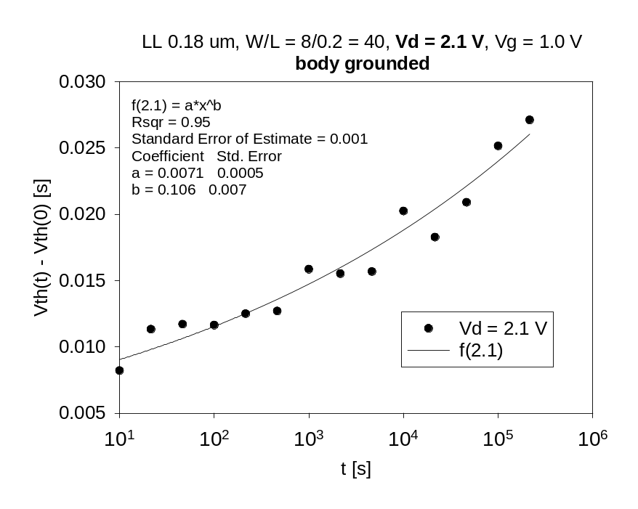
Fig. 4: Threshold voltage shift of body-grounded, 0.2-um NFET with cumulative stress time at Vd = 2.1 V
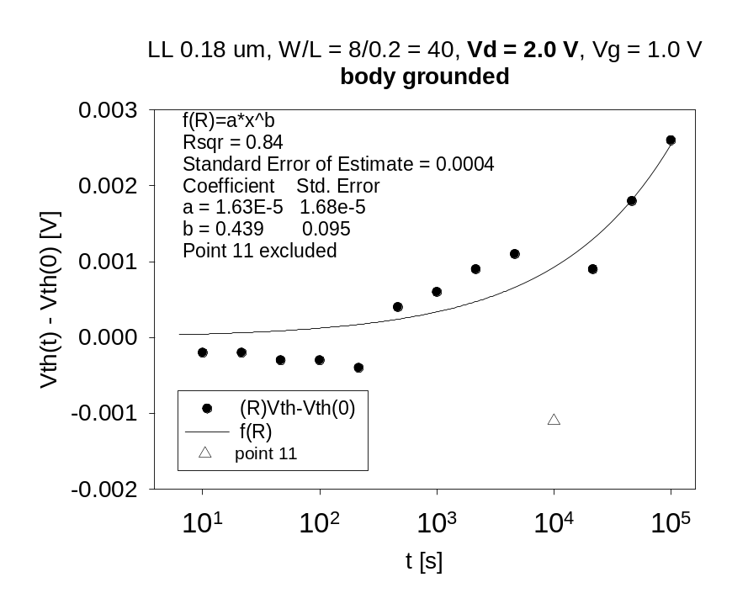
Fig. 5: Threshold voltage shift of body-grounded, 0.2-um NFET with cumulative stress time at Vd = 2.0 V
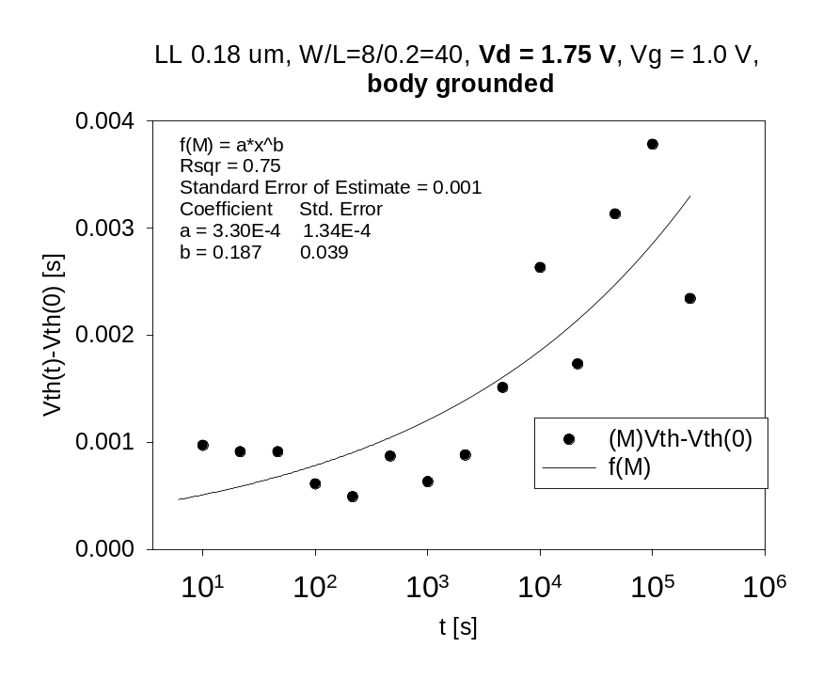
Fig. 6: Threshold voltage shift of body-grounded, 0.2-um NFET with cumulative stress time at Vd = 1.75 V

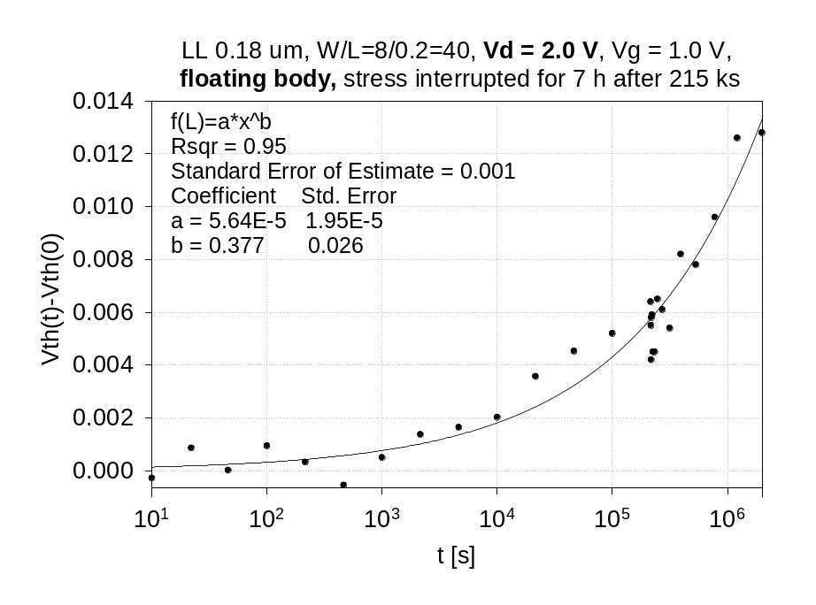
Fig. 7: Threshold voltage shift of floating-body, 0.2-um NFET with cumulative stress time at Vd = 2.0 V

done in Excel. One point in the 2.0-V data lay outside the 95% confidence interval and was excluded from the fit. A warning was also given on the last two points, which pull the exponent up strongly. The exponents b are listed in the plots and range from 0.1 to 0.4.

It was also tested at Vd = 2.0 V if letting the body float made any difference. The result, which combines the data from two subsequent measurements, is shown in Fig. 7. The fitted exponent is similar to that from the grounded-body experiment. Also, the 7-h interruption between the two measurements had no significant influence.

The extracted coefficients were used to predict a lifetime τ , defined by the time at which the threshold voltage shift becomes 20 mV. This value was chosen as being close to the standard deviation σ of the initial threshold voltages, cf. Table 2.

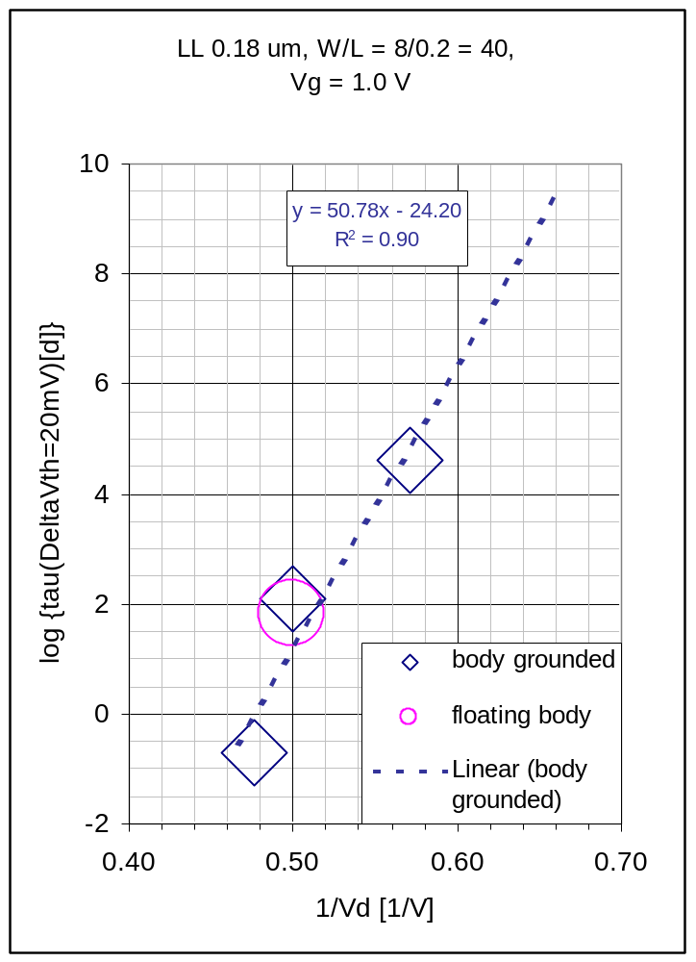
Fig. 8: Dependence of threshold-voltage lifetime (in days) on stress drain voltage for 0.2-μm NFETs. Symbol height of ±0.6 represents estimated error in log τ.

In Fig. 8, the logarithm of the lifetime for the 0.2-μm transistors is plotted against the reciprocal of the drain voltage, as suggested by . The fitted line predicts a lifetime of 125 days at a drain voltage of 2.0 V, 110 years at 1.75 V, and practically unlimited life at the nominal drain voltage of 1.5 V.

In an idealized model, the exponent b is independent of Vd , and Eq. 1 can be transformed into

ΔVth / σ = [t / τ] ^{b}
Eq. 2
with
τ = τ₀ × 10 ^{(Vc / Vd)} .
Eq. 3

Hence, the curves in the lifetime plots follow

log τ = log τ₀ + Vc / Vd ,
Eq. 4
In the case of Fig. 10 the characteristic voltage, given by the slope, is Vc ≈ 50 V. The time constant τ₀ ≈ 10 ⁻²⁴ s has, of course, no physical meaning besides that of a reference.

H-Gate Transistors with L = 0.4 μm

Similar procedures were applied to NFETs with 0.4 μm gate length. Here, as expected for the lower electric fields at given drain voltages, the lifetimes were larger, and the stress tests had to be done at higher voltages, as listed in Table 2. In Fig. 9, the threshold voltage shift is plotted for drain voltages of 2.5 V, 2.7 V, and 3.0 V. The coefficients for a power law fit are given in the legend. The 2.7-V curve reaches a shift of σ ≈ 20 mV about the same time as the 2.5-V curve, although the latter has clearly a smaller slope. The reason lies probably in some initial charging. Therefore, we extracted also a lifetime for a shift of 2 σ ≈ 40 mV, which fits the ideal model better, see Fig. 10.
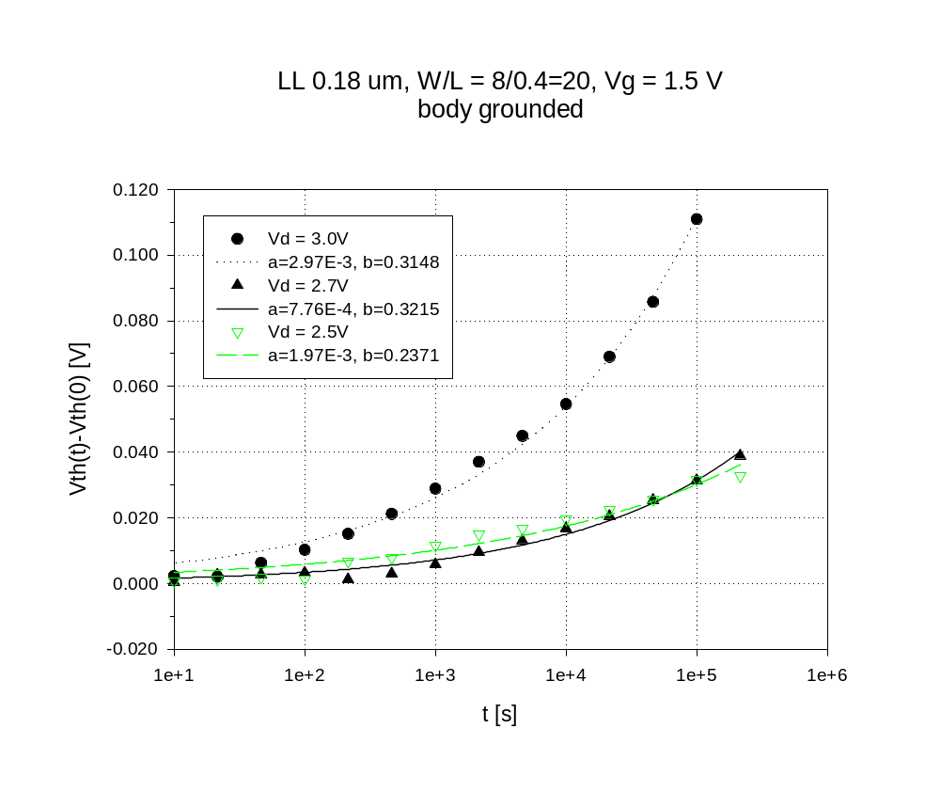
Fig. 9: Threshold voltage shift of grounded-body, 0.4-μm NFET with cumulative stress time at different drain voltages
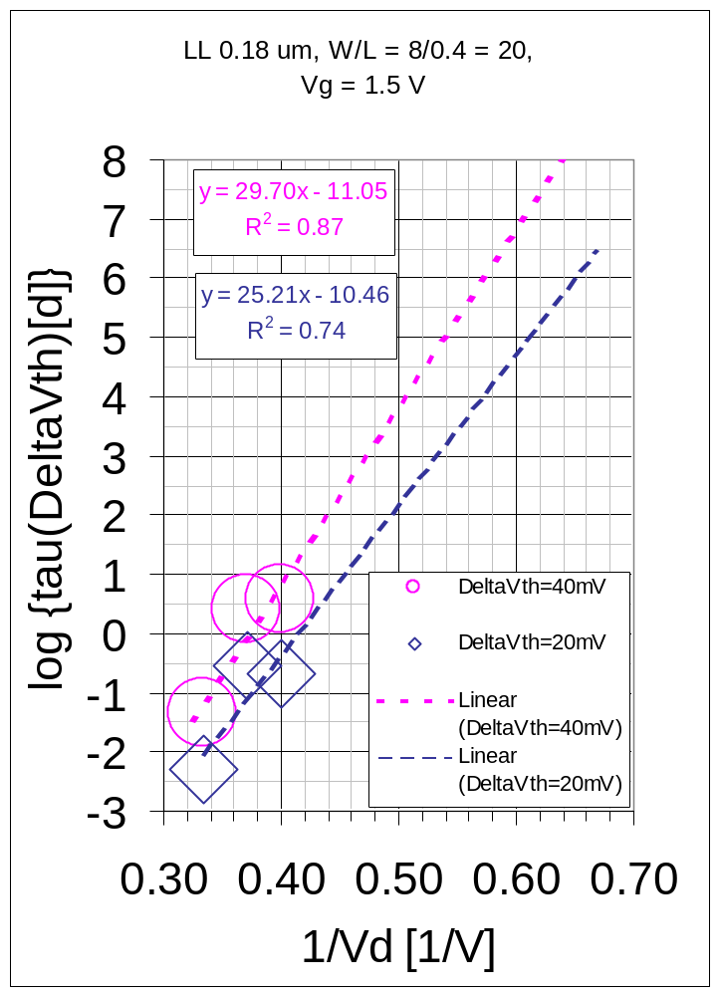
Fig. 10: Dependence of threshold-voltage lifetime (in days) on stress drain voltage for 0.4-μm NFETs. The two data sets represent 1-σ and 2-σ threshold voltage shifts.

In an adaptation of the idealized model to shifts in multiples n of σ , Eq. 2 can be transformed into

ΔVth / n σ = [t / τ] ^{b}
Eq. 5
with
τ = τ₀ n ^{1/ b} × 10 ^{(Vc / Vd)} .
Eq. 6

Hence, the curves in the lifetime plots should follow
log τ = log τ₀ + (log n)/ b + Vc / Vd ,
Eq. 5
with a common slope Vc and an offset between n = 1 and n = 2 of (log 2)/ b. In the case of Fig. 10 is Vc ≈ 30 V, τ₀ ≈ 10⁻¹¹ s , and (log2)/b ≈ 1. Hence, b ≈ 0.3 in accord with Fig. 9.

0.25-μm Technology

Standard Transistors with L = 0.25 μm

The standard-gate transistors with floating-body from the 0.25-μm run exhibited a logarithmic time dependence of the threshold shift when stressed with drain voltages ≤ 2.2 V. Deviations from this law at small stress times encountered in the earlier measurements were traced to the 2-V stress exerted already in the pre-stress characterization measurements. Supplemental new measurements on Batch 2, which kept the drain voltage in the characterization below 1.6 V, produced nearly perfect straight lines in the semi-log plots, see Fig. 10.
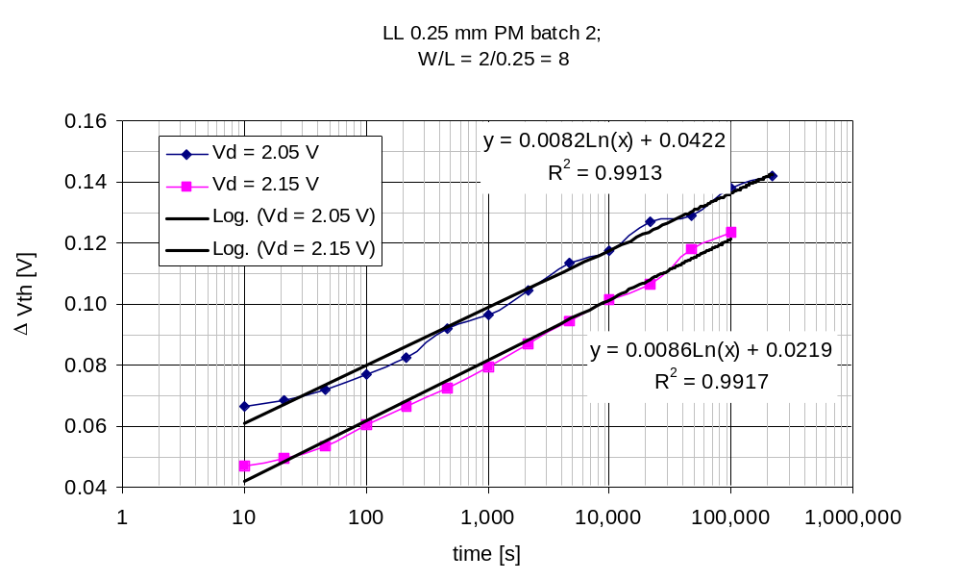Fig. 10: Threshold voltage shift of standard 0.25-μm transistors

H-Gate Transistors with L = 0.25 μm

As mentioned above, previous measurements on floating-body transistors of an earlier 0.25-μm run (“Batch 2”) revealed a threshold voltage shift that increased logarithmically with time rather than with a power law. After the experience with the 0.18-μm run, we went back to one of the Batch-2 process monitor chips and found an 0.25-μm H-gate transistor, which we stressed at Vd = 2.2 V. The threshold voltage shift follows now also a power law with similar coefficients as encountered in the 0.18-μm samples. This behavior was confirmed on two other 0.25-μm samples.
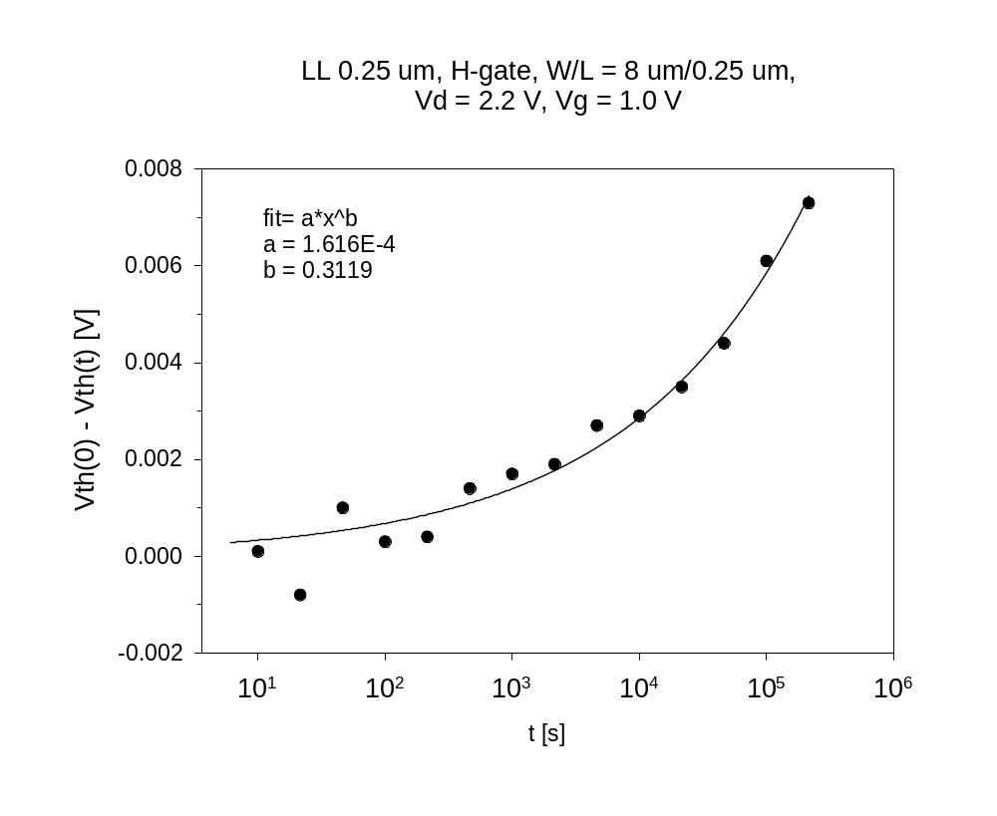Fig. 11: Threshold voltage shift in 0.25-μm H-gate NFET

In conclusion, floating of the body seems to be necessary but not sufficient to observe a logarithmic time dependence of the threshold voltage shift.

Physical Interpretation of Results

Power Time Law

The power time law, Eq. 1, is the most commonly reported in the hot-carrier degradation literature. Earlier bulk-MOS devices exhibited exponents b between 0.5 and 1, which were attributed to diffusion and reaction limited trap generation, respectively. Exponents of about 0.3 were found in contemporary bulk and SOI devices, but the explanation varies. One of the cited papers attributes a b = 0.25 to interface trap generation by injection of one carrier type only while a b = 0.5 is caused by both electron and hole injection. The picture of nearly pure electron injection from the front channel into the front and/or the back oxide is compatible with our experimental results on the grounded-body transistors. Unfortunately, in the 0.18-μm process the buried oxide was so leaky that it could not be biased into accumulation without permanent breakdown. So we could not distinguish between front and back oxide degradation.

The lifetimes for the different gate lengths, which were presented in Fig. 8 and Fig. 10, can be unified when plotted against 1/(Vd – Vsat), where Vsat is the drain saturation voltage. The reason is that the maximum lateral field near the drain can be calculated from

Emax = (Vd – Vsat) / lc ,
Eq. 6
where lc is a characteristic length independent of the gate length. Expressions for Vsat and lc will be given in the next section. The result of this transformation is shown in Fig. 12. The improved fit, especially that for ΔVth = 40 mV, confirms that, at the relatively low gate voltage of 1.0 V, it is indeed the lateral field, which determines the mean hot electron energy.
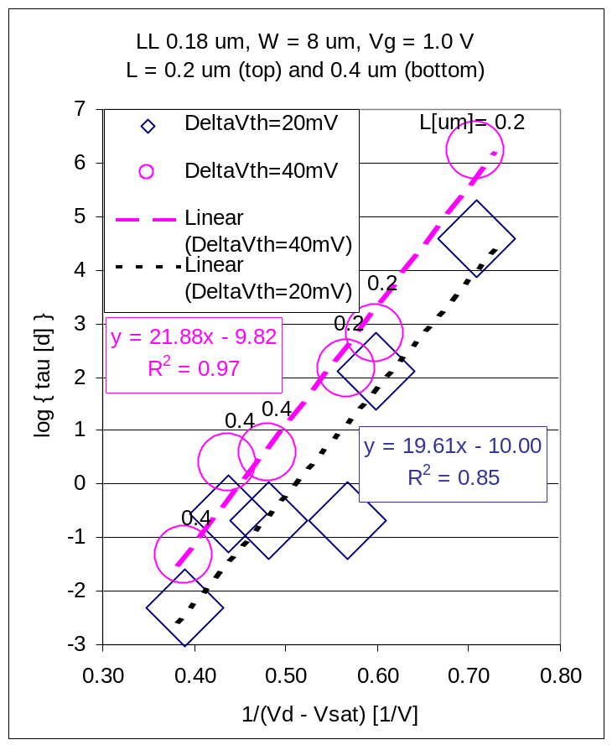
Fig. 12: Unified plot of lifetime for NFETs with different gate lengths. Vsat is the saturation drain voltage.

Logarithmic Time Law

The floating-body transistors from the 0.25-μm run exhibited a logarithmic time dependence of the threshold shift when stressed with drain voltages ≤ 2.2 V. This shift disappeared when the back interface was biased into accumulation.

Wang et al. have also found a logarithmic time dependence for ΔId/Id on stressed bulk PMOS transistors and explained it quantitatively by charge injection into existing traps in the gate oxide. The logarithmic time law originated from the gradual expansion of a zone of filled traps from the drain toward the source. By way of analogy, we concluded that in our case electrons were injected into existing traps at the buried oxide interface, thus causing a positive threshold voltage shift.

We apply now the Wang theory quantitatively to our situation and compare the predicted behavior to the experimentally observed one. Then, for the threshold voltage shift we obtain

ΔVth = K exp{-Vc / (Vd -Vsat)} ln{t/to} ,
Eq. 7
where

Vc = ( lc / λe) Φact / q
Eq. 8
is a characteristic voltage with Φact being the activation energy for carriers to be trapped, λe the mean free path, and -q the charge of electrons. The characteristic length lc is given by an empirical expression, which depends on the silicon thickness dsi and the oxide thickness dox as

lc = 0.22 μm ^{1/ 6} dsi ^{1/ 2} dox ^{1/ 3} .
Eq. 9
The quantity Vsat is the voltage at which the channel electrons reach the saturation velocity and is given by

Vsat = [ (Vg – Vth)⁻¹ + (Esat Leff)⁻¹ ] ^{–1} ,
Eq. 10
where Esat is the saturation field and Leff the effective gate length.
Finally, to is a scaling time that is usually set to 1 s and K is a proportionality factor, which is proportional to the number of uncharged traps before stress. The input parameters for this set of equations are listed in Table 3.
Table 3
Parameter | Value | Unit | Source
dsi | 0.050 | μm
dox | 0.195 | μm
→ lc | 0.0285 | μm
λe | 0.0062 | μm | Ref.
→ lc/λe | 4.60
Esat | 4×10⁴ | V/cm | Ref.
Leff | 0.25 | μm
Vg | 1.0 | V
Vth | 0.4 | V
→ Vsat | 0.38 | V

Since the experimental stress curves were sometimes disturbed by initial charges, we extract only their slopes d Vth / d ln(t/1s) in the semi-ln plots. The logarithms of these slopes are then plotted against 1/(Vd – Vsat), see Fig. 12. For comparison with the experiment, we differentiate Eq. 6 and obtain

ln {d Vth / d ln (t/to)} = ln K - Vc / (Vd -Vsat) .
Eq. 11
From fitting a straight line to the experimental points we obtain Vc = 4.0 V and then, with Eq. 7, an activation energy of Φact = 0.9 eV. Due to the large scatter in the data, the error in Vc and Φact is about 100%. In comparison, the energy of the conduction band barrier between Si and SiO₂ is 3.2 eV. Hence, injection should take place into interface states in the oxide bandgap between 1.4 eV and 2.3 eV below the oxide conduction band edge. It is likely, however, that the scatter does not as much originate from a variation in Φact as from variations in the number of uncharged interface states in the unstressed devices, which all come from different chips and may even come from different wafers.

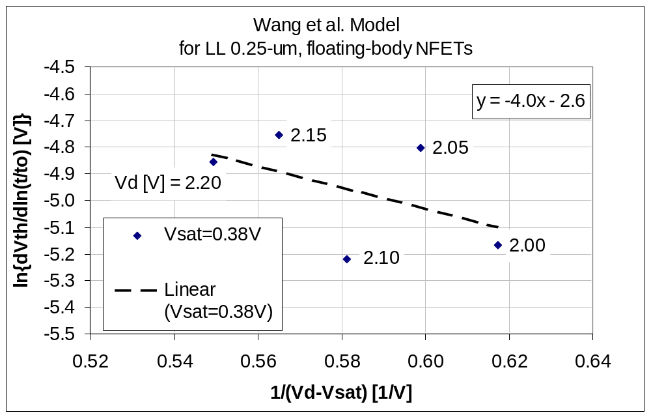
Fig. 12: Extraction of Vc in Wang model. Standard error of slope is about 100%.

Simulation

The 0.25-μm, floating body NFET was simulated in two dimensions with DESSIS. It was first verified that the Id vs. Vg characteristic resembled that of the experimental devices. Then the bias parameters were set at Vg = 1.0 V and Vd = 2.0 V. In Fig. 13 the total structure with the potential distribution is shown.

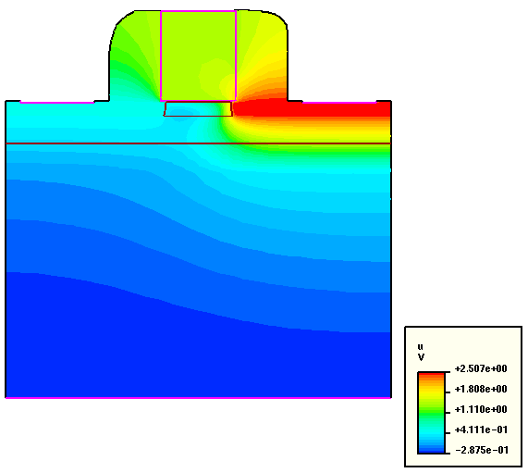
Fig. 13: Cross section of 0.25-μm NFET with electrostatic potential

The simulator allowed to directly extract the electron temperature Te, which is plotted in Fig. 14. The maximum temperature is, as expected, located near the border of the medium doped drain (MDD) zone. The high-temperature zone extends vertically all the way to the buried oxide (BOX). The darkest stripe in the plot with an average width of about 10 nm encompasses a Te-range of about 3200 K to 3500 K. This corresponds to an energy per degree of freedom Φe = k Te / 2 in the range of 0.14 eV to 0.15 eV since Boltzmann’s constant is k = 8.62×10⁻⁵ eV/K.
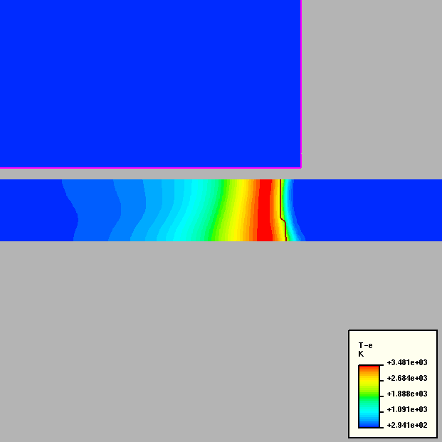
Fig. 14: Electron temperature distribution near the drain. Dark line delineates left border of MDD.
Next, Fig. 15, the electron density n in the body is plotted. It is, as expected, high in the channel region before pinch-off. But at the BOX interface, in the high temperature region, it is still in the order of ns = 10¹⁶ cm⁻³. This allows for a current density that is large enough to charge interface states at the BOX. The initial particle current density has been estimated from thermionic emission with Richardson’s equation as

Js = ns √ ( k Te / 2 π mo m* ) exp (- Φact / k Te )
Eq. 12
where mo = 9.1×10⁻³¹ kg is the free electron mass and m* ≈ 0.3 the effective mass factor.
With the upper limit for the interface state activation energy Φact = 1.8 eV from the previous section and the lower limit
k Te / 2 = 0.14 eV = 1.6×10⁻¹⁹ (J/eV) × 0.14 eV = 2.2×10⁻²⁰ J,

one obtains a lower limit

Js = 10¹⁶ cm⁻³ √ (2.2×10⁻²⁰ J / 0.3 π 9.1×10⁻³¹ kg ) exp (-1.8 eV / 2 × 0.14 eV )
= 10¹⁶ cm⁻³ × 1.6×10⁵ (m/s) × 1.6×10⁻³ = 2.6×10 ²⁰ cm⁻² s⁻¹.

This particle current should be able to charge interface states, which have an upper density limit of about 10¹⁵ / cm², in a fraction of a second. However, the charge current diminishes as charge builds up in the interface states due to Coulomb repulsion. We hope to incorporate the thermionic emission model into DESSIS in the future, in order to simulate the threshold voltage shift and other degradations directly. The built-in gate current model does not apply for the charging of interface states at zero back bias.

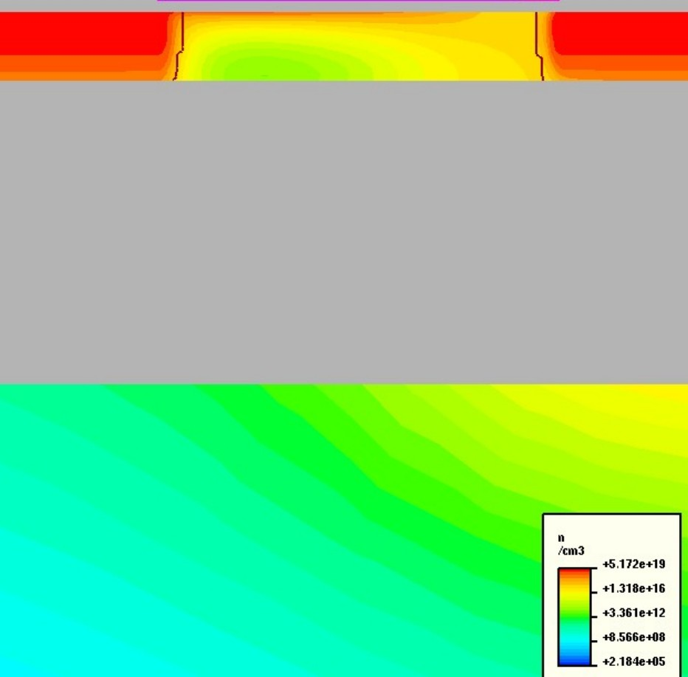
Fig. 15: Electron density in Si-film

Conclusions and Recommendations

It has been shown that the buried oxide in these fully depleted SOI processes is the weakest link. Failure mechanisms have been identified as oxide interface state generation or charging by hot electrons and excessive oxide leakage. Interface state charging, which lead in the 0.25-μm process to an intolerably short lifetime at the nominal 2-V operating voltage, can be suppressed by the H-gate design with grounding of the transistor body. The penalty for this design is, of course, its larger footprint. Tolerable lifetimes can also be achieved through lowering the supply voltage. Quantitative prediction formulas have been presented for that case. The oxide leakage in the 0.18-μm process seems to be of no consequence as long as no voltage is applied between source and substrate. In fact, a 125Kbit SRAM that was fabricated on the same run functioned satisfactorily. The predicted hot carrier lifetime for a 0.18-μm transistor at the 1.5-V supply voltage is excellent. However, it deteriorates fast when the supply voltage is raised. A scaling relation of the hot-carrier lifetime for larger than minimum gate lengths was also presented. By balancing drain voltage with gate length, some power transistors may be possible.

As a first defense, of course, the SOI substrates, which are usually procured from outside vendors, should be properly qualified before any IC processing. We have shown that a characterization of the buried oxide interface that relates to hot carrier effects is indispensable. Such a characterization, which should be applied to every wafer and require no processing, could be based on interface parameter extraction with point contact diodes and subsequent transistor hot-carrier simulations or directly on nano-contacted pseudo-transistors .

References

U. Lieneweg and L. Reiner, “Test Results of Magnetic, Photo and Thermal Sensors on 0.18-um FDSOI”, JPL Internal Report, November 23, 2026
U. Lieneweg and A. Vandooren, “Reliability Evaluation of Silicon-on-Insulator (SOI) Processes: Hot-Carrier Degradation in SOI MOS Transistors”, JPL Final Report for FY’00, December 2000, CL#00-2728
E. Takeda, C.Y. Yang, and A. Miura-Hamada, “Hot-Carrier Effects in MOS Devices”, Academic Press, San Diego, 1995
U. Lieneweg and A. Vandooren, “Reliability Evaluation of Silicon-on-Insulator (SOI) Processes: Hot-Carrier Degradation in SOI MOS Transistors”, JPL Final Report for FY’00, December 2000, CL#00-2728
Hu C.M., Tam S.C, Hsu F.C., Ko P.K., Chan T.Y., Terrill K.W., “Hot-Electron-Induced Mosfet Degradation - Model, Monitor, And Improvement”, IEEE T Electron Dev 32: (2) 375-385 1985
S.-H. Renn, C. Raynaud, J.-L. Pelloie, and F. Balestra, “A thorough investigation of the degradation induced by hot-carrier injection in deep submicron N- and P-channel partially and fully depleted Unibond and SIMOX MOSFETs”, IEEE Trans. Electron Dev., vol. 45, no.10, p. 2146, October 1998.
Sinha, S.P.; Duan, F.L.; Ioannou, D.E.; Jenkins, W.C.; Hughes, H.L., “Time dependence power laws of hot carrier degradation in SOI MOSFETs”, SOI Conference, 1996. Proceedings., 1996 IEEE International , 1996, Page(s): 18 -19
U. Lieneweg and A. Vandooren, “Reliability Evaluation of Silicon-on-Insulator (SOI) Processes: Hot-Carrier Degradation in SOI MOS Transistors”, JPL Final Report for FY’00, December 2000, CL#00-2728
Q. Wang, M. Brox, W.H. Krautschneider, and W. Weber, “Explanation and model for the logarithmic time dependence of p-MOSFET degradation”, IEEE Electron Device Letters 12, 218 (1991)
U. Lieneweg , “Hot-Carrier Degradation of 2-Volt Silicon-On-Insulator (SOI) Transistors”, Second Annual NEPP Conference on Electronic Parts, Packaging, and Radiation Characterization for Space Applications, May 2001, Pasadena, California
Ong T.C., Ko P.K., Hu C.M., “Hot-Carrier Current Modeling And Device Degradation In Surface-Channel P-MOSFETs”, Ieee T Electron Dev 37: (7) 1658-1666 Jul 1990
DESSIS, ISE-TCAD Manuals, Release 6, Vol. 5, Integrated System Engineering (1999)
Ong T.C., Ko P.K., Hu C.M., “Hot-Carrier Current Modeling And Device Degradation In Surface-Channel P-MOSFETs”, Ieee T Electron Dev 37: (7) 1658-1666 Jul 1990
E. Takeda, C.Y. Yang, and A. Miura-Hamada, “Hot-Carrier Effects in MOS Devices”, Academic Press, San Diego, 1995
B.R. Blaes, JPL, private communication
Cristoloveanu, S.; Munteanu, D.; Liu, M.S.T.: “A review of the pseudo-MOS transistor in SOI wafers: operation, parameter extraction, and applications”, Electron Devices, IEEE Transactions on , Volume: 47 Issue: 5 , May 2000, Page(s): 1018 -1027
U. Lieneweg , “Hot-Carrier Degradation of 2-Volt Silicon-On-Insulator (SOI) Transistors”, 2nd Annual NEPP Conference - Electronic Parts, Packaging, and Radiation for Space Applications - May 15 - 16, 2001, Pasadena, CA

