MEASUREMENT OF CHARGE STORAGE AND LEAKAGE IN POLYIMIDES *

A. R. Frederickson and C. E. Benson
California Institute of Technology Jet Propulsion Laboratory
5800 Oak Grove Drive
Pasadena, CA 91109
and
James F. Bockman
NASA Langley Research Center
Langley, VA
28 November 2001

I. ABSTRACT

Resistivity and electric charge storage properties of LaRC-SI and Kapton polyimide samples were studied in a dark evacuated environment, both before and after 5-megarad cobalt-60 gamma irradiation. The data is intended for application to spacecraft insulators that may experience charging induced by space radiations. A “new” measurement method is developed. Effects with both copper and aluminum electrodes were examined. In different tests, slow electrons, and 4-keV electrons were used to charge surfaces of 50-micron polyimide to about 500 volts while the opposite surfaces were metalized and grounded. The subsequent decay of surface voltage can be interpreted as a current through the resistivity of the dielectric. The same samples tested by classical ASTM and IEC methods provided resistivities of order 1E16 ohm-cm, but when tested by our evacuated charge decay method the resistivity was 5E19 to 5E20 ohm cm or more. Charging with low energy electrons produced resistivity data reasonably similar to that produced by charging with 4-keV electron beams. The gamma irradiation, followed by one month of rest under no bias, reduced the resistivity by a factor of ½ in both materials. Raising temperature from the normal 20C to 50C reduced the resistivity in Kapton, but the reduction was not observable in the LaRC-SI material. Even after twenty days of “constant-bias” the rate of fractional charge loss continued to decline indicating that polarization current rather than ideal resistivity was the cause of most voltage decay, and that the true resistivity is higher than the values determined here, and much higher by several orders of magnitude than the values determined in classical ASTM and IEC test procedures. The effects of electron beams at 20 keV were also briefly studied. Under electron beams the LaRC-SI material was considerably less leaky than was Kapton, and the LaRC-SI produced fewer discharge pulses than did the Kapton.

* Most of this work was performed at the California Institute of Technology, Jet Propulsion Laboratory as part of a program managed at NASA Langley Research Center, and under contract with NASA.

II. INTRODUCTION

Electrical Insulators on spacecraft are irradiated with high-energy electrons in the space environment, and subsequently charged, sometimes to high voltages. Occasionally such charged-insulators generate spontaneous electric partial-discharge pulses of current of order mA to ten Amperes and lasting tens to thousands of nanoseconds. Such pulses can disrupt spacecraft, or destroy microcircuits. The pulses are very similar to the pulses developed in normal applications on Earth by a walking person becoming charged and then touching an electronic circuit, or a car door handle. These events are known to disrupt, and sometimes destroy microcircuits.

When evaluating the threat to spacecraft, reliability analysts will calculate the rate of charge introduced into the insulators from space, and attempt to balance this against the rate of charge leakage from the insulators. The charge leakage current density is assumed to be the quotient of electric field in the insulator divided by the bulk resistivity of the insulator. The bulk resistivity of the insulator is typically found in the material handbooks and is based on IEC or ASTM test methods [1,2]. As the insulator in space accumulates charge the electric field rises until the leakage current equals the accumulation current, or until the insulator “breaks-down” and generates a pulse.
Thus, the design of spacecraft is critically dependent on the value for insulator resistivity.

It is likely that ASTM and IEC methods are not applicable to this spacecraft problem. ASTM and IEC methods occur in air, place conductors on both surfaces of insulators, and measure the leakage current after only a few minutes to hours of bias application. But spacecraft often have only one surface of the insulator in contact with a conductor, are in vacuum, and experience reasonably steady bias for a year or longer.

That the leakage current in metalized insulators stressed by constant voltage continues to decay for days and weeks is well known by Dielectricians, and is briefly mentioned in the IEC test guidelines. Apparently normal applications for the resistivity data in handbooks have, until now, not been interested in the fact that the resistivity continues to increase well after it has been measured. But in spacecraft we need to know how the leakage decays for as long as a year or more.

Therefore we develop a method for measuring the charge storage and leakage in insulators over extended periods intended for spacecraft applications. We have measured the surface voltage continuously on some samples for up to 38 days. There is no limit to the length of time that the measurement can proceed. The handbooks [3,4] indicate values for resistivity in polyimides from 1E16 to 1E18 ohm-cm based on ASTM and IEC methods. Based on our method the actual resistivity is found to exceed 5E19 ohm-cm for Kapton polyimide, and for the LaRC polyimide exceeds 5E20 ohm-cm.

Long-term storage of charge in spacecraft applications is a detriment. It implies that unless a mechanism for leakage is provided, eventually spacecraft insulators will accumulate sufficient charge to generate a dangerous discharge pulse. It is known that polyimides can be made conductive by pyrolosis. Irradiation by high-energy rays such as electrons, protons or gamma rays produces some of the same changes in solids as does pyrolosis. Polyimide is especially interesting because it maintains thermal and mechanical properties under pyrolosis, yet reduces resistivity by many orders of magnitude. If one sufficiently pyrolizes polyimide it will not store dangerous charge in spacecraft applications.

Therefore, it may be possible to simply irradiate polyimide to reduce its resistivity in order to prevent pulsing in space applications, yet maintain other desirable properties. To investigate this possibility we irradiated samples with cobalt-60 gamma rays and assessed the change in resistivity after the irradiation.

III. EXPERIMENTAL METHODS

Both LaRC-SI and Kapton (tm: DuPont Co.) samples were measured. Sample surfaces were charged to high voltage using two methods: charging by slow electrons and charging by multi-keV electrons. All tests were performed at high vacuum, typically 1E-6 Torr. The surface voltages were monitored with an electrostatic field probe that did not contact the surfaces. Samples could be heated or cooled, but results were obtained at 20 and 50 degrees Celsius only.

III.A Charging the Samples

III.A.1 Technique To Charge Insulators To High Voltage By Slow ~10 eV Electron Impact.

The simplest arrangement for charging an insulated surface is defined by the following arrangement in Fig. 1. The insulated surface of the sample faces the electron source and/or the field probe. The other surface of the sample is metalized and connected to the sample mount so that it can be biased relative to Earth.

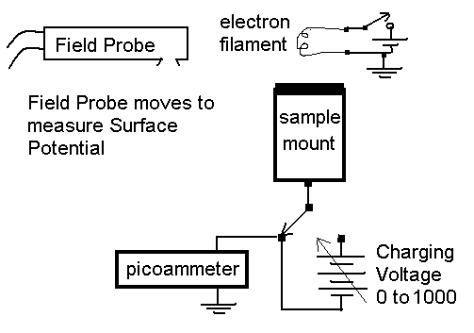
Figure 1. Arrangement for Charging Using Slow Electrons, and Subsequent Measurement of Sample Surface Voltage. The picoammeter is not necessary, but it sometimes provides useful diagnostic information during charging, or if the sample is discharging across the vacuum due to photoemission or other means.

The field probe is moved to face the sample when one wishes to measure surface potential. The filament is spaced about 10 cm from the sample and is powered by about 1.5 volts at 0.35 watts. The field probe is spaced roughly two cm from the sample face when the potential is measured. The apparatus is placed in a vacuum chamber that also contains an electron beam that can alternately be used to charge the sample surface.

Imagine that the sample is a perfect insulator. If the charging voltage is set to, say, +100 volts the field probe will measure "100-volts". The field probe is then moved away from the sample. One then turns on the filament and the electrons emitted by the filament travel to the surface of the sample and "ground" the surface of the insulating sample. This establishes 100 volts across the sample. The filament is then turned off and the 100 volts remains across the sample. The field probe may then be moved to face the sample and confirm the fact that the sample surface is grounded by measuring 0-volts.

One then grounds the rear electrode of the sample and instantly the field probe should register –100 volts as the surface voltage on the insulating sample. If the sample is leaky, the –100 volts decays through the sample bulk and into the ground wire, and its decay time constant is measured. The resistivity of the sample is determined from its decay time constant, τ = RC.

This experiment is ideal because it does not produce radiation damage to the sample and measures its pre-radiation property. It is simple and direct. It does not require de-convolving electron depth-dose and charge deposition phenomena. It truly measures the dark conductivity of the sample material.

Tests with one-inch samples have determined the smallest samples that can be conveniently studied, 1-inch diameter. The field probe becomes both hard to calibrate and much less sensitive for smaller samples.

Use of other insulators in the chamber to isolate the actual sample would, in effect, produce data characteristic of the isolating insulator, and not of the sample. One must be careful that the only insulator contributing to electric fields sensed by the probe is the sample. Additionally, one must be certain that other insulators do not affect the charging-up of the sample under test. Other insulators exposed to the electrons emitted from the filament may charge and then deflect subsequent electrons in the chamber, thereby affecting the charging-up process.

III.A.2 The Preferred Charging Field-Geometry.

The best geometry is one that allows only the front of the sample to be irradiated and charged. In Fig. 2, the vacuum chamber walls and the aluminum mounting structure prevent electrons from irradiating any but the front surface of the insulator. None of the wiring is irradiated either. Thus, the front of the sample is the only insulated surface to be exposed to radiation. Also, note the copper guard ring electrode on the rear of the sample. This prevents edge effects from affecting the measurements at the center electrode of the sample. Guard rings are recommended in the IEC Method [2] and are often good practice in electrostatic studies.
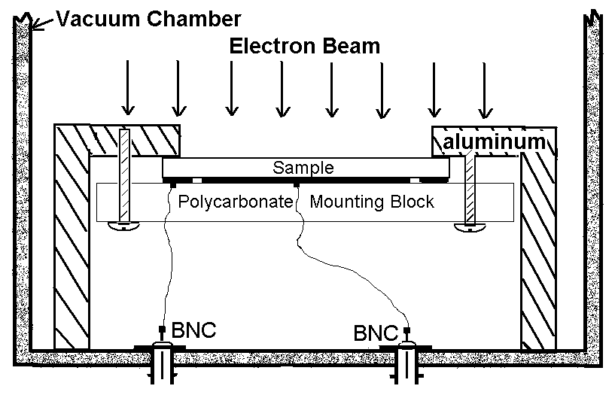
Figure 2. The arrangement for the tests of Polyimides.

Other arrangements may be satisfactory in some cases. The critical issues are: possible effects of other insulators in the chamber, and control of the electron currents in the vacuum to produce known charging of the test sample. For example, samples may be simply mounted on a back-plane of metal and connected to the electronics. Alternately, large samples may be stretched on a frame that is mounted to metallic underpinnings. The sample can be made of a larger area than its metallic supports and thus avoid measurement error due to secondary electron effects across the surface.

Note that care is taken to prevent insulators near the sample from being charged by the electron beam and by scattered electrons. The Peltier cooler has some insulation associated with its construction, and the sample mount has insulators, but all insulators are electrostatically decoupled from the space around the face of the sample. It is difficult, not impossible, for electrons to charge these insulating structures, so they should be electrostatically decoupled.

III.A.3 Method of Charging with kev Electrons in Vacuum.

In order to measure resistivity under spacecraft conditions where non-metalized surfaces of polyimide are exposed to vacuum one may use an electron beam to charge the sample. It is, in fact, high-energy electrons in space that charge the sample. Once charged, the surface of the sample can discharge to ground through the bulk-conductivity of the sample and onto the grounded copper electrode at the other (rear) surface of the sample.

The test method is simple. First one charges the surface. Then the surface voltage is monitored using an electrostatic field probe. The decay of surface voltage is related to the conductivity of the sample. It is assumed that the decay is a simple exponential decay where τ is the 1/e-time decay constant. The decay of surface voltage is related to the resistivity, ρ, by the equation τ = ρε = RC. The permittivity of the dielectric is ε.

Based on published ASTM methods [1], previous measurements on LaRC SI polyimide in this laboratory indicated that its (so-called) resistivity is of order 1.4E16 ohm cm. Its permittivity is 2.76E-13 Farads/cm (relative dielectric constant is 3.12). Thus, based on the ASTM measurements, one expects that τ = ρε = 3.86E3 seconds = 64 minutes. Therefore the experiment is arranged to measure decay constants of order 64 minutes efficiently. One must be certain that surface voltage does not decay by currents passing through the vacuum and, therefore, the measurements are performed in the dark, and without vacuum gages being near the sample. (Some vacuum gauges have been seen to emit a small amount of plasma and thereby discharge surfaces.)

Second Crossover Point

One must charge the samples with electrons and not overcharge to the point of breakdown. One is advised to know the energy at the second crossover so that overcharging of the surface by keV electron beams does not occur. Since the samples are 0.051 mm (two mils) thick, one must not exceed 1-kV on the surface for long periods (20 kV/mm is typical breakdown threshold). Additionally, one may be concerned to avoid high field conductivity effects and stay below the level of 10 kV/mm. Our measurements using the ASTM method applied 64 volts through the sample, roughly 1/10 of the voltage where high-field conductivity effects begin to be important. High-field conductivity greatly exceeds regular conductivity. Therefore the electron beam tests should initially stay well below 1-kV potential on the surface.

A beam of 1-keV electrons is not capable of charging most polymer surfaces because for every electron incident more than one secondary electron is emitted. In order to charge the surface one must raise the energy above the energy of the so-called second crossover point, above which secondary electron emission is less than the incident particle flux. For higher energy beams the surface voltage will ultimately achieve a value given by the electron accelerator voltage minus the second crossover voltage. For example, a 10 keV beam incident normally on a surface with 1.8 keV second crossover will eventually charge the surface to –8.2 kV (provided the beam incidence remains normal). For our samples such charging voltage should be avoided.

The second crossover point was measured in both samples by exposing the samples to electrons over the range 0 - 5,300 keV and measuring the voltage on the floating back copper electrode. Back electrode voltage vs. beam energy was plotted to locate the second crossover point. The crossover point was determined to be 1.8 keV. Above this energy the electrons entering the film are greater than the number being knocked off the surface, and negative charge begins to accumulate.

The second crossover point is measured with the apparatus diagrammed in Fig. 3.

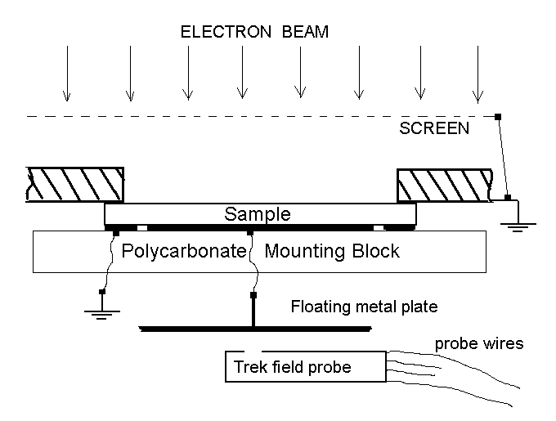
Figure 3. Apparatus for determining second crossover point, and for charging the sample with keV electron beams.

The grounded screen decreases the deflection of the electron beam by the charged sample. This holds the incident electron trajectories so that they are incident upon the sample close to normal (perpendicular to the surface). The field probe is fixed in position near the floating metal plate that is attached to the back copper electrode. The field probe is calibrated by impressing a known voltage on the floating metal plate. For these tests, the field probe was spaced so that its reading indicated 0.75 Vplate. Thus a 400-volt plate indicated as 300 V on the field probe.

During the irradiation at each beam energy, say 2keV, the irradiation proceeds long enough to fully charge the sample. The potential on the metal plate is measured only when further irradiation at 2 keV does not further charge the sample, and steady state voltage has been achieved. The results are shown in Fig.4.
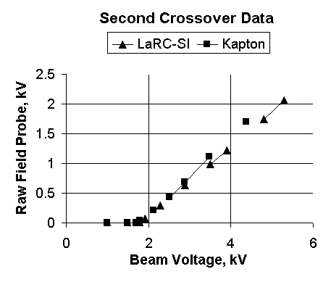
Figure 4. Ultimate Surface Voltage vs. Electron Accelerator Voltage.

From the second crossover data in Fig. 4 one sees immediately that the second crossover point occurs at 1.8 kV for both samples. The two slopes are slightly different because the placement of the probe near the Kapton sample was not identical to that of the LaRC-SI sample creating a slightly different calibration factor. The slopes are not exactly equal to 0.75 because the grid did not fully eliminate the effect of beam deflection by the charged surface.

Capacitance Voltage Divider Model

For this kind of test there is one further calibration factor that needs to be determined. Capacitive voltage division causes the front surface voltage to be different from the back electrode voltage.

The following capacitance model represents the electric field probe experimental setup. The field probe monitors the voltage, V_{BE}, on the rear electrode. The field probe voltage was calibrated by applying a known voltage, V_{BE,} and reading the field probe. The field probe reading was 75% of the applied V_{BE}. But when the voltage is caused by a charge, Q, on the surface of the sample, there is a voltage drop in the sample causing a smaller voltage to appear on the back electrode. We need to determine a correction for this effect. Figure 5 illustrates the effect.
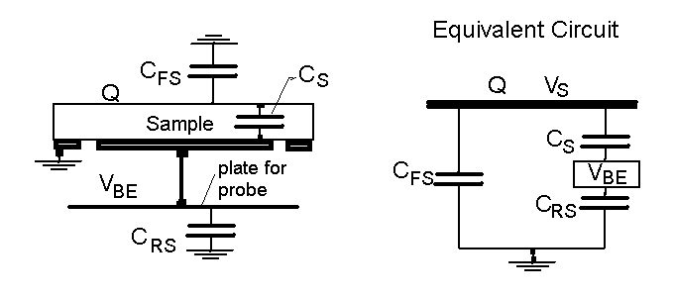
Figure 5. Equivalent Circuit for Field Distribution at Field Probe.
C_{FS} - Front surface capacitance (sample surface opposite the center electrode to mounting hardware and vacuum chamber walls).
C_{S} - Sample capacitance (front of sample to copper electrode at rear of sample).
C_{RS} - Rear probe plate capacitance (connecting wire and plate to grounded objects including the mounting hardware, guard ring, etc.).
Q - Charge injected into sample (electrons from electron beam are stopped within the first micron which is essentially on the surface).
V_{S} - Front surface voltage on sample.
C_{RS} = 10.5pF
C_{FS} = ~1-2pF (estimate)
C_{S} = εA/d = (3.12) ( 8.85E-14 F/cm) (16.6cm²) / (.0051cm) = 899 pF
Dielectric constant of LaRC-SI = 3.12
Dielectric constant of Kapton = 3.4

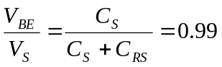The solution to this system is

Thus the capacitance division requires one to make a small correction, only 1%, which in this work can be ignored.

III.B. Surface Voltage Measurement Techniques

Samples KA001 (Kapton) and SI001 (LaRC-SI) were charged using the low energy electrons with an applied bias on the rear electrode in the configuration of Fig. 6. The only insulator that can be charged by the electron beam, or by the slow electrons, is the sample surface itself.

Figure 6. The Sample Mounting Configuration. Usually the guard ring is held at ground potential. The diameter of the center electrode on the sample is 4.6 cm and its area is 16.6 cm². The diameter of the opening on the aluminum mount is 5.08 cm. The vacuum chamber is 73 cm long so that two samples and a ground reference sample were simultaneously in the chamber. By remote control the field probe is placed in front of either a sample or the ground reference, or placed near the edge of the chamber.

The vacuum chamber was nearly light tight. The vacuum gauges were usually left off so that they would not contribute plasma to the chamber. The vacuum was nominally 1E-6 Torr or better during the extended period of the test. Unless otherwise noted the temperature was between 20 and 25 C.

Figure 7 describes the method for surface voltage measurement. This method has the advantage of being insensitive to drift in the calibration of the electrostatic field probe. First the field probe is positioned in front of a grounded plate and its zero is established. A voltage applied to the plate may be used to assess if the field probe sensitivity is approximately normal. Then the field probe is placed in front of the sample and its surface voltage, as indicated by the probe, is noted for reference. However, the surface voltage is measured by adjusting the voltage source until the field probe reads zero volts. The surface voltage is then equal, and opposite in polarity, to the voltage source.

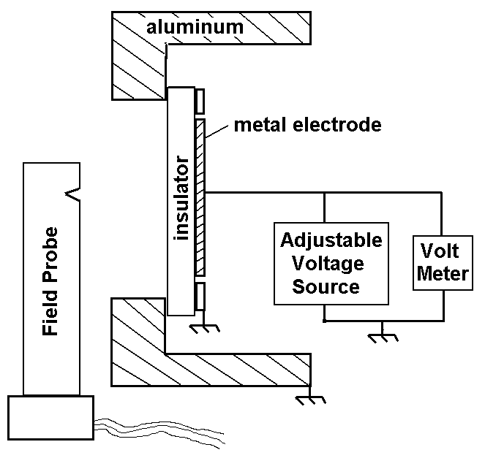
Figure 7. Measurement of the surface voltage by adjusting the voltage source so that the field probe reads zero volts.

The samples were charged using a positive bias of 500 volts on the rear electrode as the electron-emitting filament (Fig. 1) provided several nanoamperes per cm² to the sample surface. At incident energies below 500 volts, all of the electrons are stopped within the first 1000 Angstroms of the insulator sample. After about ten minutes, the filament was turned off and the surface voltages were monitored for 38 days while the rear electrode was held grounded (except during the voltage measurement). If the samples were conductive, charge would flow to ground through the rear electrode causing the surface voltage to decrease.

Pictures of the Apparatus

The polyimide samples were mounted in their circular mountings as shown in the next picture.
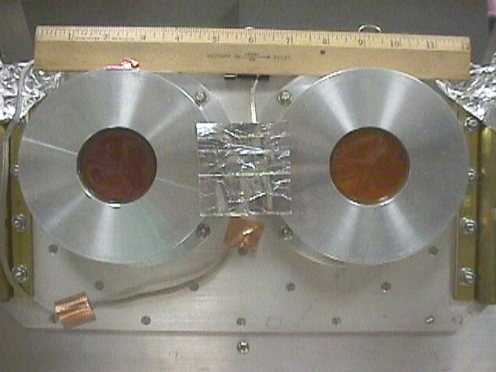

As a piggy-back experiment, a piece of Mylar was mounted between the two polyimide samples. The Mylar experiment will not be discussed in this report. The field probe was placed on a transit stage before the array of the three samples as shown in the next picture.
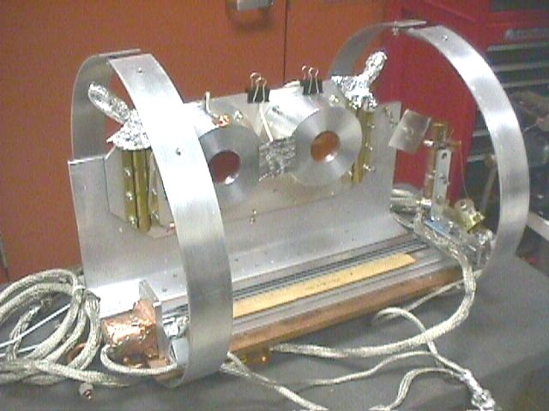

The field probe is contained in the vertical copper tube near the right-most end of the transit stage. As the probe moves towards the left, it first passes in front of a diamond-shaped plate whose bias can be set, thence in front of the kapton-001 sample, thence in front of the Mylar, and finally in front of the LaRC-SI-001 sample. As indicated in the following picture, the field probe is spaced approximately 5 mm from the surfaces of the sample holders as it moves on the transit stage. The complete apparatus is inserted into the vacuum chamber with the two circular rings tightened against the walls of the cylindrical chamber.
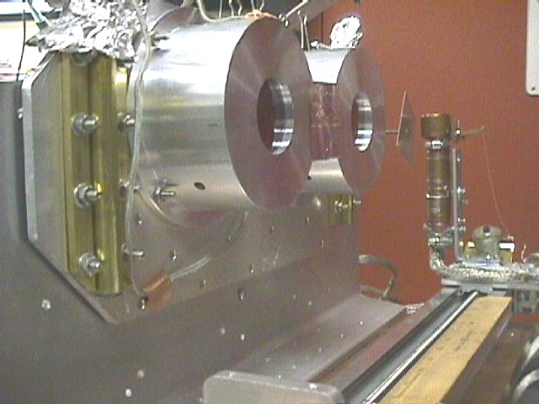

The brass tubes contain resistive heater elements that heat the aluminum plate upon which are mounted the circular polyimide sample holders. The Peltier coolers are squeezed between the aluminum plate and a cooled aluminum “T” beam.

Temperature Effects

The samples are expected to demonstrate their worst charging behavior at low temperatures. Low temperature will be achieved by the use of an in-chamber liquid-cooled thermal sink aided by electric Peltier coolers to achieve a larger range of temperature. The base plate, to which the sample mounts, is cooled by the Peltier cooler, or is heated by the resistor heaters that are enclosed in the brass tubes. The cooler/heater was constructed as part of this task.

The Peltier coolers allow lower temperatures to be achieved, colder than the circulating fluids in the base plate. The cold thermal sink cools everything in the chamber, including the field probe. The field probe works neither at very low temperatures, nor at very high temperatures. Thus the Peltier coolers are used to locally cool the sample beyond the range of the field probe.

By reversing current through the Peltier coolers, they become heaters. By passing hot fluid into the cold plate it becomes a heater as well. Thus the temperature of the samples can be raised well beyond that of the field probe. Resistive heaters are also available to heat the samples.

Because the samples stored charge for exceedingly long times at room temperature (20 – 25 C) there was no need to go to lower temperatures in the testing.

Experimental Measurement of Leakage Through the Vacuum Itself

It is known that light from the electron-emitting filament also removes electrons from the sample surface, and may induce conductivity through the bulk of the samples. This effect may generate errors in the measured data. Additionally, plasma in the vacuum can alter the surface potential. Plasma is generated by the vacuum gauges and by the ion vacuum pump. Usually, these sources remained off if there was the possibility that they would generate false data. However, it is best to actually measure the magnitude of the ion currents so-generated.

A square plate, 5x5 cm², was connected to the vacuum tank BNC feed-through with several feet of coaxial cable. The capacitance to ground (tank walls) of the plate and cable was measured to be 130 pF. A bias of +500 volts was maintained overnight on the system in order to “fully” polarize the cable dielectric. With the plate at +500V the field probe measured 277 V, thus providing a calibration factor of 1.805.

The bias was removed and the 130 pF system was allowed to slowly discharge while both the ion gage and the ion pump were off. Vacuum was maintained with the oil diffusion pump system which generates no plasma or light. After 5-hours the field probe reading had decayed to 261V, or 471 volts on the surface of the sample. The decay rate was 29V/5 hr = 5.8 V/hr. Most of this decay probably occurs through the coaxial cable dielectric.

The same test was performed while the ion pump alone pumped on the chamber. It was pumping at a “rate” of 20 mA, near its maximum rate at about 5E-6 Torr. At this rate it is generating the maximum amount of ions and electrons that it can for extended times. After 5 hr 20 minutes the surface voltage had decayed from 471V to 437V. The decay rate is therefore 34V/5.333hr = 6.4 V/hr.

Perhaps the data can be interpreted as if the ion pump and ion gage cause the 130 pF system to decay by 6.4 – 5.8 = 0.6 V/hr. Considering the errors in these measurements, the decay rate induced by the pump and gage was definitely less than 1 V/hr on 130 pF. The discharge current through the vacuum due to ion pump and ion vacuum gage is thus less than C*dV/dt = I = 3.6 E-15 Amperes. This when the ion pump is generating its largest sustainable ionized gas level.

It is interesting to speculate on the present capability of the system to measure small currents in the chamber. We can certainly measure a change of 2-volts with an error of 1-volt. We could do this on a witness plate suspended by long and thin, effectively non-conducting, polymer or glass strands. Such a plate would have a capacitance of less than 50 pF to the chamber walls, assume approximately 10 pF. Assume that we monitor the voltage decay for 12-days = 1E6 seconds. Then CdV/dt = 2E-17 amperes which is approximately 100 electrons/second.

Leakage through the vacuum is “in parallel” with leakage through the insulator sample. The vacuum currents thus have the effect of making the insulator sample appear more conductive than it really is. The vacuum currents have been shown to be less than 3.6E-15 Amperes from a sample area (two sides) of 50 cm². As experiments are performed the actual vacuum currents will become better known. For example, the samples being tested have a capacitance of 9.0E-10 F. The smallest measured decay rate was about 0.33 V/day, or 3.8E-6 volts/second. The current I = CdV/dt = 3.4E-15 Amperes onto the sample with a surface area of 16.6 cm². Thus it is possible that the leakage in our samples was partially provided by currents in the vacuum!

After the irradiations at all energies have been completed, the surface voltage can be discharged using a continuous irradiation beginning with electrons at 1 keV above the surface voltage and continuing while very slowly lowering the beam energy to less than the second crossover energy. Although this removes the surface voltage, it does not remove an internal dipole field just below (within about 1000 Angstroms) the surface. The internal dipole field is a remnant of the stopping depths of the electron beams (and other effects).

IV RESULTS OF CHARGE DECAY TESTS ON POLYIMIDE WITH COPPER ELECTRODE

IV.A. After Charging by Slow 50-500 eV Electrons.

The virgin Kapton 001 and virgin LaRC-SI 001 samples were first charged with low energy electrons, 50-500 eV, on 17 April, 2001. This was accomplished by biasing the rear copper electrodes at +500 volts and lighting the electron-emitting filament in the vacuum spaced about 20 cm from the sample's front faces. The un-metalized surfaces of the samples were thereby charged to approximately minus 400 to 500 volts relative to the copper electrodes on the rear faces of the samples. It takes more than one minute to move the field probe into position before the sample and take a surface voltage measurement. Because the operations of the field probe occur slowly, one cannot know the exact starting voltage on the samples, except that it cannot “exceed” (-)500 volts.

Five hundred volts was chosen for good reasons. Generally, conductivity in dielectrics increases, resistivity decreases, with increasing electric field strength. Five hundred volts is near to the maximum electric field that can safely be placed on this material for many years without generating partial discharges that could harm sensitive electronics. Additionally, space radiation induces similar electric fields in good insulators. One wishes to know the amount of conductance that is available to remove radiation-induced space-charge at field strengths where it is safe from partial discharge pulsing, but not unreasonably safe.

The potentials of the un-metalized faces were then periodically monitored from 17 April to 7 May 2001 at room temperature, and from 8 May to 11 May at 50 C. Initially there was a steep decline of surface voltage, about 20% on the Kapton sample and 10% on the LaRC-SI sample during the first three days. The early decay is shown in Fig. 8. Afterward, as shown in Fig. 9, the LaRC SI polyimide maintained nearly all of its charge even during the application of 50 C temperature. Fifty degrees C was maintained on both samples between 20.6 days and 23.6 days when the increased rate of charge decay can be seen in the Kapton sample.
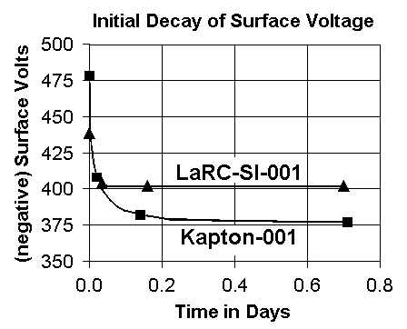

Figure 8. Decay of surface voltage during the first day. It is important to note that the ASTM D 257-99 method for measurement of conductance takes its measurement after only ten minutes of bias application. Although leakage current is still substantial at ten minutes, it is significantly reduced after a few hours.

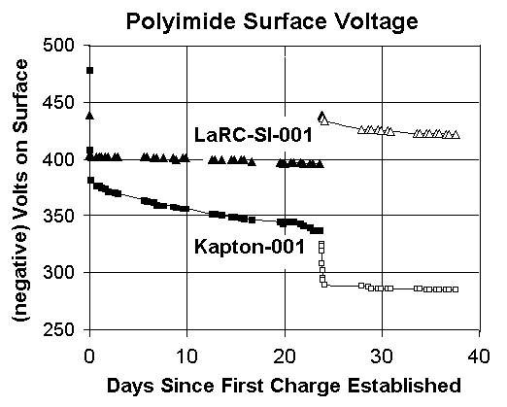
Figure 9. Surface Voltage Decay for Two Polyimide Samples. The first 20-days were at room temperature, Days 20.6-23.6 at 50 C, and room temperature thereafter. Electron beam charging occured at 23.7 days.

IV.B. Electron Beam Discharging and Charging of the Sample Surfaces

The next step in the test procedure is to generate the surface voltage using 4 keV electrons instead of the <500 eV electrons. This is done in order to see how the charge storage properties compare for the two methods of charging. The purpose of this comparison is only a matter of careful analysis and verification of our modeling. We expect to see, at most, a small difference between the two methods.

Consider the fact that the sample surfaces have been maintained at roughly (-) 350 to 400 volts for several weeks. The polarizations of the internal dipoles have become relatively stabilized by this time (a presumption). The field internal to the region of penetration by the 500 eV to 50 eV electrons has also become stable. Now, the 4-keV electron irradiation will penetrate more deeply into the faces of the samples and produce a different charge depth profile than was produced by the <500 eV electron charging case. Electrons and holes will be excited into traps over the range of depths penetrated by the 4-keV electrons. Later some of these trapped carriers will be thermally excited into the conduction (valence) band and move so as to reduce the local electric fields. The experimental data is taken in an attempt to see if this happens in a measurable way.

Discharging:
First, the sample surface is discharged to nearly zero volts. Discharging is accomplished by irradiating the surface with electrons at incident energies between the first and second crossover points for secondary electron emission. Since the sample surfaces have been charged to approximately minus 400 volts, an electron beam at 1 keV will hit the surface with 600 eV energy. This will emit more than one secondary electron per incident electron, thereby discharging the negative surface potential. The samples were bombarded with roughly 0.5 nA/cm2 for several minutes as the beam energy was continuously lowered from an initial 1.5 keV to zero eV. The sample surfaces were then measured to be within 3 volts of ground. The sample surfaces remained at zero voltage for nearly 30 minutes before being recharged by the 4-keV beam. This 30-minute time span allowed their polarizations to partly relax towards the zero-field condition.

Charging:
The electron beam was raised in energy to 4 keV. The second crossover energy had previously been determined to be roughly 1.8 keV. Therefore 2 keV is the minimum energy required to develop 200 volts surface potential. A 4-keV electron beam is able to develop more voltage. The samples were radiated for about 4 minutes at 4 keV. The radiation was performed in a sequence of short irradiations over a time span of 20 minutes so as to monitor the voltage as charging progressed and thereby develop surface voltages similar to those developed in the 0-500 eV electron charging case.

The Kapton was charged to about (-)325 volts, and the LaRC-SI was charged to about (-)439 volts. Again the Kapton exhibited a rapid decay of surface voltage, from 325 to 293 volts in 2 hours 41 minutes. The LaRC-SI surface voltage decayed very little, from 439 to 437 volts in the same time. The open data points in Fig. 9 describe the results after discharging and recharging with the electron beams.

If charging by the 4-keV electron beam is different than charging by 50-500 eV electron impact, Fig 9 does not indicate a dramatic difference. Perhaps after the 4-keV charging the LaRC-SI sample is slightly more “leaky”. And perhaps the Kapton is less “leaky”. The differences are not dramatic.

The following table of data is provided so that one may see the results in full detail.

Table of data from which Fig. 9 is generated.
Kapton sample #KA001
LaRC-SI sample #SI001
Data of april-may 2001.
Room temp., 20-24C
Kapton  KA001 | Kapton  KA001 |  | LaRC-SI001 | LaRC-SI001
DAYS | VOLTS |  | DAYS | VOLTS
0 | 478 |  | 0 | 438.7
0.021 | 408 |  | 0.036 | 403.8
0.14 | 382 |  | 0.16 | 402
0.71 | 377 |  | 0.7 | 402
0.95 | 377 |  | 0.95 | 402
1.18 | 375 |  | 1.15 | 402
1.58 | 374 |  | 1.58 | 402
1.92 | 372 |  | 1.91 | 402
2.62 | 371 |  | 2.61 | 402
2.92 | 370 |  | 2.91 | 402
5.6 | 364 |  | 5.6 | 402
5.9 | 363 |  | 5.9 | 402
6.6 | 362 |  | 6.6 | 401
6.9 | 360 |  | 6.9 | 401
7.6 | 359 |  | 7.6 | 401
8.6 | 358 |  | 8.6 | 401
8.9 | 357 |  | 8.9 | 400
9.6 | 356 |  | 9.6 | 401
9.9 | 356 |  | 9.9 | 401
12.6 | 351 |  | 12.6 | 400
12.9 | 351 |  | 12.9 | 400
13.6 | 350 |  | 13.6 | 400
14.6 | 349 |  | 14.6 | 400
14.9 | 349 |  | 14.9 | 400
15.6 | 348 |  | 15.6 | 400
15.9 | 347 |  | 15.9 | 400
16.7 | 346 |  | 16.7 | 398
19.6 | 344 |  | 19.6 | 397
19.9 | 343 |  | 19.9 | 396
20 | 344 |  | 20 | 396
Change Temperature to 50 C.
20.6 | 344 |  | 20.6 | 397
20.9 | 344 |  | 20.9 | 397
21.6 | 343 |  | 21.6 | 397
21.9 | 341 |  | 21.9 | 396
22.6 | 339 |  | 22.6 | 396
22.9 | 337 |  | 22.9 | 396
23.6 | 337 |  | 23.6 | 396
Return to 22 C. Discharge the surfaces.
Then charge surfaces with 4 keV electrons.
23.871 | 325 |  | 23.871 | 439
23.875 | 323 |  | 23.873 | 439
23.88 | 319 |  | 23.88 | 439
23.89 | 308 |  | 23.89 | 438
23.905 | 302 |  | 23.905 | 438
23.95 | 295 |  | 23.95 | 437
23.98 | 293 |  | 23.98 | 436
24.11 | 289 |  | 24.11 | 434
27.9 | 288 |  | 27.9 | 426
28.6 | 287 |  | 28.6 | 426
28.9 | 286 |  | 28.9 | 426
29.6 | 286 |  | 29.6 | 426
29.9 | 286 |  | 29.9 | 425
30.6 | 286 |  | 30.6 | 425
30.9 | 286 |  | 30.9 | 424
33.6 | 286 |  | 33.6 | 423
33.9 | 286 |  | 33.9 | 423
34.6 | 285 |  | 34.6 | 423
34.9 | 285 |  | 34.9 | 423
35.6 | 285 |  | 35.6 | 423
35.9 | 285 |  | 35.9 | 423
36.6 | 285 |  | 36.6 | 422
36.9 | 285 |  | 36.9 | 422
37.6 | 285 |  | 37.6 | 422

IV.C. Alteration Of Charge Storage By Irradiation With Cobalt 60 Gamma Rays

An experiment was performed to see if radiation can be used to permanently make polyimides more conductive, and thus less able to store charge. Irradiation generates traps, radicals and free carriers that can contribute conductivity to polyimides. It is well known that extreme heating (pyrolosis) causes polyimides to become conductive.

Irradiation

The same two samples were irradiated to 5-megarads with Co-60 Gamma rays. The Cobalt-60 radiation chamber consists of the stack of materials surrounding the sample as shown in figure 10.
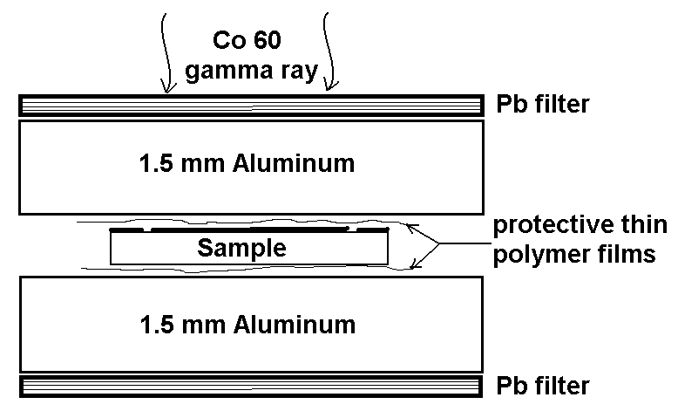
Figure 10. Sample Irradiation System. The entire system is located in vacuum adjacent to the cobalt gamma ray source.

We want to keep the internal charging generated by the cobalt and scattered photons to a minimum. The interface dose-enhancement effects should be minimized, knowing that they cannot be eliminated. Thus we require the lead (Pb) in order to attenuate the broad low-energy peak of scattered photons below 300 keV that is typically generated by Co-60 sources. A factor of ten attenuation is more than sufficient. At 300 keV, the mass attenuation coefficient, A, for Pb is 0.38 cm2/g. If T is thickness, then TA=2.3 for an attenuation factor of ten. Thus, T = 6 g/cm2. The density of Pb is 11.3 so that the lead need not be thicker than 5 mm, but should exceed 2 mm. In a similar line of reasoning, the aluminum is used to attenuate the fluorescent photons that the lead generates, as well as its Auger-electrons and photoelectrons. Additionally, the Al comprises the support structure and protective encasement for the samples. Finally, the thin polymer foils protect the sample from being coated by aluminum while under compression in the encasement.

Although one might worry about the effects of oxygen, in this arrangement there is a limited amount of oxygen available to the sample during cobalt irradiation. Never the less, we have procured a small vacuum chamber in which the irradiations can proceed. The radiations proceeded in an evacuated air chamber at less than 10⁻⁴ atmospheres (100 microns Hg), but more than 10-6 atmospheres (1 micron Hg).

The radiation intensity was measured with an air-ionization chamber temporarily placed between the aluminum sheets where the samples are normally placed. The probable error is +/- 20%. The dose rate was 22.6 rads(Si)/second and the samples were exposed for 3670 minutes starting at 17:20 on 17 August 2001, and ending on 20 August, thus providing 5.0 megarads to the samples. The sample irradiation temperature is estimated to have been between 25 and 30 degrees C, and storage temperature varied from 20 to 25 degrees C.

Testing After the Cobalt-Irradiation

The samples were subsequently stored for one month: unbiased in the dark in air until 31 August, and then in vacuum unbiased until testing began. Thus, the effects of the cobalt irradiation had approximately one month to decay before any charge storage measurements were performed. The rest was scheduled in order to simulate the fact that in actual application of radiation treatments, the irradiated material would not be immediately pressed into service.

Sample KA001 was then first charged using +500 volts on its electrode and the filament electron emitter at 09:00 on 14 September. It alone was monitored until 09:00 on 17 September when sample SI-001 was similarly charged. Testing of charge storage occurred in the dark at a vacuum of roughly 3E-6 Torr at room temperature, 20 – 25 degrees C.

The post-radiation data for the polyimide samples is provided in the following table.

SEPT, 2001 data | post-rad | post-rad
DAYS | Kapton-001 | LaRC-SI-001
 | volts | volts
0 | 496 | 473
0.0007 | 494
0.0014 | 488
0.0042 | 473
0.007 | 461
0.0104 | 453
0.0146 | 446
0.0222 | 428
0.0257 | 425
0.0306 | 421
0.0521 | 409
0.0604 | 407
0.0868 | 402
0.159 | 398
0.17 |  | 471
0.22 | 397
0.23 |  | 467
0.254 | 396
0.96 | 384 | 468
2.06 | 377 | 467
2.37 |  | 466
2.88 | 371
3.05 | 345 | 467
3.125 | 345
3.26 | 344
4 | 340 | 467
4.3 | 338 | 466
5 | 334
5.3 | 334
6 | 332
6.3
7 | 329 | 465

Evaluation of Resistivity, ρ.

Assume that the sample is a simple uniform parallel-plate leaky capacitor. Apply a voltage, Vo, until time t=0. At t=0 disconnect the voltage source from the capacitor so that the following functions hold.

V = Vo exp[-t/ρε] . ρ is the resistivity of the sample material, ε is its permittivity.

For small t/ρε, exp[-t/ρε]= 1 - t/ρε .

Our experiments always deal in the regime where t << ρε and the decay is only a small percentage of the initial surface voltage.

Then (1/Vo)(dV/dt) = (-1/ρε) exp[-t/ρε] = (-1/ρε) [1 - t/ρε] . Note that this function is very nearly equal to (–1/ρε) .

Therefore, ρ = -1/[ε(1/Vo)(dV/dt)] .

Thus a tabulation of (1/Vo)(dV/dt) provides the simplest evaluation of the resistivity, ρ, of the insulator sample. The dielectric permittivity, ε, for the polyimide samples is here taken to be a constant approximately equal to 3.2 x 10⁻¹³ F/cm. However, the reader should not presume that ε really is a constant. Our data proves that the dielectric constant is changing (getting larger) throughout the process of measuring charge decay. (In fact, most of the apparent charge decay current has been a polarization current which equates to a changing dielectric constant as frequency goes lower.) It does not, however, change by more than a factor of two during our measurements. So, the instantaneous value of dV/dt will be measured, and the evaluation of resistivity will proceed with the presumption of a constant dielectric constant, ε. There are practical reasons for making this simple assumption that may be discussed elsewhere. For the time being, we want to stay with the normal ideas that are generally used in this field, even if they are incorrect.

Kapton Resistivity, post 5-megarads.

The measured surface voltage decay rate for the Kapton sample is provided in Fig. 11. After six or seven days of being charged, the decay rate in the irradiated Kapton is approximately 1E-7 per second.

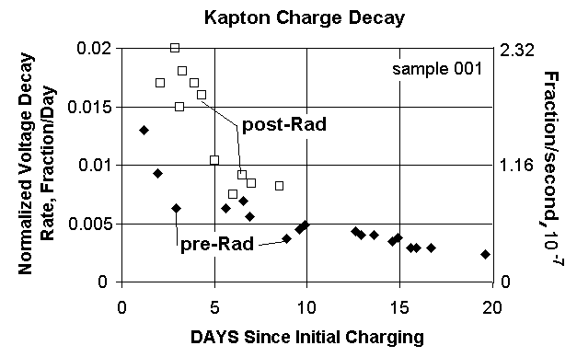
Figure 11. Normalized Voltage Decay Rate in 5-Megarad Irradiated Kapton as a Function of Time Since Charge Was Established.

We arbitrarily choose to compare the pre-rad and post-rad resistivities after one week under constant DC voltage stress when the post-rad decay rate was approximately .95E-7 (fraction/sec). Thus the resistivity of the Kapton post-rad is 1/(3.2E-13)(.95E-7) = 3E19 ohm-cm. Pre-rad resistivity at one week is about 5E19 ohm cm. The radiation has reduced the resistivity by nearly a factor of ½.

LaRC-SI Resistivity, post 5-megarads

In the LaRC-SI sample the voltage decay is too small for a graph like Fig. 11 to be meaningful because with small voltage decay, voltage differentials cannot be determined. Instead one simply evaluates the decay for a fixed time, for both pre- and post-rad. Prior to irradiation, the sample decayed by only one volt, from 402 to 401 volts, from day-2 through day-7 after initial charging. After irradiation, the LaRC-SI sample surface-voltage decayed by two volts, from 467 volts to 465 volts from day-2 through day-7 after initial charging. Perhaps the radiation has increased the conductivity in this sample by a factor of two as it did in the Kapton. The error in a measured voltage difference between two of the readings is approximately one-volt. Because of this error bar, the evidence for radiation-enhanced conductivity is weak in the LaRC-SI.

The results for both samples are summarized in the following table. For reference, the estimated value for resistivity is provided in (brackets).

Table of Decay Rates and Resistivities
SAMPLE | Pre-Rad Decay  Fraction/day (resistivity) | Post-5MRad Decay  Fraction/day
Kapton (#001) | 0.005 (>5E19 ohm-cm) | 0.009 (>3E19 ohm-cm)
LaRC-SI (#001) | 0.0005 (>5E20 ohm-cm) | 0.0009 (>3E20 ohm-cm)

The following table of surface voltage data was used to generate the graph in Fig. 11. One can see that although the resolution of absolute voltage is about one volt, one could obtain better resolution by fitting a smooth function to the data.

Table of Surface Voltage Decay for Figure 11.
Kapton | pre-rad | pre-rad |  | Kapton | post-rad | post-rad
DAYS | (1/V)*(dv/dt) | Surf Volts |  | DAYS | (1/V)*(dv/dt) | Surf Volts
0 |  | 478 |  | 0 |  | 496
0.021 | 1.7 | 408 |  | 0.0007 | 11.6 | 494
0.14 | 0.12 | 382 |  | 0.0014 | 12.3 | 488
0.71 | 0.016 | 377 |  | 0.0042 | 10.2 | 473
0.95 |  | 377 |  | 0.007 | 7 | 461
1.18 | 0.013 | 375 |  | 0.0104 | 4.4 | 453
1.58 |  | 374 |  | 0.0146 | 4.7 | 446
1.92 | 0.0093 | 372 |  | 0.0222 | 4.4 | 428
2.62 |  | 371 |  | 0.0257 | 1.96 | 425
2.92 | 0.0063 | 370 |  | 0.0306 | 1.44 | 421
5.6 | 0.0063 | 364 |  | 0.0521 | 1.15 | 409
5.9 |  | 363 |  | 0.0604 | 0.5 | 407
6.54 | 0.0069 | 362 |  | 0.0868 | 0.23 | 402
6.9 | 0.0056 | 360 |  | 0.159 | 0.094 | 398
7.6 |  | 359 |  | 0.22 | 0.044 | 397
8.6 |  | 358 |  | 0.254 | 0.044 | 396
8.9 | 0.0037 | 357 |  | 0.96 | 0.044 | 384
9.6 | 0.0045 | 356 |  | 2.06 | 0.017 | 377
9.9 | 0.0049 | 356 |  | 2.88 | 0.02 | 371
12.6 | 0.0043 | 351 |  | 2.95 |  | 345
12.9 | 0.004 | 351 |  | 3.125 | 0.015 | 345
13.6 | 0.004 | 350 |  | 3.26 | 0.018 | 344
14.6 | 0.0035 | 349 |  | 3.92 | 0.017 | 340
14.9 | 0.0038 | 349 |  | 4.29 | 0.016 | 338
15.6 | 0.0029 | 348 |  | 5 | 0.0104 | 334
15.9 | 0.0029 | 347 |  | 5.3 |  | 334
16.7 | 0.0029 | 346 |  | 6 | 0.0075 | 332
19.6 | 0.0024 | 344 |  | 6.5 | 0.0091
19.9 |  | 343 |  | 7 | 0.0084 | 329
20 |  | 344 |  | 8.5 | 0.0082
 |  |  |  | 10 |  | 321

V RESULTS OF CHARGE DECAY TESTS ON POLYIMIDE WITH ALUMINUM ELECTRODE

Samples with aluminum electrodes were studied because one of us (ARF) had made a mental note at an IEEE Dielectric Conference (nearly ten years previously) that some data in a poster paper for Kapton samples with aluminum electrodes on both sides behaved strangely. The poster paper appeared to misinterpret the data, but it could be reinterpreted to mean that aluminum electrodes actually inject holes into Kapton, and that the holes drift as much as 5-microns before being stably trapped. Such an effect would have excellent consequences for the spacecraft charging problem because holes injected into Kapton would reduce the effect of electron charging.

LaRC-SI and Kapton samples were prepared at NASA Langley with Aluminum electrodes in the same arrangement as described for copper electrodes in Fig 6, above.

V.A. LaRC-SI Sample with Aluminum Electrode

On September 27 at 15:38 hours the sample was initially measured in grounded configuration to have a pre-existing surface voltage of +13 volts. Note that this initial condition could be caused by any of a number of events, but is not in disagreement with the thesis that aluminum electrodes inject holes into polyimides.

From 16:00 to 16:07 hours on September 27 the sample electrode was then biased to +500 volts and the electron-emitting filament turned on to inject electrons onto the free polyimide surface. The first surface voltage measurement (with grounded electrode) was quickly completed within two minutes to indicate -501 volts (+/- 1 volt) had been achieved on the surface.

The surface voltage then decayed to –499 volts at 17:55 hours, approximately 108 minutes after charging the surface. By September 28 at 10:00 hours the surface voltage had decayed to –494 volts, a decay rate of 1% in 16 hours.

Contrast this with the LaRC-SI001 sample with copper electrode where the surface voltage dropped dramatically in the first half hour by nearly 8%. (The data is shown in a table earlier in this report.) But, in the next 16 hours its surface voltage dropped by about 0.5% (from 404 to 402 volts). For the first hour the copper electrode appears to provide dramatic voltage decay. For the succeeding 16 hours the aluminum electrode provides the superior decay, by a factor of two.

Perhaps the aluminum injects holes, more than copper, over the long run. But long run data is not available for this sample.

Later the same day, on September 28, the LaRC-SI02 sample with aluminum electrode was exposed to light for a few minutes from the electron-emitting filament (while the Kapton sample with aluminum electrode was being charged with electrons) during which time its surface voltage decayed to only –80 volts. Light from a yellow tungsten filament causes rapid decay of surface voltage on our charged samples. Therefore the experiment with this sample effectively ended at this time.

Because of the very different results for the Kapton sample, below, it must be noted that this LaRC-SI02 sample with aluminum electrode produced stable readings with a clear interpretation, as did the two samples, above, with copper electrodes.

V.B. Kapton Sample with Aluminum Electrode

This sample was difficult to characterize. There may have been problems with the sample, or problems with our understanding of the measurements in general.

Initial Conditions
On September 27 at 13:55 hours, prior to any treatment, it appeared to have approximately +23 volts surface charge. Again one might find this result consistent with injection of holes by aluminum electrodes. But it was difficult to calibrate the geometric factor for the field probe because the surface voltage drifted rapidly when bias was applied to the electrode.. At 14:00 the electrode was lifted from ground and biased to +500 volts. The field probe initially read +195 volts and rapidly drifted to 208 volts. This again is consistent with injection of holes (and with other explanations). Assuming an approximate calibration factor of 2, this is a drift of over one volt per minute. (On Oct. 1 at 9:00 the sample surface was stable and negatively charged to –228 volts while the field probe read –128 volts, thus providing a geometry calibration factor of 1.78, a reasonable number.)

Later, at 16:00 on 27 Sept., the electron filament was on while charging the other sample. The electrode of this sample was grounded at this time as it was general practice to not allow the potential of any metal to float. Light from the filament, and perhaps electrons, would change the charge distribution in the sample.

On September 28 at 10:03 the sample appeared to be biased at approximately –21 volts (-12 volts on the Field Probe). Again the geometry calibration factor was made difficult by drifting surface voltage. Application of +500 volts to the electrode produced a rapid shift in field probe reading from –12 volts (with electrode grounded) to +195 volts indicating an approximate calibration factor of 500/207 = 2.42. Such a geometric factor is difficult to believe because it implies that the field probe is much further from the sample than usually occurs for the arrangement of sample mount and field probe transit stage. Beginning at 10:04 with initial application of the constant +500 volt bias, the field probe reading drifted as shown in Fig. 12.

The cause for the behavior in Fig. 12 has not been determined. Perhaps the sample is loose in its mounting and drifting closer to the field probe. Perhaps the electrode is not well-attached to the Kapton. Perhaps there is something very special about the sample such as a very large drifting internal or transverse dipole field.

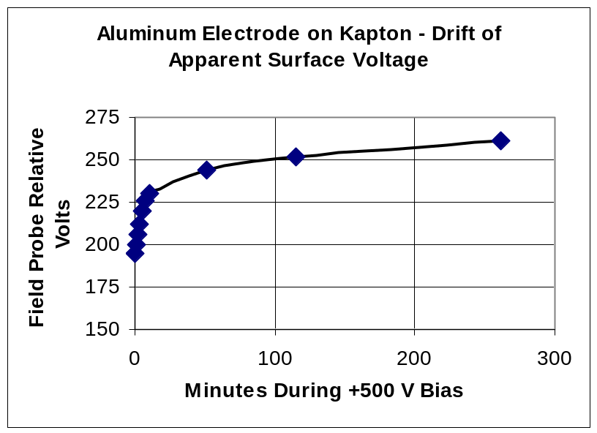
Figure 12. Drift of Kapton Surface Voltage Upon Application or +500 Volts to the Aluminum Electrode (Sept 28, 2001). Theoretically, one multiplies the field probe voltage by 1.78(?) to obtain actual surface voltage, but for this sample it is uncertain.

Charging the Sample
On Sept. 28, within minutes of obtaining the last data point (at 261 minutes) in Fig. 12, the electron-emitting filament was activated while the +500 volt bias was maintained for the purpose of negatively charging the Kapton surface. Note the picoammeter in Fig. 1 which can be viewed while charging the sample. In a normal charging test, the picoammeter indicates that the charging current flowing from the filament decays smoothly to near-zero as the sample becomes charged. For this sample the digital picoammeter bounced wildly as if the sample was occasionally pulse-discharging. Normally it takes one or two minutes to charge the sample, but in this case the picoammeter had not settled even after ten minutes, so the filament was turned off at ten minutes to see what had been achieved.

The field probe reading was monitored for three hours as it slowly varied between -125 and -132 volts while the sample electrode remained at ground. During the first 13 minutes it started at –125 V and drifted monotonically to –132 volts, and afterward slowly drifted monotonically to –128.5 V. Assuming a calibration factor of 1.78 this corresponds to surface voltage range of -222 to –235 volts. The sample was then left in the dark in vacuum with grounded electrode until Oct. 1.

October 1 at 9:00 hours the field probe indicated –128 volts, right where it was last measured on 28 Sept. Perhaps no holes had been injected into the Kapton from the aluminum during the nearly three days of storage. At 9:02 hours +228 volts was applied to the electrode which brought the field probe reading to 0 volts, and showed that the geometric calibration factor is (hopefully) 228/128 = 1.78. The sample was then grounded for nearly five hours until 14:00. At 14:01 it was determined that +237 volts on the electrode produced zero volts on the field probe indicating that the sample surface (or at least the part of the surface to which the field probe was most sensitive) had drifted to –237 volts.

Interpretation (or understanding) of this sample is problematic. Beyond the problems relative to Fig. 12 there are the problems related to charging and probable pulsed discharging. One can imagine strong transverse electric fields and charge density gradients on this sample, especially after the charging procedure. The field probe senses the electric field over a limited region of the sample surface, and does not average over the entire surface. It does not appear advisable to continue this study until the existing data can be explained.

Future work should bring the apparatus into air and perform the electrode bias study alone, without the electron-emitting filament. In air one can observe the sample to see that it is mechanically stable. With the exception of transverse field effects, the drifting problem in Fig. 12 should not occur. When the causes for the drifting problem have been removed, or understood, only then may in-chamber studies be meaningful.

VI. ELECTRON BEAM-INDUCED DISCHARGE PULSES AND CHARGE STORAGE

In anticipation of developing a “leaky sample” by either Cobalt Irradiation, or hole injection at the aluminum electrode, some preliminary discharge pulsing tests were performed on 25 May 2001 on the samples with copper electrodes. A leaky sample would provide the opportunity to demonstrate reduced pulsing by the leaky sample relative to the standard sample. Because a leaky sample was not achieved, the pulsing tests will not be presented in detail.

In anticipation that LaRC-SI would provide superior immunity from radiation-induced arcing due to its superior electrical arc-tracking performance, the statistics for pulse rate and pulse amplitude created by the 20 keV electron irradiation are compared between LaRC-SI and Kapton.

Samples KA-001 and SI-001 were irradiated with 20 keV electrons at 0.2 nA/cm² for about 30 minutes and developed 44 pulses. Rough measurement of surface voltage found SI-001 at roughly 6000 volts, and KA-001 at roughly 4000 volts, on average during the test. These surface voltages, as well as the internal electric fields, far exceed those to be expected in space, or in normal applications by a factor of roughly 5 to 10.

At one hour after beam charging started, and with roughly 4-kV on its surface, the voltage on sample KA-001 was decaying at roughly 50 V/minute, and on SI-001 the 6-kVsurface voltage was decaying less than 5V/min. If we had developed leaky samples, these numbers would be important to study as a function of electric field and temperature in the sample. Without examining it in detail, the Kapton surface voltage was decaying 50/4000 = 1.25% per minute. With only 400 volts on its surface and roughly one hour after bias application, this same sample decayed by 26 volts during a 3-hour time span, or at 0.036% per minute (see Fig. 9 and its associated table of data). As usual for any material, the resistivity of the Kapton insulator is dramatically reduced at high electric field. The electric field strength with 4-kV and 6-kV on the 50-micron thick samples (roughly 100 volts/micron) was sufficient to produce frequent breakdown pulses, more than one per minute.

Mono-energetic electron irradiations produce severe over-voltage conditions unless they actually penetrate the sample or unless the sample is exceedingly thick. Our test definitely produced over-voltage conditions that would not occur in actual space radiations. A caution is in order here before one places confidence in the findings. The electric field inside insulators actually developed in space conditions depends upon a parameter that we cannot determine from these tests; a parameter called the Coefficient of Radiation-induced Conductivity. Unless LaRC-SI is unusual in this regard, it is probable that radiation-induced conductivity effects would cause the LaRC-SI material to be even better than our limited tests found. Further testing would be required to prove this.

Although one might assume that the extra leakiness of Kapton would help to prevent radiation charging in Kapton compared to that in LaRC-SI, this is not true in general. It would be true only for a narrow range of radiation intensities where the radiation-induced conductivity is comparable to the material dark conductivity. The extra leakiness in Kapton did provide our Kapton sample with a smaller voltage stress during the electron beam tests, yet the LaRC-SI performed better in spite of this. The leakiness advantage of Kapton is expected to be less of an advantage in real space radiations.

The following table clearly shows the superiority of LaRC-SI. It pulses less frequently, its pulses are not larger, and it withstands larger voltage stress. In real space radiations the superiority of LaRC-SI is expected to improve further.

Table of Pulsing Performance During 20 keV Electron Irradiation
Sample: LaRC-SI-001 (copper) |  | Sample: Kapton-001 (copper)
Electric field stress, 120 V/micron |  | Electric field stress, 80 V/micron
# of pulses during test = 14 |  | # of pulses during test = 29
Average peak pulse amplitude, 1.7V |  | Average peak pulse amplitude, 2.9V

VII. CONCLUSIONS

When a material is used in space applications the material properties appropriate for that environment must be taken into account. Contrary to this advice, resistivity measurements for insulators are usually performed in the earth atmosphere, 1 atm, 20C, with some humidity present and with electrodes attached to the sample. We have repeated such atmospheric tests over a year ago to find resistivity in polyimide of order 1.4E16 ohm-cm. Such a resistivity predicts a charge decay time constant of ρε = (1.4E16 ohm-cm)(8.85E-14F/cm)(3.12) = 64 minutes. Thus, charging by space radiation may be incorrectly assumed by an analyst or spacecraft designer to quickly (1-hour) dissipate.

For the space environment we have measured the resistivity of Kapton polyimide to be >5x10¹⁹ ohm cm, and of LaRC-SI polyimide to be >5x10²⁰ ohm cm. Inappropriate resistivity values of various magnitudes are commonly assumed for space applications. The Guide to Plastics by the Editors of Modern Plastics Encyclopedia tabulate the resistivity of polyimides as " >1E16." W. Tillar Shugg in Handbook of Electrical and Electronic Insulating Materials, 2nd Ed. tabulates polyimide resistivity as “E18”. The units are ohm-cm. The charging test methods introduced here are the proper ways to test any space material.

We have performed the measurement of resistivity in a simulated space environment, 1E-6 torr, 25C in our experiment lasting many days. There was only small measured charge decay even with heating the samples to 50 degrees C. At the minimum, charge will be stored for several months so that Earth and Jovian radiations may strongly charge up polyimide insulators. This result clearly demonstrates the need to take into account the proper sample conditions in a space environment.

While air molecules, humidity, and other effects help dissipate charge buildup in earth applications, in a space environment the radiation-induced charge will continue to build until harmful discharges occur. If these characteristics are overlooked and precautions not taken, using materials such as LaRC-SI and Kapton for flex circuit material or packaging in space could result in serious ESD damage to electronic circuitry. The material that is least likely to pulse, probably LaRC-SI, would be preferred.

However, it is believed that there are ways to lower the resistivity of Kapton or LaRC-SI material to dissipate charge, and yet not cause circuit cross talk. Irradiation with Cobalt-60 to 5 megarads has been shown in this work to lower the effective resistivity by a factor ½. However, our limited test did not induce enough conduction to provide a complete solution to radiation-induced charging in space applications. Irradiation to perhaps 100 megarads or more might provide relief.

The generation of conductivity by hole-injection at aluminum electrodes on polyimides was investigated. The Kapton-aluminum sample produced confusing results and acted anomalously. More study would be necessary to learn how this material combination behaves. Aluminum on LaRC-SI material showed some promise at inducing charge injection with resulting conduction in the polyimide, but a significant (useful) effect did not occur. Because some positive effect was seen on these samples, where care was not taken to deposit the aluminum with complete adhesion, study of improved samples with tight-bonded aluminum might show improved properties. But a hoped-for dramatic effect was not observed.

The LaRC-SI provides superior performance in a radiation-induced charging environment. It generates fewer arcs and sparks than does Kapton even when stressed to higher electric field than Kapton.

As a final note it might help the reader to realize that there is on-going discussion in the insulator community to explain the results of applied voltage in the classical manner of a parallel plate capacitor with metallic electrodes. Evidence is mounting that conductive electrodes introduce charge into the insulator sample, usually as mobile ions, which continue to move for many days and cause the applied voltage to generate a current flow due to the mobile ions (often in IEEE Trans. Dielectrics and Elec. Insulation). That this effect is suppressed in the evacuated electron beam case where only one electrode (or perhaps none) is on the sample may provide a partial explanation for the strong difference between our measurements and the classical ASTM methods. This difference must no longer be ignored by the spacecraft analyst.

VIII. REFERENCES

1.) ASTM D 257-99, Standard Test Methods for DC Resistance or Conductance of Insulating Materials, (1999)

2) IEC 93, International Electrotechnical Commission Publication 93, Methods of Test for Volume Resistivity and Surface Resistivity of Solid Electrical Insulating Materials, Second Edition, 1980.

3) W. Tillar Shugg, Handbook of Electrical and Electronic Insulating Materials, 2nd Ed.

4) . The Guide to Plastics by the Editors of Modern Plastics Encyclopedia, McGraw Hill, Inc., N.Y., 1970.

IX. APPENDIX

IX.A. Comments On Resistivity And Permittivity

It is extremely important to comment on polarization current versus real current, and on dielectric constant versus resistivity. The concept of resistivity is generated by the human condition of desiring to apply Ohm’s Law or comparable ideas to the analysis of such a system. In reality, Ohm’s law is not physical, it is imagined, and our data proves that it does not apply to our case. Consider that if Ohm’s law applied, and the sample had constant resistance, then the fractional voltage decay per unit time would be a constant. In such a case the data in Fig. 12 would constitute a horizontal line. Instead, throughout the data, out to 20 days, the fractional decay is decreasing. It is very likely that this process is due to polarization currents throughout the dielectric, possibly assisted by injection and subsequent trapping of real charge near the metal-dielectric and vacuum-dielectric interfaces. These processes seem to dominate the total current out to 20 days. The fractional voltage decay out to 20 days appears to be due mostly to a change of dielectric constant (polarization currents) rather than to resistivity (free carriers effectively transiting the entire sample with a constant current density).

A full mathematical analysis of this quasi-static problem could be developed, but would consist of a number of terms that would require further experimental investigation. One would not obtain closure for the problem at hand. So, we continued with the contrivance whereby the data is interpreted as a change in resistivity. For real problems, one must remember to relate the experimental voltage decay and its time scale to the situation on spacecraft where the insulator must withstand the charging processes for the lifetime of the spacecraft, typically years. The resistivity values mentioned in this report cannot be used with Ohm’s Law alone to estimate the charging processes on spacecraft. Instead, one must consider that the voltage decay is due to changing polarization currents, and the actual resistivity values after long time in space are an unknown value. In effect, we have determined a minimum value for the resistivity (see Table of Decay Rates and Resistivities) where the real value is larger by an unknown amount.

IX.B. Comment on Data Presentation

Simple numeric data is used because it is closest to the actual experiment. It would have been interesting to fit the data to a theoretical function, or to a spline fit, in order to provide smoother derivatives, dV/dt for Fig. 11. But there is little to be gained by doing so in this brief study.

The electrostatic field probe usually, but not always, has a resolution of about 1 volt. Thus, in order to measure the decay, one should let the decay proceed for 3 volts or more. Sometimes the act of charging the samples can also charge the insides of the field probe causing it to be a little unstable and reducing its resolution to 2 volts. Because we plot a differential of voltage, these effects are the cause for the wide scatter in the data points in Fig. 11. In practice, the data presentation, and its accuracy, is improved by placing a smoothed line fit to the data. But it serves no purpose to do so here. The reader should be aware that the scatter should not be interpreted to mean that the post-rad and pre-rad data are almost equal. They really are different by a factor of almost two.

IX.C. Comment on Application of the New Information to Spacecraft

Spacecraft experience variable environments. In typical Earth orbits, the spacecraft environment varies both because the Solar wind modulates the magnetosphere on time scales from minutes to weeks, and because the spacecraft moves into and out of radiation zones on timescales of minutes to days. Consider a case where the spacecraft experiences elevated radiation for a few days, followed by many days of benign environments. If the insulators have charge decay time constants of a few days, then the charging threat consists only of the amount of charge delivered to the spacecraft in a few days. But if the insulators have time constants of a year, then all the charge accumulated in a year becomes the threat.

Figure 12 plots the voltage decay time constant as a function of insulator resistivity for dielectrics with typical permittivity. The period for one orbit in Low Earth Orbit (LEO) is also noted. It is clear that our new values for the resistivities of polyimides imply that one must integrate the spacecraft charging threat for at least one year, not 1 to 10 hours as has often been done for spacecraft.
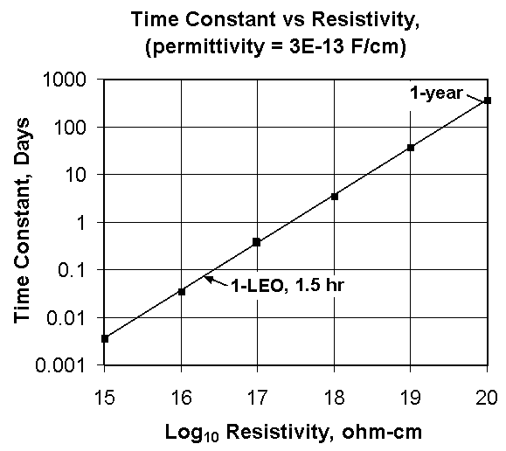
Figure 12. Theoretical Voltage Decay Time Constant as a Function of Dielectric Resistivity.

IX.D. Comment on Copper Electrode Preparation

Injection of mobile carriers at the electrode is always a possibility until proven otherwise. Our attempt to compare aluminum electrodes to the copper electrodes was motivated by this consideration. The measurement of conductivity or resistivity would be changed in the event of injection by the electrode interface. Therefore it may be important to record the manner in which the electrodes were applied to the insulating material in order to compare results from these tests to other tests that may be performed in the future. The copper electrodes were prepared as follows:

COPPER LAMINATED LARC-SI FILM SAMPLES
by Gregory K. Draughon, NASA/Langley, EATB/MTSS, September 6, 2000

The basic procedures for producing the JPL test samples are casting a fully cured LaRC-SI polyimide film, copper laminating, photolithography and etching. Test samples are composed of LaRC-SI films made of 30% solids, 3% offset poly (amic) acid gel material. All films are cast using a doctor blade at a 15-mil blade height in a glove box. After casting, the films are left in the box approximately 16 to 20 hours to become stable and tack free before being moved. The temperature of the glove box is kept around 77 degrees Celsius, at approximately 14% humidity. The films are then placed in an oven, under an aluminum cover at 65 degrees Celsius for approximately 5 hours to further dry tack free before final curing. Once curing is to begin, the full cover is replaced with a three-sided cover to allow solvents to boil off and vent during high temperature processing. It also helps protect the film from air current disturbances and any loose particulates that may be blown around in the oven. The film is then fully cured using a slow, ramping and soaking cycle up to 325 degrees Celsius under air. Once the chamber is cooled, the glass substrate that the film was cast on is then soaked in boiling water until the film separates from the glass. The final film size is usually 12" x 18" in size and range from 1 to 3 mils thickness.
LAMINATING PROCEDURES
In laminating the copper to the LaRC-SI, the copper foil that is provided with an adhesion promoter on the back provides the best results. The copper is first dipped in a 2% sulfuric acid solution to remove any oils or contaminants. After drying, one side of the copper is sprayed with a minimum of three coats of a LaRC-SI solution as an adhesion promoter and dried at 65 degrees Celsius for 20 minutes between each coat. The LaRC-SI film and copper are then layered and vacuum bagged for autoclaving. In the lay up, upilex is used as a release film, and alzac, a finely polished aluminum is used directly outside of the release film to prevent any scratches, which are common in stock aluminum, from being transferred to the surface of the sample. Because of its softness the alzac must have a second layer of regular stock aluminum on its outer sides to prevent the pattern of the fiberglass used for bagging from being transferred to the work piece. The lay up is vacuum bagged and processed at 300 degree Celsius, 100 psi and held for 1 hour. The result is a strong bond of LaRC-SI film to copper, which can now be patterned and etched.

PHOTOLITHOGRAPHY AND ETCHING
The pattern transfer is done using normal photolithography procedures. The copper film samples are coated using Shipley 1805 photo-resist, and pre baked at 90 degree Celsius for 30 minutes. Samples are exposed using the Nu-Arc plate maker exposure unit at 30 to 40 light units. Samples are then developed using a 50/50 mixture of Shipley photo resist developer and deionized water. Samples are then post baked at 140 degrees Celsius for 30 minutes. After post baking, the pattern is then ready to be etched.
Etching of the copper is done using a mixture of 2/3 water and 1/3 sulfuric acid heated to 190 degrees Fahrenheit. The sample is submerged into the mixture until the copper pattern is cleanly etched. The sample is then thoroughly rinsed with deionized water and dried. The last step is to remove the remaining photo-resist using preheated photo-resist remover, and thoroughly rinse the sample again with deionized water.

