Technology Readiness Overview of
SiC High Temperature Microsystems and Packaging
- For NEPP program

Liangyu Chen, OAI/NASA Glenn Research Center

1. Brief description of the technology

Single crystal silicon carbide (SiC) has such excellent physical and chemical material properties that SiC microsystems including MEMS sensors/actuators and signal conditioning/computing electronics can operate at temperatures in excess of 600ºC. Microsystems which can operate in harsh environments (~600ºC) are necessary for many space and aeronautic applications such as sensors and electronics for a space mission to the inner solar system or combustion/ emission control sensors/electronics located in an aeronautical engine environment. The Propulsion Instrumentation Working Group (PIWG), a working group composed of government labs and engine manufacturers, suggested that the minimum environmental temperature requirement for sensors operating in an aerospace engine (fan area) is 500ºC. SiC MEMS and semiconductor devices fabricated at NASA GRC have been demonstrated operable at temperatures as high as 600ºC.

Besides the SiC sensor/device technology, packaging technology is essential for high temperature microsystem technology. Currently, most high temperature MEMS sensors/actuators and electronics are tested only in laboratory environments, and commercially available products have not been validated for long term operations. One of the major reasons for this is that packaging technology for high temperature microsystems operable at and over 500ºC has not been completely validated/evaluated. Validating packaging technologies for SiC MEMS sensors/actuators and electronics is an immediate need for many NASA missions, and therefore, is one of the current tasks of the NASA Electronic Parts and Packaging Program.

2. State of technology and TRL

Researchers at Glenn Research Center developed new prototype packages for high-temperature microsystems using ceramic substrates (aluminum nitride and 96- and 90-wt% aluminum oxides) and gold (Au) thick-film metallization. Packaging sub-components, which include a thick-film metallization-based wirebond interconnection system and a low-electrical-resistance SiC die-attachment scheme, have been tested at temperatures up to 500 °C. The interconnection system composed of Au thick-film printed wire and 1-mil Au wire bond was tested in 500 °C oxidizing air with and without 50-mA direct current for over 5000 hr. The Au thick-film metallization-based wirebond electrical interconnection system was also tested in an extremely dynamic thermal environment to assess thermal reliability. As shown in Figure 1,the current-voltage (I–V) curve of a SiC high-temperature diode was measured in oxidizing air at 500°C for 1000 hr to electrically test the Au thick-film material-based die-attach assembly.

As required, the electrical resistance of a thick-film-based electrical interconnection
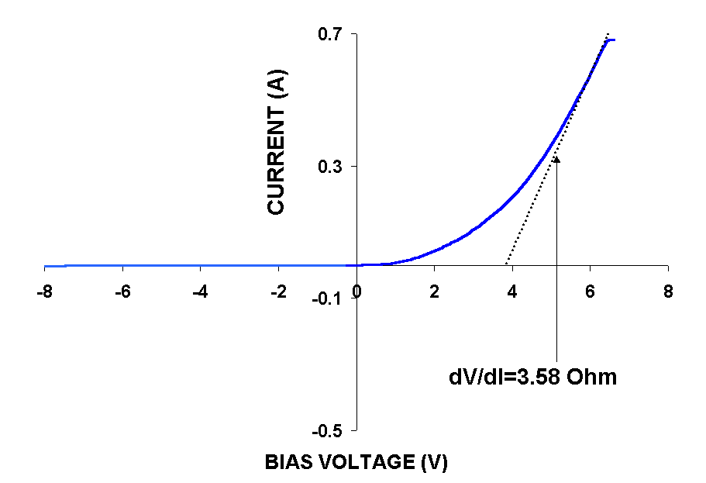
system demonstrated low (2.5 times the room-temperature resistance of the Au conductor) and stable electrical resistance (decreased less than 5 percent during the 5000-hr continuous test). Also as required, the electrical isolation impedance between two neighboring printed wires (of the package shown in Figure 2) that were not electrically joined by a wire bond remained high (>0.4 GΩ) at 500 °C in air. Gold ribbon-bond samples (1 mil by 2 mil) survived 500 thermal cycles between room temperature and 500 °C (with 50 mA direct current), at the rate of 53 °C/min, without electrical failure. An attached SiC diode demonstrated low (< 3.8 Ω-mm²) and relatively consistent forward resistance from room temperature to 500 °C. These results indicate that the prototype package and the compatible die-attach scheme meet the initial design requirements for low-power, long-term, and high-temperature operation. Printed circuit boards to be used to interconnect these chip-level packages and passive components are being fabricated and tested. The following figures show the chip level packages and printed circuit boards to be used to characterize eight-pin low-power packages and devices at temperatures up to 500°C. In summary, ceramic substrates and thick-film metallization based high temperature packaging material systems have been established and evaluated for high temperature microsystems packaging.
Figure 1: I-V curve of a SiC Schottky diode measured in 500ºC oxidizing environment after 1000 hrs at 500ºC.
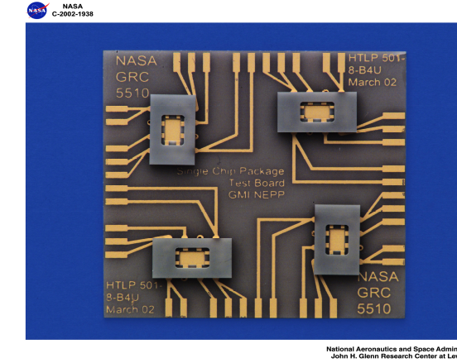
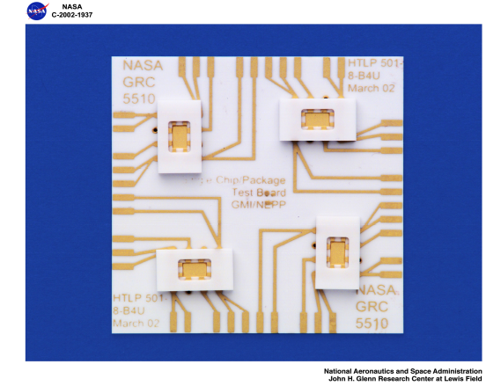
Figure 2: Aluminum oxide and aluminum nitride high temperature 8-pin chip level packages and printed circuit boards.

Using this packaging technology, a SiC electronic device (Schottky diode) has been successfully tested in 500°C oxidizing environment for over 1000 hrs.

SiC piezoresistive MEMS pressure sensor chips developed by Kulite Semiconductor Products (with NASA Glenn support) have been demonstrated functional at temperatures up to 600°C. Packaged sensors have been tested at 500°C and on an aerospace engine. Long-term testing and validation of these products, especially the packaging system are still needed.

Sienna Technologies Inc. is working with NASA Glenn in developing and commercializing SiC power Schottky diode and pressure sensor packaging technologies. Packaged SiC pressure sensor chips have been tested at temperatures up to 600°C. However, these packaging systems need long term high temperature validation.

IJ Research has been working under US Army and Navy contracts on a packaging technology for high temperature high power devices. AlN chip level packages for electronics passed extreme condition tests including thermal shock, thermal cycle, a short term life test at 500ºC, and room temperature hermetic tests before and after these thermal excursions. Currently, chip level packages are commercially available for high temperature high power device packaging. However, long term reliability tests of these packages with power devices are needed.

With these discussions the Technology Readiness Level (TRL) of the packaging technology for SiC high temperature sensors and electronics is between level 5 and 7.

The high temperature packaging technology Glenn is testing and validating is not limited to SiC high temperature sensors/devices, they are also useful for GaN and SOI (silicon on insulators) technologies. Honeywell has SOI devices/circuits on the market for applications at temperatures up to 300ºC. These products include: linear amplifier in 4-lead pin-out ceramic Dual-In-Line-Package (DIP), analog switch in 4-lead standard pin-out ceramic DIP, 12-Bit analog-to-digital (A/D) converter, 80C51 microprocessor, and pressure sensor/transducer. Most of these products have been tested for 225 – 300ºC long term (5 years lifetime) operation. Endevco Corporation (Stockholm, Switzerland) has high temperature dynamic pressure sensors for measurement of pressure up to 500 psi at temperatures up to 320ºC. The high temperature packaging technology that Glenn is testing will also benefit these SOI and GaN products.

3. Producibility/manufacturability issues and available vendors

The Glennan Microsystems Initiative, a NASA supported harsh environment microsystem technology initiative is going to commercialize various high temperature and harsh environment sensors/actuators with packaging technology in the next few years. Kulite Semiconductor Products has commercialized SiC high temperature pressure sensors for short term applications. High temperature chip level packages for high temperature high power electronic devices are available from IJ Research. The products of Kulite and IJ Research have only been evaluated/validated for short term applications so far, partially because of packaging issue. Currently, the high temperature low power 8-pin packages of AlN (aluminum nitride) and 96% alumina designed at NASA GRC are fabricated by a commercial vendor. The packaging technology NASA Glenn is evaluating is not limited to applications for NASA missions, it is also suitable for commercialization and large scale production of other (non-SiC) high temperature operable devices/sensors. Besides these SiC sensors/devices and packaging technologies designed for temperatures up to 500-600ºC, Honeywell has SOI products (both die and multi-chip packaging module) for applications in a temperature range from -55 C to +300ºC as indicated in section 2. 300ºC operable packaging manufacturers include Honeywell and CTS Corp. et al.

The manufacturers for advanced packaging materials evaluated for high temperature applications include precious metal thick-film manufacturers: DuPont, Ferro, Electro Science Laboratories Inc., Heraeus et al. AlN ceramic substrate manufacturers include Carborundum (Saint-Gobain Advanced Ceramics), Hitachi, Kyma et al.

4. General reliability

An advanced electronic sensing system is crucial to integrated vehicle health monitoring. This is evidenced again by the recent Columbia tragedy: the earliest warning signal of the failure was the unusual behaviors of the temperature/pressure signals near the left wing. This illustrates the importance of a distributed electronic sensing system on advanced spacecraft and aircraft.

NASA is developing next generation aerospace engines with self-monitoring and self-control capabilities. In order to achieve this technology, a microsystem which is able to operate in situ within a high temperature combustion environment is essential to real time monitoring and control of engine combustion processes. The Propulsion Instrumentation Working Group (PIWG) concluded that high temperature operable sensors for real time and in situ combustion characterization are needed for the next generation aerospace engines. These microsystems based on high temperature MEMS sensors and electronics not only improve the capability of the next generation engines but also improve the overall reliability of the engine system. High temperature operable electronic systems can reduce electrical wires/connectors and the gas/liquid cooling system. These extended wiring and mechanical systems are certainly an overburden to the vehicle reliability. High temperature microsystem based sensing and control systems not only improve overall health and reliability of the engine system but also improve the environment compatibility of the next generation aeronautic and spacecrafts. For example, optimization of combustion processes can save fuel and significantly reduce emissions.

Knowledge of inner solar planets is important to better understand our earth and the environment of our earth. The previous Venus explorations indicated that the planet surface and atmosphere temperature is about 500°C and the atmosphere is very corrosive (acid). So any landing probes to Venus must be able to withstand a high temperature and reactive chemical environment. Many sensors have to be directly exposed to high temperature. A cooling system for an electronic system for any long term operation in 500°C environments is apparently not feasible. Therefore, high temperature microsystems and packaging technologies are necessary for these inner solar planet probes. High temperature pressure sensor and acoustic sensor are primary sensors for characterization of Venus atmosphere and surface. An Extreme Environments (sensors and electronics) Technologies for Space Exploration workshop organized by Code Q and S was held in Pasadena in May 2003. The workshop concluded that 500ºC electronics and sensor technologies are essential to coming NASA space missions to inner solar planets such as Venus.

5. Specific reliability and radiation issues

For high temperature microsystems the reliability at both device and packaging levels are big concerns. At temperatures up to 600°C long term reliability of materials and joining interfaces between different materials are basic issues. The reliability concern of a complete packaging system is electrical as well as mechanical. As discussed in the previous section the ceramic substrate and Au thick-film metallization based electrical interconnection system have been evaluated at 500°C with 50 mA DC bias for over 5000 hrs. However, we observed that the thin pure Au wires degraded, as evidenced by very slow increase of wire resistance. For long term operation in extremely dynamic thermal environments (at temperature rates above military standard of thermal shock rate) this kind of degradation becomes more apparent.

Both operation and performance of MEMS sensors and electronics can be sensitive to the thermal mechanical stress generated in the die-attach assembly due to the mismatch of thermal expansion (CTE) between the die material (such as SiC), the substrate material, and the die-attaching material. For high temperature microsystems including MEMS devices the thermal reliability is even more critical. First, the environment temperature range is much wider compared with that of conventional electronics, and second the MEMS operation is at least partially mechanical so both the device configuration and device response can be very sensitive to thermal stresses on the device/chip. Therefore, the thermal stress of the die-attach structure must be suppressed in order to achieve long term precise and reliable operation because thermally induced stress may generate unwanted device response to the thermal environment.

As indicated in Section 2, the basic packaging subcomponents such as ceramic substrates, Au thick-film metallization, Au wirebonds, and conductive die-attach all have been evaluated at high temperature (500ºC) in the laboratory. In order to use these subcomponent technologies in an in situ application environment, such as the fan area of an aeronautic engine, a practical and versatile high temperature packaging module with integration of these subcomponents still needs to be validated with SiC sensors and electronics. This testing module can be a spark-plug type package which is suitable for various SiC sensors with electronics for real applications in various high temperature harsh environments.

6. Qualification problems and possibilities

High temperature and harsh environment microsystems and packaging are newly emerging technologies. The qualification problem of high temperature microsystems and packaging technology has to be addressed with respect to specific application and operation environment which can be dramatically different from one case to another. For example, for a space mission to Venus (Decadal Survey, Code Q and Code S) planned recently by JPL, the planet surface gas environment is 460ºC and chemically corrosive (96% carbon dioxide). The pressure is 0 – 1305 psi. The probe lifetime requirement is from 3hrs to a week. For the application of combustion characterization of an aeronautic engine (Code R) the environment temperature is 500°C (fan area), the line pressure is up to 500 psi (the burst pressure can be as high as 3000psi). The minimum lifetime is several hrs for an engine ground test run. However, for a sensor used for self-monitoring/control of a flight engine the lifetime requirement should be 12 months. The chemicals involved in combustion include hydrocarbons, oxygen, carbon monoxide/dioxide, nitrogen oxide, and water vapor. Based on these discussions, qualification standards of high temperature sensor/electronics are very much mission/application dependent. Therefore, mission/application dependent operational and environmental requirements will be used to establish qualification standards for high temperature sensors/electronics designated for each NASA mission/application.

7. Time table for readiness

Because of the dramatic differences in device/system performance requirements for various high temperature applications the readiness level of different microsystem/ sensors/devices are different at this stage. The following time table indicates the time lines of various high temperature and harsh environment microsystem projects at GRC and other institutions. The development and validation of packaging technology, as a part of the device/system, have to meet these time lines to deliver the final products:

a) Kulite Semiconductor Products currently has prototype high temperature SiC and SOI pressure sensors (not validated for long term applications) on market.
b) Honeywell has SOI high temperature (up to 300ºC) sensors/electronics and packaging modules on market.
c) Glennan Microsystems Initiatives: pressure sensors tests in engine environment in FY03.
d) High Operation Temperature Propulsion Components: pressure sensor for engine combustion monitoring and control is due in FY05.
e) Smart Engine Components: Acoustic sensor for measurement of temperature distribution of combustion chamber will be tested in a burner in FY04 – 05.
f) Ultra Efficient Engine Technology: A high temperature RF telemetry system for wireless data transfer is going to be demonstrated in FY05.

8. Technology evolution in near term

The development of SiC microsystem and packaging technologies is very likely to be in parallel with product validation and commercialization for the next generation (or more advanced) of products. High temperature and harsh environment microsystems and packaging technologies are still very young, so both device and packaging technologies will certainly be in constant evolution in order to meet further requirements for new applications. As we learned from MEMS packaging, it is very unlikely that one package design will fit many high temperature microsystems which include MEMS devices. So we do expect gradual evolution of packaging technology for high temperature microsystems in both near term and long term, however, at this stage we do not see abrupt technology change in the near term.

9. Will one be able to write a specification and/or requirements for technology items

The basic specifications of a packaged high temperature harsh environment microsystem include maximum operational temperature, lifetime, maximum temperature rate/cycle lifetime, maximum power dissipation etc. Specifications of high temperature harsh environment microsystems and packaging systems can be, and will be systematically established. Establishing a qualification/specification system for high temperature harsh environment microsystems is vital to the success of application of this technology down the road.

10. Considerations addressed in all three NEPP projects

The reliability considerations of a complete product should be covered by all three aspects of packaging, parts, and radiation. Various high temperature harsh environment microsystems needed for NASA missions should also be validated/evaluated as individual parts as these parts approach application. SiC has a wide energy bandgap so this material has very good resistance to radiation, and therefore, SiC microsystems are very suitable for space applications. This indicates that radiation related reliability should also be considered later for SiC products. However, as discussed earlier, a high temperature packaging technology is essential for testing high temperature devices. Gold thin-film coated tungsten ‘high temperature’ probe tips fail at 450ºC, so electronic devices can not be long-term tested at the wafer level using conventional probe stations. Therefore, high temperature testing of microsystems is not possible without an appropriate package. This indicates the critical role and the importance of high temperature operable packaging technology to infuse SiC high temperature harsh environment microsystem technology into NASA missions.

11. Conclusion

A validated high temperature packaging system suitable for long term operation at temperatures up to 500ºC is a critical element to expedite application and commercialization of high temperature SiC microsystems. NASA Glenn has been validating basic packaging subcomponents for long term high temperature applications. As the next step, a practical and multi-purpose high temperature packaging module that integrates these subcomponents needs to be validated. A long term validated high temperature packaging technology, an essential part of high temperature microsystems, benefits both NASA’s space missions and commercial technologies.

